Mathematical problems in music (and how we can fix them)

Notes and frequencies

Every sound we hear comes from pressure waves in the air, which are different to light waves and other electromagnetic waves, but similar in their concepts of frequency, amplitude, and other wave properties. While the experience of hearing sound is perhaps more of a biological or philosophical question, we can explain certain phenomena that are common in music theory using the mathematics of waveforms.
Let’s take the note that we tune instruments to: A440, the note with a frequency of 440Hz (or 440 vibrations per second). You may know already that an octave leap corresponds to exactly a double in frequency, so the A one octave below this will have a frequency of 880Hz, and the A above this is 220Hz. These notes are all called ‘A’ because they sound very much alike, as a result of this very simple ratio of 2:1. You can test out how the sounds of frequencies relate to each other using this website (open in multiple tabs to play more than one pitch): https://www.szynalski.com/tone-generator/. Generally, intervals with a simple frequency ratio, such as 3:2 create nicer sounds – this is the principle on which all musical harmony is based on.
We usually divide these octaves into a 12-note chromatic scale, as seen on any piano keyboard (every step between adjacent notes is a semitone), and since each of these intervals is the same, we can see that an interval of a semitone corresponds to a ratio of $2^{\frac{1}{12}}$. Of course this is an irrational number, so we can see that every other interval apart from an octave will not have a perfect integer frequency ratio.

In fact it is impossible to have all the notes in the scale have an integer frequency ratio. Pythagoras first saw this in a famous experiment where he measured the sound produced by hitting hammers of different sizes – he tried to create a tuning system based off only the 2:1 (octave) and 3:2 (perfect 5th) ratios – but he quickly realised that no integer power of $\frac{3}{2}$ will ever reach an integer power of 2 – so no number of perfect 5ths (equal to 7 semitones) will exactly reach a number of octaves, and thus we cannot have a perfect tuning system. Pythagoras tried, using the following system, where he would start from the lowest note, and move up 5ths (multiply by $\frac{3}{2}$) and down octaves (divide by 2) where necessary, to get all the pitches of a twelve-note scale:
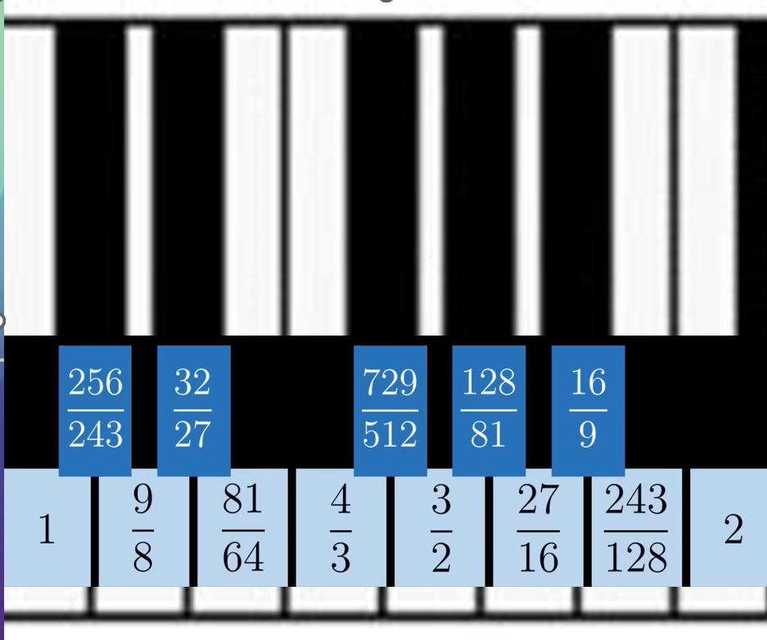
Pythagoras wasn’t a fan of irrational numbers, but a more modern accepted version of this (the ‘equal temperament) just uses the $2^{\frac{1}{12}}$ ratio, which our brain approximates to integer ratios.
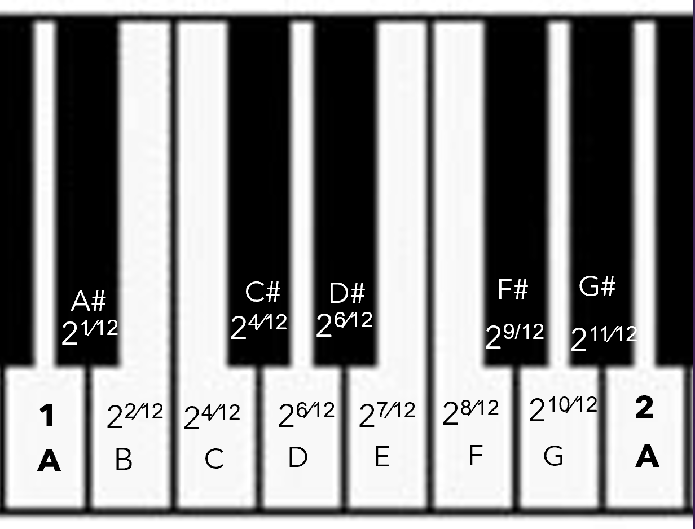
A perfect 5th for example is 7 semitones, corresponding to a ratio of $2^{\frac{7}{12}}=1.498.. ≈ \frac{3}{2}$,
while a perfect 4th is 5 semitones, corresponding to a ratio of $2^{\frac{5}{12}}=1.335..≈\frac{4}{3}$
We call intervals that sound nice, such as these perfect 5ths and 4ths consonant, but intervals that don’t sound nice dissonant.
A tritone, for example, is 6 semitones, we have a ratio of $2^{\frac{6}{12}}=\sqrt{2}= 1.414$, approximating to $\frac{45}{32}$, which is a far less nice ratio.
The reason for this is to do with the period of the resulting waveform, which is much shorter for a simple whole number ratio, and the brain finds this much more pleasing, while dissonant intervals create more complex waveforms.
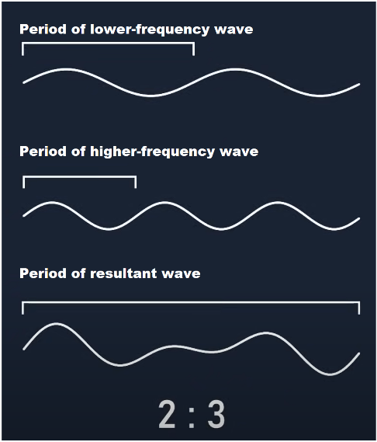 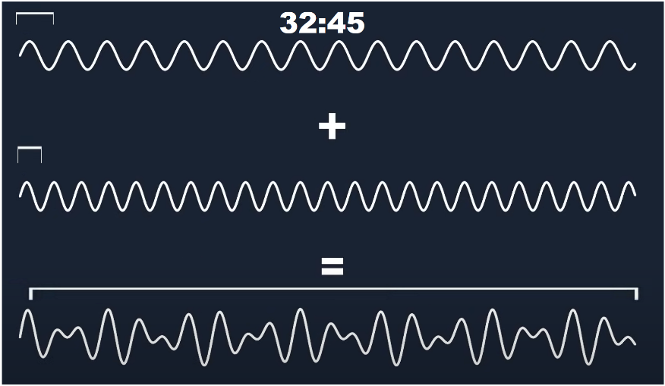[4]
There is more to the concept of dissonance than this, however. In an experiment conducted by Plomp and Levelt [1], pairs of sine waves were played to volunteers, who were asked to say how consonant the intervals sounded. While, as expected, the unison had maximum consonance and intervals close to it were dissonant, the most surprising result was that there were no other local maxima of consonance. The graph below shows dissonance relative to frequency interval (consonance graph flipped upside down). The region marked “beats” represents dissonance where interference occurs between the two sine waves since their periods differ slightly – but noticeably so. Credit to William A. Sethares for producing this graph using a MatLab program [2]
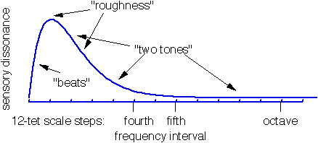Figure 1 [2]
To understand why this is the case, and yet in all instruments there seem to be specific consonant intervals other than unison, we first need to understand overtones.

Overtones

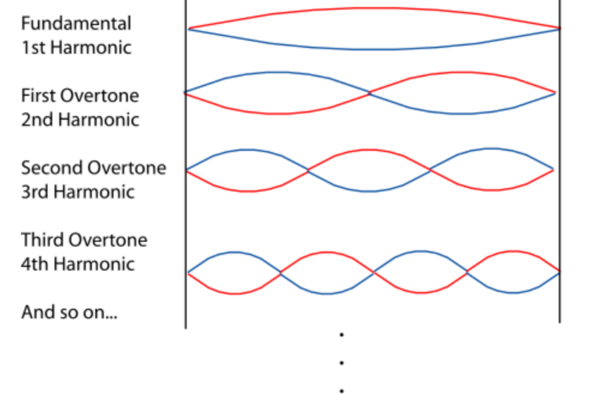
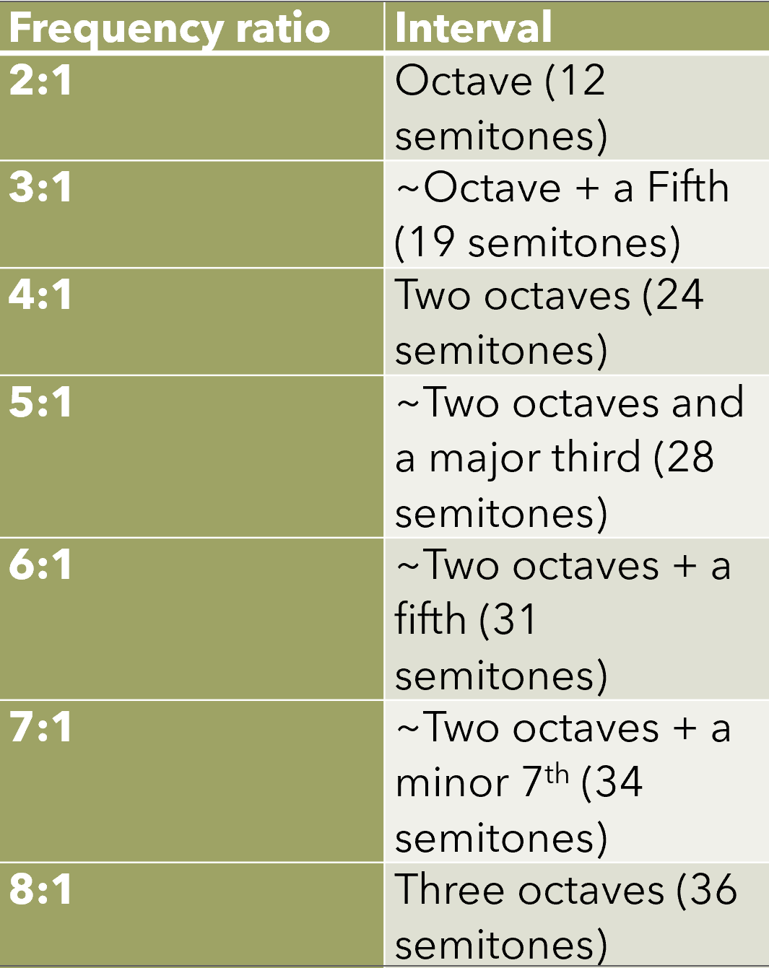
Sound waves usually oscillate between the walls of the tube in a wind instrument, or the two points of tension in a stringed instrument. The result of this is that a standing wave is formed, where the waves interact to vibrate at integer multiples of the fundamental frequency (the original frequency played). We usually don’t listen to these, but they are almost always there, even if they are very quiet!
Due to the shape and material of different instruments, these interactions vary heavily, causing certain overtones to vibrate with a greater amplitude than others; for example, all pipe instruments (flutes, oboes, clarinets etc.) only vibrate with the odd integer multiples of the fundamental frequency. This is what gives an instrument its ‘timbre’, the quality of a sound, which is why you can recognise a violin playing two different frequencies as the same instrument, and why a violin and clarinet playing at the same frequency sound different.
Let’s now look at how this affects consonance and dissonance. If we construct a graph similar to Figure 1, but instead we add up the dissonances of each sine wave pair formed by the overtones, we get a graph that now has local minima of dissonance, which now agrees with the ideas that we’ve seen about frequency ratio!
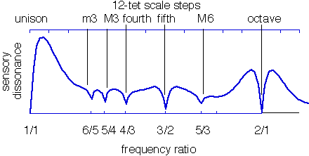Figure 2
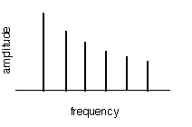Figure 3
Note that the dissonance graph (Figure 2) was made by a sound with overtones shown in Figure 3. We can see now also that there is the same minimum dissonance for an octave as for unison.
For this timbre, it makes sense to split the octave into 12 semitones, as many of them align with local minima of dissonance; but different timbres can create different dissonance graphs.
For example, a xylophone has harmonics at very odd positions: as ratios to the fundamental frequency, they are 1, 2.758, 5.406, 8.936, 13.35, 18.645, 24.82. [3]
Plugging this into the program, we get this dissonance curve, that has equally strange local minima points:
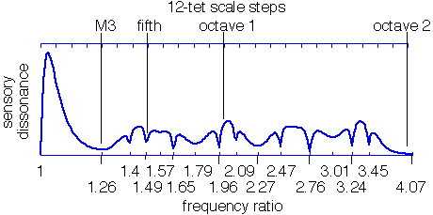[2]
It seems then that theoretically we should tune xylophones to this scale, with frequency ratios (1, 1.26, 1.4, 1.49…), at least when they are played on their own; unfortunately, it is rare to hear a xylophone outside of an orchestra. The other issue with irregular interval spacing is that one can’t transpose music.
But now we’ve seen that even an existing instrument could be optimised to a different tuning system, it leaves us to wonder if the reverse could be engineered – instruments where different tuning systems are optimal for consonance. Music synthesisers are our friends here, and we could indeed synthesise sounds with overtones that give us n-tet scales (n regular intervals in an octave)
Here are 3 examples of timbres (abundant harmonics listed in order of ratios to the fundamental frequency) that lead us to a 10-tet scale, which is very dissonant for most instruments we use (credit again to William A. Sethares for producing these graphs [2]):
(1, 2^{10/12}, 2^{17/12}, 2^{20/12}, 2^{25/12}, 2^{28/12}, 2^{30/12})
(1, 2^{7/12}, 2^{16/12}, 2^{21/12}, 2^{24/12}, 2^{28/12}, 2^{37/12})
(1, 2^{7/12}, 2^{13/12}, 2^{17/12}, 2^{23/12}, 2^{28/12}, 2^{30/12})
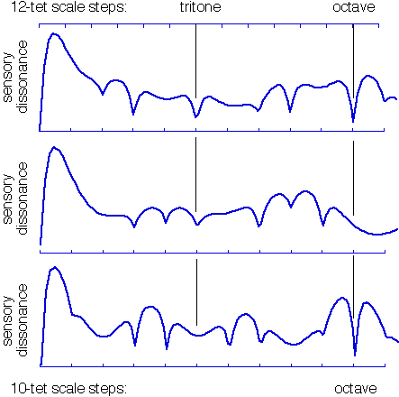 [2]
In fact, this is the basis for xenharmonic music – you can hear a piece that uses a 10-tet scale: https://www.youtube.com/watch?v=H1EcfmRFunA

Conclusion

While xenharmonic music sounds strange to human ears, this may be due to our constant conditioning of the 12-tet scale. Our 12-tet scale makes sense mathematically for our logical human eardrums, but this gives me hope that there won’t be a point where we run out of new music. Perhaps there is alien race out there listening to 19-tet music, all thinking that our taste in music is very weird.

References
[1] R. Plomp and W. J. M. Levelt, "Tonal Consonance and Critical Bandwidth," Journal of the Acoustical Society of America.38, 548-560 (1965)
[2] Willliam A. Sethares: https://sethares.engr.wisc.edu/consemi.html

[3] N. H. Fletcher and T. D. Rossing, The Physics of Musical Instruments, Springer-Verlag (1991).

Image credits:
Willliam A. Sethares: https://sethares.engr.wisc.edu/consemi.html
[4] ‘Gonkee’ on Youtube: https://youtu.be/Y7TesKMSE74 3:26, 4:13

