An exploration of the mathematics of encryption

The basics of encryption
Encryption is the process of translating information from a readable form into ciphertext that cannot be understood. A common example of this is a caesar cipher, in this cipher we assign each letter of the alphabet a number e.g. A is one, B is two, C is three. Then we shift the letters by a set amount, this is our key. Let's say our key is +2. A is now represented by 3 or in ciphertext C.

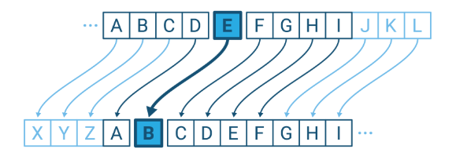
An example of a caesar cipher

However encryption has become much more sophisticated than in Caesar's time, now encryption is much more commonplace, whereas before you would only encrypt messages if you were a spy or wanted to confuse germanic tribes. Nowadays encryption is used every day by people like you and me. It is used to send text messages, emails, when making online payments or using an ATM.

Key exchange
A key exchange is a way of sharing some kind of parameters, like a secret keyword that allows a message to be encoded by one person and decoded by another.

However in order to get this key (our secret word or number for a caesar cipher) the two people must communicate in an open channel in which anyone could hear what they are saying. Imagine you and your friend are trying to secretly communicate over a public channel. You each have a pair of keys (a key being a process that converts readable text e.g. hello into ciphertext e.g.”khoor”). One key in each key pair is publicised, each key is created so that it can only be deciphered by the other key in the key pair, which you have kept private. Equally any message encoded with your private key can only be deciphered by your public key.
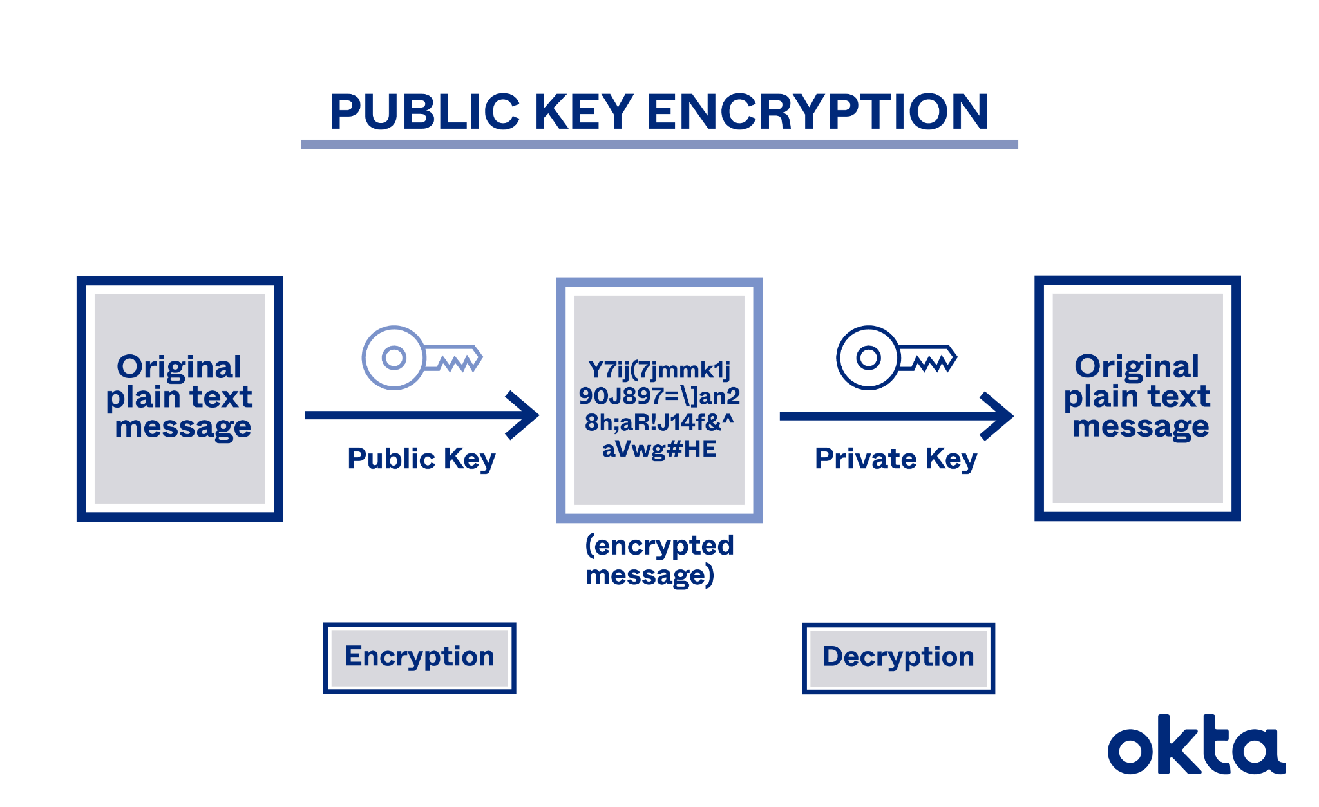
In this system you are able to encode a message using your private key, to prove that the message came from you, as it can uniquely be deciphered using your public key. You can also encode the same message using your friends' public key to ensure that only they can decipher the message using their private key.
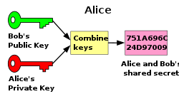

In the example above Alice sends a message to Bob. Alice's private key can be deciphered using Alice's public key, to confirm that the message came from her. However only Bob can decipher the second part of the message using his private key. Therefore the message is securely encrypted and its origin can be confirmed.

In practice instead of using keys mathematical expressions are used to encode and decode messages; an example of this is the Diffie Hellman protocol. Which uses number theory to enable a secure key exchange allowing people to communicate secretly. One of the main theorems used in this is Fermants little theorem. Which states that
α^{x-1}≡ 1 mod(x)

for any prime x, provided α is coprime with x (meaning that x and α only have one common divisor, 1).

Why large prime numbers are used
Much of modern day cryptography relies on large prime numbers, This is because the product of two large primes only has four factors itself, one, and the two primes it was created from. These primes are incredibly difficult to determine without knowledge of either one of the factors. Making them ideal for cryptography.

Diffie Hellman protocol
A common key sharing algorithm is the Diffie Hellman protocol.
In this example imagine you and your friend agree to use a large prime number (p) and an integer (y) as the components of your public key.
Then we follow the protocol in steps

- Raise y to the power of a random number (z) below p
- Take the modulus of the result by p
- This will give us a result (ε)
- We can then send this result to our friend
- Simultaneously our friend has completed the same steps 1-4 for another random number below p to get β
- After receiving β from our friend we can raise it to the power of our random number (z)
- We can then take the resultant number (equivalent to y^{mz} where m is the random number our friend chose) and take the modulus of that by p to get γ

If our friend follows the same steps above (but given ε not β, and using random number m instead of z) they will also arrive at γ. This allows them to easily calculate the random number we chose (z) and we can calculate the random number they chose (m). However due to the laws of indices, it is difficult for an outsider to find z or m even given β,γ,ε,p and y. This allows the values z and m to act as keys.

You

y^{z} (mod p) =ε

β^{z} (mod p) = γ

(y^{m})^{z} (modp) = γ

Friend

y^{m} (mod p) =β

ε^{m} (mod p) = γ

(y^{z})^{m} (modp) = γ
The general case of the Diffie Hellman protocol
The Discrete logarithm problem
Now we’ve established a common key sharing protocol. Let's see how someone might try to crack it. Now they'll have a hard time doing this because we've used modular arithmetic. In the example above a spy or anyone with malicious intent would have to guess either the integer z or m given γ, p, y, ε and β. This problem cannot be solved in a clever algebraic way and must be brute forced trying all possible combinations, this is an extremely difficult and time consuming process. Even with a supercomputer it would be incredibly difficult to find z or m. This is because the keys are generated using “One way functions”. This means they are functions that are easy to solve in one direction but incredibly difficult to solve in the other direction. We may be able to calculate γ but there are infinite values of m and z that give this result.
7¹ (mod 19) = 7

7² (mod 19) = 11

7³ (mod 19) = 1

7⁴ (mod 19) = 7

7⁵ (mod 19) = 11

7⁶ (mod 19) = 1
This is because if y and p are relatively prime (no common factors other than one so coprime) the result of the modular division follows a cyclical pattern. In the example above you can see the periodic nature of modular division with relatively prime numbers. This makes it incredibly difficult to determine z when 7^{z} mod 19 = 11. The only thing you can say for certain is that z follows the arithmetic sequence z = 2 + 3n. Thus the private key is securely protected.

RSA encryption and key generation
Another encryption algorithm that uses modular division is the RSA encryption algorithm.
The keys in RSA encryption are generated by selecting two large prime numbers. Then multiplying these numbers together gives us part of our public and private keys (N). Then a private key is generated by taking Φ* of N. Then by following specific conditions a number (m) is chosen that is greater than 1 and less than Φ of N. This number chosen also forms the final part of the primary key [(N,m) is our public key]. Then a second number can be chosen (z) with the condition that mz(mod Φ(N)) = 1. This gives a range of possible values for d that can form our final component of the private key (z,N).

P = a large prime Q = a second large prime

N = PQ
Φ(N) = (P-1)(Q-1)

m = (m | 1< m < Φ(N) ∩ m is coprime with N, Φ(N))

z = z | zm (mod Φ(N)) = 1

The general case of RSA key generation

*A note on Φ
Φ(N) in this case denotes a function that calculates the number of integers that are coprime with N meaning numbers that share no common factors with N and also one. Φ can be calculated in this case by subtracting 1 from our two original prime prime numbers and then multiplying these together.

