To Infinity, and Beyond!

Contrary to popular belief, infinity is not a number. It is merely a mathematical concept which describes something that is boundless, or never-ending. Infinity is often depicted using this symbol: ∞, but that is not the only infinity, and I will cover some other infinities and problems that are associated with infinity.

Infinities can be either countable or uncountable. Countable infinities are those in which they can be identified in different relationships, but the length of the relationship is infinitely long. Uncountable infinities contain so many elements that it becomes impossible to count all of them. For example, pi has an uncountably infinite number of digits, so it is impossible to list all of them.

To get a number that is larger than infinity, many people believe that you could just do ∞+1. However, this remains ∞. Even ∞+∞=∞. Infinity is so vast that it remains the same when anything is added to it, so infinity plus another infinity, remains infinity. So all infinities are the same size, or are they?

The smallest infinity is aleph-zero (which can also be named aleph-nought or aleph-null). This infinity (ℵ₀) describes the number of natural numbers (integers) there are. ℵ₀ is countably infinite, as the cardinality of aleph-zero is any infinite set, so can be counted, eventually.

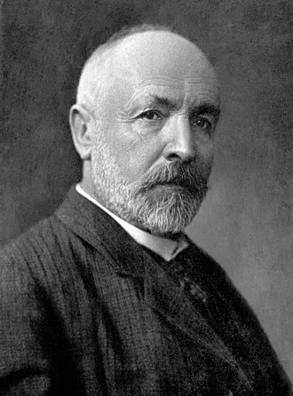
A set can be described as having a cardinality of aleph-zero if it can correspond to the natural numbers (1, 2, 3…). Some examples of these sets are all of the integers and all of the infinite subsets of the integers. For example, the square numbers, the prime numbers, the triangular numbers and others like that.
Georg Cantor, Wikipedia

However, the largest infinity is the ‘absolute infinity’, denoted with the Greek letter ‘omega’: Ω. This infinity describes any set that is inconceivably large, and uncountable. Georg Cantor, the German mathematician who proposed this concept, linked this infinity with God. He also proclaimed that absolute infinity has numerous mathematical properties.

The absolute infinity describes the cardinality of any set that is larger than all other sets that are conceivably or inconceivably large. It can be viewed as a number that is bigger than all of the other numbers that have ever been thought to exist, and bigger than any number that we could only dream of having some understanding of its size.

There is a concept developed by Philip Jourdain and/or Georg Cantor, where some sets are not sets because they are ‘too large’. This concept is called ‘limitation of size’. The axiom of limitation of size is an axiom (statement) developed by John von Neumann, which states that a set that is not ‘too large’ is a set, but a set that is ‘too large’ is not a set.

You might be wondering: how many infinities are there? Well, there are theoretically infinite amounts of infinities, each one with a different cardinality (size). This theory was first proposed in the late 19th century by Georg Cantor.

A paradox associated with infinity is ‘Hilbert’s Hotel’, introduced by David Hilbert in 1924. In this paradox, there is a hotel with countably infinite rooms, all in a long corridor. All of the rooms in this hotel are occupied, so you might believe that there is no more room. However, there are infinite rooms, so there is space somewhere, eventually.

Say, one more guest enters this hotel and wants a room, what do you do? You can’t make the guest walk infinitely down the hall, that is bad customer service. So, you move all of the guests up one room. So, move the guest in room 1 into room 2, room 2 into room 3, room 3 into room 4 and so on. Solved! All guests have a room. So, the guest in room n will now be in room n+1.

Now, a countably infinite amount of guests walk in, and all want a room. What do you do now? Again, you can’t make them all walk down the rather long corridor, that is bad customer service. The solution is to move all the guests into the room double their number. So, room 1 into room 2, room 2 into room 4 and room n into room 2n. Now all guests have a room!

Now, a countably infinite number of coaches arrive, each with a countably infinite amount of people on board. Now what do you do? One method of solving this is using prime factorisation. The expression for working out the room number is 2^{s}3^{c}, where s is the seat the guest is in on the bus, and c is the coach number. For people already in the hotel, c = 0. Now, everyone is in a room and is happy!

Let’s say that this hotel is located in a popular seaside resort. Now, a countably infinite number of ferries arrive, each with a countably infinite number of coaches on board, each with a countably infinite number of guests. Disaster. What are we going to do now? There is another expression for this, and is an adaptation of the prime factorisation method from before, all we need to do is add a new prime number, and this can be done for any more layers of infinity. The expression for three layers of infinity is: 2^{s}3^{c}5^{f}, where s is the seat that the guest is in, c is the coach number and f is the ferry number. f = 0 for the guests that are already in the hotel.

You can use the prime factorisation method for any number of layers of infinity, so 2ª3^{b}5^{c}7^{d} and so on.

A common example of infinity in mathematics is pi, or π. Pi is the constant ratio between the circumference of a circle and its diameter. It is often called an ‘irrational’ number, as it has infinite digits, and is impossible to write out in its entirety. Pi is often shortened to 3.14, or in some cases 3.14159. Also, pi is approximately 22⁄7.
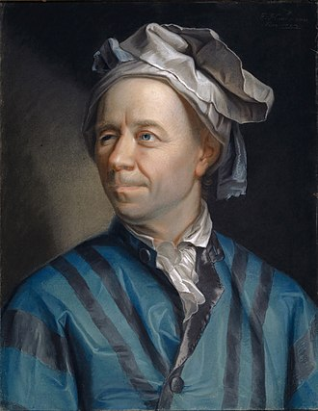
Leonhard Euler, Wikipedia
Another irrational number, like pi, is Euler’s number, or e. This is a constant discovered by Jacob Bernoulli in the late 1600s. He was working on a question about interest, where an account starts with $1.00, and is credited with 100% interest a year. He worked out what would happen if the interest is added to the account more often, like 50%, twice a year.

So, the account would start with $1.00, and is credited with 50% interest, so becomes $1.50. Then 6 months pass, and 50% interest is added again. Half of $1.50 is $0.75, so the balance would become $2.25. So, this is better than once a year.
Now, what would happen if the account is credited with 1⁄4 interest every 3 months? Well, the account would start with $1.00, and is credited up to $1.25. 3 months pass and the account is credited again, which brings the balance up to $1.5625, which we can call $1.56. Another 3 months pass, and the account is credited again, which brings the total balance to $1.95. Yet another 3 months pass and interest is added again. This now brings the grand total balance of the account to around $2.44. Even better! The expression for working out the interest if it was given one every 3 months would be $1×{\left(1+\frac{1}{4}\right)}^{4}$.

A few more examples: once a week would be $1×{\left(1+\frac{1}{52}\right)}^{52}$ which gives an answer of around $2.69. Once a day would be $1×{\left(1+\frac{1}{365}\right)}^{365}$. This gives an answer of around $2.71. The general expression for working out the interest then would be $1×{\left(1+\frac{1}{n}\right)}^{n}$.

Eventually, this reaches a mathematical limit, around $2.718. This is Euler’s number, or e. Euler himself worked out e to 23 digits in around 1748, which is: 2.71828182845904523536028. Later, other people worked out more digits, and we now know over 100,000 digits of e. Steve Wozniak, co-founder of Apple, used the Apple II computer to work out around 116,000 digits of e.

e is so important because it is able to bring some other mathematical constants into one formula. Euler discovered that $e^{iπ}+1=0$. i = $\sqrt{-1}$. This is called an ‘imaginary number’. Euler also worked out that the following formula also worked to find his new constant: $e=2+\frac{1}{1+\frac{1}{2+\frac{1}{1+\frac{1}{1+\frac{1}{4+\frac{1}{1+\frac{1}{1+\frac{1}{6+\frac{1}{1+\frac{1}{1+\frac{1}{8...}}}}}}}}}}}$.

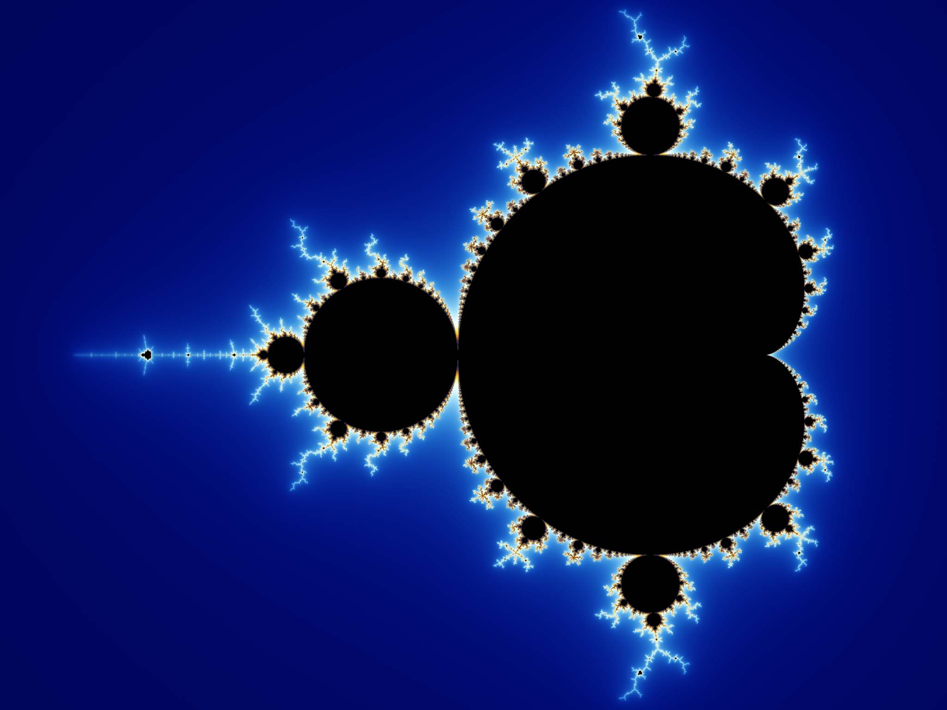
Circles have a lot of infinite properties. Another one is its number of lines of symmetry. A perfectly drawn circle has infinitely many lines of symmetry, as there are infinitely many lines that can be drawn through the centre point, and, of course, each of those are lines of symmetry. Interestingly, a circle’s diameter is always a valid line of symmetry.
Fractal, Wikipedia

There is a shape with an infinite perimeter. That shape is called a fractal. A fractal has many repeats of the same shape as you keep zooming in, therefore, its perimeter can not be measured.

Another interesting paradox that relates to the idea of infinity is the coastline paradox. If you, for example, measure the length of the coastline of Great Britain, you would get an answer, and that seems correct. But, how precise was it? You could do it in 100 km units, 1 m units, or indeed, 1 nm units. As the unit of measurement gets smaller, the coastline will seem to get longer, because you are being more precise about measuring it. So, that means that coastlines can not really be measured correctly, as you could always be more precise about actually doing the measuring.

The first study of this paradox was done by Lewis Fry Richardson, and was improved upon by Benoit Mandelbrot. They thought that coastlines were a lot like fractals, where their complexity increases the further you zoom in.

In conclusion, there are many different infinities, each with their own cardinality. For example, aleph-zero is the smallest and the largest is the ‘absolute infinity’. Also, infinity has been used in many paradoxes, like Hilbert’s Hotel and the Coastline Paradox.

However, we will never know how big infinity really is.

