A car is travelling from one city to another, let’s say from London to Luton. The overall journey is 50 kilometres and it takes 1 hour. How fast is the car going?

Well, this question is not quite as it may seem. First, let’s talk about what speed actually is; what does the question mean when it says ‘how fast’?
Speed, or how fast something is going, is how far it goes in a set time; therefore we can say that the speed of an object is its distance travelled per unit time. Thus we can describe speed as:
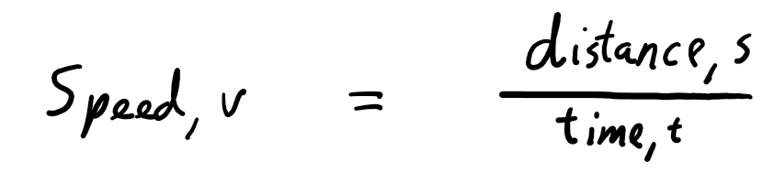
Lets call this ‘formula 1’.
You may notice that in this formula speed is denoted by a ‘v’, standing for velocity. This is because it is useful to know in which direction an object is travelling – speed is simply a measure of how far it travels per second. This means that it will be the same regardless of direction; values like these are known as magnitudes. Given that speed has only a magnitude, it is a scalar. An interesting result of this is that speed can never be negative. Velocity on the other hand has a magnitude and also a direction, making it what’s known as a vector.
This formula shows that velocity is the rate of change of distance travelled with respect to time. Therefore, going back to our original question, given that the distance travelled is 50 kilometres, and the time taken is 1 hour, then the speed of the car would be 50 kilometres per hour. As of right now, the car could be going in any direction; we have only specified a magnitude. In this case, the car is going at that speed in the direction of the distance travelled, so the direction from London to Luton. We now have enough knowledge to answer the question simply: the car is travelling at 50 kilometres per hour from London to Luton.

In the above paragraph, I mentioned that ‘velocity is the rate of change of distance travelled’. This concept can be extended to say that velocity is the gradient of a distance travelled over time graph.
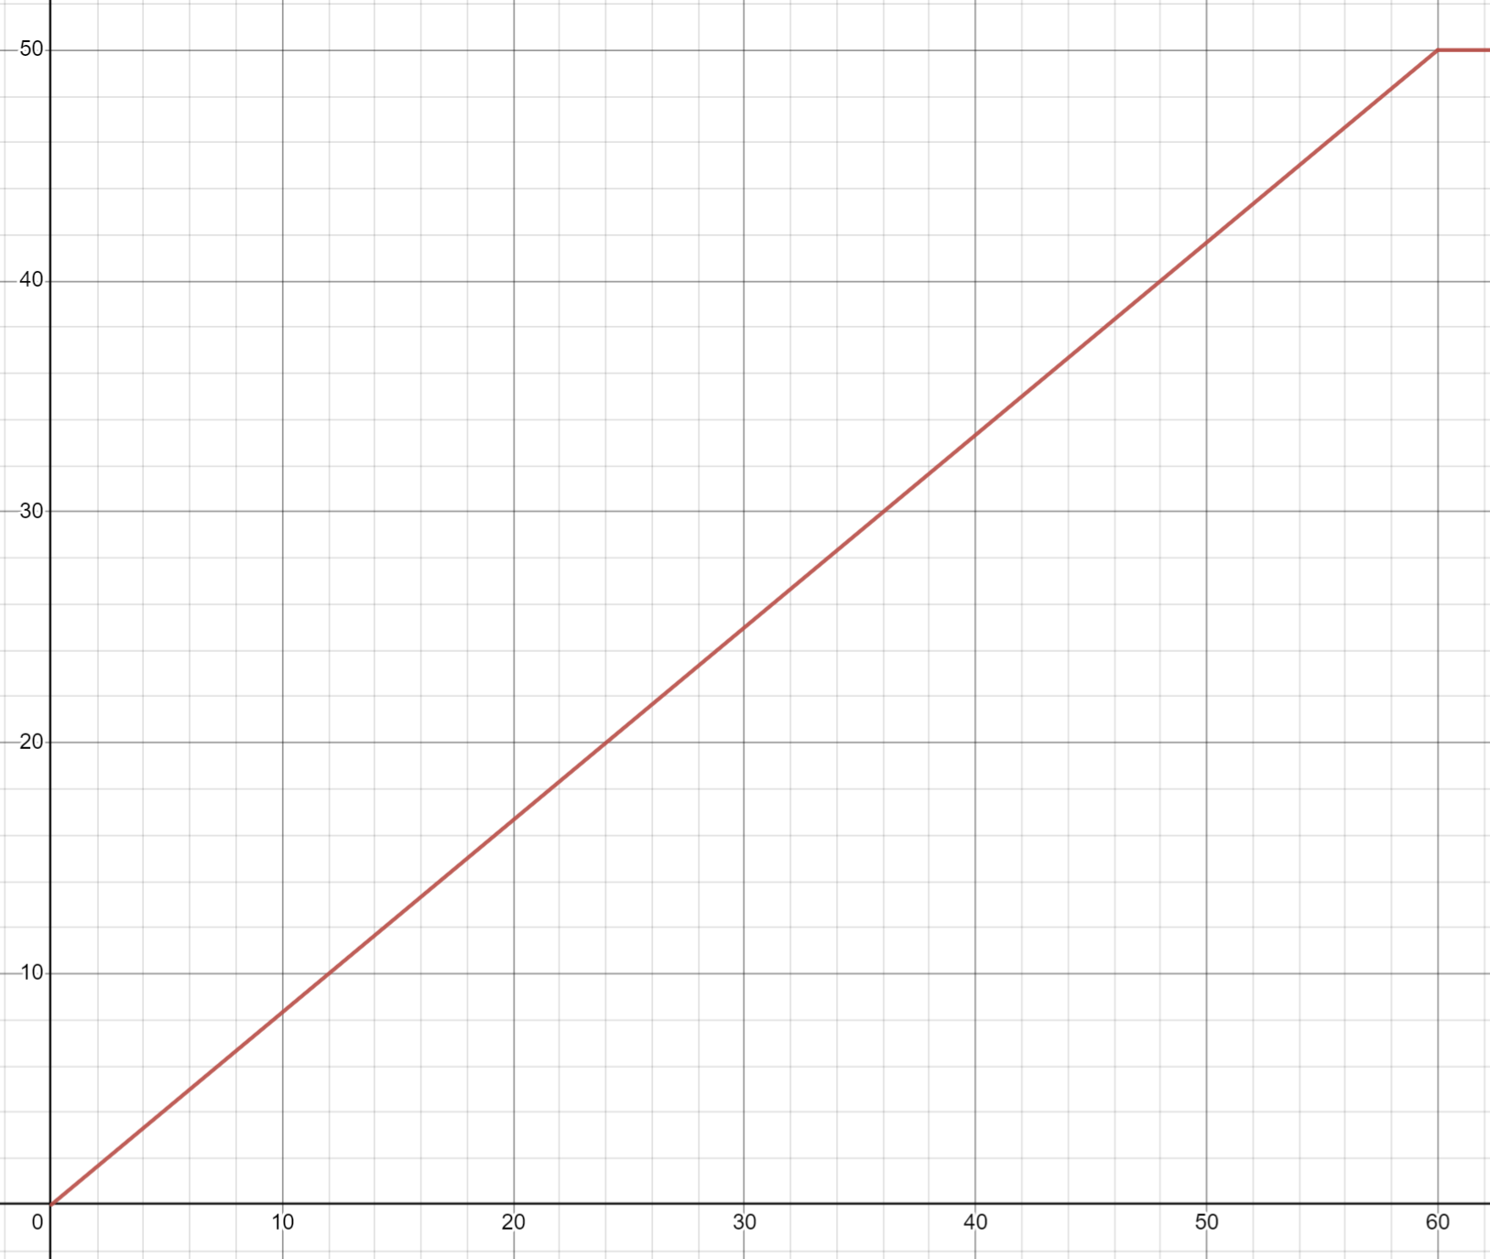
If we plot this graph (plotted for convenience on https://www.desmos.com/calculator), where the x axis denotes time taken in minutes and the y axis denotes distance travelled in kilometres, then we can calculate the gradient of the function by using the formula below:
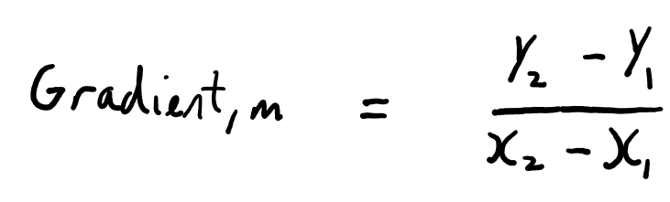
Lets call this ‘formula 2’.
By reading 2 coordinates on the graph, let’s say (60,50) and (0,0) we can now find the gradient:
Gradient = (50 - 0)/(60 – 0)
= 50/60 kilometres per minute
= 50 kilometres per hour, which matches up with the answer we found before.

In reality, the car would have to stop at traffic lights and slow down for other vehicles, so would not be travelling at a constant velocity. If we look at the first formula, the distance travelled would still be 50 kilometres and the time taken would be unchanged, so the speed of the car would be unchanged. This is because the result of the formula gives the average speed, which is still 50 kilometres per hour. This is the same with formula 2; m is the average gradient over that period of time.
For this example, let’s say that the car is travelling with this formula where x is time (in minutes) and y is the distance travelled (in kilometres):
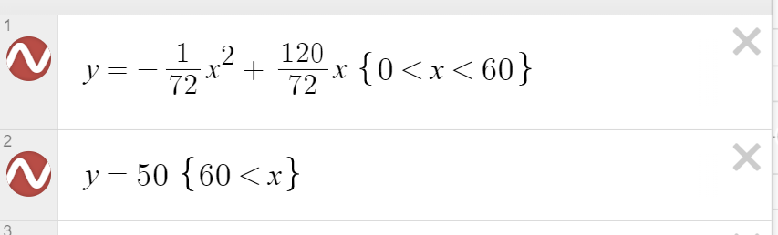
This gives the graph of: (given from time 0 onwards because the motion before is unimportant)
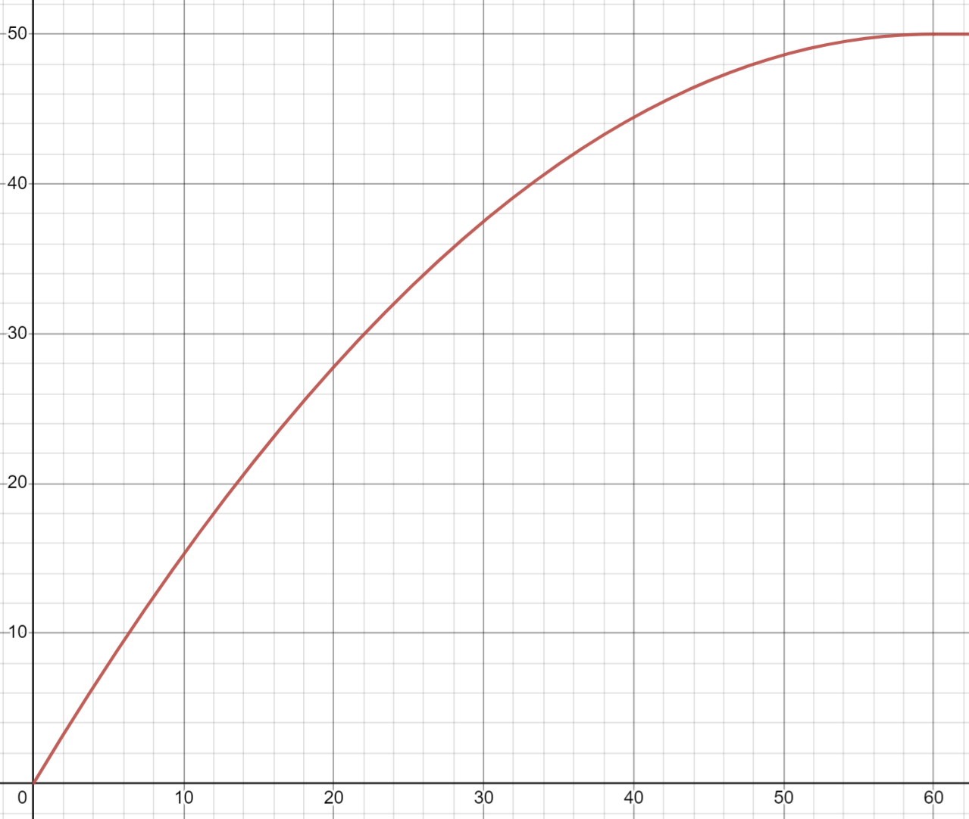
This is an unusual graph for the distance travelled by a car, but it shows the following concepts well. Also, you may notice that the values are quite strange, but that is just to fit with the prior graph in beginning and end.
The question ‘how fast is the car going?’ is rather vague; at an hour, the car is not moving. Before this, the gradient of the line on the graph does not appear to be constant so its velocity is changing. A better question would be ‘at a time of 20 minutes, what is the velocity of the car in the forward direction?’.

We have already found that velocity is the rate of change of distance travelled with respect to time, so the velocity is the gradient on a graph with these axes, as pictured above. Our task is to find the gradient of the graph at time = 20 minutes, so when x = 20.
The most fundamental ways to find the gradient of a graph at a point are either to find the gradient of the tangent or to use the gradient formula, pictured below for convenience.
I think that the second way is more relevant, so I will use it. For this, I need to sample 2 points, (x₁,y₁) and (x₂,y₂). The first will be at x=20, so using the formula for the graph, point 1 = (20, 27.78).
The gradient function above gives the average gradient over that period of time, so It will give a more accurate result if a smaller range was used. For this reason, my x₂ will be 21, making y₂ = 28.88.
Therefore at time = 20:
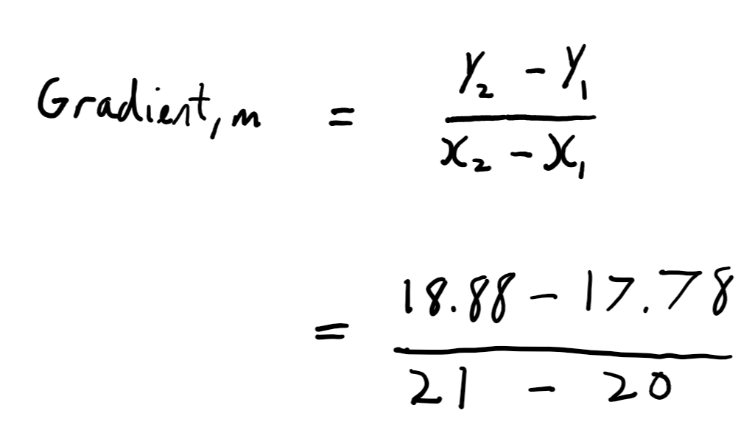
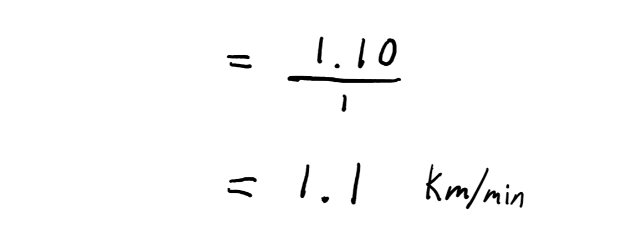
Which is about 66 kilometres per hour.

This is interesting, but it would be very useful to have a formula to be able to find the velocity of the car at any time.
To do this, we can extend the gradient function concept; it gives you the average gradient over a section of a graph. Therefore, if we had a function which took in x and produced y, y = f(x), then if we were to have a very small number, let’s say h:
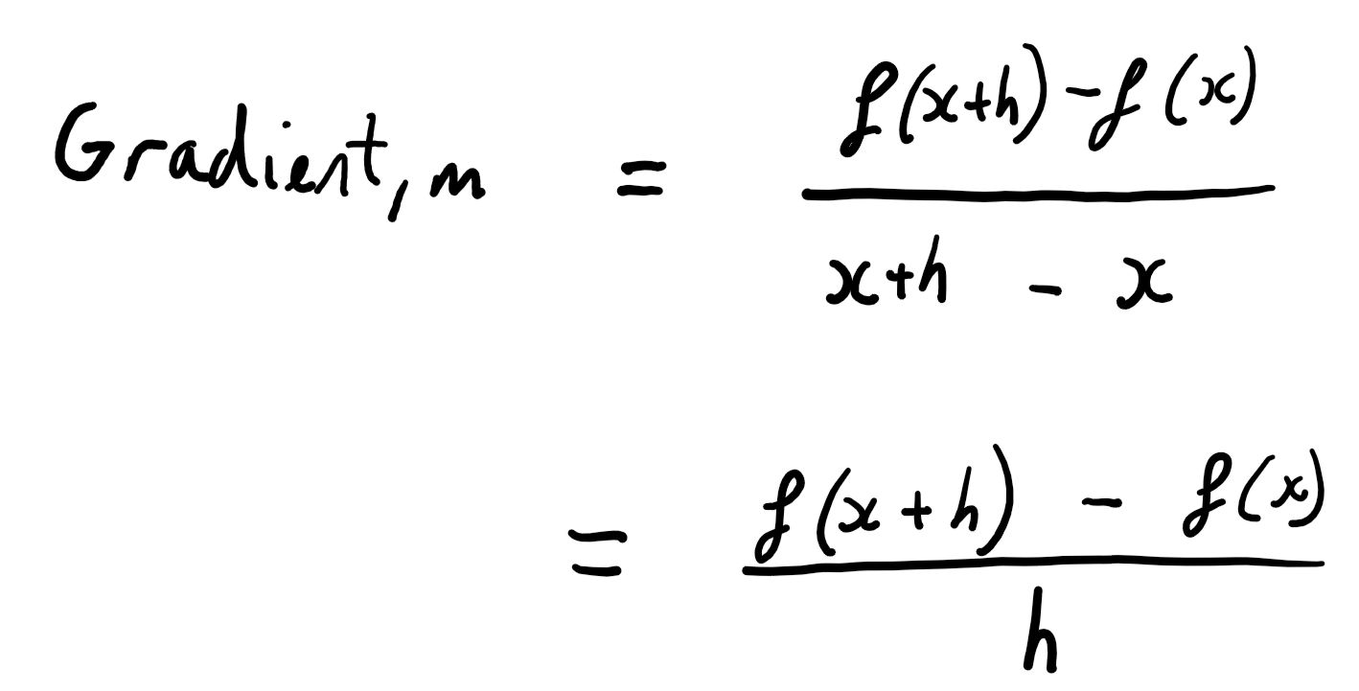

What this is effectively saying is that the gradient is the resulting change in y for a small change in x.
If we were then to set f(x) to our function for distance travelled:
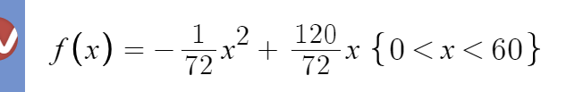
Then our formula goes as follows:
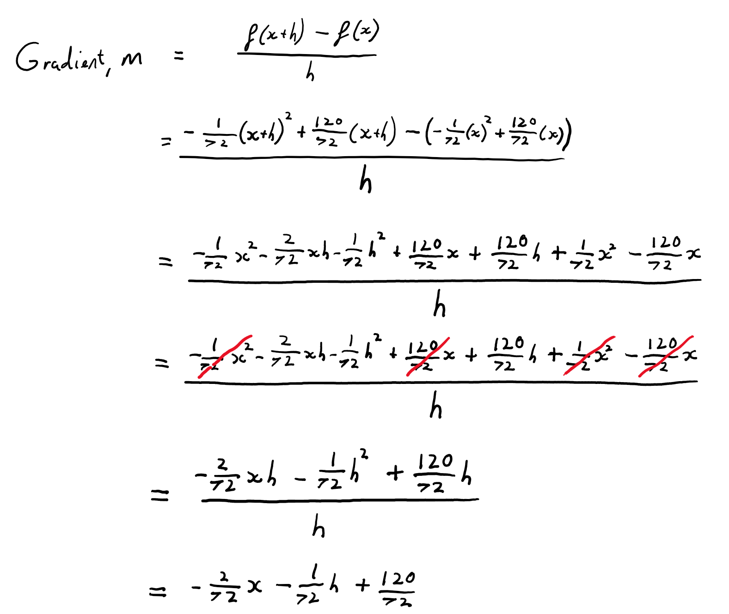
There is an ‘h’ term in the resulting equation. Given that h is a very small number, any h terms quickly disappear as h tends towards 0. We call this concept limits, more on these later.
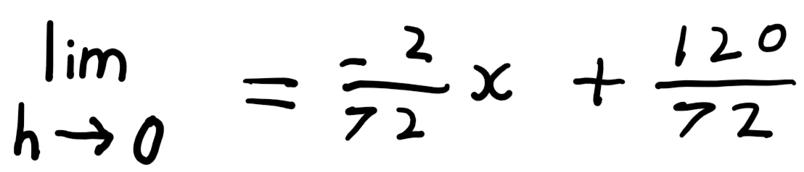
We have just proven that for any given time input, x, then the velocity at that time is given by the above. Given that the velocity is the gradient of the graph, we can call this function the ‘gradient function’ of the graph.
We can test this by substituting 20 into x:

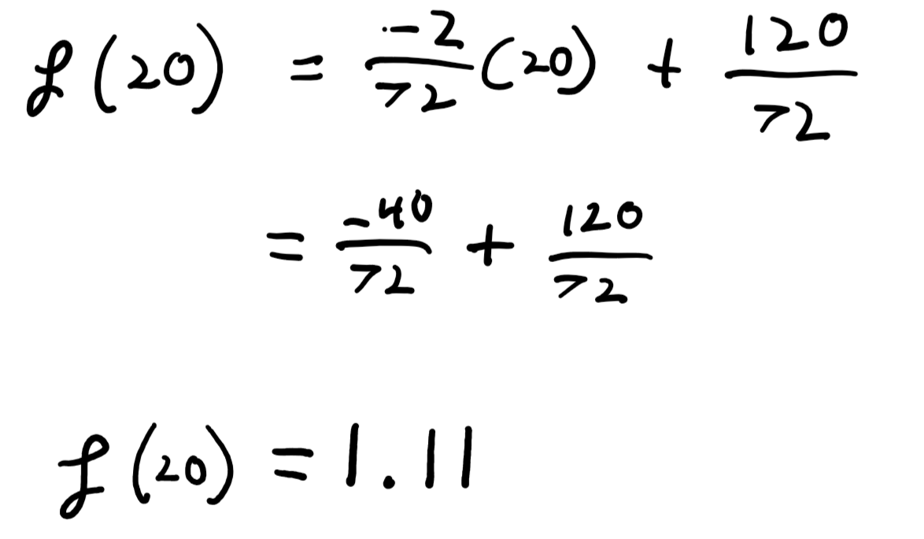
As we can see, the resulting answer is very similar to the 1.10 obtained before (there is a slight difference because in the equation before, we were unknowingly using our gradient function but with h = 1).
Taking the gradient function is known as differentiating the function and is, I hope you agree, one of the most amazing and beautiful areas of Mathematics. The result of taking the gradient is called the derivative.

One of the slightly odd things about the gradient function is to do with the first line of the proof:
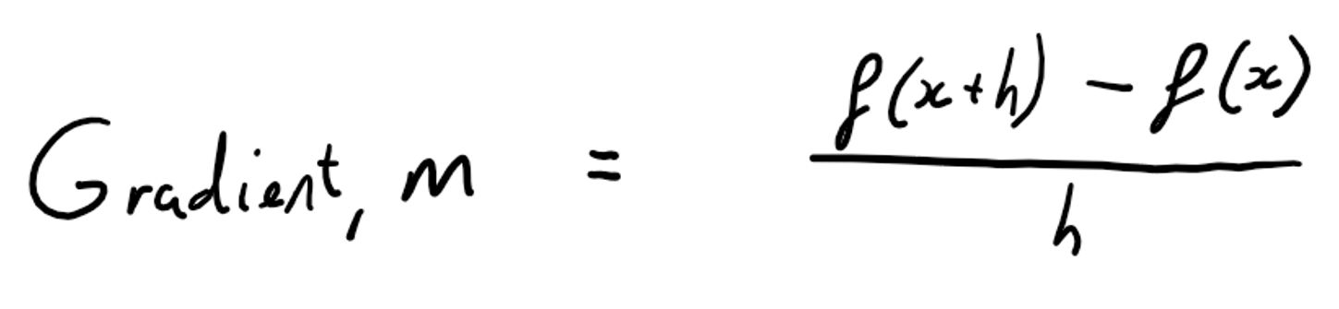
As you can see here, our gradient is a fraction where the denominator is h. This is fine, but we later ignore an h term, implying that h is 0:
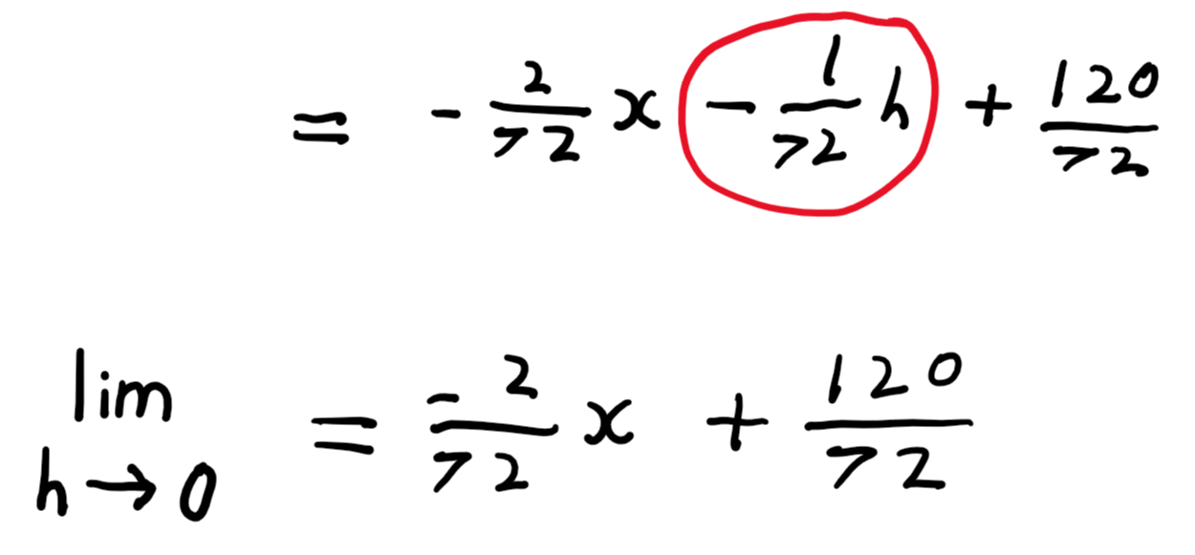
There is a big problem here that puzzled mathematicians for a long time: h, our small number, cannot be 0 because otherwise the denominator of the gradient will be 0 and so our gradient will be undefined, but then later we seemingly set h to be 0 to get the gradient. Something is wrong; h cannot simultaneously be 0 and not 0.
There is a subtle point about h that is quite important: it is smaller than you could imagine but is still finite. Numbers like this are known as infinitesimals. This is an interesting concept and is well visualised with pizza slices. Imagine that you have a normal pizza. you cut it into a very large number of slices and take one. No matter how many times you cut the pizza, the slice that you will be holding will still be a tangible object (whilst not a particularly nourishing one). In the same way, if you keep making a number smaller and smaller, the number will become insignificantly tiny, but will still exist. This is what we mean when we say the limit as h tends to 0.
In reality, h is known as dx, which means ‘a tiny nudge in x’. Similarly, dy means ‘the resulting tiny nudge in y due to dx’. In fact d followed by anything just means an infinitesimally small change in that thing. Hence in calculus the gradient function is denoted by:
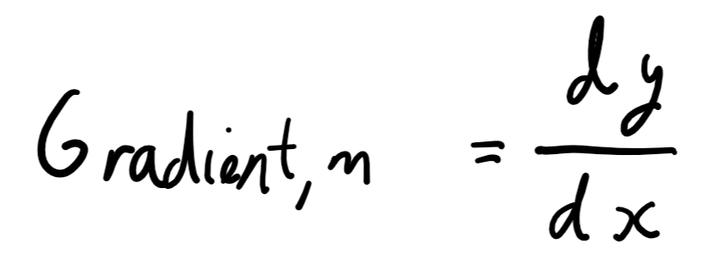
You may have heard this said as ‘dy by dx’, and it sounds rather daunting, but all it means is ‘how much does y change for that tiny nudge in x, dx divided by that tiny nudge’.

What we have just been through is the fundamentals of differentiation; all other rules can be massaged out of this concept, most surprisingly easily. I hope that reading this has given you a sense of how simply wonderful this field is, and how utterly confusing it must have been for the pioneers of the subject. To quote Keith Devlin, “Calculus works by making visible the infinitesimally small.”.

References:
https://www.youtube.com/watch?v=9vKqVkMQHKk&list=PLZHQObOWTQDMsr9K-rj53DwVRMYO3t5Yr&index=2&ab_channel=3Blue1Brown
My amazing maths teachers who have taught me not only to be able to do maths, but to understand and enjoy it
Images and diagrams by me on Onenote
Graphs by https://www.desmos.com/calculator

