The mathematics of fractals
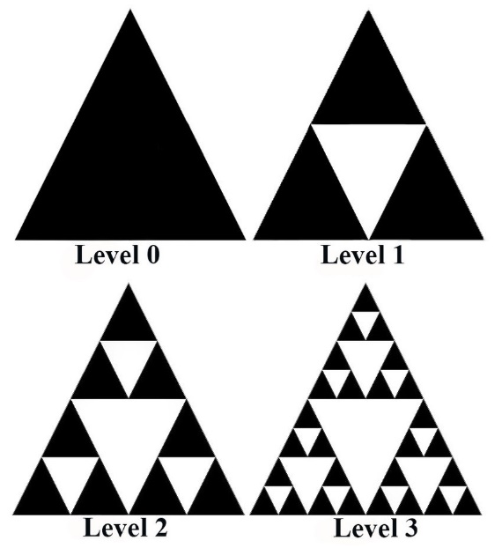
Like all good mathematical arguments let us begin with some definitions; A fractal has many properties, but, for me the most intuitive is that no matter how far you zoom in or out the shape will look the same or similar. This idea encompasses the self-similarity principle- the idea that a mathematical object can be the same or similar might be frustrating to the purists however, strict definitions are a problem we come across when dealing with fractals. Another property is that you will find detail even when you are observing an arbitrary small part of the fractal. A property that emerges from this idea is that a fractal cannot be described by Euclidian geometry and requires the idea of a recursive relationship to describe; this is where the next step requires the previous step, famous examples are the Fibonacci sequence (where the next term is the sum of the previous 2), factorials (where n!=n.(n-1)!, so using the previous factorial you can generate the next) or fractals! In a fractal the next step in generating a fractal relies on adding to the previous one, a recursive process, (figure 1) and this idea cannot be described using Euclidian geometry. These definitions are useful as, they allow us to differentiate between a fractal and a straight line, a straight line may appear to exhibit self- similarity, but it doesn’t have detail when you “zoom in” and can be easily described with Euclidian geometry.
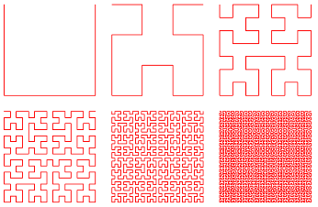
It used to be thought that a fractal could be defined as, a space which had a fractal dimension which is greater than its topological dimension. However, this definition was violated by space filling curves, this is a curve where the range reaches every point in a higher dimension. Such as the Hilbert curve (figure 2), which has an image which is the unit square. Its fractal dimension is 2 which is equal to its topological dimension.

Figure 2-Construction of a Hilbert curve

What are topological dimension and fractal dimensions?

N.B. I am going to be using a slightly informal method for describing topological dimensions as, I felt the formal definition using set theory and topological spaces, would not really add to the understanding of most readers and honestly was a bit out of my current reach too.
Figure 1-Sierpiński triangle
Take $n$ to be the dimension of the shape, which is the shape with the minimum dimension, that can separate a given space into two separate spaces, and we will define nothing (the empty set) to have dimension of -1, the dimension of a space is given by $n$ +1. Let’s look at some examples, a single point cannot be separated, i.e. is separated by nothing, therefore has topological dimensions=-1+1=0, take a straight line, it can be separated by a point, therefore it has topological dimension=0+1=1, we can repeat this for infinite dimensions. Why is it the shape with the minimum dimension? Because, since a point cannot be separated further, it technically experiences the same “level of separation” when you pass a straight line through it, as when you pass nothing through it, the same with a straight line if we were to pass a plane through it is still separated, therefore we must take the shape with the minimum dimension to avoid contradicitons.
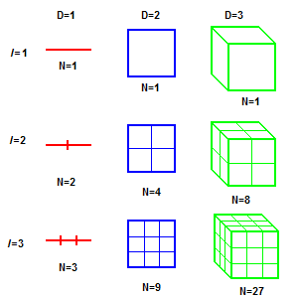
The fractal dimension introduces the idea of non-integer dimensions. A good way of thinking about this is its effectiveness in filling space for example a curve with dimension close to 1 e.g. 1.1 will behave very similar, in terms of the way it fills space, to a line with topological dimension of 1, however something with a fractal dimension of 1.99 would behave much closer to a 2 dimensional space by curving so much that it can almost fill a whole plane (like the Hilbert curve which does in fact curve so much as to fill a whole plane).
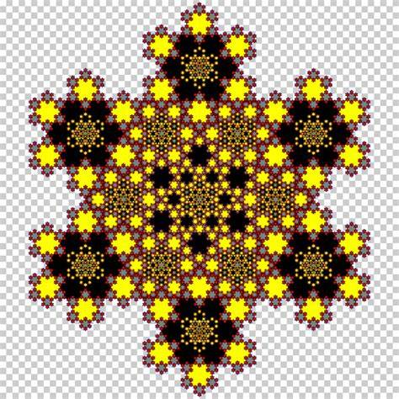
The weirdness of these non-integer dimensions is first exhibited in there scaling, take a straight line of length 1, now change the definition of length so the $new unit length=\frac{old length}{2}$ i.e. 0.5, it now has length 2.We can do the same with a square give the square an area of 1 now measure area again using a square with $new unit side length=$ $\frac{originl side length}{2}$ it will have 4 times the area (Figure 3).
Figure 3- Illustration of scaling
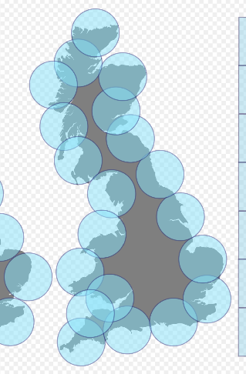
This relationship is shown by the general scaling rule, $N=ε^{-D}$, where N is the scale by which the measurement has increased, given our original measurement to be 1, ε is the scale by which we have changed our unit length and D is the dimension. However, when dealing with fractal dimension the scaling is less intuitive, take a Koch snowflake (Figure 4), it has an approximate Hausdorff dimension of 1.26. To show where the 1.26 comes from we need to use the equation $\log_{ε}{N=-D}$, this is a rearrangement of the general scaling rule and we can see it works for our examples from earlier e.g. when we halved the unit of length for the straight line we got twice the measurement therefore, we have $\log_{0.5}{2=-1}$ therefore, D=1, now for our Koch snowflake we use the knowledge that when $ε=\frac{1}{3}$ , $N=4$ so $D=-\log_{\frac{1}{3}}{4=1.26…}$
Figure 4- A Koch snowflake
Now, you may realise that we have just been given that $N=4$ and that $ε=\frac{1}{3}$ , but how would one find this, the truth is, it is very difficult and there are lots of methods for doing it. As said above, one is the Hausdorff dimension, the one I am going to discuss is the Minkowski-Bouligand dimension (also known as the box counting dimension) - it’s important to note that all these methods give only estimates. There is two versions of this method too, one uses boxes and the other circles (Figure 5) the advantage of the circle method is that it can be generalized for any Metric space (X,d) where d is a distance function on set X (a distance function is just a function which calculates the distance between two points in a metric space, it has to obey certain rules, an example of this is $d\left(\left(x_{1},y_{1}\right),\left(x_{2},y_{2}\right)\right)=\sqrt{{\left(x_{2}-x_{1}\right)}^{2}+{\left(y_{2}-y_{1}\right)}^{2}}$ , you might recognise this as an application of Pythagoras’ theorem in the Euclidian space). The Minkowski-Bouligand dimension is calculated by the minimum number of open balls of diameter at most ε required to the cover the borders of a bounded set (which is just a shape that has closed edges) and relates this to the dimension by $Dimₘ\left(K\right)=\lim_{ε→0}{\frac{\log{N(K,ε})}{\log{\frac{1}{ε}}}}$, when the limit exists. N(K,ε) denotes the minimum number of balls diameter at most ε to cover the borders of a shape K.
Figure 5-box counting dimension for coastline of Britain
The main method used to calculate this is a linear regression model (plotting a line of best fit), in which you will calculate values by brute force for various values of ε, as ε approaches 0,the more the better, then use this to plot a graph, $logN\left(ε\right)=D×log⁡\frac{1}{ε}$, then you can find the gradient of this graph and that would be the dimension.

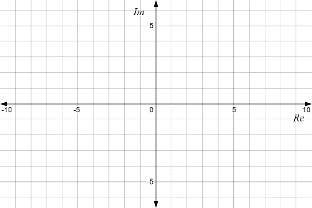
How do we generate fractals?
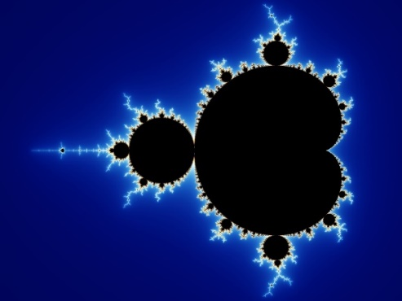
Strangely enough we produce fractals using, an iteration process within the complex plane (Figure 6), note that the complex plane includes all real numbers they just have imaginary part 0 and lie on the x axis. For example the formula we use to generate the Mandelbrot set (Figure 7 & 8) is $Z_{n+1}=Z_{n}^{2}+C$where $C$ is some point (x,y) within the complex plane, we will always start with $Z_{0}=0$ , but $C$ is only a member of the Mandelbrot set when the sequence doesn’t diverge (approach positive or negative infinity).
Here are two examples of the formula being used, in example one when $c=1$ the sequence diverges, however when $c=-1$ the sequence doesn’t diverge and forms a periodic sequence, therefore, C=-1 is a member of Mandelbrot set and C=1 is not and reaches the escape point after two iterations.
Figure 7- The Mandelbrot set
Figure 6- The complex plane
$$\begin{aligned}Z_{n+1}=Z_{n}^{2}+C \\ 1.z_{0}=0C=1 \\ z_{1}=0^{2}+1=1 \\ z_{2}=1^{2}+1=2 \\ z_{3}=2^{2}+1=5 \\ z_{4}=5^{2}+1=26 \\ z_{5}={26}^{2}+1=677 \\ 2.z_{0}=0C=-1 \\ z_{1}=0^{2}-1=-1 \\ z_{2}=-1^{2}-1=0 \\ z_{3}=0^{2}-1=-1 \\ z_{4}={-1}^{2}-1=0\end{aligned}$$
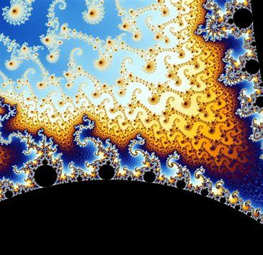
Now, two important things need to be decided on before you can finally apply the algorithm, the maximum number of iterations and the escape point, the maximum number of iterations is the number of iterations after which if you have not reached the escape point, you will stop iterating the sequence and declare that the sequence diverges for that $C$, the escape point is; the value$Z_{n}$ that when it is reached you can be certain the sequence will diverge For the Mandelbrot set, this has been proven to be when $\left\|z_{n}\right\|<2$, so in example 1 above, we would stop iterating after $Z_{2}$.Therefore since $Z_{0}=0$ it follows $\left\|C\right\|<2$ , for C which doesn’t diverge, as, $Z_{1}=C$ and so if $\left\|C\right\|>2$ then $\left\|z_{1}\right\|>2$ which leads to divergence, therefore for members of the set $\left\|C\right\|<2$. So, this leads to quite a wonderful result that all the points on the Mandelbrot set which diverge(black in Figure 7) are within a circle of radius 2.You might be wondering where the colours come from, well for the points which converge you will assign a colour, usually black, then for the points which diverge you will assign different colours for the number of iterations it takes for them to diverge e.g. 10 iterations= blue 200= yellow etc., this then leads to the famous beautiful patterns you can find when you zoom in on the set (Figure 8). The Mandelbrot set has a fractal dimension of 2. I think it is important to stress, that this is not the only way to generate the set however, it is the most common way, but, you can find all sorts of versions on the internet.
Figure 8- A zoom in on a Mandelbrot set
Fractals are common in nature, my favourite example of this is the rings of Saturn (Figure 9), which have a box counting dimension between 1.63 and 1.78. But not only are fractals nice to look at, we can use them in mathematical modelling to predict growths of things like cities which often follow a fractal pattern of growth or even predict patterns in the stock market (Figure 10).
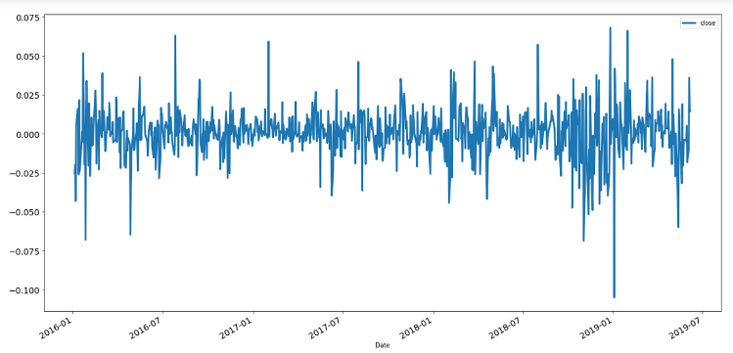
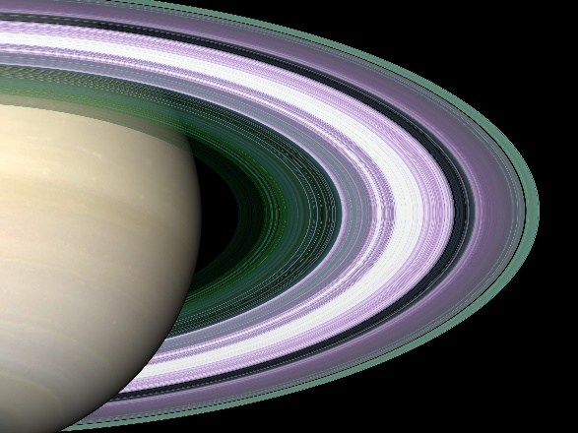

Figure10- A fractal stock market pattern

Figure 9-rings of Saturn
Infinite perimeter?
If you think back to our original definitions of fractals, specifically detail at arbitrarily small scales, you might have guessed this anyway. Those of you on the ball might say that, if the length gets smaller and smaller as we zoom in wouldn’t the length tend to zero allowing us to find a sum to infinity. However, when we create a fractal, you can find that the rate at which the perimeter increases, per iterations of the recursive sequence you used to develop, i.e., as you make it more and more detailed. It gives a geometric series with ratio>1 and these will diverge.
From, this we can say that it is impossible to differentiate a fractal, because the gradient at a point would keep changing when you zoomed in further. This links back to why fractal dimensions are so important; it is so difficult to describe them with standard methods. And why do we want to do that? To make predictions! One of the beautiful things which mathematics allows us to do.
I would like to now leave the reader with some food for thought. Despite having infinite perimeter, fractals have a finite area, and this can be shown by essentially the reverse of the argument above. But maybe you challenge yourself; can you find a fractal and try to prove it?
Thank you for taking the time to read my essay, I hope you have learnt something today, it must be said that without the advancement in computer technology we would never be able talk about these things in such depth and it brings to light what a lucky time we live in and to finish a quote from Mandelbrot himself. “Beautiful, damn hard, increasingly useful. That’s fractals.” — Benoit Mandelbrot.

References:
Mandelbrot set - Wikipedia
Fractal - Wikipedia
Fractal -- from Wolfram MathWorld
3.2 Topological Dimension – The Chaos Hypertextbook
Minkowski–Bouligand dimension - Wikipedia
general topology - Intuitive picture for topological and fractal dimensions of a fractal - Mathematics Stack Exchange
The Mandelbrot Set - YouTube
Fractal Dimension - Box-Counting & Correlation Dimension - YouTube

