Interesting information about Information Theory

What, how, why?

I invite you to participate in a little game.

There is a person A aged between 1 and 100. You cannot see or talk to this person, cannot make any deductions of their age. Your task is to guess the age of person A. You are allowed only to talk to person B and ask them Boolean question in each guess. Eg “Is Person A less than or equal to ‘x’ years?”. By the way, the interesting part of the game is - you need to get an answer in the lowest possible guesses.

By intuition, one may start with “Is Person A less than or equal to 50 years?” Let’s see why. Regardless of the response, the search window is halved. Bingo! By getting a response, we get some information. Let’s measure the amount of information. The amount of information allowing us to “halve” the search result is referred to as 1 bit.

If one starts with “Is Person A less than or equal to 25 years?” and if the response is “Yes”, the search window is now 1-25 ie reduced by a factor of 4 and the information gained from this is 2 bits.

This is the Information Theory at it’s very core. Information Theory quantifies how much information we expect to get from a certain situation or alternatively by how much our uncertainty is reduced given some information.

Back to our little game or actually any problem using Information Theory, if we were to gain “n” bits of information following a question, that would mean that our search window has been reduced by a factor of 2^{n} – i.e., 1/2^{n} of its original size.

We see that probability of such an event happening has p = 1/2^{n}. Rearranging, we get n = $\log_{2}{\frac{1}{p}}$, or n = - $\log_{2}{p}$.

This formula may look intimidating, but it’s just the measure of how many times your total possibilities have been cut in half given some information.

Suppose I told you it’s sunny in the Sahara desert and I also told you it’s sunny in the UK. Since it’s always sunny in the Sahara, you wouldn’t gain much information from it at all, but it being sunny in the UK has an astronomically low probability, so you could deduce a lot – for example, it’s most likely a summer month. Therefore, we see that if an event is more unlikely, we gain more information from it.

Back to Age Guessing Game

Let’s continue building on the age guessing game and the two strategies for the first guess : (1) is age <=50 (2) is age < = 25. Let X be the discrete random variable representing the different outcomes for bits gained for (1) and Y the different outcomes for (2), we can see the different situations which can arise.
For (1)
outcome | Age <= 50 | Age > 50
x (bits gained) | 1 | 1
P(X = x) | 1/2 | 1/2

For (2)
outcome | Age <= 25 | Age > 25
y (bits gained) | 2 | ${- log}_{2}{3/4}$ = 0.415 (3sf)
P(Y = y) | 1/4 | 3/4

For (2) we see that there is a chance to gain a higher number of bits, but this has a lower chance of happening. If we want to see which one is optimal, we can calculate the amount of information ie the number of bits we expect to get (on average). This is called expected value.

For example, if we wanted to find the expected value of a (fair) dice roll, we can consider the following: 1/6 of the time, we’ll get a roll of a 1, another 1/6, we’ll get a 2 etc. Hence if we expect to get each number from 1 to 6 about 1/6 of the time, the expected value of a roll would be $1 × \frac{1}{6}$ + $2 × \frac{1}{6}$ + .. + $6 × \frac{1}{6}$ = 3.5. The formula for this is $\sum{X × P(X = x) = 1}$ i.e., multiplying each value by the proportion of times it will come up.

In Information Theory, the expected information gained following an outcome is referred to as entropy. It is a measure of the amount of uncertainty or randomness in a random variable. If the variable is completely predictable, its entropy is low, since there is little uncertainty, hence it makes sense that an unpredictable variable would have high entropy.

Expected values of E(X) and (Y) are:
E(X) = $\sum{X × P(X = x) = 1}$
E(Y) = $\sum{Y × P(Y = y) = 0.811 (3 sf)}$
As E(X) > E(Y), strategy (1) i.e., if age <= 50 is more likely to give more information, hence the better strategy.

Let’s now generalise this for age ‘a’, we can fill out the distribution of the random variable W which shows all possible results from the guess.
The probability that the age of the person is <= a is clearly $\frac{a}{100}$, hence the probability that the age is > a will be $\frac{100- a}{100}$. Using n = - $\log_{2}{p}$ where n is the number of bits of information gained from an event and p is the probability of that event taking place, we can fill out the table.
outcome | Age <= a | Age > a
w | $${- log}_{2}{\frac{a}{100}}$$ | $${- log}_{2}{\frac{100- a}{100}}$$
P(W = w) | $$\frac{a}{100}$$ | $$\frac{100- a}{100}$$

Hence E(W) = $\frac{ a}{100}×{- log}_{2}{\frac{a}{100}}+ {\frac{ 100- a}{100} ×- log}_{2}{\frac{100- a}{100}}$.
Below is the graph of E(W) as the value of a varies.
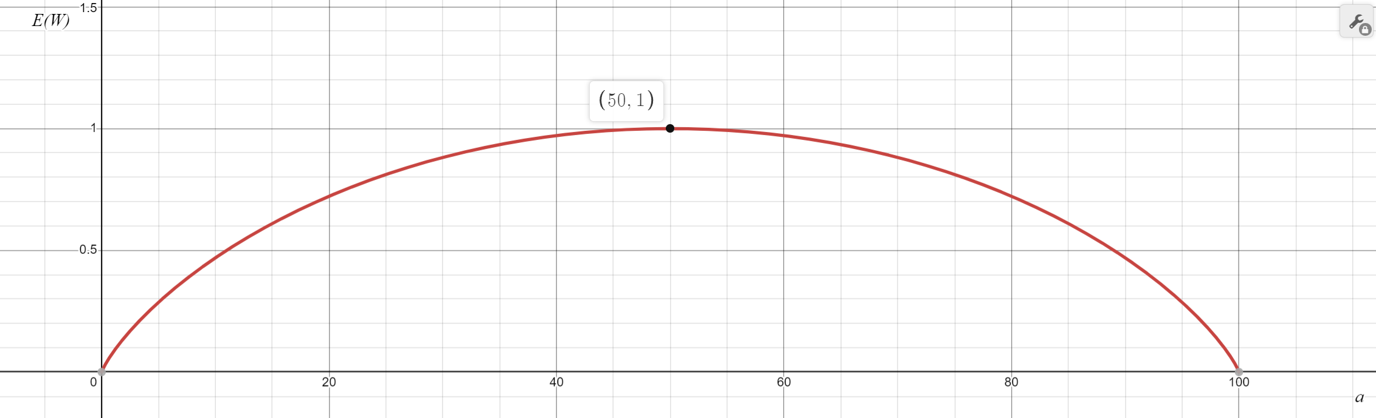
This shows that the most optimal guesses are around 50, with the highest expected number of bits gained from guessing 50 for the first guess. So, 50 is not just the better strategy, when to compared to 25, but is the best question to ask.

After the first guess, we can use the same procedure to gain more information – we can guess halfway between the upper limit and lower limit of what the age is.

For example, if the upper limits after the first guess are 50 and 100, we can guess 75. After which we will guess halfway between the new upper and lower limits and so on. After the next guess (assuming the age is less than 75), the number halfway between the two limits will be 62.5.

From above, we can see that the expected value is symmetric about the midpoint, hence guessing either 63 or 62 (with limits between 50 and 75) will give us the same expected information, hence making either guess would still be optimal.

For example, let’s say the age of the person is 58, this is how the algorithm would proceed.
Question asked | Response | Number of possible ages after guess has been made | Bits of information gained (given to 3dp)
Is your age <= 50? | No | 50 | 1
Is your age <= 75? | Yes | 25 | 1
Is your age <= 63? | Yes | 13 | 0.943
Is your age <= 57? | No | 6 | 1.115
Is your age <= 60? | Yes | 3 | 1
Is your age <= 59? | Yes | 2 | 0.585
Is your age 58? | Yes | 1 | 1

If we add up all the bits of information gained, we get 6.644. This means that after all the guesses were made we gained 6.644 bits of information.
The number of bits gained if we guessed the age of 58 on guess 1 would be ${- log}_{2}{1/100}$ which is also 6.644.

This shows us yet another important property – that regardless of how we arrived to the conclusion that the age was 58, we gained the same number of bits in the guessing process.

Matching Marks and Efforts

Now, moving on to something else – study plan, revision, exams, marks and that sort of stuff the teachers generally like to talk about.
Let’s suppose the random variable X stores data about the test score of students and Y stores data about how much revision students did. We want to try and see if we have some information on X, how much information does that give us about Y.

To keep it simple, let’s say that X has 2 different states – either pass or fail and Y also has 2 different states – either has revised and hasn’t revised.
The number of students in each category are shown in the table below.
 | X = Failed | X = Passed | Total
Y = Not revised | 6 | 4 | 10
Y = Revised | 2 | 8 | 10
Total | 8 | 12 | 20

As we saw earlier, for a discrete random variable, X, E(X) = $\sum{x ×P(X=x)}$. So for this mark predicting exercise:
E(X) = $\sum{P(X=x)} × \log_{2}{\frac{1}{P(X=x)}}$ and likewise E(Y) = $\sum{P(Y=x)} × \log_{2}{\frac{1}{P(Y=x)}}$

If we want to see how related revision and failure/success in the exam are related, we are interested in the uncertainty of Y given information on X, i.e., X | Y.

Now we need to convert the frequencies into a joint distribution of both X and Y in order to get a relation of X | Y. All possible combinations of the outcomes are shown in the table below. Each cell is the probability of that outcome occurring – i.e., the frequency of that occurrence / total occurrences.
 | X₀ (fail) | X₁ (pass) | Total
Y₀ (not revised) | 3/10 | 1/5 | 1/2
Y₁ (revised) | 1/10 | 2/5 | 1/2
Total | 2/5 | 3/5 | 1

To calculate the expected information from both the variables X and Y, we can use a similar idea as used before. We iterate through each outcome (in this case the outcomes would be X₀Y₀, X₀Y₁, X₁Y₀ and X₁Y₁) and multiply the probability of that outcome by $\log_{2}{\frac{1}{P\left(x \right| y)}}$.
Hence, E(X | Y) = $\sum_{x ∈X}^{ }{\sum_{y ∈Y}^{ }{P\left(x,y\right){×log}_{2}{\frac{1}{P\left(x \right| y)}}}}$.
The table below shows how much each cell contributes towards the total entropy.
 | X₀ (fail) | X₁ (pass)
Y₀ (not revised) | $\frac{3}{10} × \log_{2}{\frac{1/2}{3/10}}$ = 0.221 | $\frac{1}{5} × \log_{2}{\frac{1/2}{1/5}}$ =  0.264
Y₁ (revised) | $\frac{1}{10} × \log_{2}{\frac{1/2}{1/10}}$ =  0.231 | $\frac{2}{5} × \log_{2}{\frac{1/2}{2/5}}$ =  0.129

Adding the value in each cell, E (X | Y) = 0.864 (3dp). Notice that for the students who passed and revised, the contribution to the total entropy was much lower than that of the other cells.
This is because of the large proportion of students who revised out of the total students who passed (8 in 10) and relatively large proportion of students who passed out of the total students who revised ( 6 in 10). This means that we the amount of uncertainty into what the result of a student who has revised isn’t much (hence by definition of entropy, this leads to a lower entropy).

In contrast, we are much more uncertain about the students who haven’t revised, hence each of those cells contributes much more towards the total entropy value.

A question you might be asking is that this works well with discrete variables, but how would we extend this idea to continuous variables?

Well, we can group the data into several classes – like we do in a histogram. For example, let’s say we wanted variable Y to store how many hours of revision someone did rather than just simply whether they revised or not. Number of hours is continuous, but if we quantify it into 4 groups – 0 to 2 hours, 2 to 5 hours, 5 to 10 hours and 10 to 15 hours. I’ve assigned the values variables so we can easily observe changes as we vary them. Here’s the table of frequencies below:

 | Failed | Passed | Total
0 to 2 hours | a | 10 – a | 10
2 to 5 hours | b | 10 – b | 10
5 to 10 hours | c | 15 – c | 15
10 to 15 hours | 20 – (a + b + c) | a + b + c - 15 | 5
Total | 20 | 20 | 40

And converted into probabilities for X and Y:

 | X₀ (fail) | X₁ (pass) | Total
Y₀ (0 to 2 hours) | $$\frac{a}{40}$$ | $$\frac{10- a}{40}$$ | $$\frac{1}{4}$$
Y₁ (2 to 5 hours) | $$\frac{b}{40}$$ | $$\frac{10-b}{40}$$ | $$\frac{1}{4}$$
Y₂ (5 to 10 hours) | $$\frac{c}{40}$$ | $$\frac{15-c}{40}$$ | $$\frac{3}{8}$$
Y₃ (10 to 15 hours) | $$\frac{20-(a+b+c)}{40}$$ | $$\frac{a+b+c-15}{40}$$ | $$\frac{1}{8}$$
Total | $$\frac{1}{2}$$ | $$\frac{1}{2}$$ | 1

Once again, each cell has the amount of entropy it contributes towards the final total.

 | X₀ (fail) | X₁ (pass) | Total
Y₀ (0 to 2 hours) | $\frac{a}{40} × \log_{2}{\frac{1/4}{a/40}}$ | $$\frac{10- a}{40} × \log_{2}{\frac{1/4}{(10- a)/40}}$$ | $$\frac{1}{4}$$
Y₁ (2 to 5 hours) | $$\frac{b}{40} × \log_{2}{\frac{1/4}{b/40}}$$ | $$\frac{10- b}{40} × \log_{2}{\frac{1/4}{(10- b)/40}}$$ | $$\frac{1}{4}$$
Y₂ (5 to 10 hours) | $$\frac{c}{40} × \log_{2}{\frac{3/8}{c/40}}$$ | $$\frac{15- c}{40} × \log_{2}{\frac{3/8}{(15- c)/40}}$$ | $$\frac{3}{8}$$
Y₃ (10 to 15 hours) | $$\frac{20-(a+b+ c)}{40} × \log_{2}{\frac{1/8}{(20-(a+b+ c))/40}}$$ | $$\frac{a+b+c-15}{40} × \log_{2}{\frac{1/8}{(a+b+c-15)/40}}$$ | $$\frac{1}{8}$$
Total | $$\frac{1}{2}$$ | $$\frac{1}{2}$$ | 1

Remember E(X | Y) is just the sum of all the cell values we have above. Now, here comes the interesting part – let’s vary the variables a, b and c.

On the x axis we’ll have a and on the y axis, we have E(X | Y). The reason why the graph varies back and forth is because of the changes we have for the values of b and c, which continuously change hence causing the oscillating pattern.

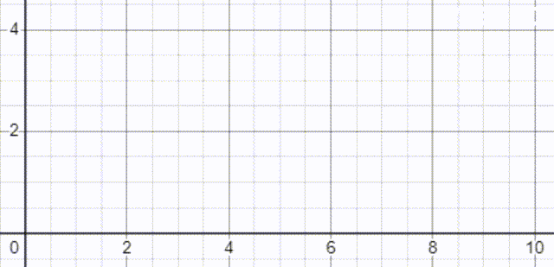

One key moment is when the value of b is 0 (strictly speaking the log of 0 isn’t defined so b will have to take a very small value which we can consider to be 0). Notice that in the animation at this point, the peak of the graph is significantly lower than that of the first graph.

This is what the animation looks like at this point:

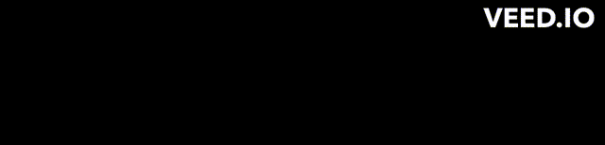

You’ll notice that the entropy in the system varies, but seems to always be below 1 bit. This means that regardless of the values of a and c, there seems to be relatively low uncertainty in the system – i.e., knowing the value of Y definitively reduces uncertainty in X.

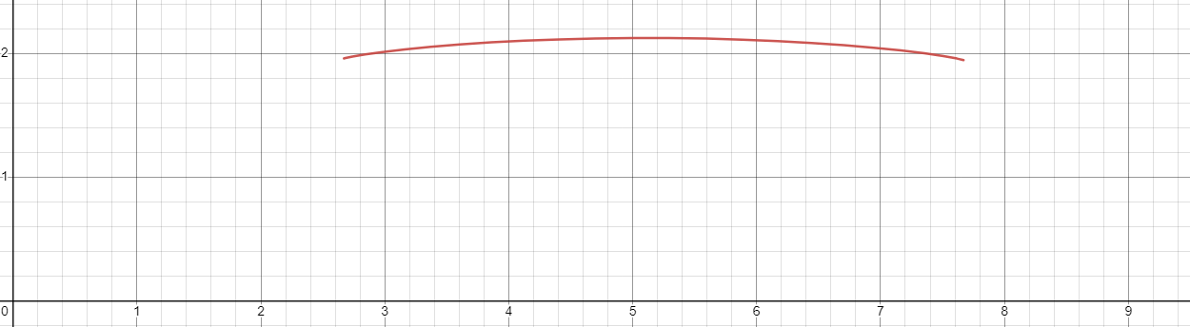

Above is another key point – it’s when the value when a is 5, b is 5 and c is about 7.5. Here is what the frequency table looks like for this case:

 | Failed | Passed | Total
0 to 2 hours | 5 | 5 | 10
2 to 5 hours | 5 | 5 | 10
5 to 10 hours | 8 | 7 | 15
10 to 15 hours | 2 | 3 | 5
Total | 20 | 20 | 40

It’s here when we notice the maximum entropy in the system of about 2 bits. This makes sense because at this point, passing and failing are equally likely regardless of how much one revises (a bit like my English Literature GCSE). This basically means given information on Y, we have no way of knowing how that influences X.

More and further more

So can you see where we’re going with this?

We can use this same idea to predict relations between any variables – whether their count is two or more, whether they’re discrete or continuous or whether their relation strong or weak.

Next time you read up about machine learning, you’ll know that capabilities like anomaly detection, feature selection, clustering, dimensionality reduction all have their roots in information theory. For example, let’s say we have a relation between 4 variables, and when plotted would give us a 4D graph – using information theory can help us decide which 2 pairs of 2 variables give us the most information. Hence, we can plot the first and third variable on one axis and the second and fourth on the other axis with the minimum compromise in the quality of our data.

Similarly, you would be amazed to find that Information Theory has applications in Neuroscience – by analysing the statistical properties of neural signals, researchers can determine how the brain encodes and decodes information. Speaking about coding, information theory lies in the centre of our understanding of the different bases and leads to a quantifiable way to identify how similar different organisms are to each other.

If you ventured out finding more information about Information Theory, you will see it everywhere – in communication system, in ecology and even gene editing!

Bibliography
- https://www.youtube.com/watch?v=bkLHszLlH34&t=3s&ab_channel=IntelligentSystemsLab
- https://www.youtube.com/watch?v=b6VdGHSV6qg&t=148s&ab_channel=Computerphile
- https://www.youtube.com/watch?v=v68zYyaEmEA&t=1087s&ab_channel=3Blue1Brown
- https://www.youtube.com/watch?v=YtebGVx-Fxw&t=63s&ab_channel=StatQuestwithJoshStarmer
- https://www.sciencedirect.com/topics/computer-science/information-theory
- https://web.stanford.edu/~montanar/RESEARCH/BOOK/partA.pdf

