Graph theory: one-dimensional Topology

During my primary school days, my classmates and I were occasionally provided with an iPad to do research projects during our math classes. If we had completed our projects before the end of the class, our math teacher would permit us to engage in games on the device. However, we were only allowed to play a specific category of game, which is commonly referred to as a "one-stroke puzzle." The objective of this game is to locate a path that covers each edge of the puzzle only once. Any graph that meets this condition is known as an Eulerian graph. At that time, I always wonder why is this type of games so specially? I was perplexed about the relevance of this game to mathematics.
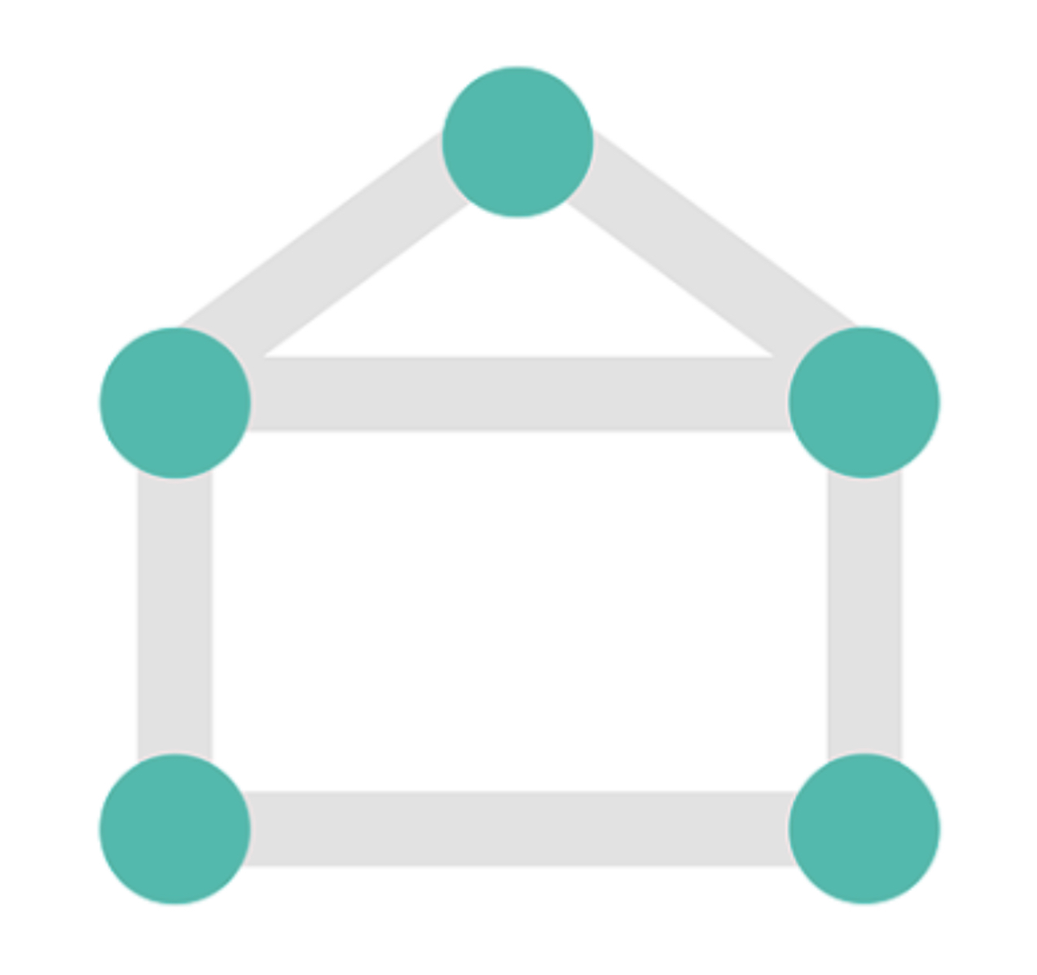

It was not until this year that I found the answer to this inquiry when I encountered the "seven bridges of Königsberg" problem. The problem "seven bridges of königsberg" was first mentioned by Lenonhard Euler in 1736. He wanted to devise a walk through the city that would cross each of those bridges once and only once.
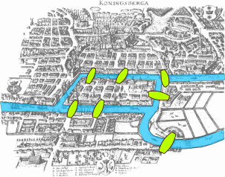
As you may have realized, the problem's rules are exactly same as those of the "one-stroke puzzle" game. Regrettably, the seven-bridge problem is unsolvable. It is impossible to walk through the city and cross each bridge only once. The reason behind this might be simpler than expected. To demonstrate this, we can first transform the seven bridges into a simple, planar graph.
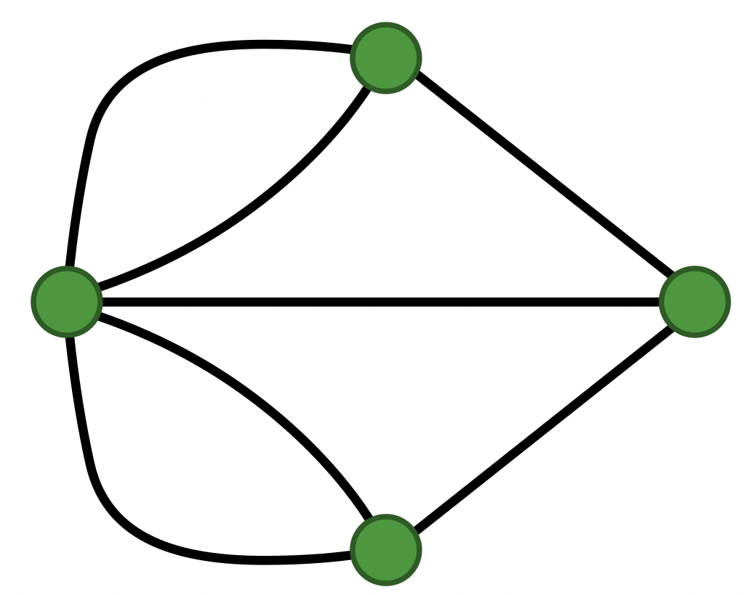
We replaced the divided landmass with vertices and connected them with lines representing the bridges. We know that whenever one enters a vertex through a bridge, they leave through another bridge. Therefore, an even number of lines connected to each vertex are required to adhere to the problem's rules. Furthermore, a maximum of two vertices connected to an odd number of lines are acceptable, as they represent the starting and ending points. Now, observe the seven bridges. There are four vertices, and all of them are connected to an odd number of lines. Hence, it is impossible to traverse each bridge precisely once.

The "Seven Bridges of Königsberg" problem is a seminal problem in both graph theory and topology. It is obvious that how it is related to Graph theory. How about Topology? How does it prefigured the idea of topology? In the seven bridges problem, we draw a picture to solve it. By the word “picture”, it seems the problem is in the field of geometry. However, the length and area of the bridges and landmasses are irrelevant to the solution. Changing the length or area, or even changing the shape of the bridge or landmass will not after the answer of the question. This unique property aligns with the definition of the topology as Wiki states: Topology is the mathematical study of the properties that are preserved through deformations, twistings and stretchings of objects. Therefore, the "Seven Bridges of Königsberg" problem provides an early example of the topological approach to problem-solving. By viewing the problem as a graph and focusing on its topological features rather than its geometric properties, the problem can be solved. This illustrates the close relationship between graph theory and topology, two important areas of modern mathematics. And the most important is, I finally get the answer for the question that I have since primary school. The "one-stroke puzzle" game is related to modern mathematics concepts! Graph theory and Topology.

There is another game my classmate and I always play in class. This time, our art teacher instructed us to colour the colouring sheets using different colours, while ensuring that no two adjacent areas sharing an edge have the same colour. This often necessitated the use of multiple colour pencils. Interestingly, there is a math problem that closely resembles this game: what is the minimum number of colours needed to colour the regions of any map so that no adjacent regions have the same colour?
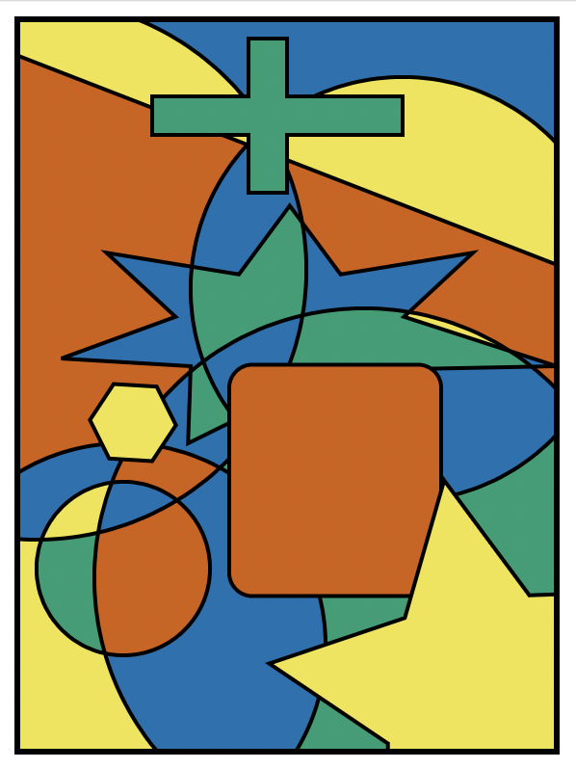
This problem took mathematicians over 120 years to solve, leading to one of the three major modern mathematics problems – four-colour problem. Four colour problem is proved in 1976 with the help of supercomputer. While it is impossible to prove the four-colour theorem with pen and paper alone, the five-colour theorem - a weaker version of four-colour theorem is proven in 1879 by Alfred Kempe in 1879 without any help from calculators.
To prove the five-colour theorem, again, we redraw maps to simple, planer graphs. For example, if we have maps (a) (b) (c) (d), we redraw them as following:
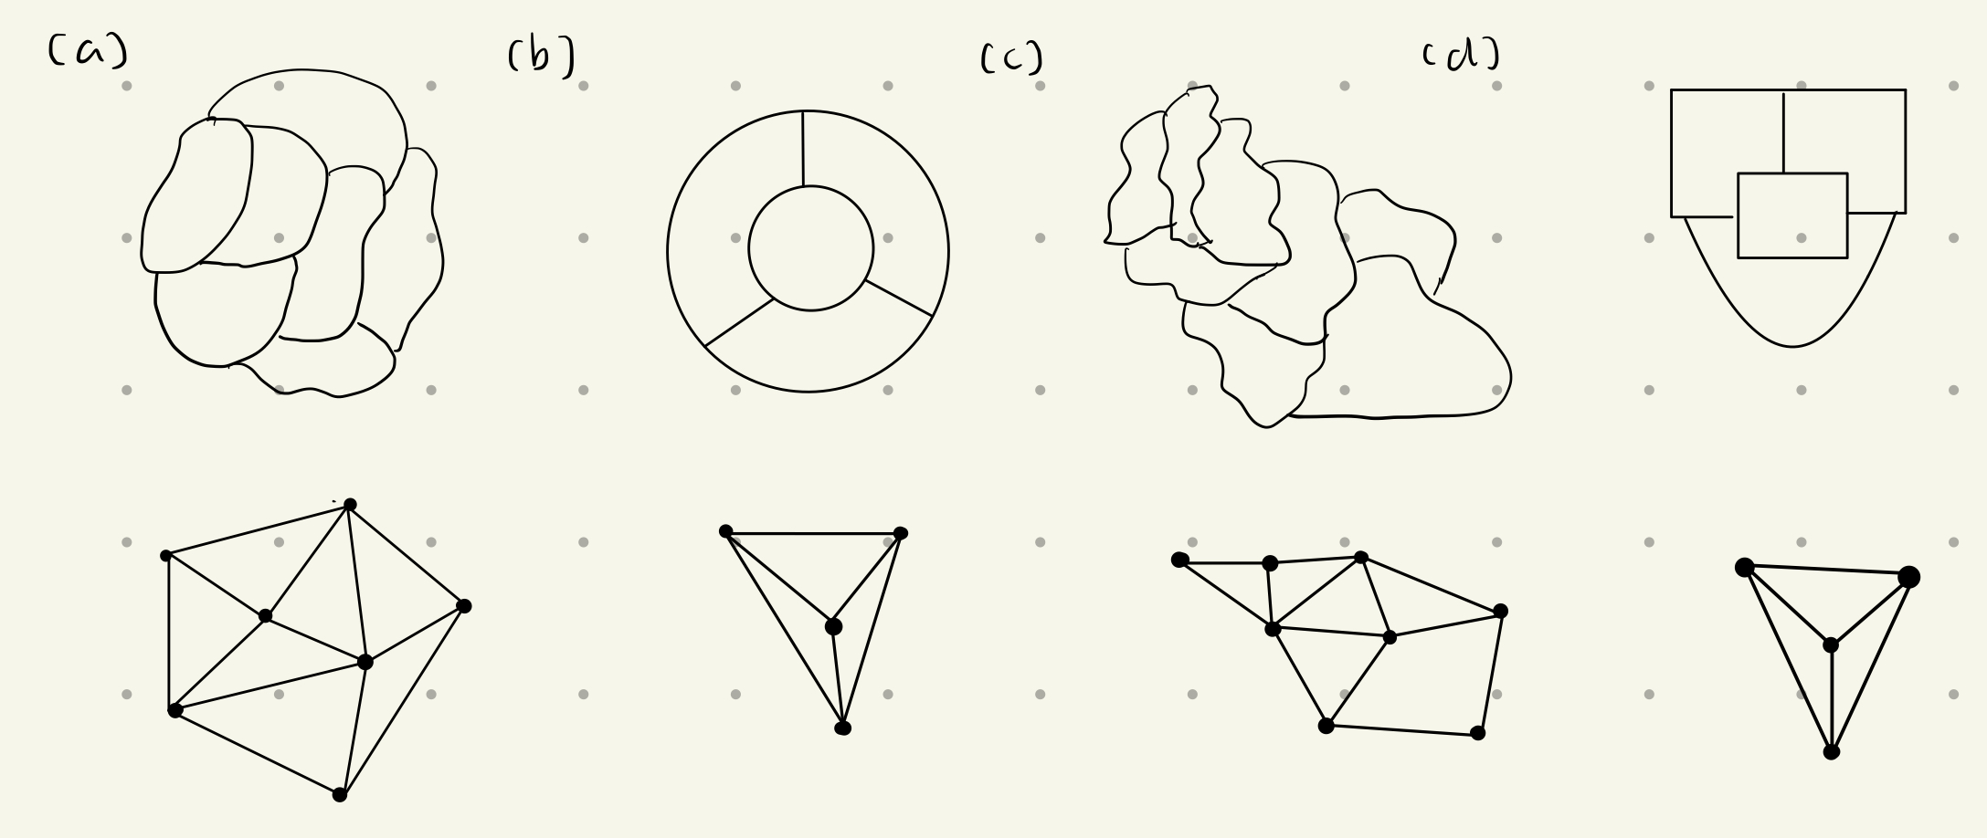
Then, by using the Euler’s formula for graph: $v-e+f=2$, where $v$ represents the number of vertices, $e$ represents the number of edges, and $f$ represents the number of faces. We can find the maximum degree of one vertex in all planer graph. We know the sum of the degrees of all vertices is equal to twice the number of edges, and the sum of the degrees of all faces is equal to twice the number of edges in any given simple planer graph.
$\sum{\deg\left(v\right)=2e}$ and $\sum{\deg\left(f\right)=2e}.$
For instance, the number of vertices in the following graph is 9, the number of edges is 17 and the number of face is 10.
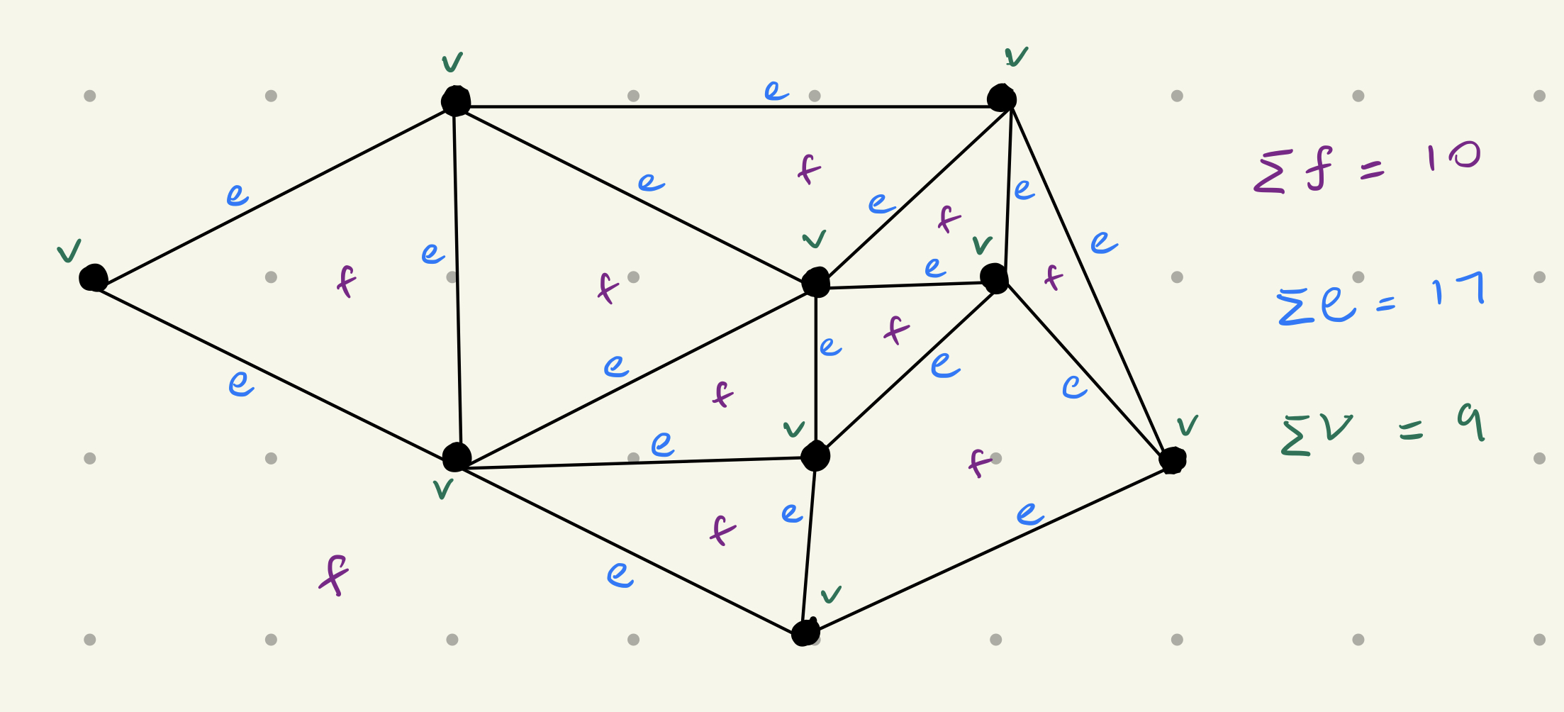
Let one green dot denote one degree of vertex, and one purple dots denote one degree of faces. We can see the total number of degrees of vertex is 34 and the total number of degree of faces is 34.
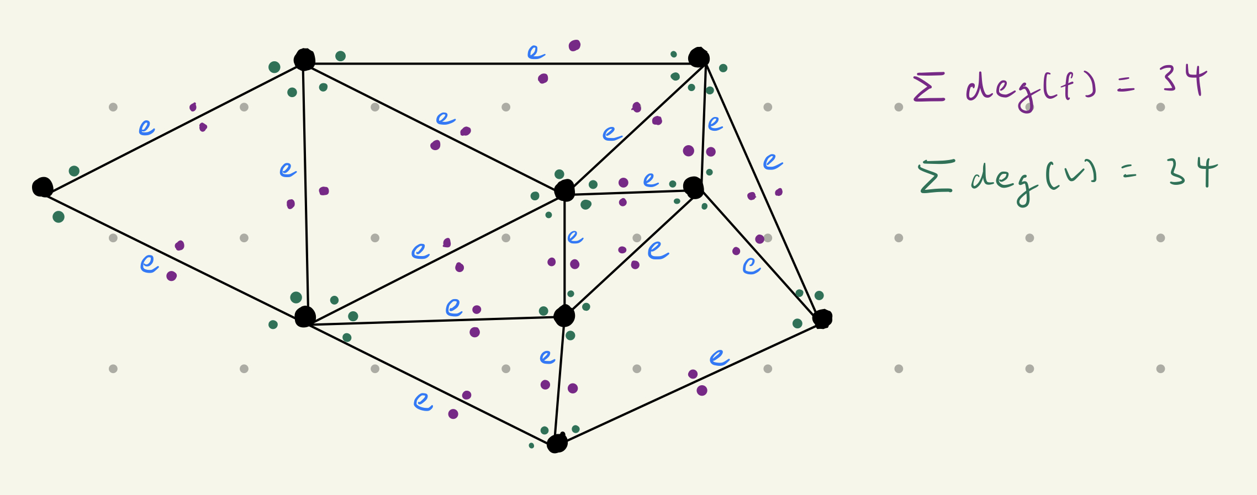
The simplest planar graph is a triangle with 3 vertices, 3 edges, and 2 faces. A graph with 1 vertex, 1 edge, and 2 faces is not considered a simple graph since it is a loop. A graph with 2 vertices, 2 edges, and 3 faces is not a simple graph either since it has two edges between the same vertices. The triangle graph shows that each face in a graph has at least 3 degrees. Therefore, we get $\sum{\deg\left(f\right)≥3f}$. By combining the two equations, $\sum{\deg\left(f\right)=2e} and \sum{\deg\left(f\right)≥3f}$. We get $2e≥3f$.
Now, go back to the equation $v-e+f=2$ and substitute $2e≥3f$ into it.
$$f=e-v+2$$
$$3f=3e-3v+6$$
$$2e≥3e-3v+6$$
$$e≤3v-6$$
This formula shows that any simple planar graph must have a vertex with a maximum degree of 5. We can use this conclusion to prove the five-colour theorem.
Mathematic induction is used to prove this theorem. Assumed that there are n vertices in a graph that can be coloured with only 5 colours such that no two vertices sharing an edge have the same colour. Now we will need to proof when there are n+1 number of vertices, the same condition holds true. In any graph, find a vertex that has a degree less or equal to 5 and let it be $v$. Remove $v$ and colour the remaining vertex connected to $v$ according to the rules. Put v back to the graph. If the vertex $v$ has a degree less than or equal to 4. there will be unused colours that can be used to colour $v$.
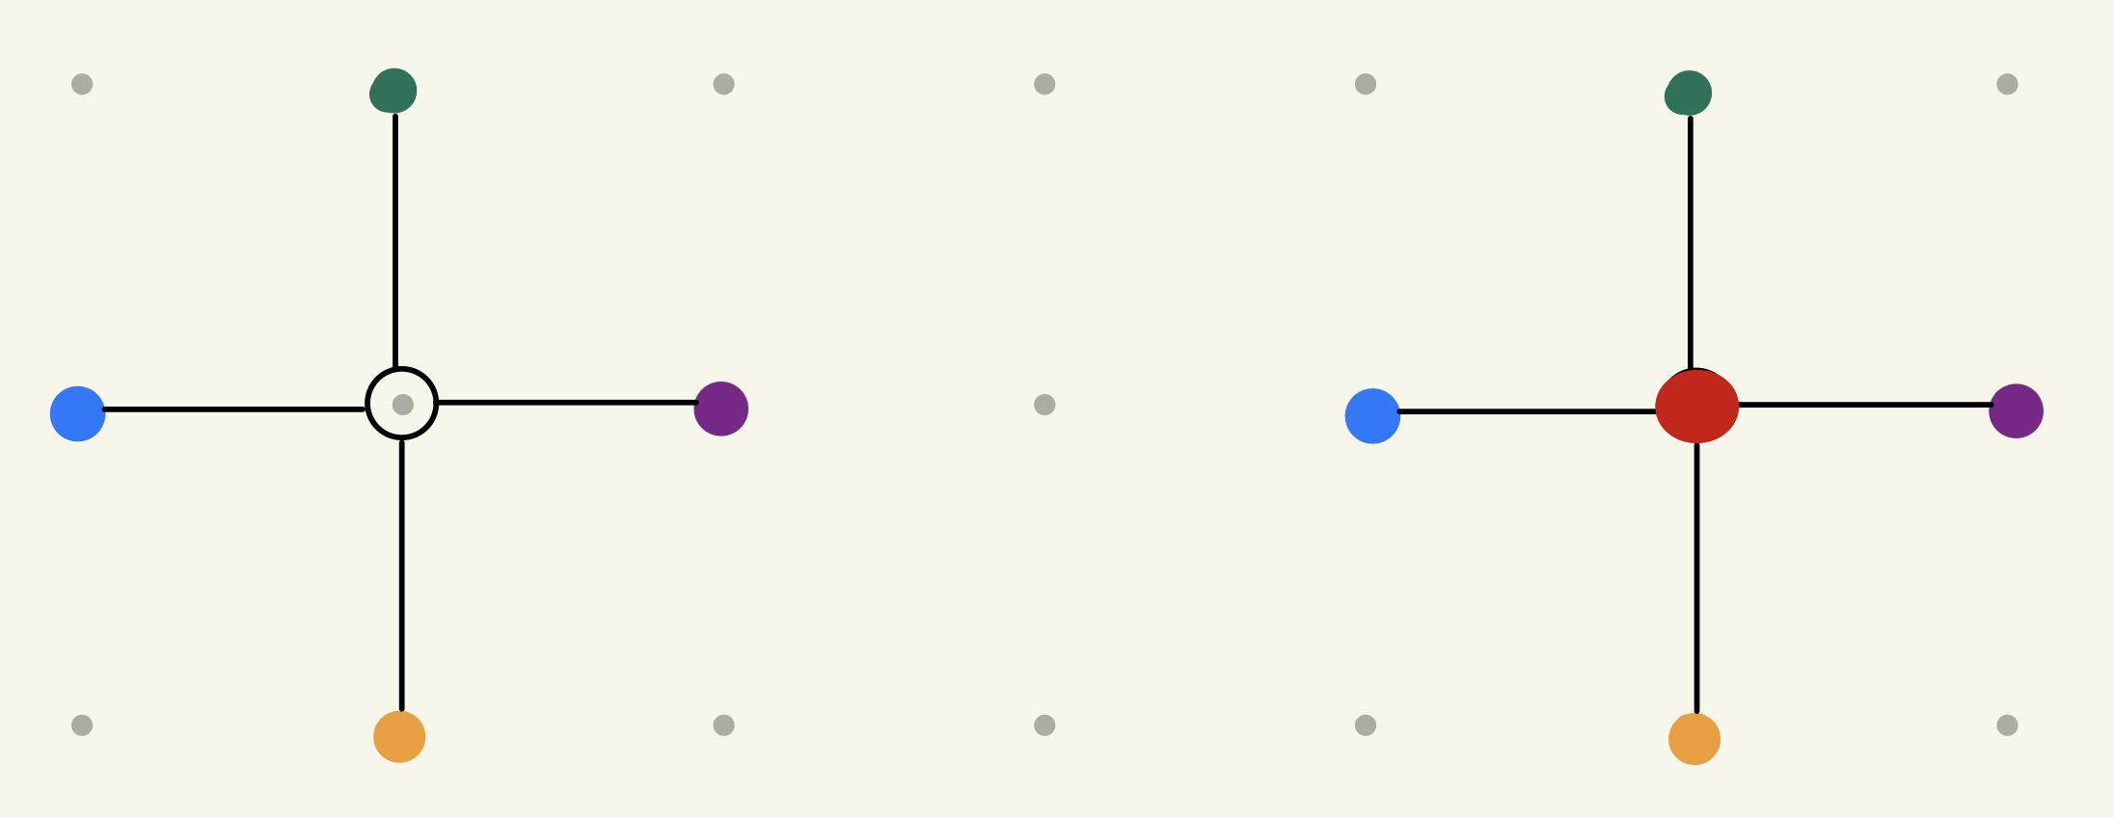
If the vertex $v$ has a degree equal to 5, there are no unused colour to colour the vertex $v$. However, if two vertices connected to vertex $v$ are not connected in a way with repeating alternate coloured vertices. We can change the colour of those two vertices into the same colour.
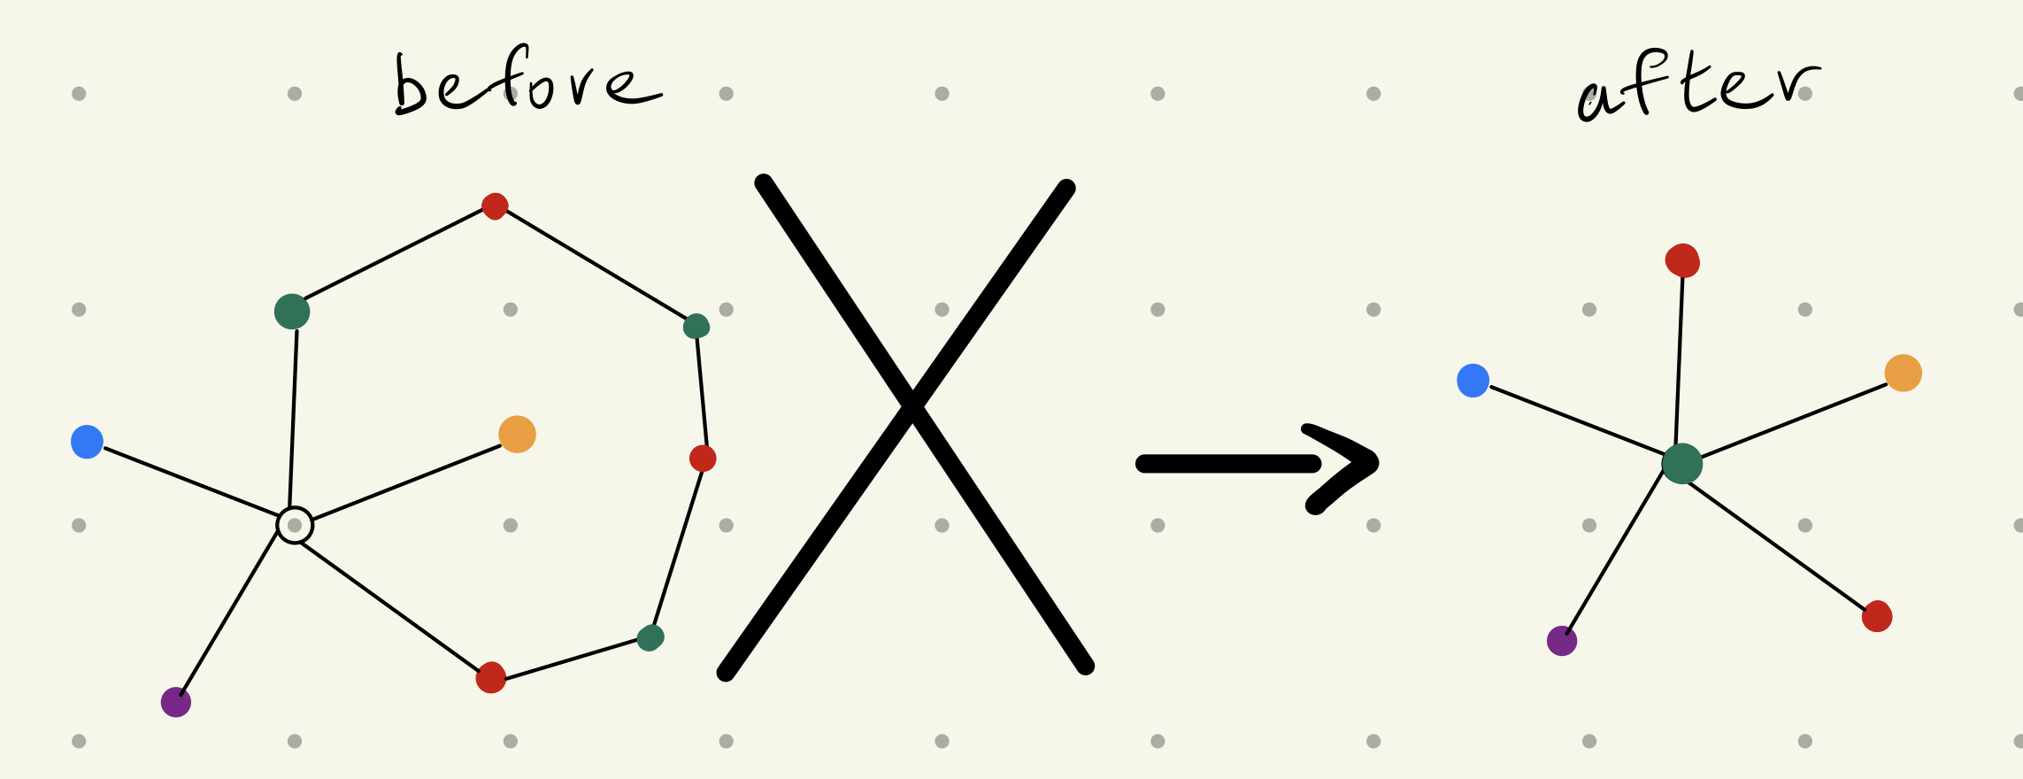
As a result, a colour is free up for colouring the vertex $v$. If two vertices connected to vertex $v$ are connected in a way with repeating alternate coloured vertices. We cannot change the colour of those two vertices. But this kind of chain also prevent the possibility of any of the other three vertex connected to vertex $v$ are connected to each other in this particular way. And we can change two of the remaining three vertex to a same colour.
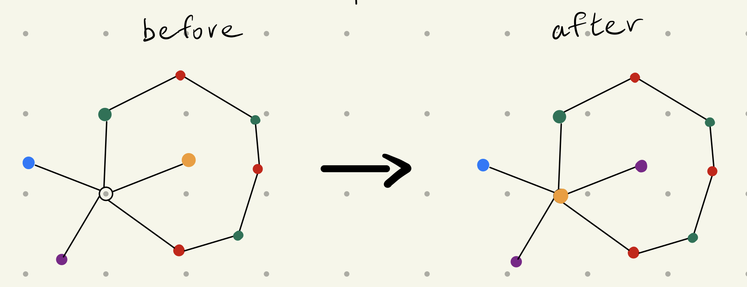
Then, one colour is free up and can be used to colour the vertex $v$. This is how Kempe proved the five-colour theorem.
The solution to the five-colour problem involves converting maps into a simple planar graph comprising only vertices, edges, and faces. In this process, the area, perimeter, and shape of individual regions in the map are deemed irrelevant and erased, in alignment with the principles of topology. As a result, the five-colour theorem resides at the intersection of topology and graph theory.
Topology and graph theory are two mathematical disciplines that exhibit close association. It is possible to expressed all the graph theory in the language of topology, and vice versa. To some extent, graph theory is considered as one-dimensional topology. When using graph theory to solved problems, properties like length, area, perimeter, volume and shape that are important in geometry become dispensable, and only vertices and edges, which constitute the fundamental elements of topology, remain. This, is how graph theory and topology are connected.
Appendix:
- https://en.wikipedia.org/wiki/Five_color_theorem
- https://en.wikipedia.org/wiki/Four_color_theorem
- https://en.wikipedia.org/wiki/Seven_Bridges_of_Königsberg
- https://www.youtube.com/watch?v=5mdH0UeBaR0
- https://www.youtube.com/watch?v=ji3HdP5mI-I
- https://en.wikipedia.org/wiki/Graph_theory
- https://math.stackexchange.com/questions/2036039/how-is-the-königsberg-7-bridge-problem-related-to-topology
- https://math.stackexchange.com/questions/2036039/how-is-the-königsberg-7-bridge-problem-related-to-topology

