What to Do When You Get Your DNA and Kittens in a Twist!

Mathematical topology aims to study geometrical properties and spatial relationships that do not change under smooth, continuous movements. Within topology, Knot theory has developed as a means to classify knots as the behaviour of a circle under transformations of Euclidean space. Although narrowly focused at first, through successive applications to various real-world problems, Knot theory now springs up in surprising places. For example, applications arise in very different areas of Physics, from rapid and explosive particle interactions to the writhing currents of Earth’s outer core. However, a lesser-known, but equally significant application of Knot theory is found deep within the microscopic cells of your very own body, in the most crucial molecule to your existence - your DNA. With the help of some twisted tangles, an adorable pet and some yarn, we are going to attempt to unravel part of the mystery of this incredibly complex chemical.

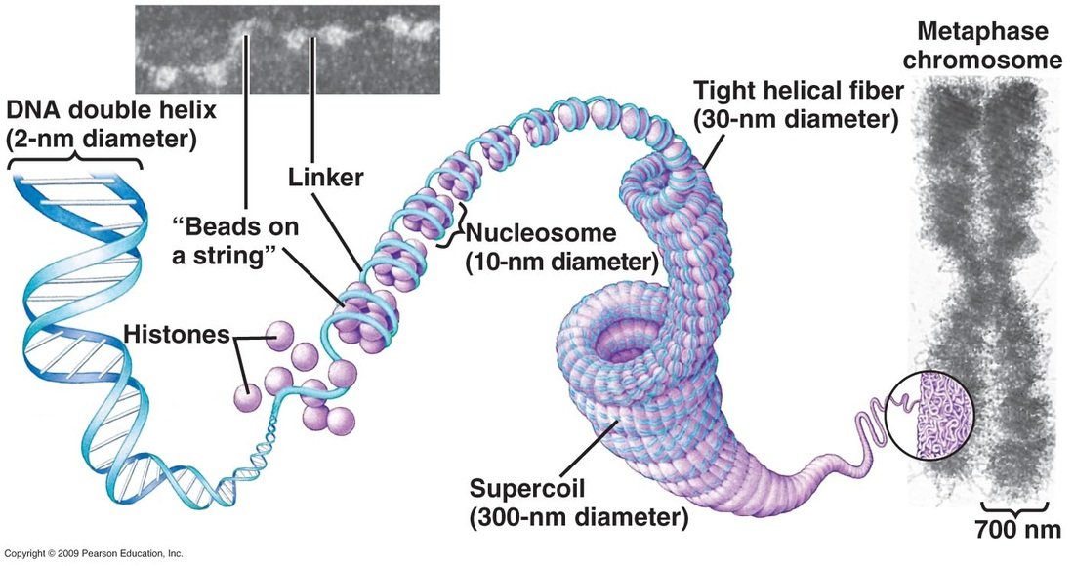
Deoxyribonucleic acid, or DNA, contains the instructions a cell uses to create life. The most common form of your DNA is two strands joined together in a double helix. In bacteria, the DNA double helix is cyclic, and so forms a closed loop. To store this enormous chain of information in the microscopic nucleus of a cell, DNA is supercoiled incredibly tightly, as shown by Figure 1. In fact, if you laid out all the DNA in one human, it would reach the Sun and back over 60 times! This supercoiling means that the DNA becomes inaccessible to the machinery that needs to replicate it for the creation of a new cell. As you might imagine, this supercoiling often leads to complex tangling of the DNA, or when the DNA is cyclic, it results in one enormous knot. Imagine two balls of wool and one cute kitten. Leave them for 30 minutes, and then take a look.
Figure 1: The supercoiling of DNA – from a twisting double helix (left side of the image) to a mess of spaghetti in the overall chromosome (a structure of DNA in its supercoiled form, shown on the right).

So how does an enzyme (a type of cell machinery) perfectly unravel such a delicate but frustratingly tight tangle? How can Biologists leverage their understanding of this process to enable new discoveries? And what happens to the kitten tangled in the wool? The answers lie within Knot theory. Through understanding this more abstract area of topology, biologists and mathematicians have been able to define and measure quantities of a process that have previously only been described qualitatively.

Before we can do this though, first we must understand the basics of Knot theory. Contrary to what many intuitively think, in Mathematics, a knot is defined as a closed loop of “string” that does not intersect itself (causing branches in the “string”) but may cross over itself. This means that anything with loose ends - like the linear DNA found in eukaryotes (multicellular organisms) - does not qualify as a knot, only as a tangle. However, this does not mean that the principles of Knot theory cannot be applied to linear DNA, as these tangles are so dense that they still abide by the rules of knots. The DNA found in prokaryotes (unicellular organisms) is all cyclic. On the other hand, by this definition, a simple, singular circle can be classified as a type of knot called an unknot. Although this idea may sound strange, the unknot is actually central to one of the aims of Knot theory: simplifying complex knots as far as possible or until it can be proven they are mathematically equivalent to the unknot.

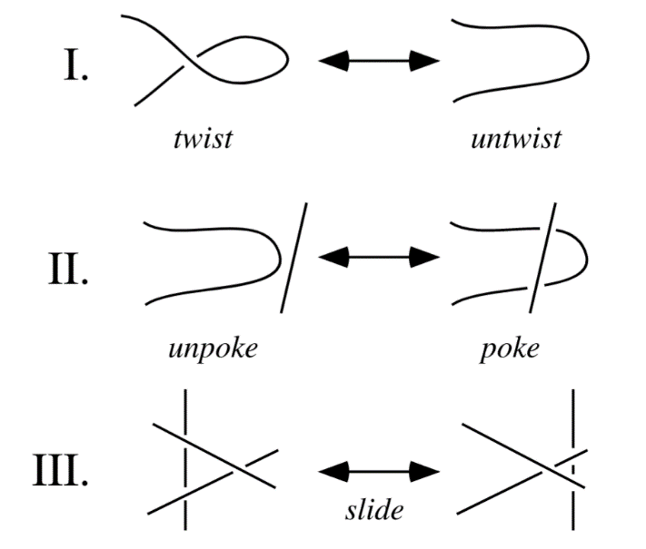
Knot theory research focuses on finding algorithms to prove a knot can be transformed into an unknot or that a knot is equivalent to another knot. Either the kitten is freed, or it isn’t. The conventional method of unravelling a knot is through using a sequence of steps called the Reidemeister moves. These are the most basic transformations that can be applied to knots to manipulate them into a different projection (an expression of the same knot but with a different appearance) as demonstrated in Figure 2.
Figure 2: The three Reidemeister moves – the twist, the poke and the slide.
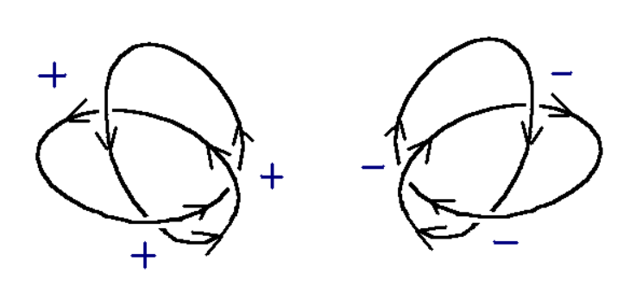
Once a knot has been simplified to its most basic structure, we can begin to quantify its properties. Firstly, the unknotting number (U) can be determined. This is the minimum number of crossings (where two strands overlap) on the simplified knot that must be switched for the knot to become the unknot. Essentially, this means you would cut the strand at the crossing point and re-join on the other side of the strand it crosses. We can also find the crossing number (C) - the sum of the values we assign to different types of crossings. For example, if we take each crossing where the overstrand runs left to right to have a value of +1, and each crossing with the overstrand running right to left to be -1, then the crossing number will be the sum of all these values, X. The simplest way to distinguish the two separate types of crossing is to take a point on the knot, then as you follow the knot in a direction of your choosing, take every crossing where the strand runs underneath as -1, and when it runs above to be +1, as shown by Figure 3. Together, these two properties can be used to describe a knot, as denoted by C_{U}.
Figure 3: A demonstration of two ways values can be assigned to crossings.

But how is this applied to DNA? When the information on the DNA strand needs to be accessed (for example to copy it), it is unwound by a family of enzymes called topoisomerases. To do this, the topoisomerase performs basic functions similar to the Reidemeister moves. However, when this cannot uncoil the DNA anymore, the topoisomerase cuts the strand at a crossing and re-joins it on the other side, just like when the crossing of a knot is switched. This is when you might need the scissors to free the tangled kitten. We can determine the minimum number of times a topoisomerase has to act on the DNA by finding the unknotting number.

In order to determine the unknotting number, there are two methods available. An electron microscope can be used to image the DNA loop, and from this, a model of the knot can be constructed. However, this equipment is very expensive, and so not particularly accessible. Another way the nature of the DNA knot can be determined is by electrophoresis. This is a process commonly used to separate sections of DNA based on their mass, as a greater mass would allow the DNA to travel further through the electrophoretic gel. However, the compactness of the DNA, and therefore its density, can also differentiate sections of DNA, as a denser strand would pass through the gel more easily. As this property of the DNA is based on how tightly knotted it is, the distance travelled in electrophoresis can be used to determine its crossing number (Figure 4). After finding this crossing number, we can quantitatively measure the compactness of DNA. Unfortunately, neither approach is particularly useful in helping free the kitten, but both work well for DNA.
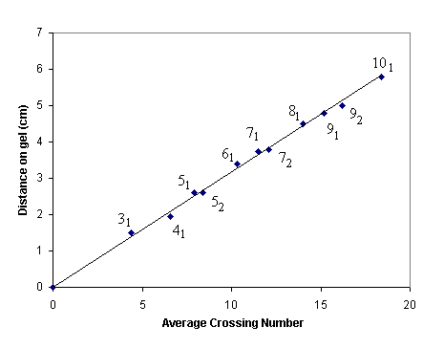
In addition, the crossing number can also be advantageous in studying the precise functioning of topoisomerases. For example, in 1979, Brown and Cozzarelli were able to determine that gyrase (a type of topoisomerase found in E. Coli) decreases the crossing number in a stepwise fashion. As this decrease was by two units each time, it was concluded that gyrase acts by cutting both strands and then re-joining them on the other side, effectively switching the crossing, as illustrated in Figure 5. This would cause the crossing number to change from either +1 to -1 or vice versa, both cases resulting in a difference of two. This shows that gyrase is a type 2 topoisomerase, as it cuts both strands. In contrast, if it were type 1, it would only cut one strand and re-join it so that it was released from the coil. This would result in a crossing of +1 or -1 being removed, or changing the value to 0, which would show a decrease of only one in the crossing number. This process of periodically testing the crossing number after adding a known volume of topoisomerase solution can be repeated for other topoisomerases, to determine their type and their rates of reaction. Creating a bank of this information helps to make other experiments that manipulate DNA more efficient and allow biologists to make informed choices on which topoisomerases to use.
Figure 4: The relationship between distance travelled on the electrophoretic gel and the crossing number of sections of DNA.
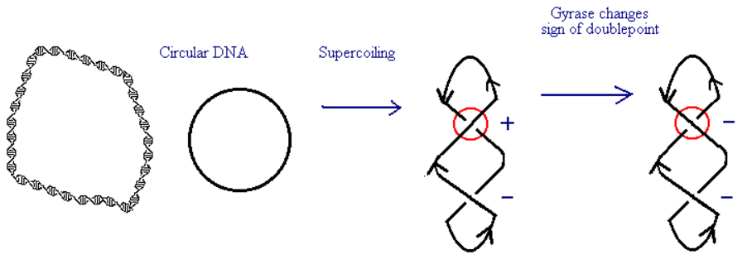
Figure 5: An example of the effect of gyrase on a cyclic loop of DNA.
Furthermore, if topoisomerases can be correctly controlled, they could possibly be used to manipulate gene expression. This means that if there is a certain instruction that we do not want the cell to carry out, we could limit the uncoiling action of the topoisomerases on that section of DNA, keeping it inaccessible to the replication enzymes. This could be applied in many areas of medicine, but perhaps most prominently, in cancer treatments. Cancer is caused by mutations in the DNA of a cell which results in the cell replicating uncontrollably and creating a tumour. Current cancer treatments are aimed at killing these tumour cells to prevent them from spreading or causing organ damage, whether this is through the usage of toxic chemicals (chemotherapy) or harmful radiation (radiotherapy). However, all the most effective treatments currently cause great damage to healthy tissues as well. In contrast, if topoisomerases can be manipulated correctly, the section of DNA in tumour cells that tells them to continually divide can be made permanently inaccessible by keeping the DNA in its supercoiled state. This would prevent the reproduction of cancerous cells and, alongside another treatment, could aid in curbing the spread and uncontrollable growth of tumours.

This illustrates just one way in which the use of Knot theory to study the relationship between DNA and different types of topoisomerases can highlight new possible solutions to some of medicine’s most pressing challenges. Could Knot theory and topoisomerases eventually lead to the manipulation of gene expression? Maybe one day a greater bridge between the two disciplines of Mathematics and Biology could make more direct treatments of genetic diseases a reality. And perhaps freeing the kitten doesn’t have to be such a knotty problem anymore…

References:
- Tomkins, J., Tompkins, J., Mann, D. and Mcloud-Mann, J. (2006). Modeling DNA Using Knot Theory: An Introduction. Undergraduate Mathematics Journal Rose-Hulman Undergraduate Mathematics Journal, [online] 7(1), p.13. Available at: https://scholar.rose-hulman.edu/cgi/viewcontent.cgi?article=1234&context=rhumj .[Accessed 21 Mar. 2023].
- Lim, J. and Martin, E. (2019). The Application of Knot Theory to Models in Biology and Physics. [online] Available at: https://math.mit.edu/research/highschool/primes/circle/documents/2019/Lim_Martin_2019.pdf.[Accessed 21 Mar. 2023].
- www.nimbios.org. (n.d.). DNA AND KNOT THEORY. [online] Available at: http://www.nimbios.org/~gross/LGrossTIEMwebsite/home/gross/public_html/bioed/webmodules/DNAknot.html.[Accessed 21 Mar. 2023].
- Ayinon, W. (2020). Knot Theory and DNA. [online] Available at: https://math.mit.edu/research/highschool/primes/circle/documents/2020/Ayinon_2020.pdf.[Accessed 22 Mar. 2023].
- Weisstein, E.W. (n.d.). Reidemeister Moves. [online] mathworld.wolfram.com. Available at: https://mathworld.wolfram.com/ReidemeisterMoves.html.[Accessed 22 Mar. 2023].
- Mehta, C. (2020). Unknotting the Double Helix: Where Knot Theory meets Biology. [online] The Cosmic Treehouse. Available at: https://www.thecosmictreehouse.com/post/unknotting-the-double-helix-where-knot-theory-meets-biology. [Accessed 23 Mar. 2023].
- KQED. (n.d.). A Long and Winding DNA. [online] Available at: https://www.kqed.org/quest/1219/a-long-and-winding-dna.[Accessed 23 Mar. 2023].

