Differential Equations in Simple, Damped and Forced Harmonic Motion
Alfred Hargreaves

Simple harmonic motion (SHM) describes an oscillatory motion under a restoring force, proportional to the displacement from an equilibrium position. Described by the relation that the acceleration is directly proportional to the displacement:
$$a∝-x$$
Why the negative sign? The force on the object in SHM is a restoring force (or sometimes called a retarding force), meaning that it will always act toward the equilibrium position of the system, and thus in the opposite direction to the displacement. This will all be explained in due course. For now, let’s study a pendulum to see how we can arrive at the conclusion the motion is simple harmonic.
A simple pendulum has a small diameter bob and a string attached to it that has very small mass and is strong enough to not stretch appreciably. In other words, we model the bob as a particle and the string as light and inextensible, as well as neglecting air resistance. We can show that the pendulum will experience SHM (through small angles, for reasons to be seen), by considering components of its weight. First, we shall recall the formula for arc length of a circle, where $θ$ is in radians, and in this case the radius is the length of string $l$:
$$x=lθ$$
$$⇒ θ=\frac{x}{l}$$
The component of the weight of the bob perpendicular to the string, and acting as the restoring force $F$ is equal to:
$$F=-mg\sin{θ}$$
Using Newton’s Second Law in the form:
$$F=ma$$
$$⇒a=-g\sin{θ}$$
Using the small angle approximation:
$$\sin{θ}≈θ$$
$$⇒a=-gθ$$
And using our expression for $θ$:
$$a=-\frac{g}{l}x$$
This is a hidden form of our definition for simple harmonic motion, as:
$$ω=\sqrt{\frac{g}{l}}$$
$$∴ a=-ω^{2}x$$
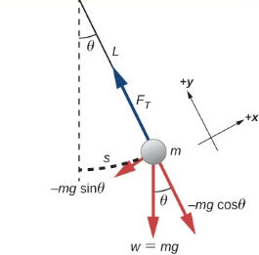
$$x$$
From the relation above, simple harmonic is hence described by the equation:
$$a=-ω^{2}x$$
Where $ω^{2}$ is our constant of proportionality. $ω$ represents the angular velocity of the system. It follows that:
$$ω=\frac{2π}{T}$$
Where T is the period of the pendulum (time to complete one complete oscillation).

As of yet, there has been no discussion of differential equations. Or so you might think…
Acceleration can be written as the derivative of velocity with respect to time, or the second derivative of displacement with respect to time:
$$a=\frac{dv}{dt}=\frac{d^{2}x}{dt^{2}}$$
Thus, we can rewrite our SHM equation as a second-order homogeneous ordinary differential equation (ODE), which we can solve to find the displacement as a function of time.
$$\frac{d^{2}x}{dt^{2}}=-ω^{2}x$$
$$\frac{d^{2}x}{dt^{2}}+ω^{2}x=0$$
Therefore, the auxiliary equation is:
$$m^{2}+ω^{2}=0$$
Giving imaginary (conjugate) roots:
$$m=±ωi$$
A general solution for this, which will not be proved in this essay, but taken as a standard result, is subsequently:
$$x=C\sin\left(ωt\right)+D\cos{(ωt)}$$
Or equally:
$$x=R\sin{(ωt+α)}$$
$$R=\sqrt{C^{2}+D^{2}}$$
$$α=\tan^{-1}{\frac{D}{C}}$$
Where $C$ and $D$ are arbitrary constants. If they are to be found, we need boundary conditions. For the case of a pendulum starting at its maximum amplitude, A:
$$t=0, x=A, v= \frac{dx}{dt}=0$$
We get:
$$x=A\cos{(ωt)}$$
As our particular solution.

But sometimes it is not as simple as this (forgive the pun!). For large angles, the small angle approximation cannot be applied, and the differential equation below is formed:
$$\frac{d^{2}x}{dt^{2}}+ω^{2}\sin{x}=0$$
Of which cannot be solved without an elliptic integral, and more advanced math, subsequently lying beyond the breadth of this paper.
However, we can refine the model for simple harmonic motion by adding an addition force that is proportional to the velocity. When this force acts to slow the particle down (such as air resistance for example), it is known as the damping force, resulting in damped harmonic motion. The general equation is as follows:
$$\frac{d^{2}x}{dt^{2}}+k\frac{dx}{dt}+ω^{2}x=0$$
Where $k$ and $ω$ are positive constants. $k$ represents the damping coefficient. There are three different scenarios corresponding to different solutions to this equation.
The first is known as heavy damping (shown in the graph below as A), also called overdamping. This occurs when the auxiliary equation shown below gives distinct real roots:
$$m^{2}+km+ω^{2}=0$$
$$∴k^{2}>4ω^{2}$$
The second, known as critical damping (graph B) occurs when the solutions to the auxiliary equation are repeated real roots. In critical damping, the object returns to its equilibrium point (centre of oscillation) as quickly as possible. (It actually asymptotically approaches zero displacement as quickly as possible).
$$∴k^{2}=4ω^{2}$$
The last scenario is light damping (C) (also called underdamping), where the oscillations continue, but their amplitude decays exponentially. The auxiliary equation is solved to give complex roots.
$$∴k^{2}<4ω^{2}$$
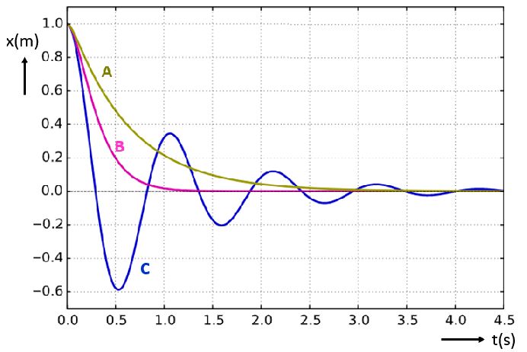
An example of damped harmonic oscillation is a mass, $m$, attached to a spring of force constant, $k$, oscillating, with an amplitude, $A$, in a viscous fluid providing the damping force.
The forces acting on the mass consist of the damping force, which is proportional to the velocity (constant of proportionality $b$), and the force of the spring.
$$F_{damping}=-bv, F_{spring}=-kx$$
The resultant force is therefore:
$$F=ma=-bv-kx$$
Giving the second-order homogenous differential equation:
$$m\frac{d^{2}x}{dt^{2}}+b\frac{dx}{dt}+kx=0$$
If the system is lightly damped, the discriminant of the auxiliary equation is less than zero, giving complex roots of:
$$-\frac{b}{2m}±i\sqrt{\frac{k}{m}-\frac{b^{2}}{4m^{2}}}$$
Where, for a damped mass-spring system:
$$ω=\sqrt{\frac{k}{m}-\frac{b^{2}}{4m^{2}}}$$
(For a simple mass-spring system, the angular frequency is the same as the natural frequency):
$$\frac{d^{2}x}{dt^{2}}=-\frac{k}{m}x, ∴ ω=\sqrt{\frac{k}{m}}$$
Then the particular solution is:
$$x=Ae^{-\frac{b}{2m}t}\cos{(ωt)}$$
The graph of this function is an oscillatory cosine wave enveloped in an exponential function, which clearly demonstrates the decay of the amplitude of oscillation:
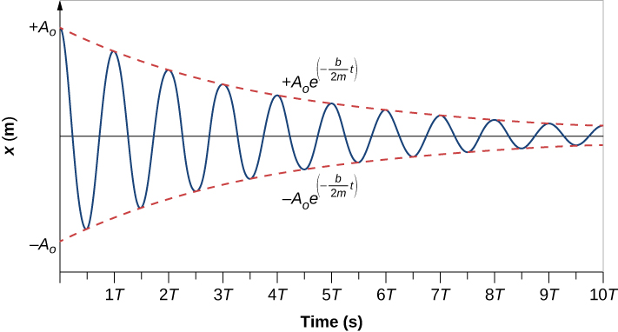
Systems can be forced to oscillate through providing a periodic external driving force. The same differential equation used to define the motion of a damped oscillator can be used, with the addition of an additional function of time. This transforms the second-order homogeneous equation into a non-homogeneous one of the general form:
$$\frac{d^{2}x}{dt^{2}}+k\frac{dx}{dt}+ω^{2}x=f(t)$$
If the driving force is periodic, $f(t)$ will likely take the form of a trigonometric function.
To solve this differential equation, you must first solve the corresponding homogeneous equation to find the complementary function. Then find a particular integral for the non-homogeneous equation. The general solution will be the sum of the complementary function and the particular integral.
The form of the particular integral depends on the function itself, (note that here $ω$ is the frequency of the driver):

Form of $f(t)$ | Form of Particular Integral
$$p$$ | $$λ$$
$$pt+q$$ | $$λt+μ$$
$$pt^{2}+qt+r$$ | $$λt^{2}+μt+ν$$
$$pe^{kt}$$ | $$λe^{kt}$$
$$p\sin\left(ωt\right)+q\cos{(ωt)}$$ | $$λ\sin\left(ωt\right)+μ\cos{(ωt)}$$

If the form of the particular integral shown in the table is already a solution to homogeneous equation, then that form is not a suitable particular integral. Instead, the form of the particular integral can be multiplied by $t$ until the form is entirely different to that of the complementary function.
If the driving frequency is equal to the natural frequency of the system (that is the angular frequency with no damping or driving forces), the system will resonate. This causes the amplitude of the oscillations to increase dramatically, and can cause a system to break, if not damped. Although, resonance can also have useful effects, such as that of musical instruments, or even radio broadcasting.
Damping a forced oscillation has the effect of reducing the maximum amplitude at resonance. The degree of the damping also has an effect on the frequency of the driver that causes resonance. It both decreases the resonant frequency of the system and increases the range over which resonance can be seen. This can be demonstrated in the graph below:
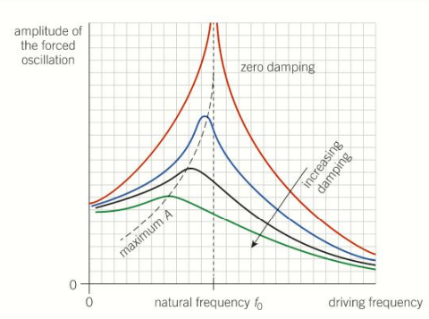
One particular example of damping to reduce maximum amplitude, is the Taipei 101, in Taiwan. As one of the world’s tallest towers (at 1,667 feet), it is very susceptible to high winds and earthquakes. To counter this, a 660 metric ton globe acts as a damper, which is suspended through floors 87 to 91.

The driver in this system is the building, which sways or shakes, subsequently causing the globe to oscillate in the opposite direction. Energy from the motion of the building is transferred to and dissipated in the mass damper, reducing the amplitude of oscillation of the tower. The natural frequencies of both the tower and the damper are the same, as this allows for maximum energy transfer and hence reduces the risk in high winds or an earthquake.
In conclusion, differential equations (second-order in particular) are extremely useful in modelling types of harmonic motion, particularly with their applications to damped systems and preventing resonance in structures such as skyscrapers or bridges.

Bibliography
Burbano, L., 2023. Taipei 101: How Does This Iconic Skyscraper Withstand Earthquakes?. [Online]
Available at: https://www.tomorrow.city/taipei-101-earthquakes/
[Accessed 30 January 2024].
Isaac Physics, 2022. Isaac Physics: Simple Pendulums 20.1. [Online]
Available at: https://isaacphysics.org/questions/phys_linking_20_q1?stage=all
[Accessed 29 January 2024].
OpenStax, 2016. University Physics Volume 1: 15.4 Pendulums. [Online]
Available at: https://openstax.org/books/university-physics-volume-1/pages/15-4-pendulums
[Accessed 29 January 2024].
OpenStax, 2016. University Physics Volume 1: 15.5 Damped Oscillations. [Online]
Available at: https://openstax.org/books/university-physics-volume-1/pages/15-5-damped-oscillations
[Accessed 29 January 2024].
OpenStax, 2016. University Physics Volume 1: 15.6 Forced Oscillations. [Online]
Available at: https://openstax.org/books/university-physics-volume-1/pages/15-6-forced-oscillations
[Accessed 29 January 2024].
Physics Stack Exchange, 2021. Solution to pendulum differential equation. [Online]
Available at: https://physics.stackexchange.com/questions/653845/solution-to-pendulum-differential-equation
[Accessed 29 January 2024].
Physics Stack Exchange, 2022. What is the motion of a pendulum for large angles?. [Online]
Available at: https://physics.stackexchange.com/questions/718494/what-is-the-motion-of-a-pendulum-for-large-angles
[Accessed 29 January 2024].
TutorChase, 2020. How does a pendulum exhibit SHM?. [Online]
Available at: https://www.tutorchase.com/answers/ib/physics/how-does-a-pendulum-exhibit-shm
[Accessed 29 January 2024].

