Does the casino always win?
“There is a very easy way to return from a casino with a small fortune; go there with a large one.”
- Nick Dandolos
A professional gambler, Dandolos, most commonly called Nick the Greek, rose from rags to riches – to rags – to riches 73 times in his life. With some days winning $100,000 ($6.5 million today) and some days losing $100,000, Nick’s life was like a rollercoaster, one which eventually crashed; he died in 1966, broke.
Although morbid, the story of Nick is a perfect illustration of how the casino always wins. As illustrated below, we can see that Nick’s equity curve looked something like shown below. Although he won and lost an estimated $500 million in his life, the casino’s true gain was the red shaded money, a minimal portion of his total wins and losses. The point being illustrated below is that casinos make money through the overall slight edge they have in terms of their odds.
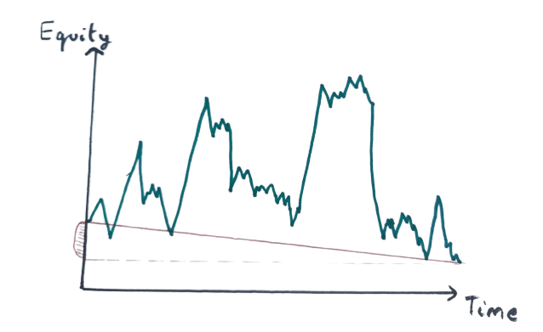
Taking a step back, the casino has many net losers and many net winners every day, but the key point is that there always are more losers than winners, causing a consistent profit for the casino. But why is this so?
Finding Consistency in Unpredictability
To understand this, we look at the law of big numbers, which states that the actual mean of results from a large number of trials will converge towards the “true mean” or “expected value”. An example of this is rolling a dice 1000 times. The expected value,
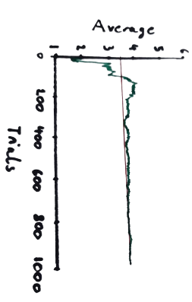
$E\left(X\right)=\left(\frac{1}{6}×1\right)+\left(\frac{1}{6}×2\right)+\left(\frac{1}{6}×3\right)+\left(\frac{1}{6}×4\right)+\left(\frac{1}{6}×5\right)+\left(\frac{1}{6}×6\right)=3.5$
A generalised version of this is $\sum{x_{i}P(X=x_{i})}$. To illustrate this point, a graph of trials against the average for the dice may look like this.

In context, although a casino may lose a game of roulette, they can rely on a long-term profit as the actual odds converge to theoretical odds, meaning actual profits converge to theoretical profits. Realising this, casinos slightly shifted the odds in order to gain that edge, also called a house advantage. This metric proved to be essential in the casino’s business model.
Going back to our beloved example of rolling dice, I may agree to pay you £5 on a £1 bet that you will roll a 4. Therefore here, our payout for winning is £5 and our loss for losing is £1. We can calculate the house advantage as shown below.
Event | Odds | Payout | Payout × Odds
Win | 1/6 | +£5 | +£0.80
Lose | 5/6 | -£1 | -£0.80
 | Casino profit (Difference in p×o) |  | £0
 | House advantage (£0/£5) |  | 0%

In an ideal, fair world, this would be the bet placed, but life is not fair. We would see something closer to this in the casino for a game of roulette, where the casino promises to double my £10 bet if I placed it on the correct colour, insinuating there is a 1/2 chance of it landing on red and a 1/2 chance of it landing on black.
Event | Odds | Payout | Payout × Odds
Win | 18/38 | +£10 | +£4.73
Lose | 20/38 | -£10 | -£5.26
 | Casino profit (Difference in p×o) |  | £0.53
 | House advantage (£0.53/£10) |  | 5.3%

Strangely, our odds are not actually ½ and rather 18/38 (due to the 0 and the 00 slot), which is unnoticeable to most people who play and to those who notice, rightfully not significant enough for one or two bets on the table. Although unimportant to an individual bettor, it is paramount to casino which will make a 5.3% margin in the long run.
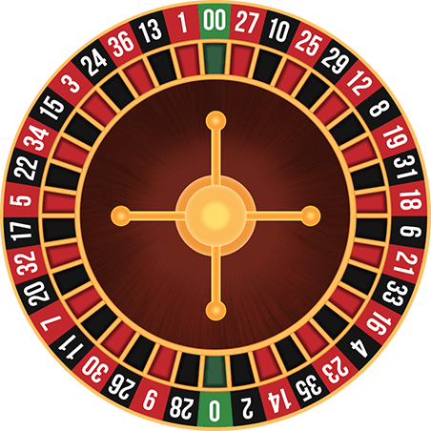
The second principle utilised by casinos is the volatility index of a game, which in essence, is a nicer sounding name for standard deviation. Despite the guarantee of long-term profitability, the short-term is still unpredictable and the casino needs to always have the cash reserves to be able to pay bettors on an unlucky day. Here is where the probability distribution comes in; as each spin of the wheel or roll of the dice is an independent, we can model our games using the binomial distribution.
The standard formula for standard deviation via the binomial distribution, $σ=\sqrt{np\left(1-p\right)}$, where p is the chance of winning and therefore 1-p is the chance of losing and n is our number of rounds played. The volatility index (VI) of a game is defined as the standard deviation of one round, when betting £1. Using roulette as an example again:
$$VI=\sqrt{1×\frac{18}{38}×\frac{20}{38}}≈0.499$$
So, what does this all mean to us?
In our ideal world, we would be able to find a game with a negative house advantage to favour us during long term. Unfortunately, if this existed, casinos would on the other hand not exist. (Almost) unable to find a game that favours the bettor, we will need to find a game that has a minimal house advantage (I say almost as there is maybe one exception). Additionally, we would ideally look for games with higher VI to maximise our deviations away from the expected value, but this is less necessary if our house advantage is low.
Our four candidates that we will consider are Roulette, Craps, Baccarat and Blackjack, the four big casino-vs-player table games. However, Baccarat has a consistent, unchangeable house edge of 1.24% so we will not go into depth.
The Big Spinning Wheel – Roulette
First played in its present form in late 18th century France, roulette is a simple to understand game whereby a bet is placed on a group of numbers or a single and if the ball falls in there, there will be a profit or payout, $payout=\left(b×\frac{36}{n}\right)-b$, where b is the bet n is the number of numbers we have bet on, e.g. if we bet on reds, we bet on 18 numbers, so n is 18. However, as previously explained, the additional 0 and 00 slot mean the true payout should be $\left(b×\frac{38}{n}\right)-b$, giving the casino an edge. But is there any way to get an edge by placing a specific bet?
By looking at it as a purely random game,
$house advantage=-expected value$[when b=£1]
Subbing in our roulette values:
$$house advantage=-(\left(1*\frac{36}{n}-1\right)*\frac{n}{38}--1*\left(1-\frac{n}{38}\right)))$$
$$(\left(1*\frac{36}{n}-1\right)*\frac{n}{38}--1*\left(1-\frac{n}{38}\right)))=1/19$$
$$∴house advantage≡1/19$$
Therefore, no betting strategy will help us. Although in 2004, a group of 3 walked out of the Ritz with £1.2 million just from roulette. By tracking, in real-time, the velocity and position of the ball when it started spinning with a laser scanner and a point later in the spin, they calculated the angular acceleration of the ball. A standard game of roulette allows you place bets until the 3rd spin, allowing them to place bets on the predicted landing sector. In a fairytale ending, the three where unable to be sued by the casino as they did not interfere with the game and walked away with their money.
Being just as confused as the reader as to how we got here, I want to explain the mechanics behind their method [for educational reasons].
There are two spinning components we need to consider: the spinning wheel in the middle and the spinning ball on the outside. Our 6 inputs that the laser scanner gets are the angular velocity and angular position (in radians) relative to a fixed mark at time $t_{0}$, $ω_{0}$ and $θ_{0}$ respectively and at time $t_{1}$, $ω_{1}$and $θ_{1}$.
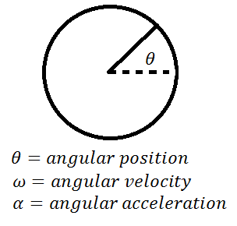
By subbing it into the formulae of $ω=ω_{0}+αt$, where $t={t_{1}-t}_{0}$, we can derive acceleration $α$. We can then put $α$ back into the formula to find the time at which $ω=0=ω_{2}$, $t_{2}.$ We can then find the final angular position at time $t_{2}$ through the formula $θ{=θ}_{0}+ω_{0}t_{2}+\frac{1}{2}α{t_{2}}^{2}$. This gives us the ball’s relative stopping position to the fixed mark.
We can repeat this for the spinning wheel in the middle as well (with the green 0 slot as our point), just making sure that we account for the velocities and other vector measurements in the negative direction to represent the opposite direction of the spin. By repeating this, we can find the angular position of the 0 slot, $ϕ_{2},$at time $t_{2}$. Making sure both $ϕ_{2}<2π$ and $θ_{2}<2π$, we get the relative position via $θ_{2 }-{ ϕ}_{2}$. Each relative position corresponds to a specific slot e.g. the 2 slot is in relative position range $\frac{π}{2}≤x≤\frac{π}{2}+\frac{π}{38}$. However, this will be quite inaccurate so we would need to bet on the 2 slots around it at least as well.
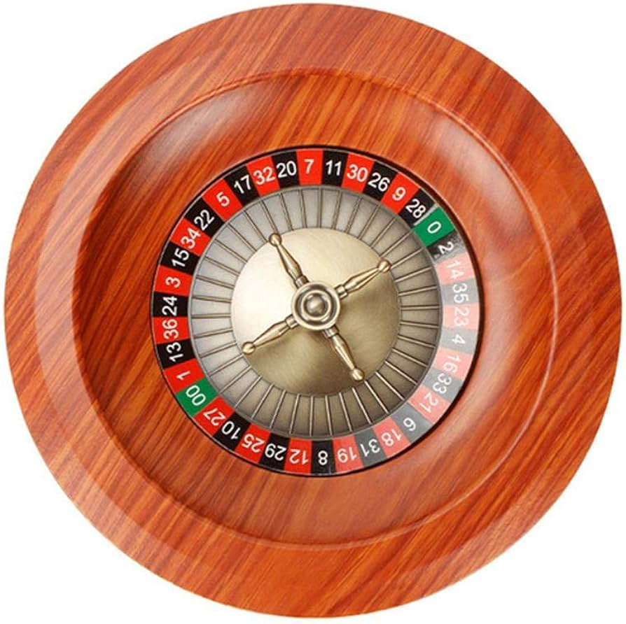
$$ϕ_{2}$$
$$θ_{2}$$

Unfortunately, our system is far from perfect as it we do not consider the drag, tilt or the bumpers which exist on many roulette wheels, causing the ball to jump around erratically before stopping to stop things like this from happening. However, as proven by example, it is very possible to devise a system like this.
Another similar anecdote was seen in the early 90s in Spain, where Gonzalo Garcia-Pelayo put the real-time data of hundreds of spins into his computer and noticed that the wheel had a slight tilt, creating a bias towards a region, winning him €1.2 million.
Shooting Dice – Craps
Often the game we imagine when we think of the casino, Craps is essentially a game where a wager is placed on the sum of 2 dice rolled together.
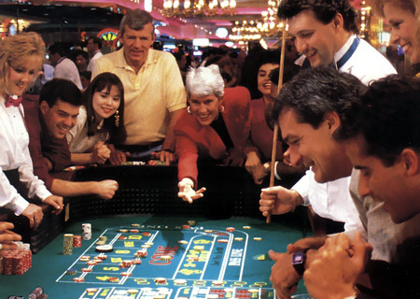
Before the dice are rolled, a Pass Line bet can be placed, meaning that we win if a 7 or 11 roll or lose if a 2, 3 or 12 roll. Any other number becomes a ‘point’ and the dice is continually rolled until the point is rolled or a 7 if rolled; if the point is rerolled, it’s a win and if a 7 is rolled, it’s a loss. If won, the payout the same as your bet.
Before or after the initial roll, a Don’t Come/Don’t Pass bet can be placed, where you win on 7 and 11 and lose on 2, or 3, if a 12 is rolled, you reroll. Any other roll acts as a ‘point’. However, this time, to win we must roll a 7 before that number. This bet also has the same payout as your bet and is a bet on the roller losing.
From the sample space diagram of two dice rolls below, we can see that the probability of winning a Pass Line straight away is 22.22% as $\frac{1}{6}+\frac{1}{18}=22.22\%$, the probability of losing is 11.12% and a point has a probability of 66.66%.
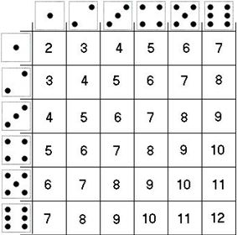
Say, for example, we roll a 4. The game doesn’t end until a 4 or a 7 is rolled so we can simplify it to the chance that a 4 is rolled given that a 4 or 7 is rolled, $P\left(4 rolled\right|4 or 7 rolled)$; We also know that $P\left(A | B\right)=\frac{P(A∩B)}{P(B)}$. Therefore, the chance of winning considering we rolled a 4 is
$$P(4 rolled)×P\left(4 rolled\right|4 or 7 rolled)=\frac{3}{36}×\frac{\frac{3}{36}}{\frac{6}{36}+\frac{3}{36}}=1/3$$
To get our overall chance of winning, we now need to add together
$$P\left(winning straight away\right)+P(4 rolled)×P\left(4 rolled\right|4 or 7 rolled)+P(5 rolled)×P\left(5 rolled\right|5 or 7 rolled)…+P(10 rolled)×P\left(10 rolled\right|10 or 7 rolled)$$
$$∴P\left(win\right)=\frac{2}{9}+\frac{1}{36}+\frac{2}{45}+\frac{25}{396}+\frac{25}{396}+\frac{2}{45}+\frac{1}{36}=\frac{244}{495}≈49.29\%$$
Repeating this process for a Don’t Come bet, we get $P\left(win\right)≈47.93\%$ but $P\left(lose\right)≈49.29\%$, not adding to 100 due to the probability of rolling a 12. Consequently, a Pass Line bet has a house advantage of 1.41% but a Don’t Come bet has a 1.36% edge, making the Don’t Come always more favourable.
However, unique to craps, there is a way of turning our house advantage to 0. Kind of. In addition to our original Don’t Come bet, we can also place “odds” bet on top of it. To avoid confusion, the odds bet is separate to our Don’t Come bet. Say we have placed a £100 bet on Don’t Come, our $expected payout=-0.0136×100=-£1.36$. However, say we additionally take a ×2 odds bet; therefore, an additional £200 bet with no house edge is placed on Don’t Come. Consequently, our expected value for the £200 bet is £0, causing a total expected payout of $-£1.36$ for a £300 total bet, meaning $house advantage=\frac{1.36}{300}=0.453\%$. Often the odds bets go up to ×10, meaning $house advantage=\frac{1.36}{1100}=0.124\%$.
Purely strategically, the optimal bet in craps is a Don’t Come maximum odds bet where our total bet matches our originally planned bet, e.g. if we were to place a £$b$ bet originally, with $×n$ odds, our flat bet,
$f+nf=b →f\left(n+1\right)=b → f=\frac{b}{n+1}$
Here, we see a method of minimising house edge, and although the casino often advertises odds bets as zero house edge, it is still paramount to remember that the total house edge is still in their favour.
Vingt-un – Blackjack
Probably the most popular game at the casino, last but not least is blackjack. A seemingly simple game compared to craps, with ironically much harder calculations, blackjack features a player pitting off against the dealer, which hands out cards one by one to the player. I could talk about blackjack strategies for this whole essay due to its complex nature so I will have to go into very little detail.
The player initially gets two cards and then repeatedly has the choice of saying hit or stand: hit meaning to receive another card and stand meaning no more cards. The goal is to get the sum of your cards as close to 21 as possible without going over. The dealer does the same, but you can only see one of his cards until you are finished, where he does the same as you. The winner is the one closest to 21.
However, there are many nuances, which make the game more complex. The dealer firstly must stand when they are past 17 or at 17. The odds are even again unless you get an ace (worth 11) and a royal (worth 10), which is called blackjack and has a payout of 6/5 (the payout was originally 3/2). Some high-value cards are also removed to give the dealer more advantage. I could keep going but mathematically, all this means is that the house advantage keeps rising. A standard game with no nuances has an approximate house advantage of 2%. However, we can see the effect of such rules below.
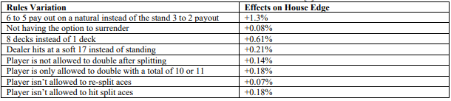
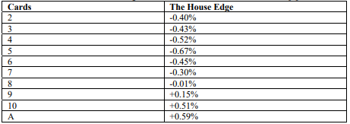
However, originally hidden in the game, but quite famous now, there is a method of creating a negative house edge – yes, negative, meaning we have the advantage. Created by MIT professor Edward Thorp in 1962, the card counting method creates a house edge of -0.5% (with one deck). The card counting method allows us to predict whether the next card will be a high card or a low card, influencing our decision to stand or hit. We do this by keeping a “running count” of the cards placed, by assigning values to each card placed. E.g. if the last few cards have gathered us a large running count, we know the next few cards will be most likely low so we can safely call.
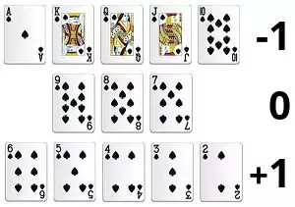
Unfortunately, as earlier said, life in not fair and after discovered, casinos increased the number of decks they play with at once to decrease the predictability of the next card. However, the house edge is still minimal and definitely an improvement over 2%.
The problem? If you are caught, you will be banned from that casino and likely other casinos forever.
The Conclusion
The lesson to take away from the maths that we have run through today is to not enter a casino, ever. But, if you must, do not consider it a way to make money sustainably as the maths says otherwise. Have fun and ironically, good luck.
Ending with another story from Nick the Greek, he was once tasked with showing Einstein (yes, Albert Einstein) around Las Vegas. After the long day, he remarked that nobody can win at roulette “unless he steals money from the table while the croupier isn’t looking.”

A Guide to Casino Maths – University of Denver
Everything you wanted to know about Craps odds bets – Anthony Haage
Probability of Winning at Craps – Dalhousie University
The sting: did gang really use a laser, phone and a computer to take the Ritz for £1.3m? – Steven Morris

