Prime Numbers: Unpredictably Predictable
By Uma Abbas 30/03/24

Introduction
2, 3, 5, 7, 11…
This particular sequence has been embedded in our brains since primary school. ‘Prime numbers. How exciting!’ These are words that I am sure you have heard before. But are they really true? What is it about prime numbers which makes your maths teacher’s eyes light up? Why are they so exciting?
In this essay, I will embark with you on a journey through the properties and patterns of prime numbers. From their origins thousands of years ago to their continuous study today, they have not only shaped the very mathematics we learn, but they have immense applications in the real world, some of which we shall explore.

The bedrock of numbers
Since ancient times, mathematicians have quested to find the incredible properties of prime numbers. In Book VII of his Elements, Euclid (an ancient Greek mathematician in around 300BC) defined a prime as a number ‘measured by a unit alone’ i.e. the only proper divisor is 1. From here, he derived several theorems which provide the basis of number theory. Some of the main propositions and proofs involving primes were:

Euclid's lemma
‘If a prime p divides the product ab of two integers a and b, then p must divide at least one of those integers a or b’.
A proof by strong induction can be used, where the symbol ‘|’ means ‘is a factor of’:
Let n|ab where n and a are coprime. We must prove n |b.
There is an integer q such that nq = ab
Without loss of generality, let n,q, a and b be positive integers (divisibility is independent of signs). Our induction hypothesis is that we suppose the theorem has been proven for all positive values below ab. There are three cases:
- If n=a, because they are coprime n=1 and so n definitely divides b
- If n<a we can rearrange nq=ab to nq-bn = ab-bn which factorises to n(q-b) = (a-n)b
Because a and n are coprime, (a-n) and n are coprime so n cannot divide (a-n) so n must divide b, a conclusion following from our induction hypothesis as 0<(a-n)b<ab
- If n>a you can similarly rearrange nq=ab to get (n-a)q = a(b-q).
By the same argument (n-a) and a are coprime. 0<a(b-q)<ab and our induction hypothesis implies (n-a) divides (b-q) which can be written as r(n-a)=(b-q) for some integer r. Therefore, ar(n-a)=a(b-q) so ar(n-a)=(n-a)q which simplifies to ar=q. Because ab=nq, and nq = n(ar), ab=nar. Dividing by a gives b=nr, which proves n|b

Fundamental theorem of arithmetic
Also known as the ‘unique factorisation theorem’ this states that any whole number can be uniquely factored into the product of primes in only one way e.g. 28 = 2 x 2 x 7 and no other decomposition exists. A proof by contradiction is as follows:

Let n = p₁p₂p₃…p_{j}…p_{k} where p₁ ≤p₂≤p₃≤…≤p_{k} and each p is prime (prime factorisation of n)
Let n = q₁q₂q₃…q_{i}…q_{m} where q₁≤q₂≤q₃≤…≤q_{m} and each q is prime (prime factorisation of n)
p₁|q₁q₂…q_{m} so p₁|q_{i} by the lemma and since p₁ and q_{i} are both prime p₁=q_{i}
Assume p₁≠q₁
q₁| p₁p₂…q_{k} so q₁|p_{j} by the lemma and since q₁ and p_{j} are both prime q₁ = p_{j}
Since p₁ ≠ q₁ and q₁ = p_{j} p₁ ≠ p_{j}
By the ordering of p’s p₁<p_{j} as they are not equal p₁<q₁
Since p₁ ≠ q₁ and p₁ = q_{i} q₁ ≠ q_{i}
By the ordering of q’s q₁ < q_{i} q₁ < p₁
So p₁<q₁ and q₁ < p₁ which is contradiction so assumption that p₁≠q₁ is false so p₁=q_{1,} which can be extended to prove p₂= q₂ and p₃= q₃ etc. therefore there is only one unique prime factorisation for any number n.

There is an infinite number of primes
Being arguably one of the most elegant proofs in all of mathematics, Euclid uses proof by contradiction to show this:
Assume there is a finite list of all primes and let this be p₁, p₂, p₃,…, p_{n}
Consider the number N obtained by multiplying all prime numbers together and adding one N = (p₁⋅p₂⋅p₃⋅…⋅p_{n})+1
N is either prime or not prime – if it is prime then we have found a new bigger prime number and the original list was not complete. If is not prime, by the lemma there is a prime which perfectly divides it. However this prime cannot be one of the known primes in the original list as dividing N by any of the known primes would give remainder 1, therefore there is a contradiction which proves the assumption that there are a finite number of primes false.

Perfect numbers
If the series 1 + 2 + 4 + 8 +…+ 2^{k} sums to a prime then the number N = 2^{k}(1 + 2 + 4 + 8 +…+ 2^{k}) must be perfect i.e. it equals the sum of its proper divisors. For example, 7 = 1 + 2 + 4 and is prime so 28 = 4(1 + 2 + 4) must be perfect (28=1+2+4+7+14).
Therefore, for centuries prime numbers have provided the building blocks for the arithmetic we know today. The more modern definition of a prime number is ‘a positive integer >1 that has no positive integer divisors other than 1 and itself’. Conversely, composite numbers are non-prime positive integers.

Patterns and properties of primes
Although the distribution of primes is random and not formulaic, over thousands of years mathematicians have uncovered many astonishing patterns and properties of prime numbers which suggests an underlying sense of regularity and perfection and has led to new discoveries in many different areas of mathematics. Here I will be focussing on the three I find most fascinating, however I encourage you to look into further patterns:

The spiral dance of primes

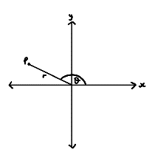
Graphing prime numbers
When you plot the primes as polar coordinates (in the form (r, θ) where r is distance from origin and θ is the angle in radians the line makes with the x-axis) where each prime p has coordinates (p,p) the distribution of these points seems quite random and disorderly at first as you would expect with their unpredictable nature. However, when you zoom out, a stunning pattern forms: 20 magnificent spirals seem to swirl around the origin to form a galactic pattern. Zooming out even more, a different, larger pattern of 280 lines (mostly in groups of 4) shoot out the origin. Despite this mesmerising beauty, there seem to be gaps in the pattern.
Figure 1: Polar coordinates
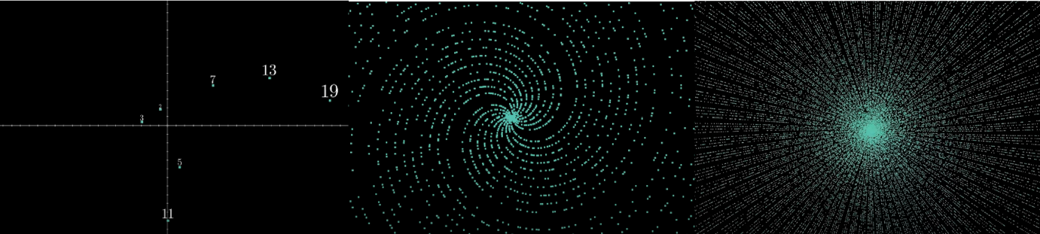
Figure 2: Three different magnifications of prime numbers plotted as polar coordinates

What is going on here?
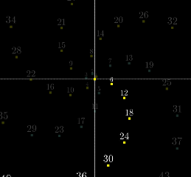
First let’s see why spirals form in the first place:
- Consider all whole numbers plotted as polar coordinates to form what is called an Archimedean Spiral.
- Zooming in, 6 little spirals appear. Each spiral corresponds to a residue class mod 6, i.e. the numbers in each class have the same remainder when divided by 6: 6k, 6k+1, 6k+2 etc.. Principally, this is because going up by 6 involves a turn of 6 radians ≈ 2π radians (a full turn) so is nearly a full turn around the origin, only slightly missing it, so points going up by 6 give the illusion of slightly curving lines.
- Even more precisely, going up by 44 is even closer to a whole number of turns as 44 radians / 2π radians = 44/2π = 7.0028… so 44 larger and less curved spirals for the 44 different residue classes mod 44 appear when you zoom out even more: Each number in the class differs by only a slight angle larger than a full turn. Interestingly, 44/22π ≈ 7 can be rearranged to say approximately π=22/7.
Figure 3: A close up of the residue class mod 6 of the form 6k
- 710 radians is even closer to a whole number of turns (710/2π=113.000009…), which can approximate pi even more accurately to π=355/113 and also means going up by 710 gives nearly the exact same angle from the origin so on an even larger scale 710 almost straight lines appear to come out of the origin.

So why are there gaps?
When limited to prime numbers only, only 2/6 little spirals remain with the forms 6k+1 and 6k+5. This is because prime numbers cannot be even (6k, 6k+2, 6k+4) or multiples of 3 (6k+3) (except 2 and 3 themselves).

For the 44 larger spirals, all even residue classes mod 44 e.g. 44k, 44k+2 etc. and multiple of 11 residue classes e.g. 44k+11, 44k+33 etc. are removed (except 2 and 11 themselves) as 2 and 11 are the prime factors of 44 so you could pull them out of the respective classes making numbers in these classes composite:
e.g. 44k+11 ≡ 11(4k+1)
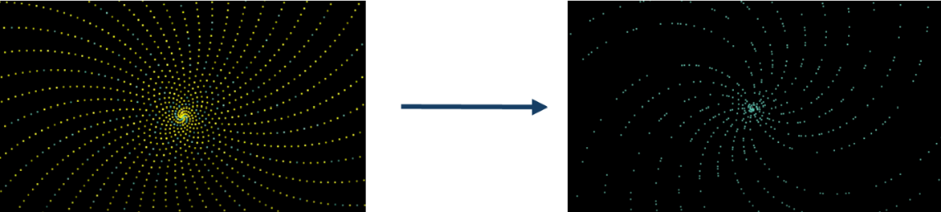
Figure 4: Before and after the 44 spirals are limited to prime numbers only

So, only spirals corresponding to residue classes that do not share any prime factors with 44 remain. There are 20 of these and they are known as coprime (i.e. greatest common divisor is 1) to 44 or Φ(44)=20 where Φ is Euler’s totient function. This new piece of notation counts the number of positive integers less than n which are coprime to n. It does this by performing the following calculation to filter out multiples of 2 and 11, the prime factors of 44:
Φ(44)= 44(1/2)(10/11) = 20
More generally:
If n=p₁^{r1}p₂^{r2}…p_{k}^{rk} where all p_{i} are distinct primes
Φ(n)=n(1-p₁)(1-p₂)…(1-p_{k})

For the 710 lines at a larger scale, when the coprime residue classes mod 710 are removed (multiples of 2, 5, 71 except these numbers themselves), only 280 lines remain as Φ(710)=280
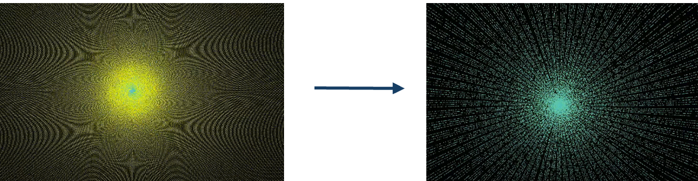
Figure 5: Before and after the 710 lines are limited to prime numbers only

Within each remaining spiral after these residue classes are removed, the prime numbers seem sporadically distributed in each spiral. Moreover, the prime numbers seem to be evenly distributed within each spiral, an observation which relates to an important idea in number theory: Dirichlet’s theorem.

Dirichlet’s theorem
‘If a and b are coprime positive integers, then there are infinitely many primes of the form na+b’.
i.e. each remaining spiral (which corresponds to a residue class mod n) will continue forever. Proven by Dirichlet in 1837. Of course, the proof itself is far too difficult to include here, involving the use of complex analysis, however more positively this theorem has practical applications in the real world such in Bayesian statistics, being a conjugate prior.

Benford’s Law
Linking closely to Dirichlet’s theorem, another astonishing pattern has been found: The distribution of the leading digit of primes can be described by a generalisation of Benford’s Law, a discovery which has applications in many areas like stock market analysis and fraud detection. Let’s take a closer look.

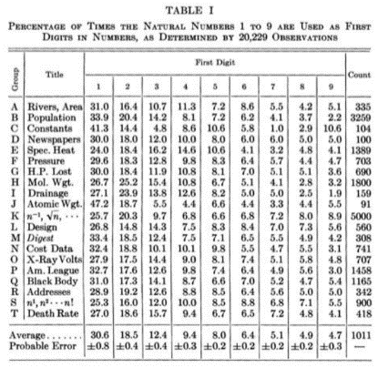
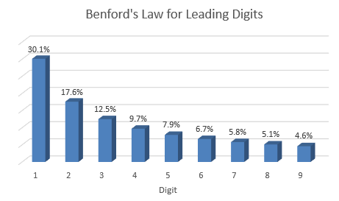
Benford’s Law (1938) describes the distribution of leading digits of numbers (1-9) in many different data sets, from the lengths of rivers to population numbers. Understandably, you might expect this to be a random or uniform distribution of 11% for each digit, since there seems no reason for it not to be. However, it is actually logarithmic, with 1 being the first digit 30% of the time, and the following digits appearing even less:
Figure 6: A graph to show the distribution of leading digits according to Benford’s Law

Figure 7: A table showing the distribution of leading digits in a range of different data sets from nature’s rivers to death rates

For decades it has been known that in very large data sets, the first digit distribution of primes is almost uniform. However, Luque and Lacasa from Spain realised that in smaller intervals of primes, there is a clear bias in this distribution; As the size of the data set increases to infinity, a uniform distribution is approached.
By analysing multiple sets of intervals [1, 10^{d}], it was observed that as d increases, the change in first digit distribution of primes became more uniform and seemed to follow a size-dependent Generalised Benford’s Law (GBL), a more flexible model which is distinctly characterised by one parameter - the power-law exponent – which can be applied to a range of data sets like stock market prices to prime numbers. In 2009, Luque and Lacasa showed that there is a parameter value for which this adapted model fits the first digit distribution of primes with incredible accuracy. The model also describes the trend of the distribution becoming more uniform as d increases.
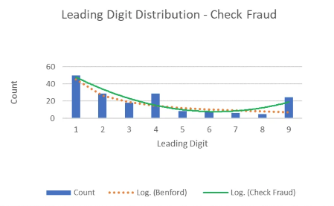
From this single discovery about prime numbers, several applications have arose: Other sequences which did not follow Benford’s Law but could follow GBL were able to be identified, and applications from Benford’s Law could also be generalised for GBL in fraud detection:
Whilst leading digits in naturally generated data in financial records, tax returns and decision-making documents obey Benford’s Law, fraudulent data does not since people falsifying data do not usually track the frequencies of the fake leading digits producing an unnatural distribution.
Figure 8: A graph to show the difference in first digit distribution in natural vs falsified hypothetical ledger data

Twin prime conjecture
‘Twin primes’ are pairs of primes that differ by 2, such as (3,5), (5,7), (29,31) etc.. As numbers get larger, gaps between primes get larger so twin primes occur less frequently. The conjecture states that there are infinitely many twin primes, and that there exists every possible gap between them. Intuitively, the random distribution of primes suggests this to be true, however despite substantial progress in this proof, it remains unsolved. One notable idea is that computational evidence shows that the distribution of twin primes seems to follow a pattern known as the Hardy-Littlewood conjecture, however this has also not been proven yet. Whilst the study of these enigmatic pairs seems quite theoretical, it actually has practical applications in cryptography to generate secure encryption keys (more on this in part 4)

Further Applications of primes
By exploring only a few of the many patterns that prime numbers create, it is clear that these discoveries can offer a range of applications in other areas of maths as well as in real world scenarios. Another more direct application of primes is in cryptography:
- RSA encryption involves scrambling secret coded messages that can only be unscrambled by the receiver and no one else who might intercept them, which usually requires a key for scrambling which the receiver uses in reverse to unscramble, making the key the weak link in data security if it were to end up in the wrong hands.
- To combat this, in 1976, the Diffie-Hellman key-exchange protocol was invented, based on the fact that it is difficult to calculate the discrete logarithm modulo a large prime number p, that is finding z from g^{z} mod p. For example, let the two parties trying to communicate be Jen and Bob. They first agree on the prime modulus p and primitive element g. Jen then picks a random number x and sends a=gx modp to Bob and likewise Bob picks a random number y and sends b=gy modp to Jen. Bob computes a^{y} mod p = g^{xy} mod p and Jen computes b^{x} mod p=g^{xy}mod p so that they both have the key: the value of g^{xy} mod p. This cannot be computationally solved by the attacker, protecting the data, however the only downfall to this method is it is subject to vulnerability when exchanging the numbers x and y.
- In 1977 Rivest, Shamir and Adleman discovered a different way primes could be used in RSA encryption: A public key could be easily made by you taking 2 large prime numbers, each containing up to 80 digits, and multiplying them together to form a larger non-prime number which can only be broken down into the 2 original primes (and 1 and itself) . This makes the scrambling process easy as only knowledge of the large non-prime number is required, which could be published for anyone to send encrypted messages, however the unscrambling process would be nearly impossible without knowledge of the two original primes, which only you would know. Even the world’s most powerful computers would take years to find the large prime factors, which by that point would be useless as the key would have been changed, making it almost impossible to decode the encrypted data.

Conclusion
In the vast entirety of mathematics, prime numbers represent the most pure and profound beauty and complexity that numbers can possess: Their seemingly random properties and remarkable patterns have captivated mathematicians for centuries; I believe it is their element of unpredictability that adds to the allure, sending mathematicians off on a journey in attempt to understand these enigmas. From providing the building blocks of number theory to having significant practical applications in the real world, these humble numbers are a constant rendition of grandeur in the mathematical world.
To be able to convey their sheer importance and supremacy in one essay would be an impossible task: From having strong ties to the Riemann Hypothesis, one of the most famous unsolved maths problems, to closely linking to the Fibonacci sequence and the natural world, there are endless more paths to traverse in pursuit of these numbers. Having only voyaged through a few of these, I hope I was able to impart my passion for primes and their incredible applications to you. They can appear in the most unexpected places so always be on the lookout; Whilst your journey of understanding primes, like many others, may not have a destination in sight, the views along the way are simply unparalleled.

Bibliography
- Štefan Porubský: Basic Properties of Primes, 2009 BasicPropertiesPrimes (cas.cz)
- William Dunham Number theory - Euclid, Prime Numbers, Divisibility | Britannica
- D. Lazard, 2024 Euclid's lemma - Wikipedia
- W. Rose, 2021 Discrete Math - Proof of Uniqueness of Prime Factorization (youtube.com)
- S.Hugtenburg 2.4: Proof by Contradiction - Engineering LibreTexts
- Simon Singh, 1997, Fermat’s Last Theorem pg 100, 101, 104, 105
- 2024, Prime number patterns: Discovering Intriguing Patterns in Prime Numbers - FasterCapital
- 3blue1brown, 2019 Why do prime numbers make these spirals? | Dirichlet’s theorem and pi approximations - YouTube for figures 2,3,4 and 5 and part 3.1.
- M.Penn 2019, Number Theory | A Formula for Euler's Totient Function (youtube.com)
- B.Whitfield, 2023The Dirichlet Distribution: What Is It and Why Is It Useful? | Built In
- L.Zyga, 2009New Pattern Found in Prime Numbers (phys.org)
- L.Barabesi and L. Pratelli, 2020On the Generalized Benford law - ScienceDirect
- J.Frost Benford’s Law Explained with Examples - Statistics By Jim for figure 6 and 7
- E. Kessel 2020 Benford's Law: Potential Applications for Insider Threat Detection (cmu.edu) for figure 8
- R.Wright 2007Diffie-Hellman Key Exchange - an overview | ScienceDirect Topics
- 2023, Explained: Why are mathematicians obsessed with prime numbers? - Times of India (indiatimes.com)

