The chaos theory- Alisha Angra

Introduction
“Does the flap of a butterfly’s wings set off a tornado in Texas?”
Most of us will have heard of the butterfly effect, the idea that something as insignificant as the flap of a butterfly’s wings can change the course of history. It has become a phrase that we use regularly in our daily lives to signify how our small actions could impact us for the rest of our life. The term “the butterfly effect” comes from the quote above. It was the title, chosen by Philip Merilees, for a talk presented by Edward Norton Lorenz at a meeting for the Advancement of Science in Washington in 1972. But who was Edward Lorenz and what did he do?

Edward Lorenz
Lorenz was an American meteorologist from MIT who was the original discoverer of the chaos theory. It all stemmed from a time in 1963 when Lorenz made a computer simulation to investigate atmospheric convection using the Navier-Stokes equations. He did this with 12 equations that consisted of 12 variables (like temperature, pressure, humidity, etc…) and the computer printed out each time step as a row of the 12 variables- this allowed him to see how the variables changed over time. However, what is interesting is that when Lorenz redid a run of this (from halfway through his previous printout), the result of this printout was completely different to the previous one as it showed a vastly different state of the atmosphere (shown in figure 1 and 2).

(Figure 1)

(Figure 2)
The reason for this was that the computer calculated these figures to 6 decimal places (figure 1), whereas the printer truncated the initial conditions at 3 decimal places. This shows us that even the difference of less than 1/1000th can create completely different results. We now know that the reason that the tiniest change in the initial values created such a disproportionate big difference in the state of the variables after a short period of time was because the system was chaotic.

The Lorenz system
Lorenz was astonished by this result, so he simplified his simulation to only have 3 variables by borrowing a set of 7 convective fluid motion equations from a colleague, and then eliminating 4 equations (as 4 components went to 0). But he still wanted to make sure that the equations displayed the feature of sensitive dependence on initial conditions so he could study this more deeply. He came up with these 3 equations (figure 3).
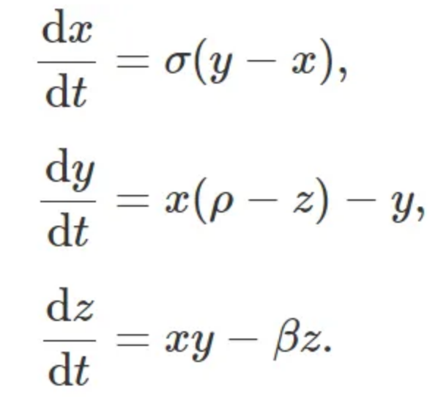

(Figure 3-The Lorenz System)
The model (figure 3) is known as the Lorenz System. It describes convection cycles in the atmosphere in a more simplified matter as they model a single thin layer of fluid being uniformly heated from above and below. The 3 time evolving variables x,y and z represent the convective flow, the horizontal temperature distribution and the vertical temperature distribution respectively. While, the 3 parameters describing the character of the model itself, σ(sigma), ρ(rho), and β(beta), represent the ratio of fluid viscosity to its thermal conductivity, the difference in temperatures between the top and bottom of the system and the ratio of the width to height of the box holding the system(respectively). So, what are some of the properties of these equations? So firstly, these differential equations are autonomous because the independent variable time(t) only appears in the derivatives on the LHS of the equation and not the RHS. They are nonlinear because of the two nonlinearities xy and xz. But they are also deterministic i.e. if we input the exact same initial conditions, we will get exactly the same result meaning that the results are not random.
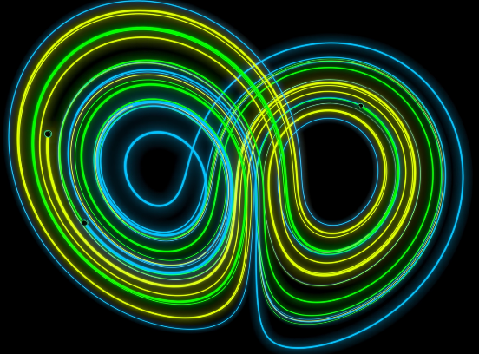
Now let’s input σ=10, ρ=28, and β=8/3- the values that Lorenz used:
In this model (figure 4), even though the 3 starting states are very closely spaced, as t increases, their trajectories initially start off closely together but very soon start diverging off massively. This shows the sensitive dependence on initial conditions, and we can say figure 4 shows a chaotic result.

(Figure 4- The Lorenz attractor)
Chaos theory
Even though there is no universally accepted definition for the term “chaos”, Lorenz went on to summarize it as “When the present determines the future, but the approximate present does not approximately determinate the future”. Generally, there are 3 conditions that anything that is chaotic will follow:
- Aperiodic long-term behaviour: as time(t) approaches infinity, the trajectories don’t settle down to fixed points or any periodic orbits.
- Deterministic- as mentioned before the system has no random inputs or parameters and its irregular behaviour is only a result of the equation’s non-linearity.
- Sensitive dependence on initial conditions: the trajectories diverge exponentially rapidly even with initial nearby trajectories.

Now we know that the Lorenz attractor is chaotic, and it is important to note the values that he chose for σ, ρ, and β- 10, 28 and 8/3.

Lorenz Attractor as strange
To gain information from the systems that nonlinear equations form, we make a “phase space”, where we plot the values of one variable against the corresponding values of another variable. The initial values assigned to each variable are used to approximate new values for the variables an instance in time later and this process is iterated. The plotted points in the phase space form the trajectories. These trajectories will always evolve with time to towards a specific region in the phase space called an “attractor”.

When a system is non chaotic, the attractor will have one of several well-defined geometrical shapes. This makes the system predicable as it will end up a certain way no matter what- almost suggesting inevitability. For example, let us use a pendulum. The pendulum at rest represents a “fixed-point attractor” as the state of rest has attracted the system due to gravity and friction. However, when a system is chaotic, its trajectories evolve towards a “strange attractor”. Strange attractors are irregular and complex in shape and take a variety of forms. The reason this happens is because no point in the phase space is visited more than once by the same trajectory. Otherwise, the trajectory would travel in a predicable way. Another important point is that no two trajectories with the same parameters will intersect as if they did they would merge onto the same path- giving 2 different sets of initial conditions the same outcome (this would completely disprove everything!). Let’s now use a 2-D phase space to represent figure 3 with the parameters that Lorenz used (σ=10 ρ=28 and β= 8/3)
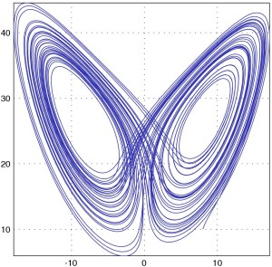
It is completely coincidental that this phase space plot (figure 5) resembles a butterfly as it had nothing to do with the term “the butterfly effect”. However, it is interesting as the trajectory will visit an infinite number of points in the phase space as time(t) increases and the phase space will have an infinite number of trajectories. The trajectories are curves which are 1-Dimensional but as you zoom into the Lorenz attractor, there will always be more and more trajectories. The plot is made of infinitely long curves in the finite space of the phase space which means they show a fractal trend and start to fill up higher dimensions. The dimension of the Lorenz attractor is actually in between 2-D and 3-D with a dimension of approximately 2.06.
(Figure 5)
Conclusion
Going back to the start of this essay, the term “The butterfly effect” is what initially made me interested in this topic of chaos as it is a phrase I use so regularly, and I never realised how deep the theory behind it was. It was very exciting to learn about Edward Lorenz and the Chaos Theory.

