Topic:Essence of calculus
We always heard people say math is boring and does not feel joyful when doing it.Why this is happen?Should people just accept that some people are gifted in some particular field?As an instance,some who like calculate money tend to accountancy fields.Does that mean people who does not like calculation bad at accountancy?The answer is quite complex than you think.We observe people who had passion always keep up the pace and extremely love what they are doing.In other word,passion is the key for someone to be able to be good at some proficiency.If it does the key,why some student hate math and does passion can overcome hatred?
We all have learn from in elementary about simple arithmetic like addition,subtraction and others but mathematic become more harder as our life goes on.After we learn about that we learn about algebra which quite hard at first because student does not has a strong foundation in simple arithmetic.If student can not do simple arithmetic how can they learn more abstract topic such as calculus,linear algebra and real analysis which belong to higher mathematic.If someone want to be good at some subject they must have a good foundation.If foundation became fragile,all things after that became much harder hence student will be clueless with what their doing.Lets not beating around the bush to long and jump up to calculus.
What is calculus?Calculus is a concept where we study a rate of change some object.It been divided into two main concept.The first is derivative and second integral.To begin with,lets talk about the derivative.What is derivative?This is vital question that has been asked by student when they take calculus course.First to understand derivative we need to understand what is slope?Slope is how much y change at the same time x also change.Slope formula as far as we all know m=rise/run.It can be interprete as m=(y2-y1)/(x2-x1).Y2-Y1 can be decipher or read as different in y which mean dy.X2-X1 also read as different in x mean dx.So we get the idea here!
Slope=m.At the same time m =dy/dx mean (y2-y1)/(x2-x1).Hope that not hard to understand because that is the main idea of this concept.Lets imagine an easy and simple graph y=2x.We know at this graph all point will give us m=2 mean slope is always 2.Take 2 point A(1,2) and B(0.9,1.8).I purposely take 0.9 because it is close to 1.Lets find the slope.m=dy/dx so
m=(2-1.8)/(1-0.9).Guess what?!!Our slope is 2.This means as our point B approach point A.Approaching like 0.9999… our slope will be 2.That the idea of derivative!Some point approaching another point to get the slope.
Now that a derivative a slope!!Lets take another graph y=xsquare.Take our idea before.Take two point A(3,9) and B(2.9,8.41).m=(9-8.41)/(3-2.9).Guess what?!!m=5.9 .If get closer to point a means 2.99999 we get the slope is just 6.Compare to our usual power rule derivative formula.
y=xsquare.Dy/dx=2x.This thing we called slope funtions for this graph.If we want to find slope,we just plug in the x number.dy/dx=2(3).Looks!!We get dy/dx=6 means slope at that point is 6.Tadaa!!Interesting idea.This is what newton discover but I make it to more like our language rather than mathematic way to grasp the idea for our understanding.Same for higher dimension like directional derivatives.Same idea but different circumstances.That conclude the first concept of what is derivatives.
Lets enter another concept the integral.This part will really get long that derivatives,It is okay to not understand it at first glance.
Integral to find an area:Let consider a graph y=4 and x=4.We get rectangle.To find the area we use length times width.4x4=16.So area is 16.But the fun is just about to began lets use integral.Integral of y=4 is 4x evaluate from 0 to 4.We get 4(4)-4(0)=16.We arrive at same answer.This means integral does give us area under the curve.Below is how we can calculate it in normal way and calculus way.
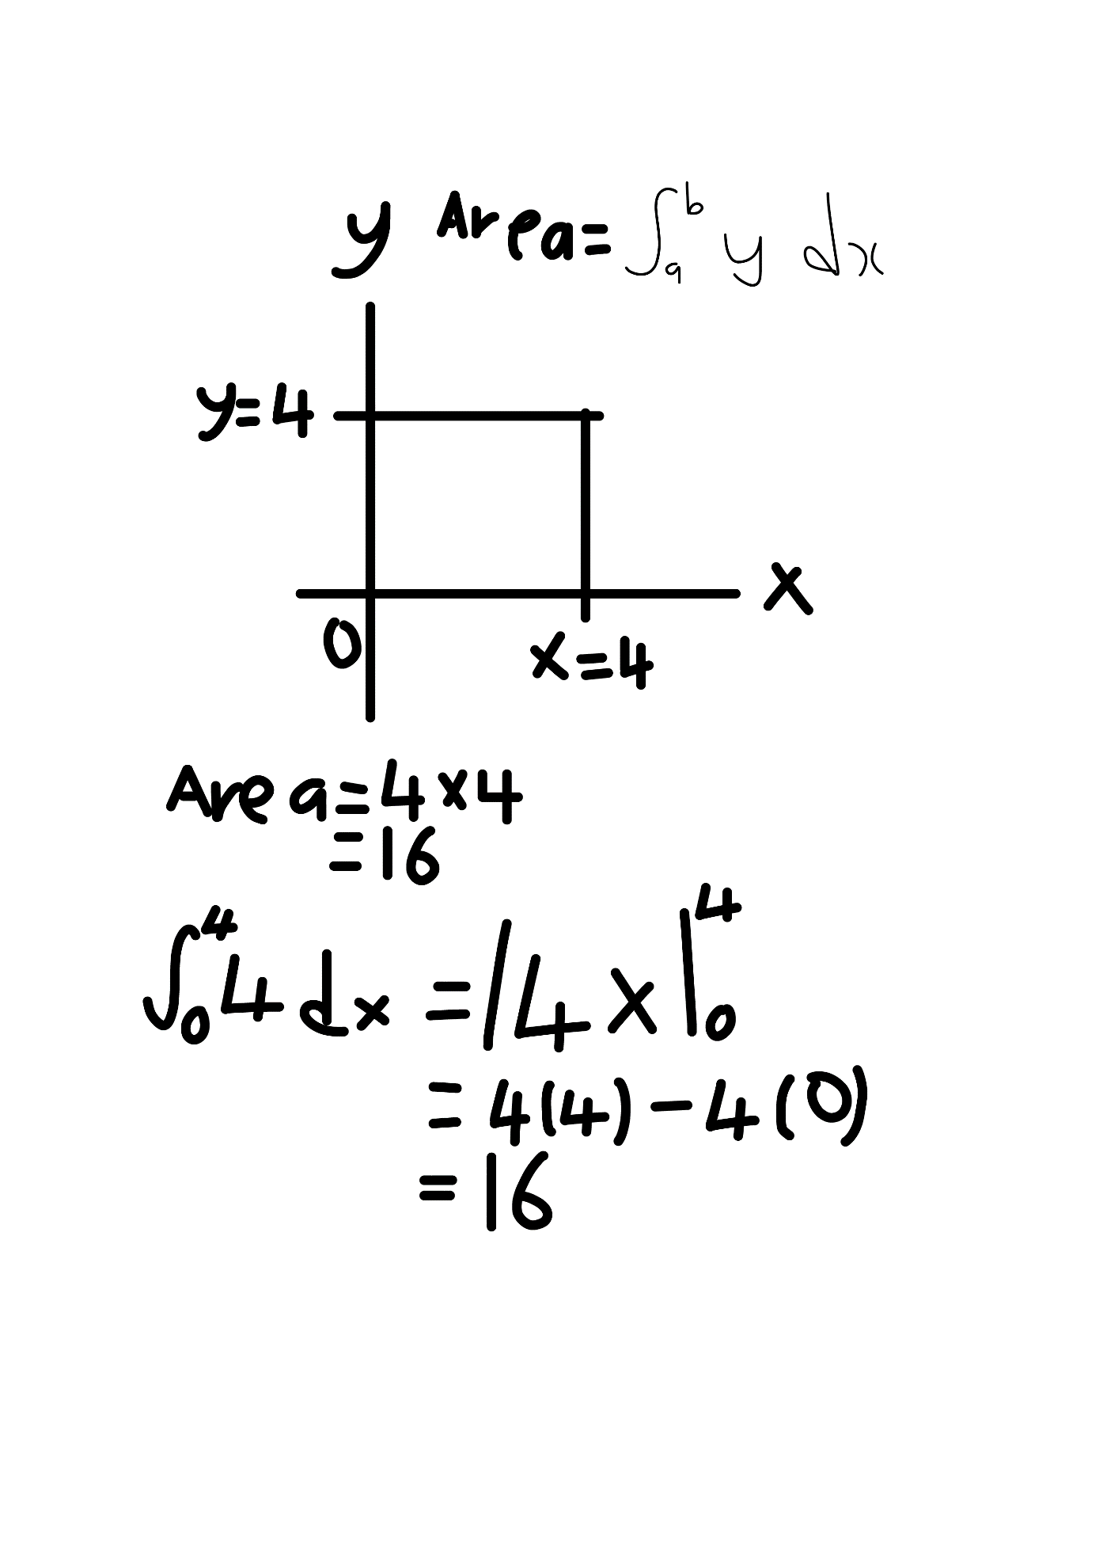

Integral for volume:It will give us volume of some object.Let take graph y=x.Using integral formula for volume ysquare=xsquare.Lets do the integral from 0 to 4 pi xsquare we will get 64/3 pi.Use another method V=1/3pi rsquare h which means our object is a cone.We arrive at same answer 64/3pi.This gives us good intuition to prove that integration is logic concept.Powerful tool for finding area and volume of some object.Thanks Newton and Leibniz.

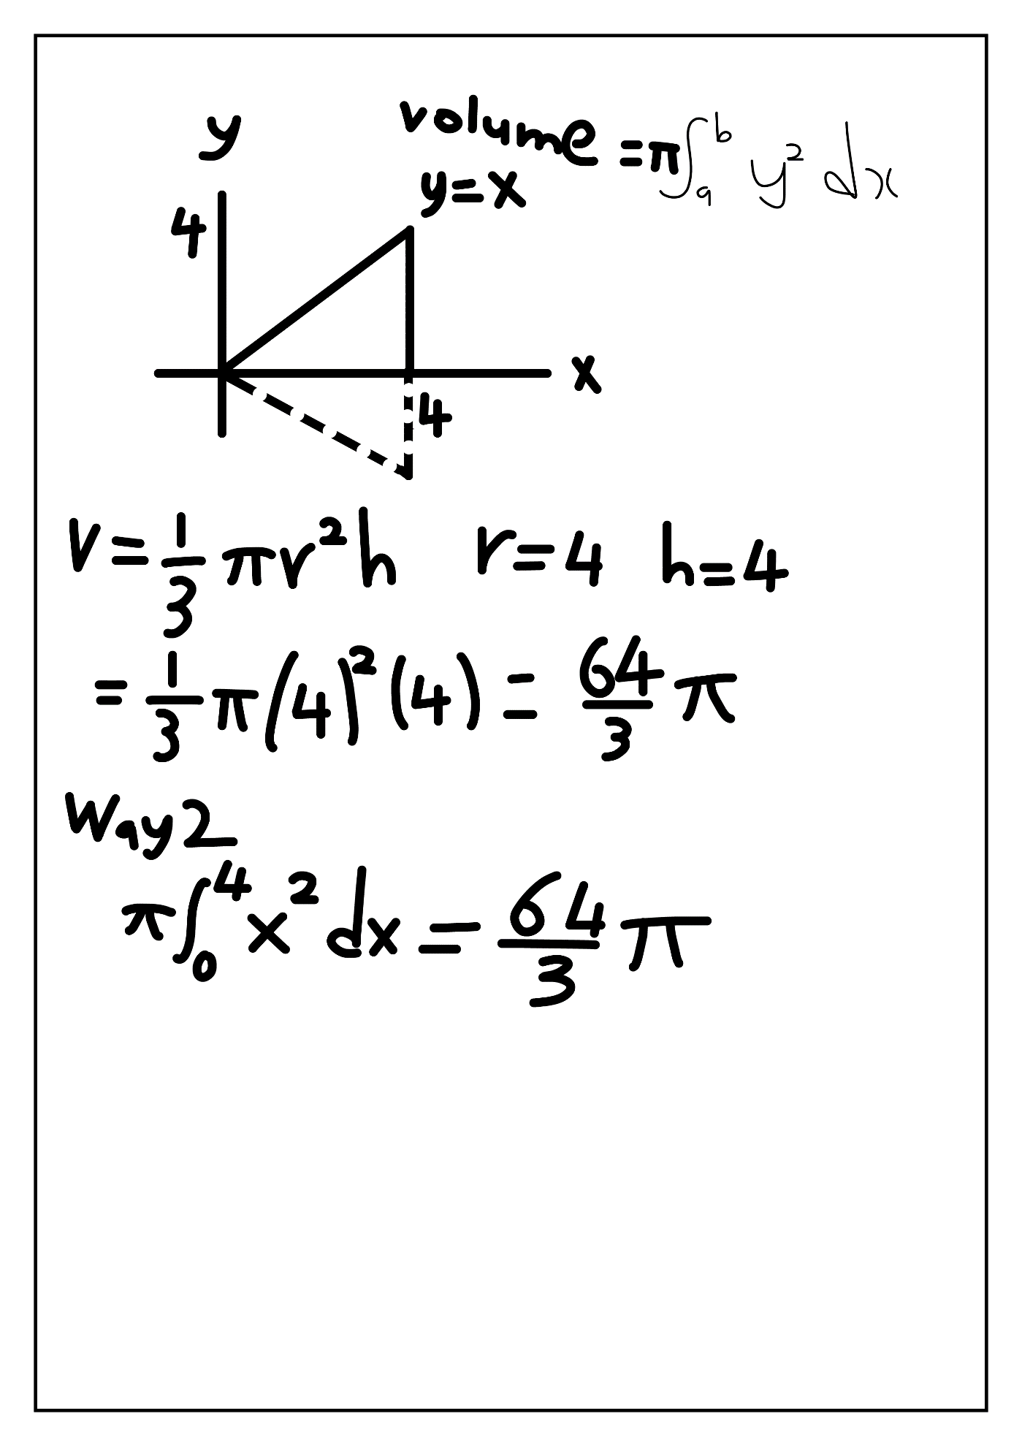
Integral for finding arc length:Consider graph y=4x/3.Using the formula of arc length finding the derivative first dy/dx=4/3.Then you use the formula of arc length integral from 0 to 3 we will get 5.There exist another method we can use to find arc length of this graph since this graph is triangle.When there is right triangle,pythagoras will become our tool.Base of this triangle is 3 and height is 4.Using pythagoras theorem we will get hypotenuse is 5.We get same answer.See below image for intuition.
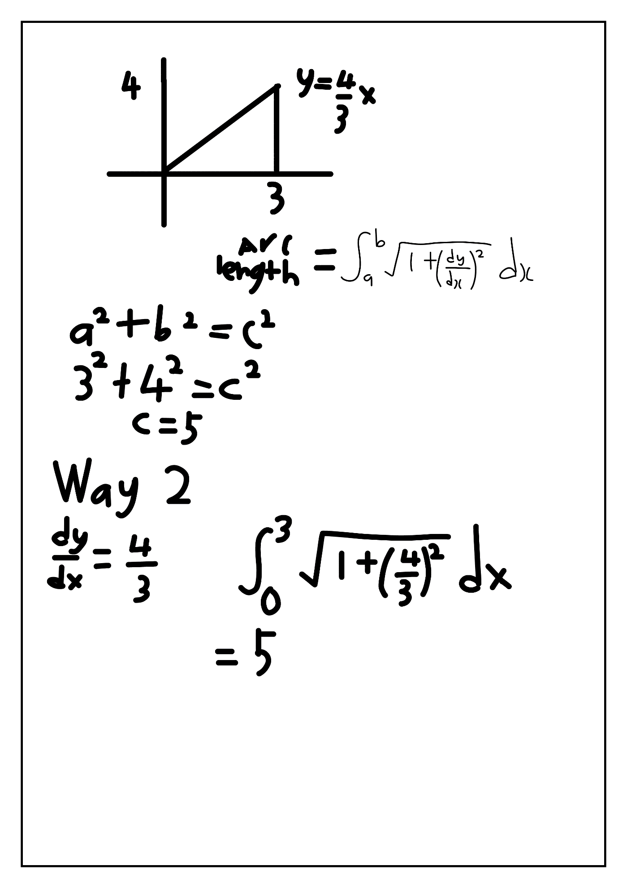
All of above is the prove that calculus was logical and makes senses to us especialy for beginner to grasp the idea of what happening behind calculus formula.For your information,I actually has study calculus approximately for 3 years since I was 16 years old.I felt that time I hate calculus so much because I don’t understand what happening behind.But I found your channel tom math and also 3blue 1 Brown.It really help me a lot to understand calculus more precise.Because now if you understand calculus,automaticly you had strong foundation in algebra.I honestly skip some of algebra part when I was 16 years old.There exist a gap in my knowledge about mathematic such as arithmetic and basic algebra.Let me also share with you how I learn calculus.I using a technique call feynman technique.This technique consist of 4 cycle of learning.This technique reject the rote of memorization.First cycle is select a concept to learn.For me I choose calculus topic to learn due to the fact that it is the hardest concept to learn.Once you think you had understand the topic lets jump up to second cycle.Second cycle is teach it to the child.I know it is a bizzare that this technique teach us to teach a kid around 12 years old.But this is the reality for understanding something.If you cannot make child of 12 years old,how you manage to understand it for yourself?I personally teach my little sister calculus with language they can digest.Next cycle is review and refine.If the explanation not simple enough this indicate you to reflect and refine your understanding.Go back to your source and material the part you don’t understand.Last but not least,organize and review.When you happy with the result that kid also can get the idea,this means your understanding had become more strong.This is where you need to sum up all of your understanding in one book or paper.This is the thing help me out to create and understand the fundamental theorem of calculus.Before end this essay let me show you the derivative intuition that I forgot to place earlier.

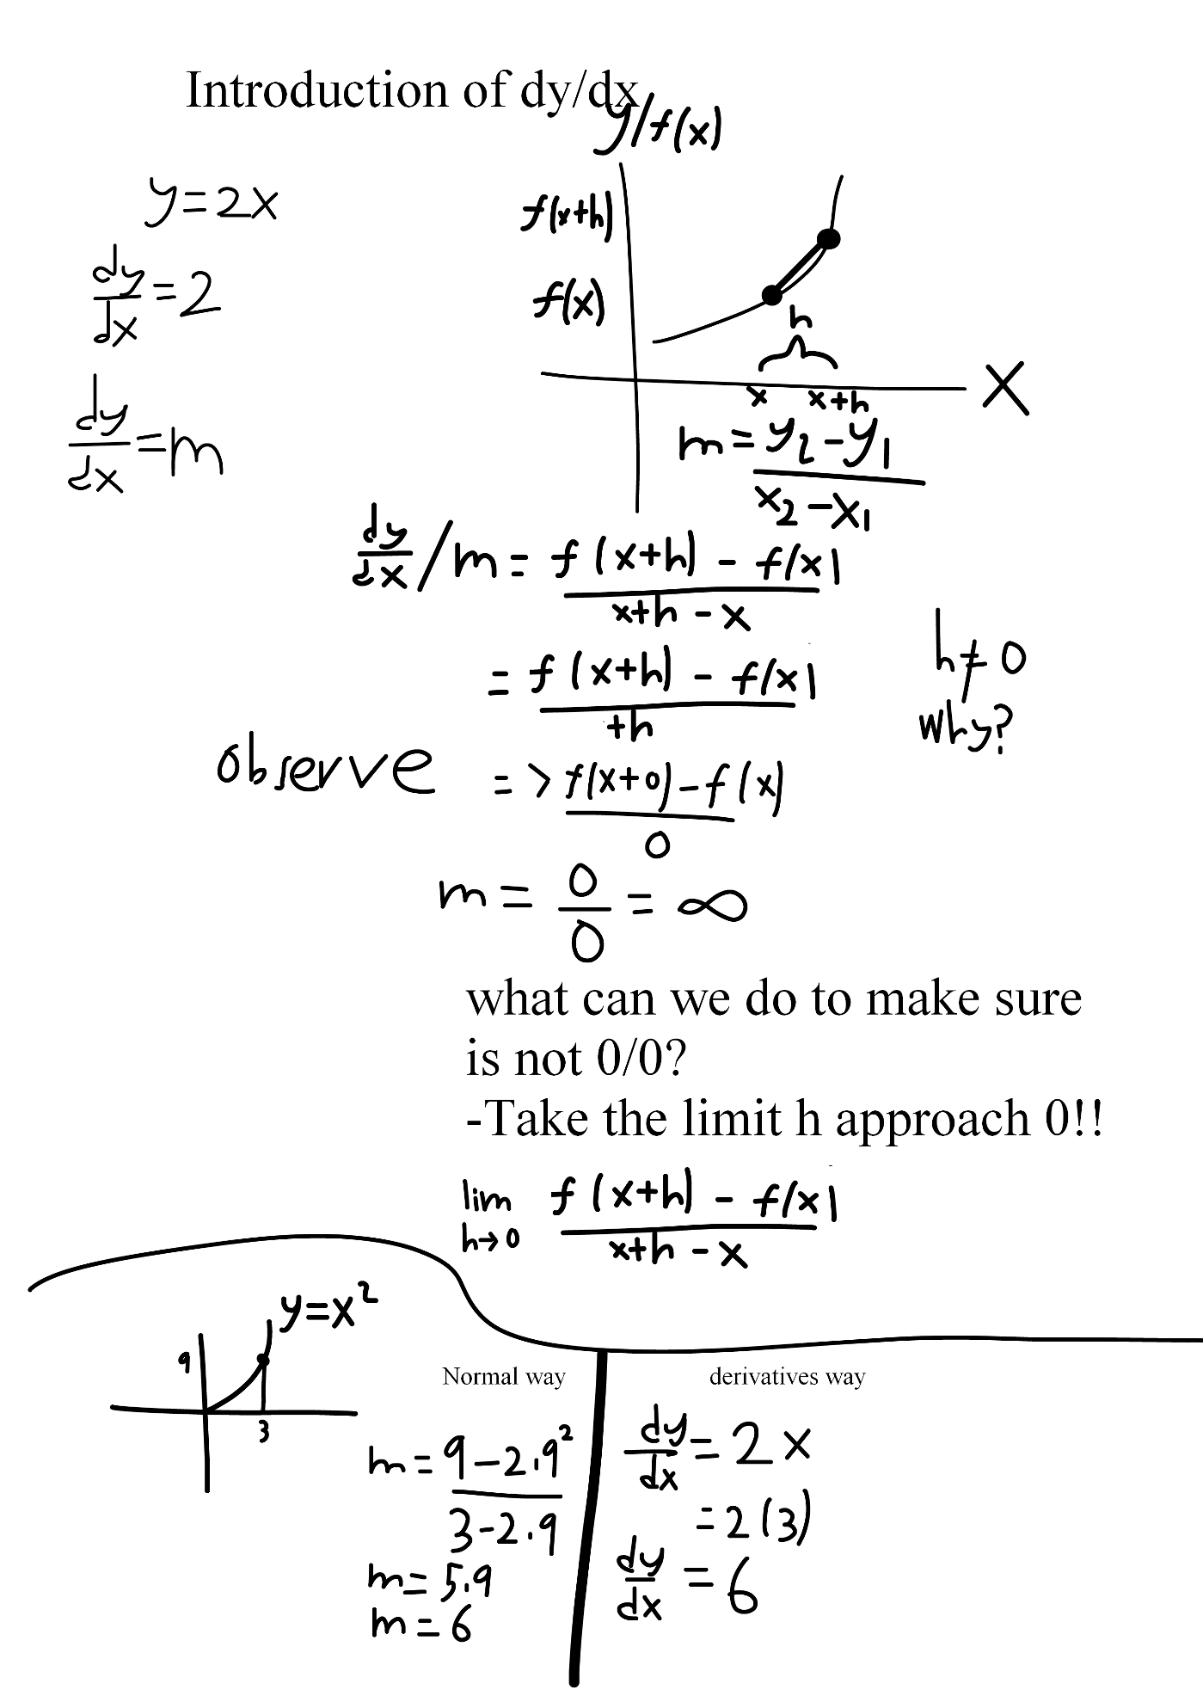
To sum up and In a nutshell,calculus is my favourite topic because it change our perspective of some complex graph for finding area,slope,volume and arc length .Fundamentaly it just normal topic if you had strong algebra,geometry and passion.Understanding is better than memorizing.


-Everyone can make thing complex but only some people manage to simplify the idea-

