Graph theory

Graph theory is the branch of mathematics that deals with the study of graphs. In the context of graph theory, graphs are made up of vertices (or nodes or points) and edges (or lines, links or arcs) that connect the vertices. In this essay I will explore 4 famous problems in graph theory as well as the applications of graph theory.

Famous problems
Four colour theorem:
The four colour theorem states that no more than four colors are needed to colour all the regions of any map so that no two adjacent regions are the same color. The conjecture was first proposed on October 23, 1852 and was proved by Kenneth Appel and Wolfgang Haken in 1976.

An example of this is a map of the USA:
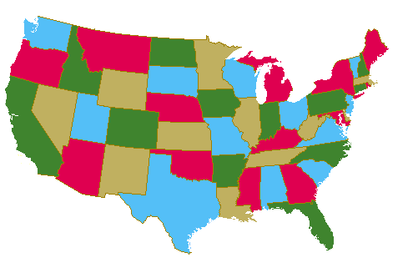
https://thomas.math.gatech.edu/FC/fourcolor.html
To prove the four colour theorem, a map can be converted into the form of a planar graph where each region of the map is represented by a vertex and the edges connecting two vertices shows that the two vertices are adjacent. For example, the planar graph of the map of the USA would be:
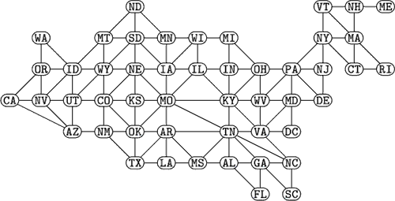
https://mathworld.wolfram.com/ContiguousUSAGraph.html

Appel and Haken made a list of 1834 networks (later reduced to 1482) that every map could be simplified to. They then checked these networks using a computer to show that each of these networks could be colored with only 4 colors, thus proving the four colour theorem.

Seven Bridges of Konigsberg:
The city of Königsberg was situated on the Pregel River and consisted of two large islands connected to each other and the mainland by seven bridges.

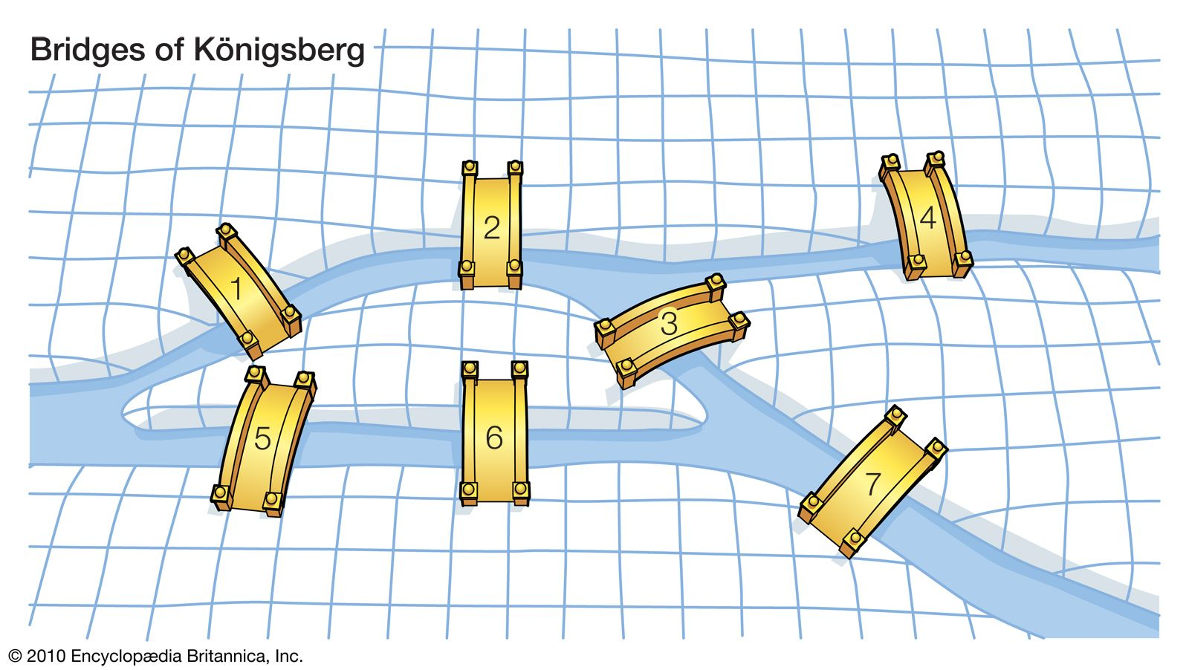
https://www.britannica.com/topic/graph-theory
The problem of the Seven Bridges of Konigsberg was to determine if it was possible to walk through the city of Konigsberg and cross each of the seven bridges only once. Euler proved that it was not possible to do this.
To prove this is not possible, the city can be mapped onto a graph with the vertices of the graph representing the land and the edges representing the bridges as seen below where a) is the original map and b) is the graph.

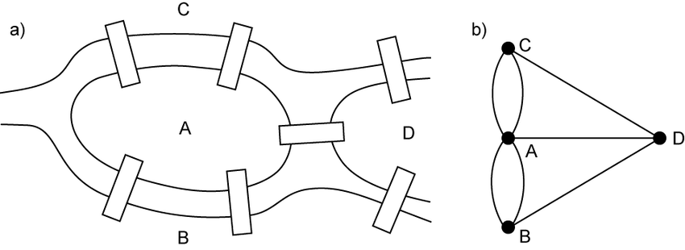
https://www.researchgate.net/figure/The-Koenigsberg-bridge-problem-a-seven-bridges-of-Koenigsberg-b-graph-representation_fig3_265219734

For a path to exist where each edge is only passed through once (also called a Euler path), there must be an even number of edges touching each vertex (the degree of the node must be even). For example:
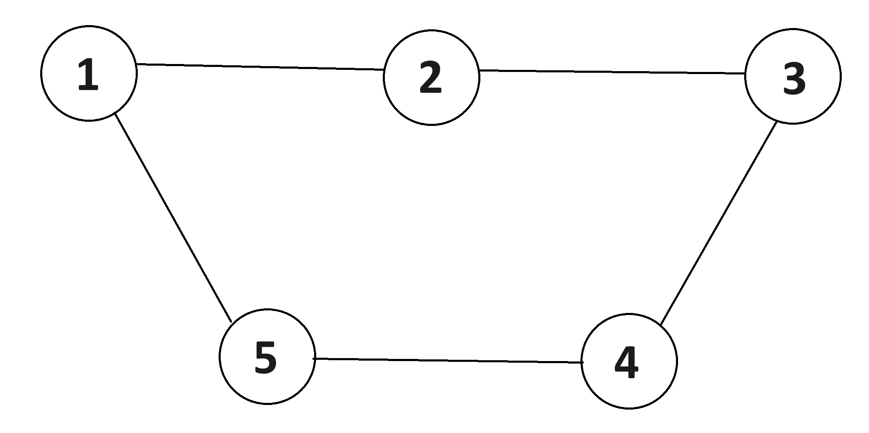
In this case each node (represented by circles) are connected to two edges meaning the degree of the node is even. This means that a Eulers path does exist (for example, going from node 1 to 2 to 3 to 4 to 5 to 1) means every edge will be passed through once.

However in the case of the Seven Bridges of Konigsberg, the degree of the nodes are all odd as each vertex has an odd number of edges touching it (1 vertex touches 5 edges and the other 3 vertices touches 3 edges) meaning that it is not possible for a path to exist where each edge is passed through only once.

The art gallery problem:
The art gallery problem is as follows : In an art gallery, what is the minimum number of guards who together can observe the whole gallery? The guards can rotate, but they cant move from their position.

For an art gallery with n number of walls, the solution is that n/3 guards are always sufficient and sometimes necessary to guard the art gallery. This is called Chvátal's art gallery theorem.

To prove this theorem the floor plan of the art gallery is first modelled as a polygon. For example:
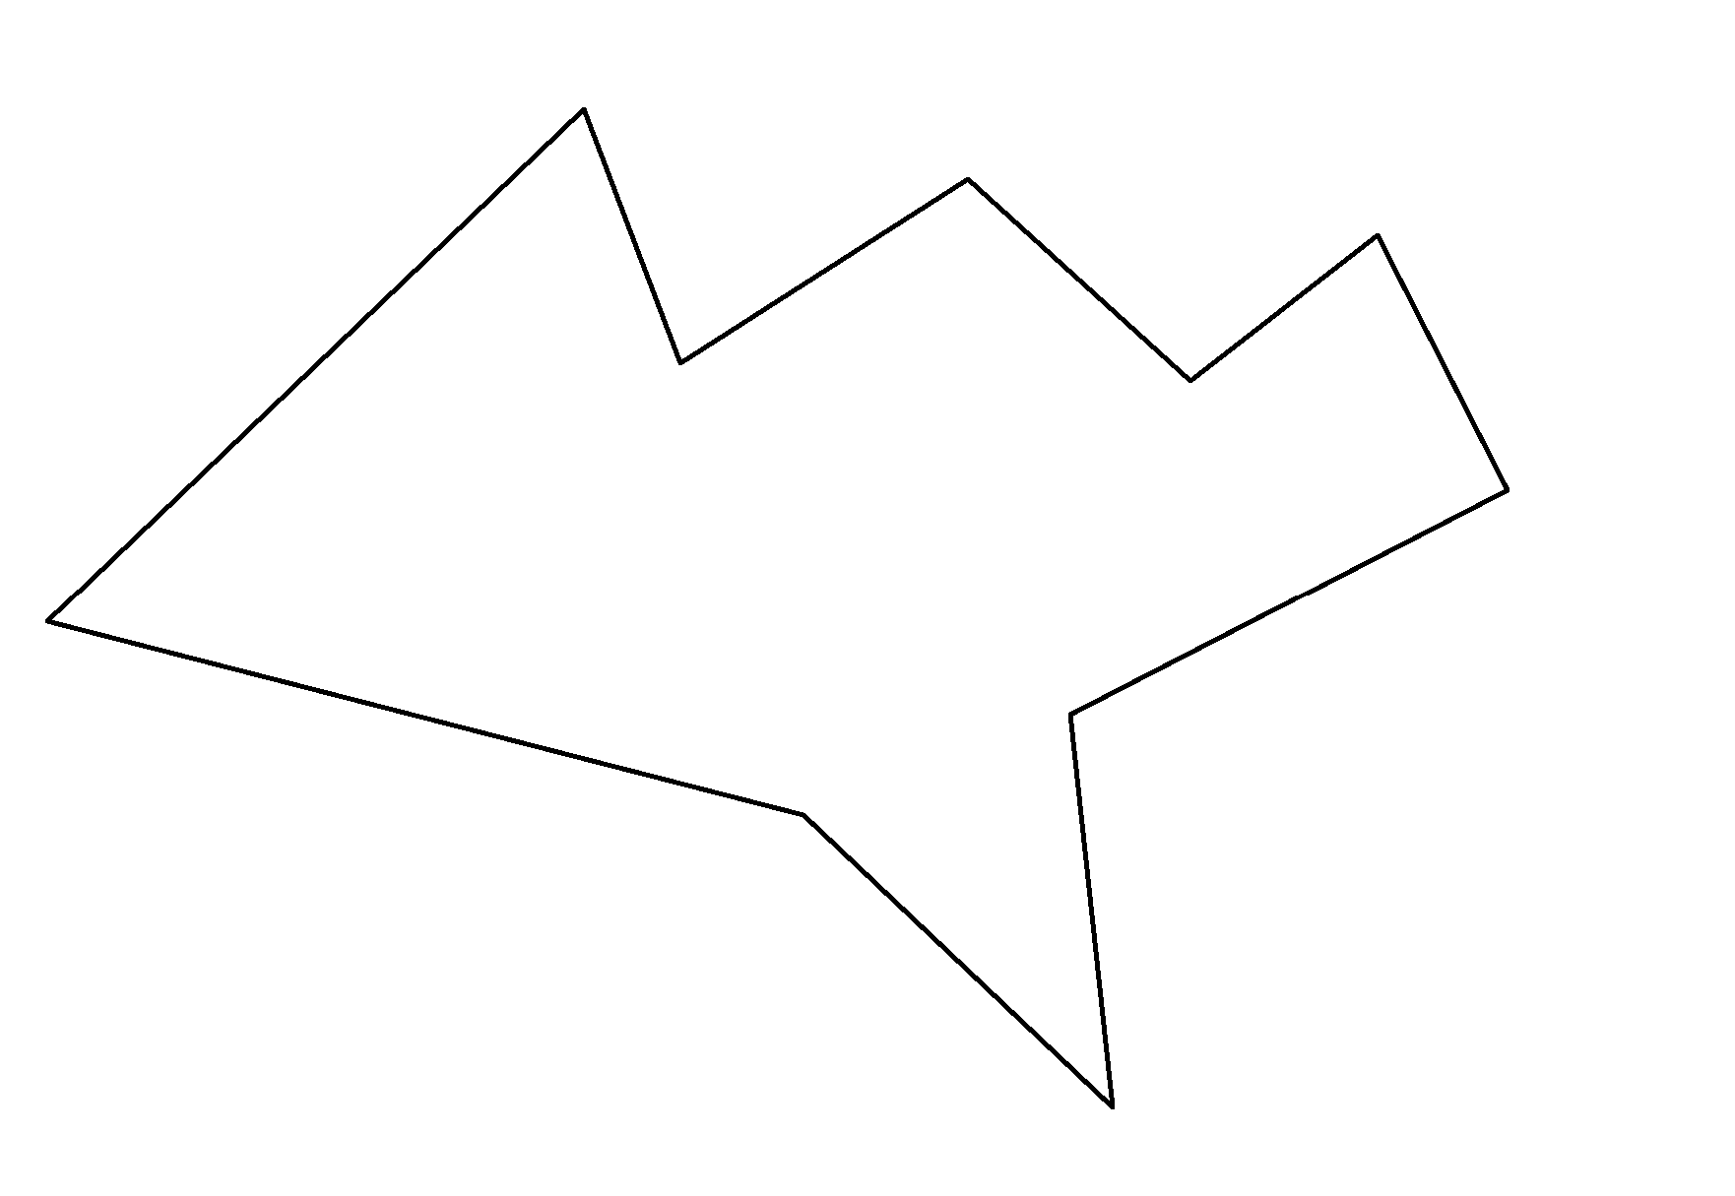
The polygon can then be triangulated as shown below: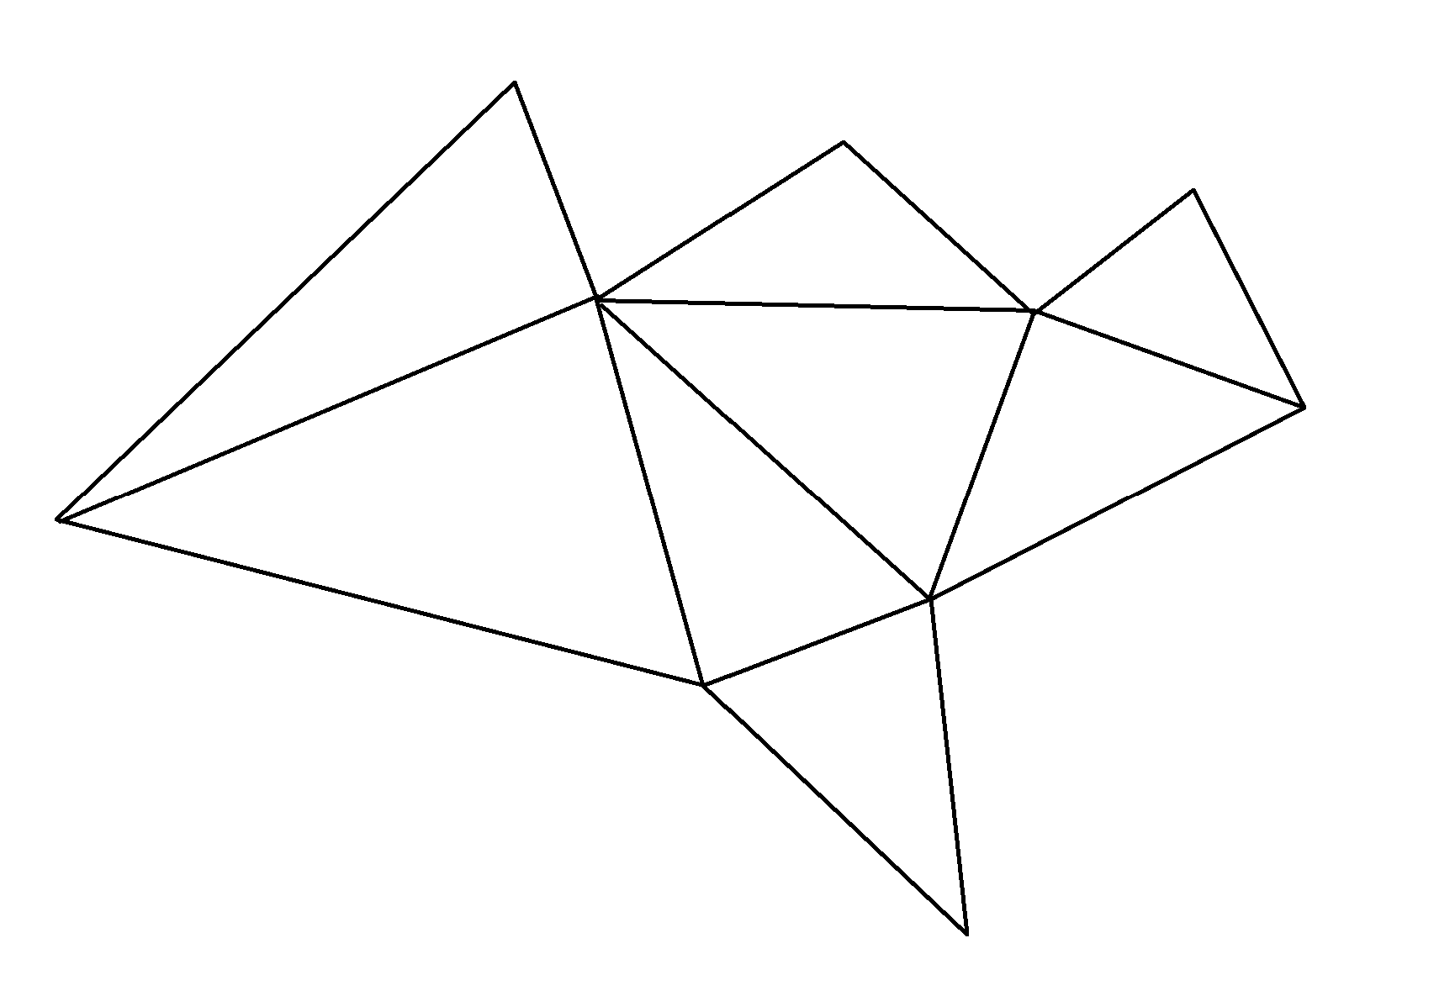
The polygon is then mapped onto a graph where each vertex represents a corner of each of the triangles formed by the triangulation.

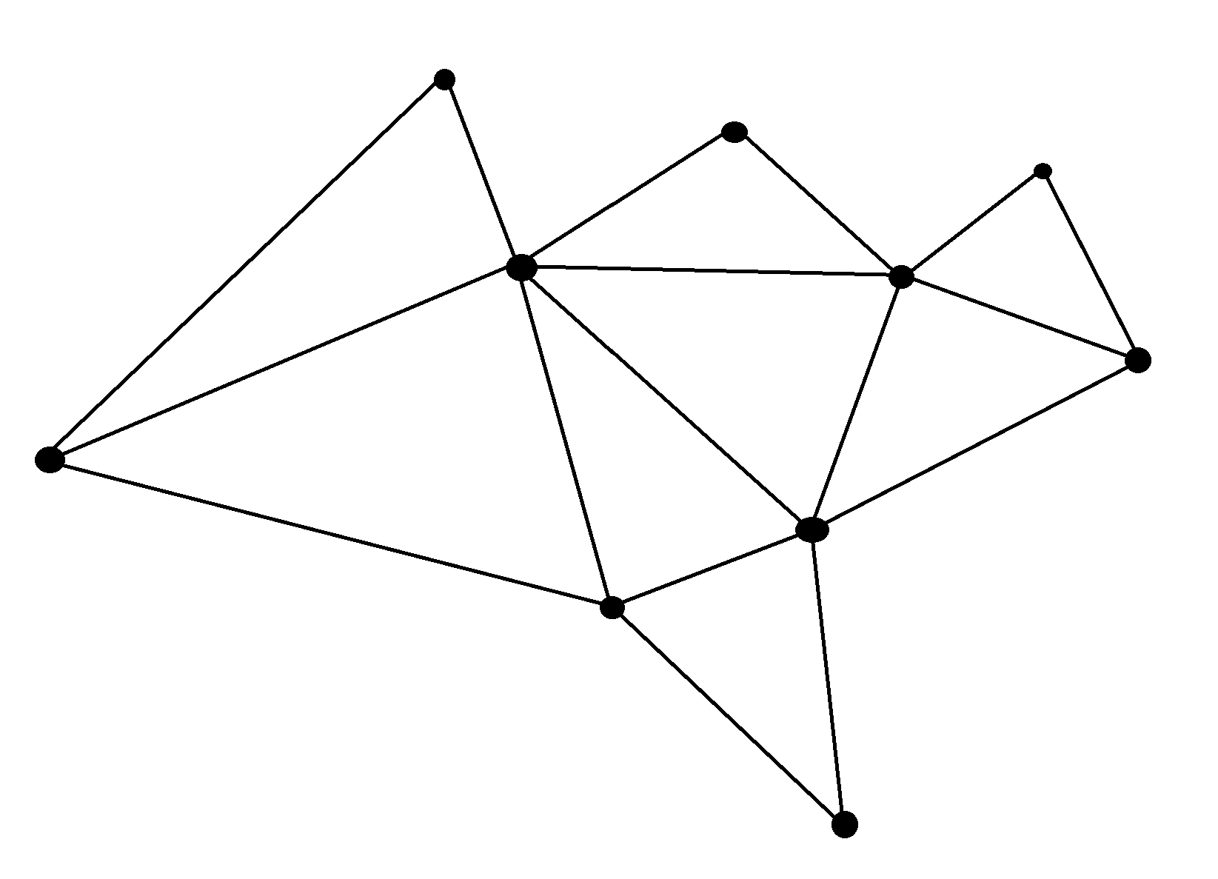
These vertices can then be 3-colored as shown below
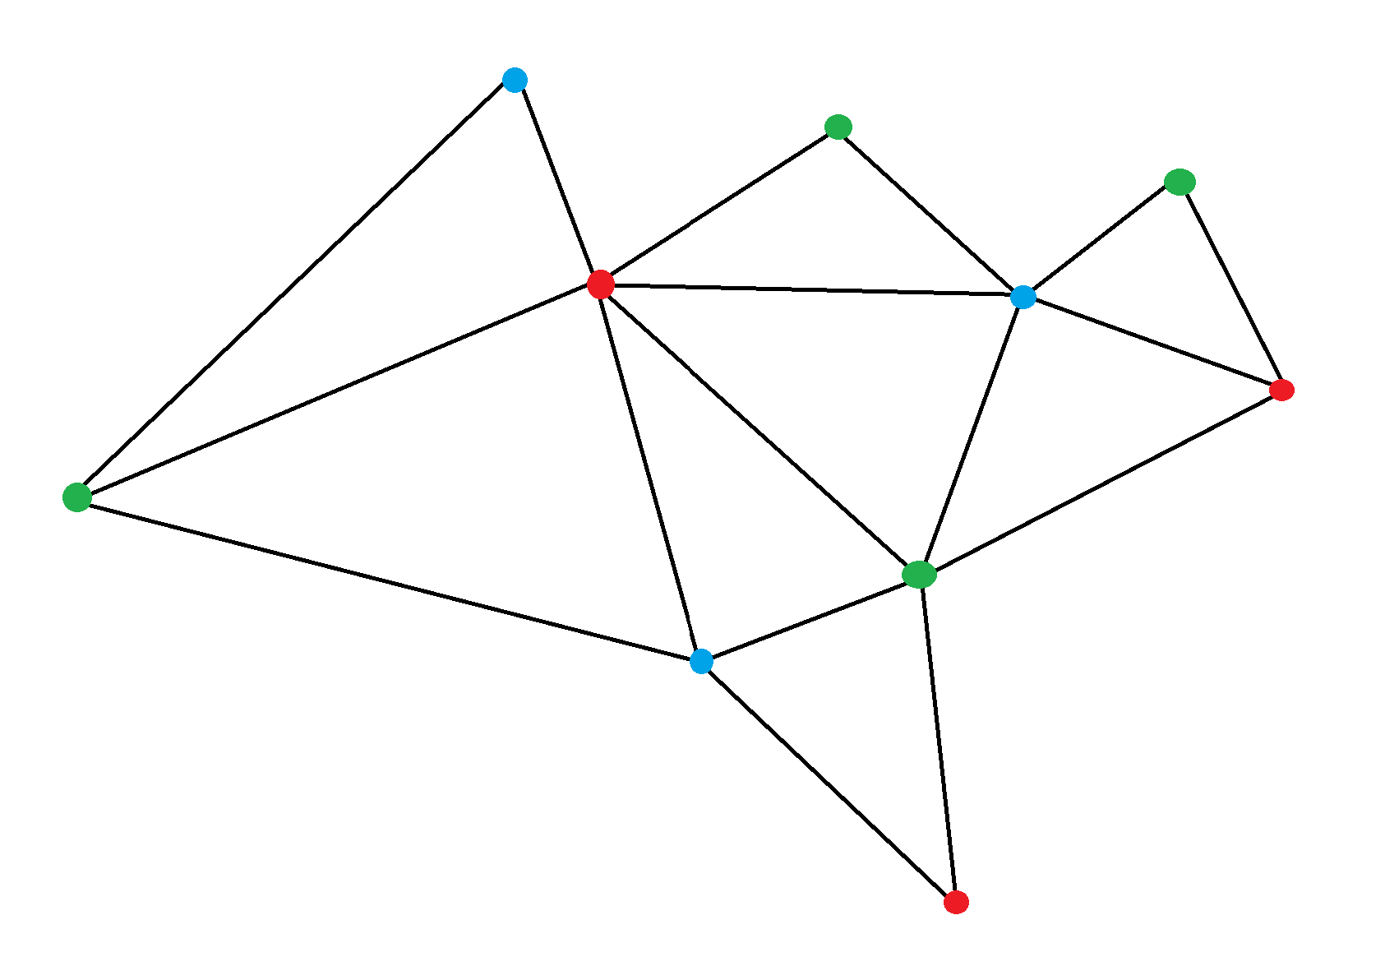
Each triangle is guarded by one of its vertices. This means guards at the vertices of one of the colours will guard the entire polygon. There are 3 red vertices, 3 blue vertices and 4 green vertices. The colour with the fewest vertices will represent the minimum number of guards needed to guard the entire gallery. This can be seen below:
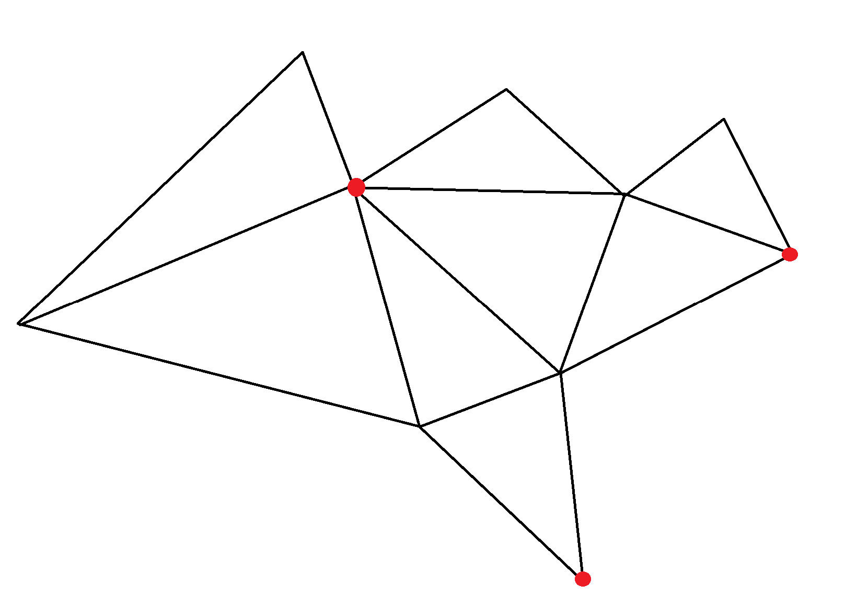
If there were guards at each of the red vertices, they would be able to monitor the entire art gallery without moving.
There are 10 vertices in total and if 3 are required, it follows the formula that no more than n/3 guards are needed where n is the total number of vertices (10/3 = 3.33 > 3).

Five room puzzle:
The five-room puzzle is a puzzle where a person has to cross through each of the walls (or the doorways) of 5 rooms only once.

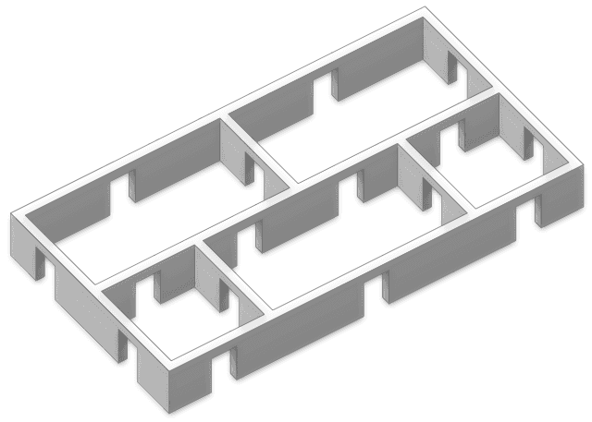
https://en.wikipedia.org/wiki/Five-room_puzzle

A 2d plan of this is :
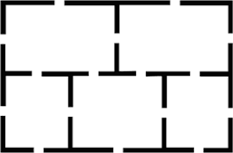
https://www.archimedes-lab.org/How_to_Solve/5_rooms.html

The puzzle can be mapped onto a graph where the node represents the room and the edge represents the doors connecting the rooms. In this case as there are multiple ways to travel from one room to another, so there will be multiple edges connecting the two same nodes. This is called a multigraph. The multigraph of this puzzle is:

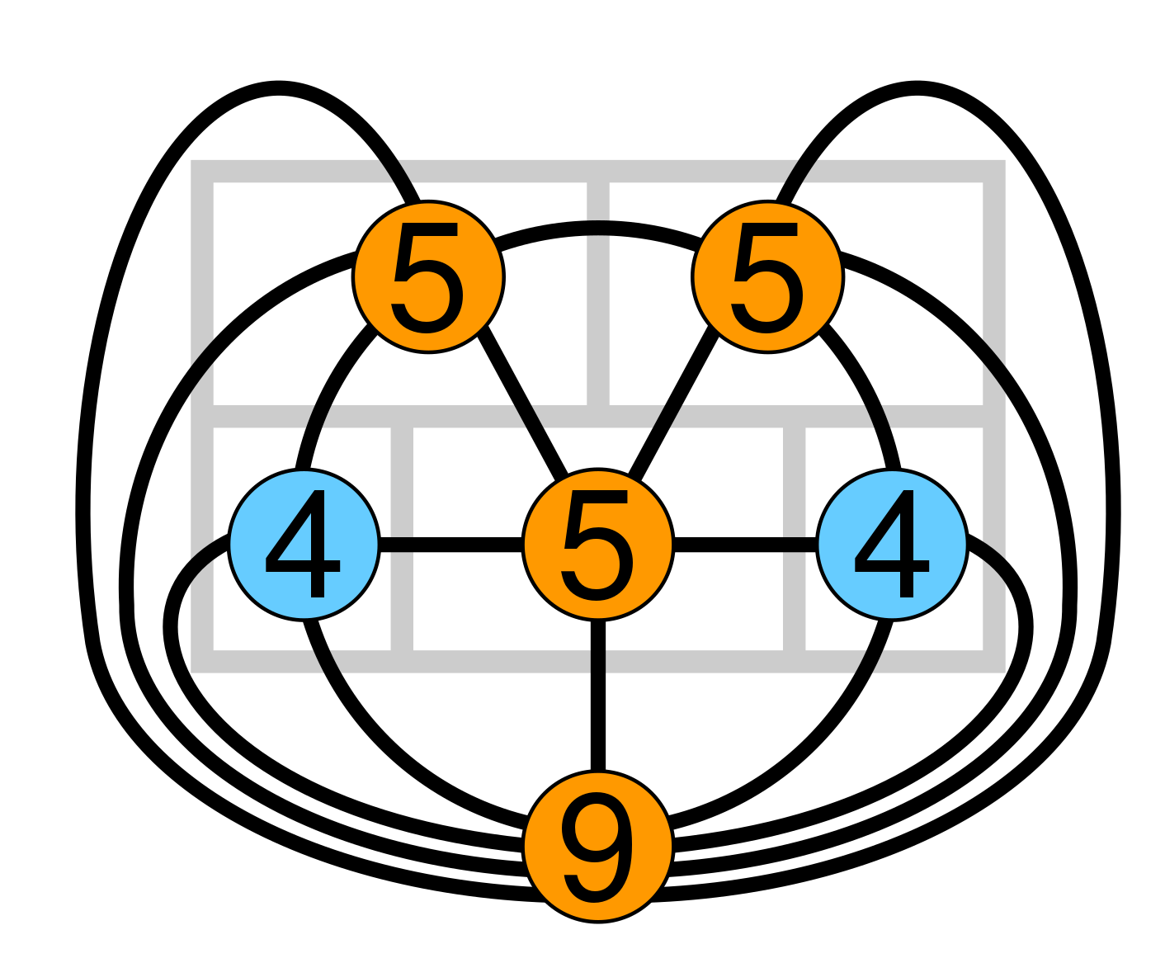
https://en.wikipedia.org/wiki/Five-room_puzzle

The number on the nodes represent the number of edges touching the node (the degree of the nodes). As the degree of 4 of the nodes are odd, a Euler path does not exist meaning it is impossible to walk through each of the doors exactly once.

Applications

Graph theory has many applications such as transportation networks, chemistry, social sciences and computer science.

Transportation networks:
Graph theory can be used to model and optimize transportation networks. These transportation networks can be modelled as a graph where the nodes could represent locations and places whilst edges could represent connections between these locations such as roads and flights. Algorithms can then be implemented to perform a range of tasks such as finding the shortest distance or quickest time to travel between locations. Graph theory can also be used to identify the optimal locations for facilities in the network. For example, businesses can use graph theory to determine the optimal place to build a new facility in order to maximise revenue or companies can determine the optimal place to build a warehouse to minimize shipping costs.
There are two very famous problems related to this. One is the Chinese postman problem. This problem asks to find the shortest closed path or circuit that visits every edge of an (connected) undirected graph at least once. This problem was created to minimize the total distance walked by a postman delivering mail. Another is the Travelling salesman problem which asks “Given a list of cities and the distances between each pair of cities, what is the shortest possible route that visits each city exactly once and returns to the origin city?". This problem has not been solved yet as it is an NP problem, although algorithms have been created such as the Nearest Neighbor Algorithm. The process of this algorithm is from a starting city, find the nearest city and go there. Repeat this step until all the cities have been visited and then go back to the original city. Although this algorithm works, it is not very efficient.

Chemistry
Molecules can be represented as graphs where the nodes represent the atoms and the edges represent bonds. For example the molecule hexane can be represented as a graph:
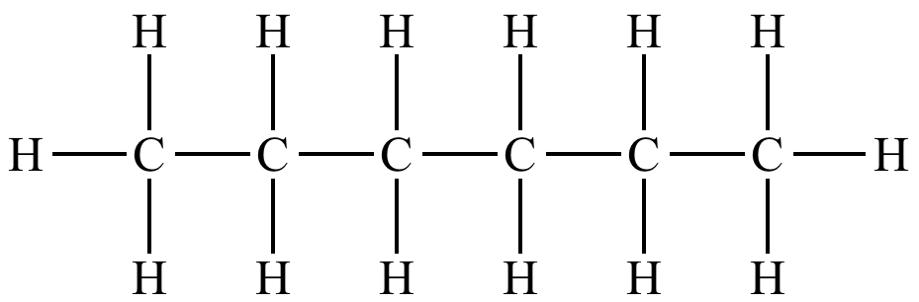
https://www.chem.ucla.edu/~harding/IGOC/H/hexane.html
The carbon and hydrogen atoms are the nodes whilst the C-H and C-C bonds are the edges.

Social sciences:
Graph theory is used in social sciences to model the interactions between different people in a community. It can be used to measure the spreading of rumours or information between people and it can be used to model friendships. Friendship graphs (where the nodes represent people and the edges represent whether two people are friends are not) can be used to determine who in a friend group are friends and who are not. For example, in this friendship graph we can see Tom and Patricia are friends but Tom and Jeff are not friends whilst Patricia and Jeff are friends.
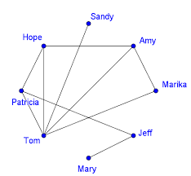
https://quizlet.com/explanations/questions/draw-the-acquaintanceship-graph-that-represents-that-tom-and-patricia-tom-and-hope-tom-and-sandy-tom-e1dce8e8-07e6-4803-b0fd-51a0962ae196

Computer science:
Graph theory is needed to model and analyse computer networks, communication networks and social networks. Graphs can be used to model the link structure of websites where the nodes represent the webpage and the edges represent links from one webpage to another. Due to the vast number of applications of graph theory, computer scientists develop algorithms to solve problems involving graph theory (from various other fields such as social studies) efficiently.

In conclusion, graph theory has many applications as mapping a real life scenario or problem onto a graph simplifies it and makes it much easier to think about logically which can be seen in the problems explored in this essay. Algorithms can also be implemented to speed up the solving process of these problems.

