Huzaifa Momand
How a mathematical understanding of ellipses could lead to becoming a mini golf prodigy.

Section ½:
What are ellipses? And what makes them so interesting?

Introduction:
An ellipse is the locus of all those points in a plane such that the sum of their distances from two fixed points in the plane, is constant. It is a mathematical marvel and geometric wonder. The geometric properties of this shape are enough to inaugurate curiosity and interest into the minds of any who dare to inspect its properties. I hope to enlighten you and show you why it should be crowned as the most fascinating shape and to show you the effects of such a thorough understanding ( becoming a mini golf prodigy)

A crash course into the features of an ellipse :
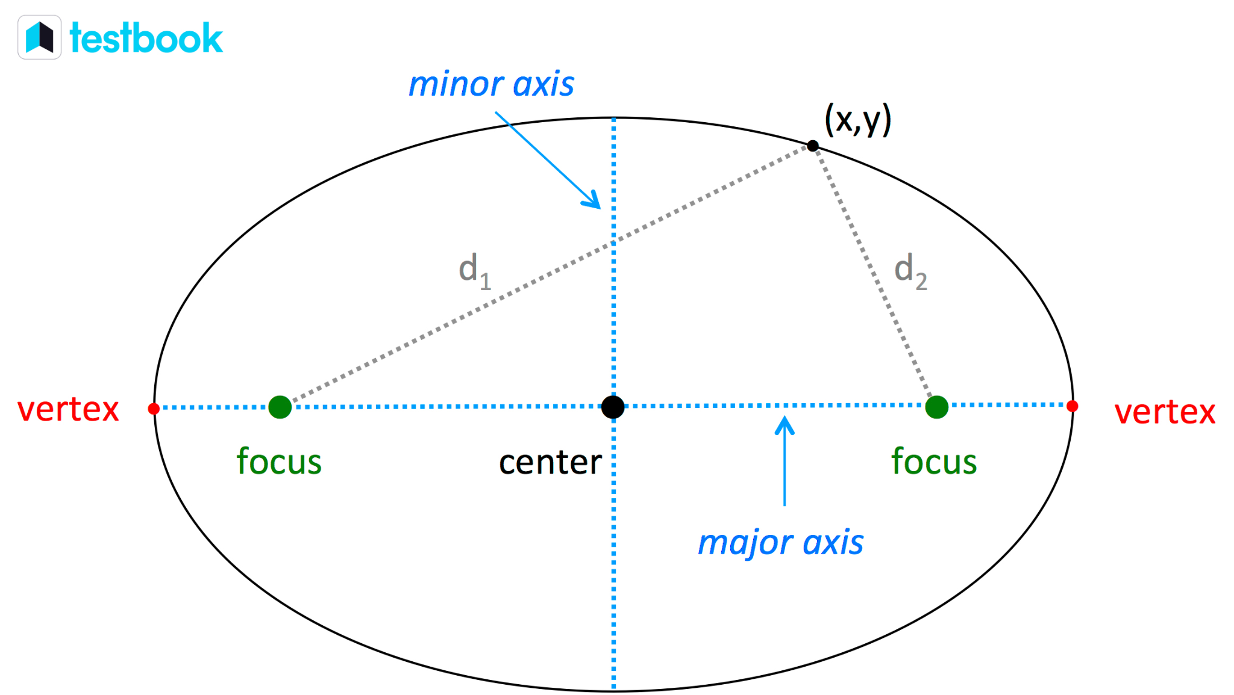

By using figure 1 , we’ll slowly break it down. Let the distance from vertex to vertex be 2a and be known as the major axis ( the x axis on a graph ).
Then let the line which is perpendicular to the major axis and passes through the centre be the minor axis worth 2b. The main defining factor is the fact that if you go from a random point on the circumference to both foci and add up that length . That length will remain constant no matter where you choose on the circumference. The reason for this is due to how an ellipse is constructed. First you dot two points on a sheet of paper and put two pins in their place. Then tie a string around those two dots and place a pencil in that string and go all the way around. The length of the string will remain the same no matter where the pencil is. Guess what, that’s not where the fun stops ; the major axis will always be equal to the sum of those 2 lines. So if we add d1 and d2, that would be equal to the major axis. To finish it, if we split the major axis into half from the centre : we get the 2 semi-major axis. If we do the same for the minor axis we get the 2 semi-minor axis.

Ellipses formulae
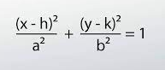
The general formula for an ellipse of any centre is figure 1 on the left , however this is when dealing with horizontal ellipses. When dealing with a vertical one, the numerators switch to compromise for this change

The equation of an ellipse with centre (0,0) will therefore be:
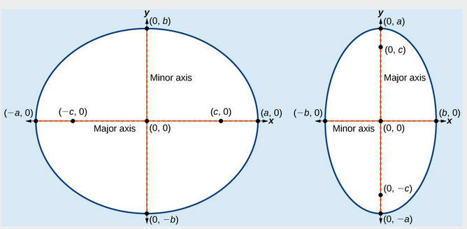
$\frac{x^{2}}{a^{2}}+\frac{y^{2}}{b^{2}} = 1$

If the ellipses is horizontal
Or:
$\frac{x^{2}}{b^{2}}+\frac{y^{2}}{a^{2}} = 1$
If its vertical

Proof for the Ellipses equation:

b
c
a
If we assume that from the centre to one foci is C, the semi-major axis is A and the semi-minor axis is b. We can use this information to construct a right-angled triangle by extending the string (used to construct the ellipse ) evenly at the top.

b
c
a
We know from Pythagoras’ formula that:

$a^{2} =b^{2}+ c^{2}$

By rearranging we can get to:

$b^{2}=a^{2}-c^{2}$

b
c
a
(-c,0)
(c,0)
From knowledge from the second paragraph, we have established that the sum of d1 + d2 is always equal to the major axis. Let's let the major axis be 2a
$d1 + d2 = 2a$

Now we use the distance formula to find the distances of d1 and d2
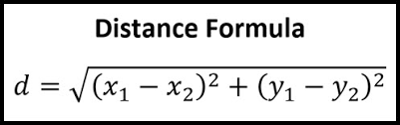
By substituting the values, we get:

$\sqrt{(x+c)^{2}+(y-0)^{2} }$ + $\sqrt{(x-c)^{2}+(y-0)^{2} }$= 2a

We then simplify it, turning y-0 into just y as subtracting zero is futile.
$\sqrt{(x+c)^{2}+(y)^{2} }$ + $\sqrt{(x-c)^{2}+(y)^{2} }$= 2a

We then rearrange the terms by subtracting $\sqrt{(x+c)^{2}+(y)^{2} }$
$\sqrt{(x-c)^{2}+(y)^{2} }$= 2a - $\sqrt{(x+c)^{2}+(y)^{2} }$
Next we square both expressions to get rid of the brackets
$(x-c)^{2}+y^{2}=4a^{2}-4a\sqrt{(x+c)^{2}+y^{2}}$+$(x+c)^{2} + y^{2}$

Then we cancel out like terms and rearrange the formula

$4a\sqrt{(x+c)^{2}+y^{2}} = 4a^{2} + 4cx$

We then have to divide by 4

$a\sqrt{(x+c)^{2} + y^{2} }$ = $a^{2} + cx$

Then we square both sides again

$a^{2}x^{2}+2a^{2}cx+a^{2}c^{2}+a^{2}y^{2}=a^{4}+2a^{2}cx+x^{2}c^{2}$

We then cancel out like terms and rearrange again

$a^{2}x^{2}-x^{2}c^{2} + a^{2}y^{2} = a^{4} - a^{2}c^{2}$

We factor by $a^{2 }-c^{2}$

$x^{2}(a^{2}-c^{2}) + a^{2}y^{2} = a^{2}(a^{2}-c^{2}$)

Then divide both sides by $a^{2}(a^{2 }-c^{2})$

$\frac{x^{2}(a^{2}-c^{2})}{a^{2}(a^{2 }-c^{2})}$ + $\frac{a^{2}y^{2}}{ a^{2}(a^{2 }-c^{2})}$ = $\frac{a^{2}(a^{2 }-c^{2})}{a^{2}(a^{2 }-c^{2})}$

We then cancel out the $(a^{2 }-c^{2})$

$\frac{x^{2}}{a^{2}}$+$\frac{y^{2}}{(a^{2}-c^{2})}$= 1

We know $b^{2 } = a^{2}-c^{2}$ so we substitute it to get the final equation of :
$\frac{x^{2}}{a^{2}}+\frac{y^{2}}{b^{2}} = 1$

We have already established that we use $\frac{x^{2}}{a^{2}}+\frac{y^{2}}{b^{2}} = 1$ when the centre is (0,0) and it’s a horizontal ellipse. However there are some additional rules that have to be true in order for the equation to be used. They say that:
- a > b
- The length of the major axis is 2a
- The coordinates of the vertices are (±a,0)
- The length of the minor axis is 2b
- The coordinates of the co-vertices are (0,±b )
- The coordinates of the foci are (±c, 0) where $c^{2 }= a^{2}-b^{2}$

We use $\frac{x^{2}}{b^{2}}+\frac{y^{2}}{a^{2}} = 1$ for vertical ellipses and we use the formula when:
- a > b
- The length of the major axis is 2a
- The coordinates of the vertices are (0,±a)
- The length of the minor axis is 2b
- The coordinates of the co-vertices are (±b,0 )
- The coordinates of the foci are (0,±c,) where $c^{2 }= a^{2}-b^{2}$

The area of an ellipse and its proof:

A circle is actually a type of ellipse, but instead of having 2 foci , the foci overlap onto one. Now the area for a circle and the area for an ellipse are therefore related.
The area for a circle is:
$πr^{2}$
But, why?
To try prove this as easily as possible ,
Let’s look at figure 1

b
h
Obviously, it is a rectangle.

Now the point of this illustration was to solidify the fact that in a rectangle
$b * h = area of rectangle$

Now let’s take a circle and divide it into 8 equal parts like so:

Let’s arrange the 8 equal slices into a shape that resembles a rectangle:
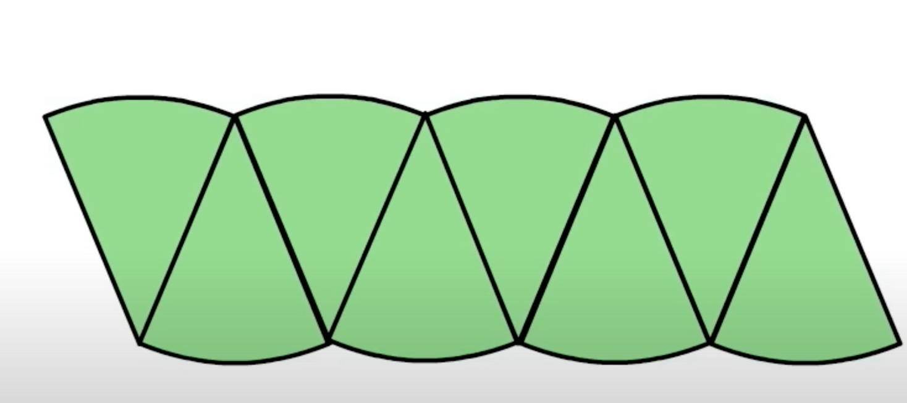

As you can see, it’s very far from a rectangle. If we keep increasing the number of slices we make into the circle, the rectangle shape is more and more apparent. If we make so many slices to the point where we can’t distinguish the lines anymore :

Once we get to this point. We can say that :
Area of the circle = area of the rectangle

We have established that the area of the rectangle is Base * Height
The height of the rectangle in this scenario is equal to the radius of the circle. So $height = radius$

Then if we take the circumference of the circle and stretch it out and compare it to the base of the rectangle, we can note that the base of the rectangle is half the circle’s circumference
$\frac{1}{2}$$2πr$
The ½ cancels out the 2 so we get:
$πr$ as the length for the base

Since the area of the circle and rectangle are equal ,
We plug in the values for base and height to find the area of the circle.

$b * h = area of rectangle$
$πr * r = area of rectangle$
$πr^{2} = area of rectangle$
$area of rectangle = area of circle$
$area of circle = πr^{2}$

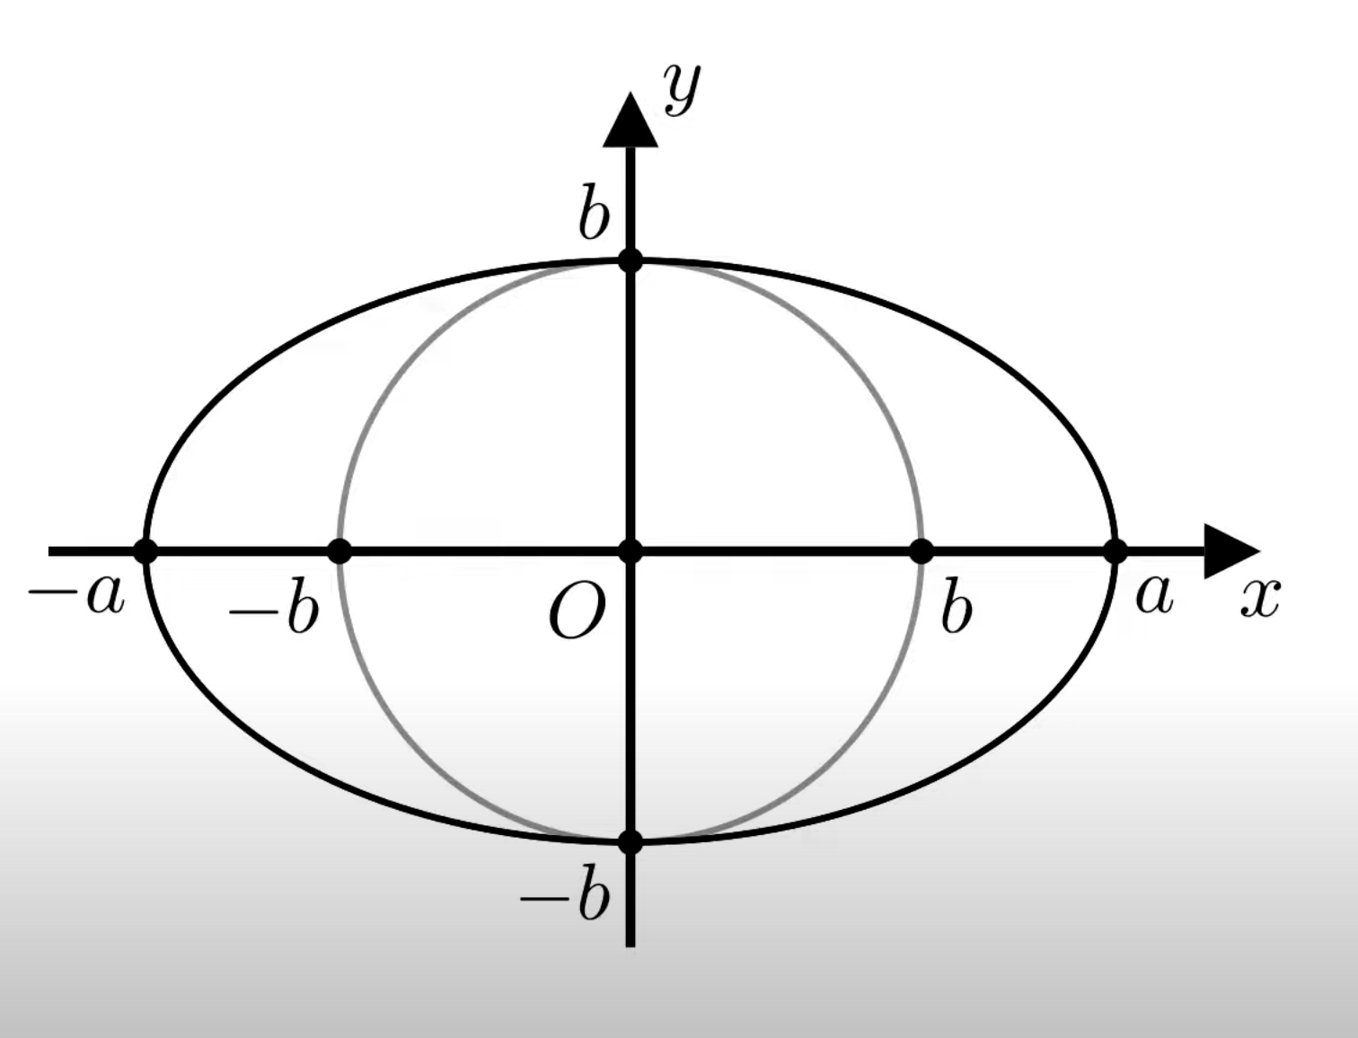
We know that an ellipse is a squashed circle. Let's draw both shapes onto a graph with O being the point (0,0,) and b being the radius.
A as the semi-major axis and b as the semi-minor axis

To get from b to a we have had to multiply it by the factor $\frac{a}{b}$
$\frac{b}{1}$$*\frac{a}{b}$$=\frac{ab}{b}$$= a$

Let’s try and generalise the transformation from the circle to ellipse:

w
h
h
a/b * w
The formula for the normal rectangle would be:

$w * h = area$

The area of the stretched rectangle would be:
$\frac{a}{b}$$w * h = area$

We can simplify the stretched triangle formula even more to:
$\frac{a}{b}$$* area of original shape = area of stretched$
The area of a circle is : $πr^{2}$
The radius in the image is b.
The area is $πb^{2}$
We can use the generalised formula of the area for a stretched shape to figure out the area of an ellipse.

$\frac{a}{b}$$* area of original shape = area of stretched$
$\frac{a}{b}$$* area of circle = area of ellipse$
$\frac{a}{b}$$* πb^{2} = area of ellipse$
$\frac{a}{b}$$* \frac{πb^{2}}{1} = area of ellipse$
$\frac{π{ab}^{2}}{b} = area of ellipse$
$πab = area of an ellipse$

The eccentricity of an Ellipse

c
a
The eccentricity of an ellipse is the ratio of the distances of a point on the ellipse from the foci and from the point on the end of the major axis.
$e = \frac{c}{a}$
This formula is reliant on the fact that :
$0<e<1$

The value of an ellipse’s eccentricity can never be 1 because if it was one, the length from the centre to the foci and from the centre to the point on the end of the major axis to be the same.

$0<e<1$

Only this inequality for e produces an ellipse

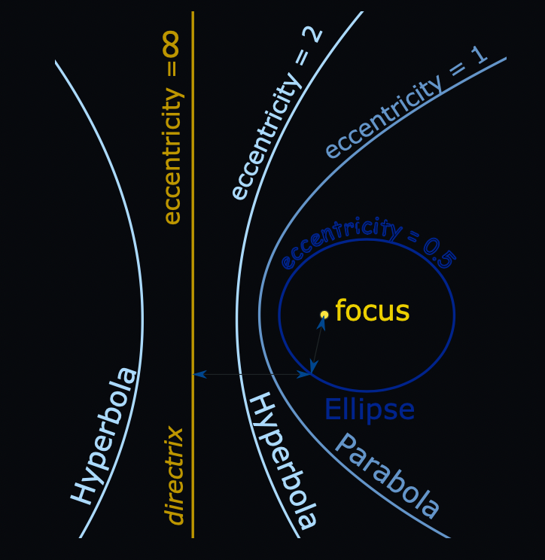

At eccentricity = 0, we get a circle
If eccentricity = 1 we get a parabola
If eccentricity > 1 we get a hyperbola
For infinite eccentricity we get a line.

Proof:

Q
(0,b)
F’
(-c,0)
(-a,0)
O
F
(c,0)
(a,0)
(0,-b)
P
$PF + PF' = OP -OF + OF' + OP$
$= a -c + c +a$
$PF + PF' = 2a$

b
c
a

$b^{2}+c^{2} = a^{2}$
$a = \sqrt{b^{2}+c^{2}}$
$QF = a$ $QF' = a$
$QF + QF' = 2\sqrt{b^{2}+c^{2}}$
$2a =$$2\sqrt{b^{2}+c^{2}}$
$a =$$\sqrt{b^{2}+c^{2}}$
$c^{2} = a^{2} - b^{2}$
$c = \sqrt{a^{2}-b^{2}}$
$e = c / a$
$e = \frac{\sqrt{a^{2}-b^{2}}}{a}$ $= \sqrt{1-\frac{b^{2}}{a^{2}}}$

The circumference of an ellipse

The circumference of an ellipse is very difficult . There are no easy formulas to provide an exact or accurate value. It’s not as simple as the circumference of a circle which is:
$circumference = πd$
The 2 formulas for the circumference of an ellipse ( using integration) are:
$P = 4\int_{0}^{a}{}$$\sqrt{1+\frac{b^{2}x^{2}}{a^{2}(a^{2}-x^{2})}}$$dx$
$P = 4a\int_{0}^{\frac{π}{2}}{}$$\sqrt{1-e^{2}sin^{2}θ}$ $dθ$
To find the circumference, we use approximation formulas:
$P ≈ π( a + b )$
We use this formula when the shape of the ellipse is approximately a circle
We use $P ≈ π\sqrt{2(a^{2}-b^{2})}$ and $P ≈$ $[\frac{3}{2}$$(a+b)-\sqrt{ab}]$
If one value , a or b, is considerably larger than the other

Then we have the ramanujan formulas which are:
- P ≈ π [ 3 (a + b) - √[(3a + b) (a + 3b) ]
- P ≈ π (a + b) [ 1 + (3h) / (10 + √(4 - 3h) ) ], where h = (a - b)²/(a + b)²

Lastly there are the formulas for the circumference of an ellipse using an infinite series. In this formula, the e is eccentricity.
$P ≈2aπ[1-(\frac{1}{2})^{2}e^{2}-(\frac{1.3}{2.4})^{2}\frac{e^{4}}{3}-(\frac{1.3.5}{2.4.6})^{2}\frac{e^{6}}{5}- ... ]$
$P ≈ π(a+b)(1+\frac{1}{4}h+\frac{1}{64}h^{2}+\frac{1}{256}h^{3}+...)$

How to draw an ellipse:
- First, draw two dots on a blank piece of paper with the same x measurement
- Then place two pins in its place
- Tie a string together and place it around the two pins
- Put a pencil in the string and extend the string and draw all the way around
What makes an ellipse so special?
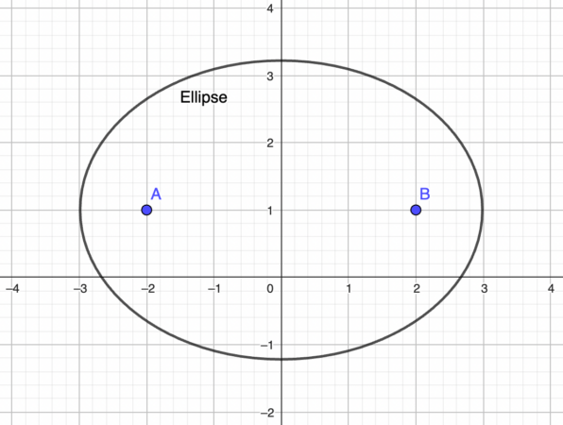
Well if you have an ellipse shape in real life with mirrored sides and you project a laser from one foci, it will always travel to the other foci no matter what angle you project it at. This works with e.m waves and even a ball that is shot from the foci. It will always end up at the other foci.

A fascinating scenario:
If you were to theoretically have an ellipse shaped room and stand at one foci and have someone else stand at the other foci and faintly whisper, you would be able to hear it even if the room was packed.
This exact scenario has actually happened as a man named John Quincy Adams built an ellipse shaped room in the Us capitol building. He had placed his desk on the focus point of the ellipse so that he could hear anyone plotting against him on the other side of the room.

Conclusion:
So theoretically, if one constructs a mini golf hole that is shaped like an ellipse with no obstacles and places the ‘T’ on a focus point of the ellipse. They could get thousands of ‘birdies’ and possibly beat the world record which would bring with it fame and the title of ‘Golfing prodigy’ . I hope my essay has given you a better understanding of ellipses . Have a wonderful day!

8

You, the reader

