Mathematical hunt of ancient geography: The true shape of the earth
Shivam Jha

Studying geography without the applications of mathematics is very much equivalent of studying literature without the knowledge of words. Modern geography uses much complex mathematical concepts. However, there was a time when philosophers must have arrived at the questions which are the basics of modern geography like what is earth? What is its position in the universe? How is it that the seasons change? What makes change in the positions of the stars? And so on. Such questions gave birth to a new branch of study called Geography. At that time, however mathematics was not as developed as it is now. In addition to that, there were not efficient measuring devices at that time. Mathematicians at that time used to calculate by using simple tools and basic mathematics. One of the questions that was troubling mathematicians was that what is the true shape of the earth? Is it flat (as believed by most of the people in ancient times) or is it round? By this essay, it will be explained that how ancient mathematicians discovered the true shape of the earth with just some simple observations. For better and intuitive understanding of the idea, one must think of himself as an ancient philosopher in order to arrive at the same conclusion as they did.
One of the most fundamental and reasonable questions asked by ancient mathematicians and philosophers were determining the shape of our planet. Many people believe that it was Christopher Columbus who discovered that the earth is actually round. But long before Columbus, almost every educated person knew that the earth is actually round. The earliest known suggestion of the earth being round was from more than two thousand years ago by the Greek mathematician and philosopher Pythagoras. He did not actually have any evidence or logical reasons, though, he just thought that a sphere should be the most perfect shape of the planet. And that is why the earth is most likely to be a sphere. Aristotle in 350 BC was the first to offer evidence of the earth being round. He noticed that during a lunar eclipse, when the earth casts a shadow on the moon, the shadow is curved. As well as this, he noticed that the stars appear differently depending on the observer’s location on the Earth. Some stars that are visible from Egypt are not visible from Europe. Let us put in account mathematically that how these two observations made him realized that the Earth is actually round in shape.
Firstly, take the case of a lunar eclipse. In a lunar eclipse, the parallel light rays coming from the Sun are blocked to some extent or completely by Earth. Now, if the earth would have been flat, every point on its side must be on the same plane and since the rays are parallel, the shadow on the moon must not be curved. These basic geometrical facts were already stated by that time.
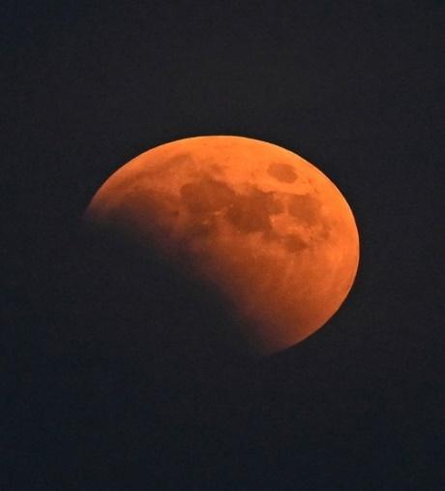
Now, take the second case when Aristotle observed that the stars appear differently depending on the observer’s location on the Earth. He observed that some stars that are visible from Egypt are not visible from Europe. This must surely be happening due to the curvature of the Earth. If you take a cross section of a sphere like the Earth, you will observe that it can have only two parallel tangents. So, if we assume light rays coming from stars as parallel rays (which they indeed are), we will see that a star can only provide its light in between those two tangent rays. And if the rays in between those two parallel lines be subtended further, we’ll see that the rays intersect the cross section of that sphere in two distinct points (which is called a secant). So, by these facts, the only conclusion for Aristotle’s observation is that Egypt and Europe are not lying on the same plane. But are lying on the portion of a sphere. And so, every place on earth is a point on a sphere.
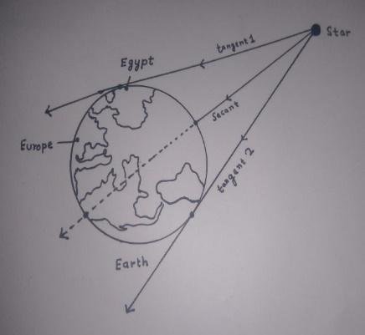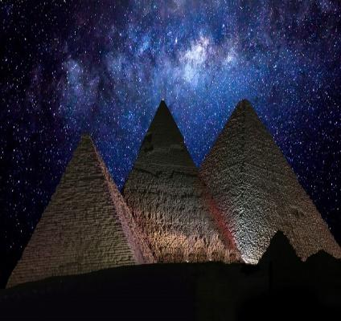
Another Greek by the name of Eratosthenes, went one step further, and actually managed to measure the circumference of the Earth, with just some simple geometry. He had heard of a place called Syene, where the Sun shone directly down a well at noon on the summer solstice (June 21st), casting no shadow whatsoever. This is due to its location almost exactly on the Tropic of Cancer. The Earth’s axial tilt is about 23.5°. Tropic of Cancer is also a latitude located at 23.5°N. Hence Sun rays falls directly on Syene on the summer solstice (for northern hemisphere of the Earth).

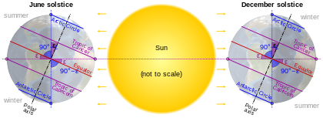
So, the Sun would be perfectly overhead. Eratosthenes measured the angle of a shadow in Alexandria at about 7°, measuring that the distance between the two cities represented about 1/50th the circumference of the Earth. The distance was known to be 5000 stadia, so, 250,000 for the whole circumference. Since the experiment was done using an ancient unit of measurement no longer in use, the ‘Stadion’, which could be converted to modern units in several different ways, the exact result of his experiment is unknown. But still it was around 40,000 km, which was certainly impressive for 2200 years ago.
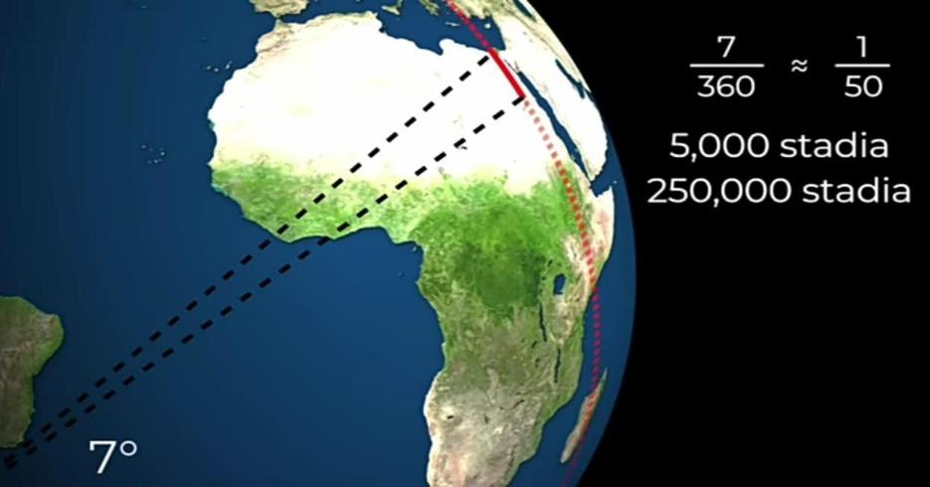

This experiment evidently proved that the true shape of the Earth is round and not flat. Because if the Earth would have been flat, then the shadows at both places, Alexandria and Syene would be of the same length.
Long after Eratosthenes, many new discoveries were made in the field of interplanetary geography or basic astronomy. In the 17th century, Isaac Newton came out with his revolutionary Universal Law of Gravitation. He used many results of Galileo and Kepler to arrive at the equation for gravitation.
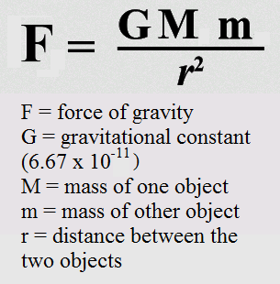
Now, even if this equation was made long after the time of Eratosthenes, it still hides the information of Earth being a round planet. It is certainly true that this equation was made after understanding that the Earth is approximately spherical in shape. But following this equation we still can come to the conclusion that Earth is almost spherical in shape. You are attracting towards the center of the Earth with the same force on every point on the surface of the Earth. By the equation it is hence clear that no matter where you are standing on Earth’s surface, you will be approximately at the same distance from its center. And hence we can come to a conclusion that Earth is round.
The only tools of our ancient philosophers and mathematicians who helped to develop our understanding of Geography were brains. Mathematics itself was developed to explain the phenomenon of subjects like Geography or Physics. Take Calculus, for example, was invented to explain the orbits of planets around the Sun. The mathematical hunt of ancient Geography not only led to better understanding of Geography, but also helped to discover new branches of mathematics.

