The Maths behind Cricket’s Duckworth-Lewis Stern Method
The History of Cricket
Cricket is a sport most widely known for the traditional version of the game, the test match. However, some matches played before 1939 had no definitive end, these were called timeless test matches, these matches would go on until all wickets had fallen, or the target had been achieved. Test matches played after WW2 finished either after 5 days, when every wicket had fallen, or when the chasing team achieved the target. To introduce a new aspect to the sport of cricket, in 1971 the first ODI (One Day International) was played between the old rivals England and Australia. An ODI is comprised of two teams each playing at maximum, a 50 over (an over is a word to define 6 balls, so a 50 over match would have 300 balls) innings and was played throughout only 1 day. As there are only 2 innings in an ODI and you could not “draw” a match, if there was a delay, for example, a rain delay, fewer overs could be bowled in a day. This means that if there was a delay in the match during the 2nd innings the target set in the first innings of 50 overs would be unfair for the team batting second to chase down as they would not have the same number of overs to chase the target down in. This presented an issue, as there now needed to be a method which would fix this issue while considering all the other aspects of a chase in cricket, including how many wickets had fallen, or how many overs were left in the match.
The Difference between a Tie and a Draw
Before I delve into the maths behind the methods used to fix this issue, I must expand on why this method was not necessary in a test match. In a test match, there are 4 possible outcomes. Your team wins the match, your team loses the match, your team draws the match, or your team ties the match. Winning and losing needs no further explanation, however, the difference between a draw and a tie is interesting. A tie is when after all 4 innings of a test match, both teams end on the same number of runs when the wickets in the final innings have fallen. This is a very rare case and only 2 ties have occurred in the 2494 tests played. A draw is a much more common result, this usually occurs when by the close of play on day 5, the batting team have not lost all their wickets and has not achieved the total set by the other team. A draw can also happen when all 5 days of a test match are abandoned due to rain or the safety of the pitch to give a few examples. So, in an ODI it is not usually possible to draw a match if the match has started as there is a set number of overs to be bowled and if you do not achieve the target in that time, your team will lose. However, if the match has started and a delay means that the teams can’t return to the pitch, the match is abandoned.
The Average Run Rate Method
Although the first ODI was played in 1971, 50-over matches had been adopted by different countries to play in their leagues, such as India who were the first to play a 50-over match in 1951, and the first 50-over match between English teams was in May 1962. During the early years of One Day cricket from 1951 until 1991, the preferred method of calculation for the revised total was the Average Run Rate method (ARR), or if it was possible, the match would be replayed on another date.
The Formula for the ARR method was:
Team 2’s New Target = (Team 1’s total x Overs available to Team 2/Overs used by Team 1) + 1
This method simply meant that Team 2 just had to match the average run rate achieved by Team 1 throughout their innings, in the remaining overs that they had to bat. To give an example of this method being used, imagine if Team 1 scored 300 runs in their first innings and there was no delay, so they batted for all 50 overs. If Team 2 had their innings reduced to 25 overs, then the new target would be (300 x 25/50) + 1 = 151.
Some of the intrinsic flaws of this method were that:
- It became much easier for Team 2, as it is easier to score at a run rate of 6 for 10 overs than it is for Team 1 who had to score at a run rate of 6 for 50 overs.
- It is also easier for Team 2, as preserving wickets was less of an issue, this means that Team 2 could be much more aggressive, as Team 1 knew that they had to try and bat for a full 50 overs, but Team 2 only had to bat for 10 overs.
- This method also did not take into account the wickets lost by Team 2. For example, if Team 2 had a revised total of 151 in 25 overs, and they finished the match 151–9 (Meaning that they had lost 9 of their 10 wickets), then Team 2 would win, but you would assume that if they had to bat for 50 overs, they would not score 149 runs, without losing a wicket.
Although modifications were implemented such as increasing the required run rate by 0.5% for each over lost, and not including maiden overs in the calculation of the new run rate. The first change was put in place to reduce Team 2’s advantage, the second change in theory just penalised Team 2 for good bowling, which although it reduced their advantage, did not seem fair. There were also no modifications put in to fix the 3rd intrinsic flaw (Wikipedia, 2024)
An example of the flaws of the ARR method was shown in the match between Australia and the West Indies during the 1988-89 World Series Cup:
In the 1st innings, Australia scored 226-4 (This notation means that Australia had scored 226 runs, while only losing 4 wickets) in 38 overs in the first innings at a run rate of 5.94. Chasing 227, the West Indies had scored 47-2 after 6 overs and 4 balls, so they needed a required run rate of 5.74 when there was an 85-minute rain delay. The West Indies innings was reduced to 18 overs which gave them a revised total of 108 as (226 x 18/38) + 1 = 108.1. So they required 61 runs from 11 overs and 2 balls, at a run rate of only 5.38. The West Indies chased this total down easily with 4 overs and 4 balls to spare (ESPN). This match decided the winner of the tournament, and this created much more criticism for the ARR method. To give a bit of perspective, if the Duckworth-Lewis-Stern method was used, the revised total would have been 139 in 18 overs at a run rate of 8.12.
The Most Productive Overs Method
In 1991, the ARR method was replaced by the Most Productive Overs method (MPO) which was created after the previously mentioned Australia vs West Indies match. This new method aimed to try and create and fair revised total which would not favour either team, however, this was not the case. The formula for the MPO method was much simpler than the ARR method as seen below (where X equals the reduced number of overs that Team 2 would face in their innings).
Team 2’s new target from their total of X overs = Runs scored by Team 1 in their highest-scoring X overs + 1
Like the ARR method, there were many issues with this system, and they mainly occurred as the MPO method was trying to create an equal match but ended up favouring Team 1. (Lewis, 1997)
- It penalised Team 2 for good bowling as the calculation only considered the highest-scoring overs when Team 1 were batting, and not the overs in which Team 2 bowled well.
- This formula, comparatively to the ARR method, did not consider the wickets lost in Team 1’s innings.
- If the least productive X overs during Team 1’s batting innings were all maidens (an over in which no runs are scored), then Team 2 will be left chasing down the total that Team 1 scored in their full innings, in fewer overs.
To try to fix these flaws, a couple of modifications were put into place. Firstly, it now was the runs scored in X consecutive overs, and the target was reduced by 0.5% for every over lost in Team 2’s innings (Wikipedia, 2023). Although the modifications decreased the advantage of Team 1, they only applied to the 3rd flaw of the MPO method, and after its use during the 1992 World Cup creating controversial outcomes, it led to the Duckworth-Lewis-Stern method being implemented in 1998.
The Duckworth-Lewis-Stern Method
After the 1992 World Cup match between England and South Africa, where South Africa needed 22 runs from 13 balls, after a short rain delay needed a virtually impossible 21 runs from 1 ball (ESPN), as mentioned before this was using the MPO method. Listening to the commentary that day were 2 English statisticians, Frank Duckworth and Tony Lewis. After the Duckworth-Lewis (D/L) method was devised, Duckworth mentioned that “It was a mathematical problem that required a mathematical solution” (BBC Sport, 2007). It was clear that the simple formulae created previously were not capable of calculating a fair revised total with the continuously changing aspects of cricket. This method was renamed the Duckworth-Lewis-Stern Method in 2014 after the retirement of the original statisticians and Steven Stern became the custodian of the method (Wikipedia, 2024).
The D/L method is based on the idea that each team has a certain percentage of resources available to them at any time. This is calculated through the combination of the number of overs that each team have left to receive, and the number of wickets that they have in hand. This then leaves a simple formula:
Team 2’s par score = Team 1’s Score x Team 2’s Resources/Team 1’s Resources
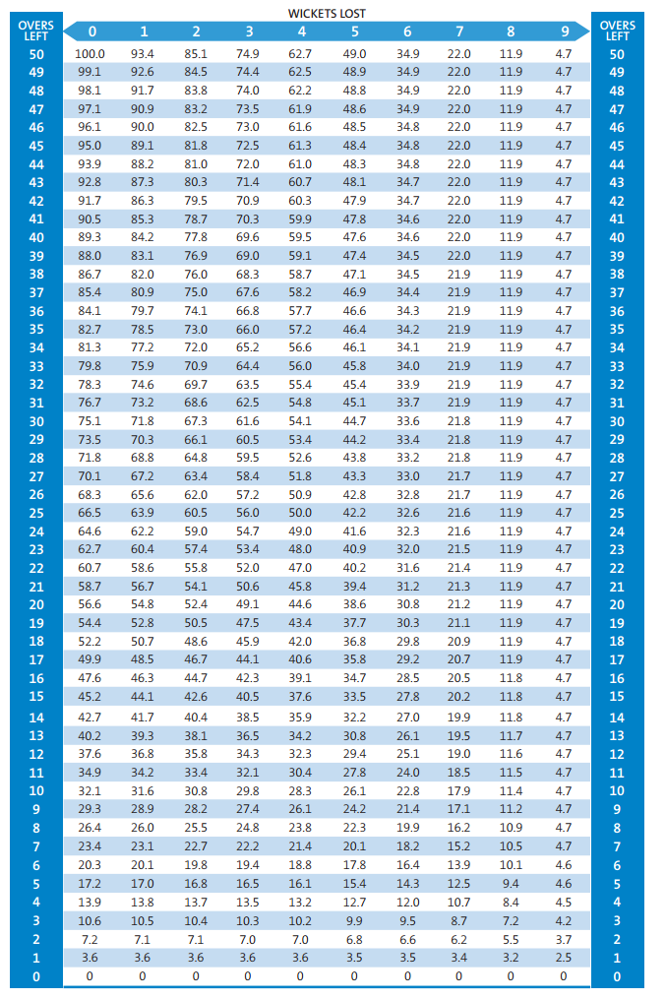
The Calculation of Resources
When the D/L Method was first introduced, it was based on the assumption that the average number of runs expected to be scored { Z(u|w)}, in the remaining overs (u), and the wickets that had been lost (w), can be represented by this exponential decay relationship where the asymptotic average total score in 50 overs is represented by Z₀F(w), and b is the exponential decay constant (Lewis, 1997)
Z(u|w) = Z₀F(w) (1- e^{-bu/F(w)})
The 2 parameters of Z₀ and b (when w was an integer between 0-9) were estimated after looking through the data from hundreds of ODIs (Oxford Brookes University , 2014).
After finding the value of Z, you can use the below formula to calculate the proportion of resources that the batting side still has when u overs are left to be bowled and w wickets have fallen.
P(u|w) = {Z(u|w)}/{Z(u=50|w=0)}
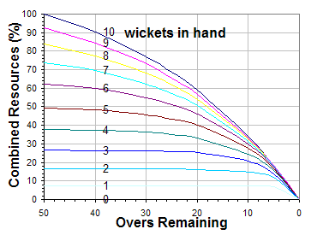
Using this formula, you can plot a graph of Combined resources (%) against the Overs Remaining, when w is between 10 and 0. For all values of u when w=10, the percentage of combined resources is 0%, this is apparent without the graph as when all wickets have fallen, no more runs can be scored. The graph also shows that the only time when the percentage of combined resources is 100% is when u=50 and w=0. When you look at the graph all the curves are exponentially decaying, however, the smaller the value of w the steeper the exponential decay curve is, and when the value of w is larger and the value of u is smaller, the gradient of the curve is very shallow, and almost flat.
The Professional Edition
The first formula in this section became known as the standard version of the D/L method, however, this formula only worked when the scoring rate of the batting side was alike the mean of previous results, so it was estimated that in around 5% of matches, this formula was not advanced enough, so the Professional Edition was created. This new version of the formula included a new parameter λ which was determined for every Team 1 innings, so a computer had to be used to calculate the revised total.
Z(u|0| λ) = Z₀F(w)( λ^{n(w) + 1}){1-e^{(-bu/[} ^{λ^{n(w)}F(w)])}}
Using the new parameter λ, this new formula gave fair revised targets even at the very highest score made, but as mentioned before could no longer be manually used (Oxford Brookes University , 2014). Unfortunately, the resource table for the Professional Edition is not available to the public, and as we don’t know the value for λ or b I am not able to create the table. The Professional Edition was adopted by the ICC in 2003.
Criticism of the D/L Method
Most of the criticism of this method arose from the introduction of T20 matches in which the batting side would score at a faster run rate, and Duckworth and Lewis were not certain if the original formula would hold up, in this new scenario. However, with a few alterations to the original formula, the D/L method was ready for use in T20 matches.
Another technical issue with the D/L method is when a batsman is ‘retired hurt’, which is when a batsman is injured, and is withdrawn from the crease, but can enter the crease later in the match if they are able to. Although this was not the case in the match between England and New Zealand in 2013, as there were no overs lost, this was an example in which the method could have been exploited. A New Zealand opener retired hurt but came back to the crease when New Zealand were 7 wickets down and batted extremely well, which would not be expected of a batsman coming to the crease at this time, so that is a slight issue, but one which couldn’t be easily resolved and happens very rarely. (ESPN, 2013) (Selvey, 2013)

Conclusion
After my research into the maths and statistics behind the Duckworth-Lewis-Stern Method and the prior methods used to calculate revised totals in limited overs cricket, it is clear to me that the D/L method will carry on being the preferred method for the near future, as it is both accurate and adaptable if any new limited over formats of cricket are created, this can be seen, in its adaptability to the creation of T20 cricket. Although some may argue that cricket is not a mathematical game, the introduction of the aforementioned formulae has changed the sport for the better.

References
BBC Sport. (2007). A decade of Duckworth-Lewis. http://news.bbc.co.uk/sport1/hi/cricket/6222943.stm.
ESPN. (2013). New Zealand vs England, 1st ODI at Hamilton, Feb 17 2013. https://www.espncricinfo.com/series/england-tour-of-new-zealand-2012-13-569228/new-zealand-vs-england-1st-odi-569240/full-scorecard.
ESPN. (n.d.). AUSTRALIA v WEST INDIES 1988-89. https://www.espncricinfo.com/wisdenalmanack/content/story/150754.html.
ESPN. (n.d.). The time South Africa needed 22 off one ball . https://www.espncricinfo.com/story/the-time-south-africa-needed-22-off-one-ball-in-the-1992-world-cup-280142.
Lewis, F. C. (1997). A fair method for resetting the target in interrupted one-day cricket matches. https://www.tandfonline.com/doi/abs/10.1057/palgrave.jors.2600524.
Oxford Brookes University . (2014). The Duckworth/Lewis Method Professional Edition. https://radar.brookes.ac.uk/radar/file/7fdf8cb7-7904-48a0-b791-440ba8d6373d/1/038%20Duckworth-Lewis%201113.pdf.
Selvey, M. (2013). England beaten after injured Martin Guptill digs in for New Zealand. https://www.theguardian.com/sport/2013/feb/17/new-zealand-england-odi.
Wikipedia. (2023). Most Productive Overs Method. https://en.wikipedia.org/wiki/Most_Productive_Overs_method.
Wikipedia. (2024). Average Run Rate Method. https://en.wikipedia.org/wiki/Average_Run_Rate_method#cite_note-4.
Wikipedia. (2024). Duckworth-Lewis-Stern Method. https://en.wikipedia.org/wiki/Duckworth%E2%80%93Lewis%E2%80%93Stern_method#cite_note-OrigPaper-11.

