To Infinity and beyond
How big is infinity? When I was a kid I would argue with my siblings and they would say “No x 10”, and I (being the smartest sibling) would say “No x infinity” and I’d always win the argument, because what could be bigger than infinity? Well, I’m about to show you that in fact, there are bigger infinities than infinity, kinda strange isn’t it? For the purpose of this essay, I will be looking at infinity as a cardinality.

How to Count
To first understand Infinity you need to know how to count. To be exact you have to recognize that numbers are a way of labelling a grouped set, eg; if I had a box of apples I could count them by labelling each apple with a appropriate number like 1, 2 ,3, you do this as you have the set of a finite number of apples and then you match them with the set of Natural numbers. This act of matching an element of one set with the element of another set is called a bijection and we’ll cover more on this later, the cardinality of a set refers to its size. The number sets I have experience with are the Natural, Integer, Rational, Real and Complex Numbers, though I will only take this as far as the Real number set.

Hibert’s Hotel Problem and its solutions
Now that you know how to count, it's time to introduce you to a really interesting problem, The Hilbert Hotel problem. The Hilbert Hotel problem is a very good way of proving the existence of greater infinities. When I was an older kid and started algebra I thought I had discovered a way to win even more arguments (because by this time my siblings started saying “No x infinity” before I could and I would lose) and that was to use algebra to win by saying “No x n+infinity”, where ‘n’ represents the number of times my sibling said ‘No’. Well, Hilbert's problem shows that in actuality both infinities are the same size. The Hilbert’s Hotel problem is this;

You are the manager of a hotel that has an infinite number of rooms, each numbered with a natural number starting from 1 and carries on infinitely. All of the rooms are currently occupied by an infinite number of people and only have enough space for one person per room.
One summer’s evening a person comes and asks for a room, intuitively you think you can’t fit anymore people as each room already contains a person, however it can. This is done as you ask every person in a room to move up to the next room, e.g. Occupant 1 moves to Room 2, Occupant 2 moves to Room 3. This is fine as you have an infinite number of rooms for your occupants to move to and this leaves you with 1 free room, Room 1 which the new person can enter. You can do this with any finite number of people (represented by n) as they only need to shift to the room that is the number of finite people away, this can be written as:

∞+n=∞

But what if, on an Autumn's frosty Morning, a bus arrives carrying an infinite number of people that all want to stay at your hotel because it is now World Renowned? Well you, the now veteran manager, knows what to do. You ask each of the hotel’s Occupants to move to the Room that is double their current Room Number e.g. the Occupant of Room 1 moves to Room 2, the Occupant of Room 2 moves to Room 4, the Occupant of Room 3 moves to Room 6 ect... Due to the fact that any number times by 2 becomes even, you’ll find out that all your previous occupants now live in a even Room number, while the Rooms labelled with an odd number are vacant and due to the fact that there are an infinite number of odd numbers (which I will prove later). You can now fit each of the new people coming from the bus with an appropriate odd number so now everyone has a room. This shows that for any finite number of buses (represented by n) carrying an infinite number of people this can be written as:

nx∞=∞

Now on a Bright Spring’s afternoon you are presented with another problem, the hotel you manage has received a large number of applications for a room, to be exact, an infinite number of buses containing an infinite number of people have arrived and they all want a room. Though this seems impossible to manage you, a now living legend in the hotel management community, are able to devise a solution for this and that is to create a table that is infinitely long for each bus and each person in the bus (each person in any bus is assigned a seat number);
 | Seat 1 | Seat 2 | Seat 3 | Seat 4 | …
Bus1 | B1S1 | B1S2 | B1S3 | B1S4
Bus2 | B2S1 | B2S2 | B2S3 | B2S4
Bus3 | B3S1 | B3S2 | B3S3 | B3S4
Bus4 | B4S19 | B4S2 | B4S3 | B4S4
…
Then you can move in a zig-zag like pattern through the table to assign each person a Room.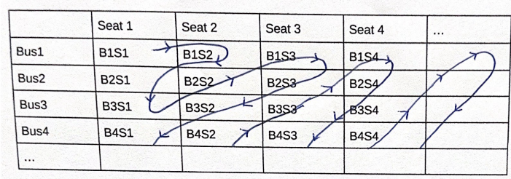 After that, stretch out the zig-zag line into 1 straight line you would be able to assign each person a Room by matching them with the corresponding natural number eg; the person represented by B1S1 gets Room 1, the person represented by B1S2 gets Room 2, the person represented by B2S1 gets Room 3 ect…

Room 1 | Room 2 | Room 3 | Room 4 | Room 5 | …
B1S1 | B1S2 | B2S1 | B3S1 | B2S2 | …

But now, on a gloomy winter night, a bus comes with an infinite number of snakes that are infinitely long (your hotel is now so popular you’ve expanded your services to animals and wildlife). However, every snake is composed of black and white stripes (where B= Black and W= White) and all want a room at your hotel. Sadly you are forced to hang up your cape and throw in the towel as your hotel isn’t big enough to accommodate every snake, this is because there is an uncountable number of snakes. If I were to arrange every snake into a line and assign them Rooms, I could then prove the existence of another snake that is without a Room, I can do this by looking at the first stripe of the first snake and then choosing the opposite colour stripe, then I look at the second stripe of the second snake and choosing the opposite colour. I repeat this till eventually I have a completely new snake without a Room, and if you assign that snake a Room, I can then create another snake using the same method which leads to another homeless snake, hence you have to turn away the bus of snakes.
Snake 1 [BBBWBBBWBBWWWWBBBW…]
Snake 2 [BBBWBBBWBBWWWWBBBW…]
Snake 3 [BBBWBBBWBBWWWWBBBW…]
Snake 4 [BBBWBBBWBBWWWWBBBW…]
Snake 5 [BBBWBBBWBBWWWWBBBW…]
Snake …
My new Snake [WWWBW…]

Breakdown of the Hilbert Hotel Problem
The Hilbert Hotel problem was devised by David Hilbert, an influential German mathematician in the 19th-20th century who devised a series of 23 problems that he believed mathematicians should spend their time solving. The Hilbert hotel problem was a question to push the boundaries of our knowledge about infinity and so to solve this question, we have to compare them using their cardinalities.
We use functions to match each of the elements in a Number set to another element, this is because a function is a way of mapping a 1 to 1 correspondence, which is what infinites of the same size would be able to do. In other words if you cannot have a bijection between two sets, then that set is bigger and hence that infinity is bigger.

The initial part of the question refers to the set of Natural numbers that tend towards infinity, it show that by adding people into the hotel (which can only be positive and a whole number as you can’t have half a person) the size of the infinity is the same, this is due to infinity’s nature as an unending size and the fact that the Natural numbers are a countably infinite set. The reason you can’t ask the person to move to the Room at the end of the hotel is due to the fact that even though there are an infinite number of rooms, each Room is a finite distance away.
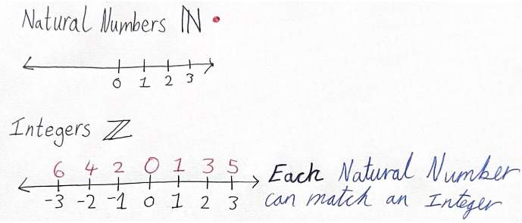

The Second part of the problem is based around the fact that there are an infinite number of odd numbers, this is true as we can prove it through proof by contradiction:
First let's assume that there are a finite number of Odd numbers.
This would mean that there is a ‘biggest’ odd number.
N=Biggest odd number
P=an integer
N=2P+1
As it is a number, you can use it for addition.
N+2=2P+3
2P+3=2(P+1)+1
As P+1 is being multiplied by 2, it is an even number. By adding 1 the to value, it becomes an odd number.
Hence N+2 is odd and N+2>N, so there is a contradiction
Therefore there are an infinite number of odd numbers and an infinite number of odd numbered Rooms.

The third part of the problem refers to infinite layering, where we have multiple infinities of the same type being combined, this represents the rational numbers. The definition of a rational number is that it can be written as a fraction, we can label each real number with the appropriate pair of Natural number which represents the rational number, this can be done by constructing a graph and going around in a circle, assigning each value a Natural number.
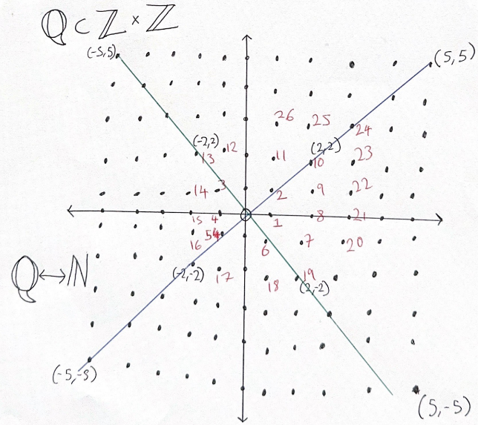
This proves that the set of Natural numbers is less than the set of Rational numbers, but the opposite also applies hence they are equal.

The final part of Hilbert’s problem is to do with Real numbers, as a Real number set contains the Irrational number subset, it can have infinitely many variations as they cannot be represented as a fraction this means that it is an uncountable infinity which was proven by Georg Cantor, which means it has the cardinality of the continuum. You can’t form a bijection between Real numbers and Natural numbers as unlike for Natural numbers where there is nothing between 1 and 2, for a Real number there are an infinite number of decimals between 1 and 2 and unlike Natural numbers which can only go upwards, Real numbers could be made between two pre-existing numbers.
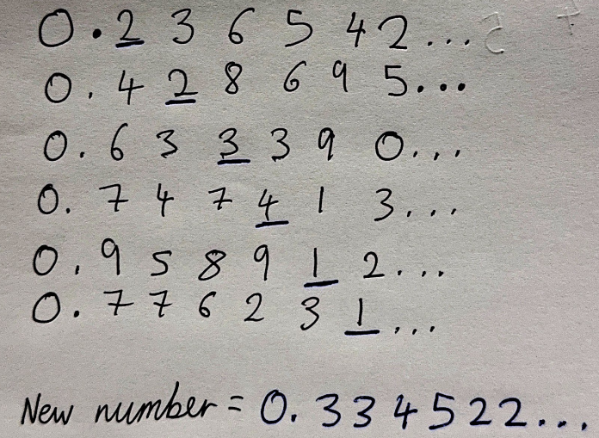
This means that the infinite set of Real numbers has a cardinality that is greater than the cardinality of the infinite set of Natural numbers.

Uses of infinity in maths and the world
There are many uses of infinity in the world and I’d like to talk to you about its uses in calculus, specifically its vital use in finding the limits of derivatives. When defining the limit of something, you say that as the variable value approaches infinity, the expression approaches a value. For example if you were to have:
Lim of $x$→∞
For $(8x^{2}-5x)/(4x^{2}+7$)
$(8x^{2}-5x)$x 1/$x^{2}=$ $(8-5/x)$
$(4x^{2}+7$)x 1/$x^{2}= (4+7/x^{2})$
The limit as $x$→∞ is
($8-0)/(4+0)= 2$
This shows that as $x$ gets incredibly big, the function approaches 2 but is never at it ( it is asymptotic), infinity in derivatives allows us to see the tendency of a graph which is useful for calculating real world problems such as in chemistry, where as time approaches infinity the new compound formed from a chemical reaction is equal to a value.

In conclusion, I hope I have been able to prove to you that all infinities are equal but some are more equal than others using Hilbert’s hotel problem and helped to at least interest you in the possibilities and uses of this value and most importantly how to better win your arguments against your siblings.

