Unicorns and Penguins, Everything from Nothing
- An exploration beyond the foundation of our mathematical system

- An infinite Request

Somewhere in the outer space, there is a planet of unicorns. They have highly advanced technology, with developed understanding and magical power to create everything from nothing. Besides, they’re all enthusiastic mathematicians, just like us.

One day, the King was presented with an interstellar traveller from the planet Earth. He was in ecstasy to greet this foreign visitor and promised to offer him a gift.

The traveller replied: “Your Majesty, I ask for nothing but one: I would like 1 grain for the first day, 2 on the second, 3 on the third, and 4 the following day … starts from today and doesn’t stop for all the eternity.”

In mathematical language, the total number of grains the traveller asked for is:

$$S=1+2+3+4+5+6+…$$

The King smiled, and, to his surprise, he smirked: “Now you owe me 1/12 of a grain”.

- From Everything to Nothing

You may now think that the King’s reply is absurd if not obviously incorrect. But before we reject an extremely clever specie, it’s wiser to carefully examine the King’s claim first.

Consider the following sequence:

$$A=1-1+1-1+1-1+1-1+…$$
or $A=Σ{\left(-1\right)}^{n+1}$

What is the value of the series?

  - Summing the Infinite

If we were to add a bracket from the second term to infinity, then magically the sequence from the second term on is exactly A again. Hence, we can then perform the following operation:

$$A=1-(1-1+1-1+1-1+…$$
$$A=1-A$$
$$A=0.5$$

However, A’s brother B comes along, with this sequence, and he wants to value himself as well:

$$B=1-2+3-4+5-6+7-8+…$$
$$B=Σ{\left(-1\right)}^{n+1}n$$

Fortunately, the same nasty trick could do it. If we were to copy another B, and write it on a paper of infinite length, in the way such that the nth term of the copied B is parallel to the (n-1)th term of the original B, and add them up;

$$B=1-2+3-4+5-6+7-8+…$$
$$B= 1-2+3-4+5-6+7-8+…$$
$$2B=1-1+1-1+1-1+…$$
$$2B=A$$
$$B=0.25$$

Now, what if A and B’s father, the sum of all natural numbers, comes along as well, with the same curiosity for his value:

$$S=1+2+3+4+5+6+…$$

We can now time S by four, and perform a similar mapping as we’ve done to A and B:

$$S=1+2+3+4+5+6+…$$
$$4S= 4 + 8 + 12 +…$$

We’re allowed for this operation since there’s a way for us to construct a one-to-one bijection between these two sets, and thus they have the same magnitude of the countable infinity. This can be derived from the Hilbert Hotel’s paradox.

$$-3S=1-2+3-4+5-6+…$$
$$-3S=B=0.25$$
$$S=-\frac{1}{12}$$

Counterintuitively, as this sequence grows larger and larger towards infinity, it approaches a value that is even smaller than the first term 1. By adding increasingly larger integers, we’ve made the series even smaller. How is that true?

  - Do you have a limit?

However, before we address this question, we must solve another concerning issue.

By the axiom of commutative law of addition, we are allowed to switch the order of addition operation without affecting the expression’s outcome. Therefore, we can perform the following – Let’s add a bracket to A first -

$$A=1-(1-1+1-1+1-1+…$$

If we were to change the order of the second one with third, fourth with fifth, or more generally, the 2k^{th} with 2k+1th, observe the pattern -

$$A=1-(-1+1-1+1-1+…$$

Then why don’t we expand the bracket and minus the new sequence from the old one?

$$A=2-1+1-1+1-1+…$$
$$A=1-1+1-1+1-1+…$$
$$0=1$$

There’s clearly something wrong.

Let’s go back to the start and revisit our intuition. As we know, A is a sequence that continuously oscillates between 1 and 0. If you take a snapshot at any value within its domain, the sequence must sum to either 1 or 0, not any other values. This oscillation, unlike any other operations, will not cause the series to progressively approach an absolute and stable value as the number of terms in the sequence increases. This nature is known as divergence.

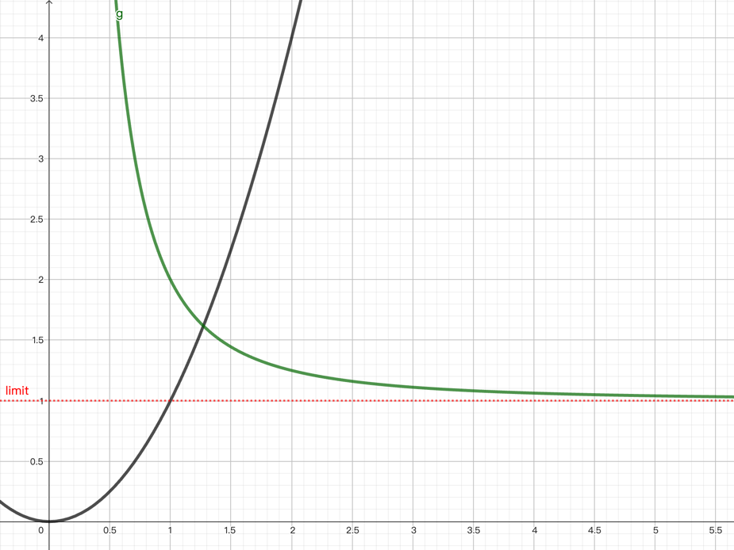
Figure 1. The black line showed the equation,$y=x^{2}$, a divergent function.
The green line is $y=x^{-2}$+1, approaching the asymptote of x=1, which is convergent.

Conversely, there is convergence, the nature for the series that grows towards a numerical value when the sequence contains of an increasing number of terms. This nature has been precisely specified by Cauchy’s law of convergence, and only sequences exhibiting these features are eligible for computing an infinite sum and hence be assigned a particular value.

$$Criterion: The sequence xn converges to something if and only if this holds: for every$$
$$ε> 0 there exists K such that |{x }_{n}- x_{m}| < ε whenever n, m>K.$$

It’s trivial that neither of A, B nor S satisfy this criterion (one example is $ε=0.1$). Assuming that these series will eventually approach a number while diverging towards infinity or oscillating between values indefinitely is, therefore, a fundamental error in mathematics. In actuality, it’s impossible to assign a value to any of the three sequences that we have mentioned.

  - From Nothing to Something via Everything

Mathematicians: “Alas! Problem solved. Time for a champagne party.”
Scientists: “Wait a minute”

For the mathematicians, with Cauchy’s criterion, everything is settled. For the scientists, however, new frustration arises.

In 1948, a noteworthy discovery is made by the physicist Hendrik Casimir. With further and deeper exploration in this field with the aid of quantum mechanics, scientists realise that our interpretation of the series might be flawed, inaccurate and insufficient. In order to comprehend this, we must first go from thinking about everything, adding up an endless number of terms, to nothing, or in fact, vacuum.

Imagine two slim uncharged conducting plates are positioned in a vacuum, with no particles, at a temperature of absolute zero, and a few nanometres apart from each other. Remarkably, an attractive force arises. Since in a classical sense, gravity is the only existing field in the vacuum, it makes intuitive sense to assume that gravity is the force. But since both plates are so thin and light, the force of gravity should be unmeasurable small. In reality, however, when these plates are placed about 10 nm away from each other, the force produced is the equivalent of 1 atmospheric pressure. A contradiction arises.

Thus, where this force comes from? To answer this question, we have to consider the following first:

Is there any energy present in the vacuum?

Heuristically, the answer is yes. It might appear to be highly counterintuitive that energy could still be present even if there’s nothing but empty space. However, with the arrival of quantum mechanics, our understanding of this conception is completely transformed. In field theory, all fields – especially the electromagnetic fields – have fluctuations. Fluctuation is the temporary change in the amount of energy in a point in space. In simple words, the field could borrow some energy from nothing for a particular moment as long as they paid it back later. This process causes the value of the actual energy at any given moment and space vary.

Vacuum, despite being at absolute zero, has fluctuating fields called “vacuum fluctuations”, with the mean energy corresponding to half of the energy of a photon.

All electromagnetic fields have a characteristic spectrum that encompass a range of waves with varying wavelengths, and it is the same in vacuum. All waves of any wavelength could happily exist in a vacuum, as the space expands infinitely in directions. (So, in theory, the energy in vacuum $E_{ϵ}$ is infinite) The situation between two plates, however, is quite different. If the cavity can accommodate an integer number multiple of half of the wavelength, the field is amplified, otherwise it’s suppressed. This is called the “cavity resonance”, and the phenomenon of suppression and amplification of fluctuations is called the Casimir Effect.

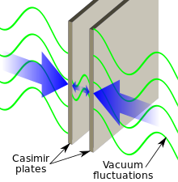
Figure 2. Visualisation of the Casimir Effect

To obtain an expression to explain the attractive force that’s exerting on the plate, it is necessary to calculate the total energy of the fluctuation between the cavity that is amplified. More precisely, the attractive force is actually resulted from the difference between the vacuum energy that exists outside the cavity,$E_{0}$ and the vacuum energy that is amplified inside the cavity. $E_{ϵ}$

$$E=E_{0}-E_{ϵ}$$

As we know, the energy of a wave and its wavelength is inversely related. How about we make the wave that has the largest wavelength, that is, the wave with precisely half a wavelength between the plates.$F$ In this way, we can express the energy of the wave that has 2 half wavelengths,$2F$ and those with 3,$3F$and so forth. We arrived at the infinite summation:
$$E_{ϵ}=F\sum_{n=1}^{∞}{n}$$

But wait a second – the sum of energy diverges to infinity! That can’t possibly make sense - not only do we have infinite energy which defies fundamental physical logic, but more incomprehensibly, the magnitude of this energy will just blow the two plates apart, contradicting the experimental result that they’ll attract one another.

However, despite its divergence, one can still extract interesting physics from the expression, and we can do this by employing a process called renormalisation.

We introduce a parameter $ϵ$ for which, $ϵ≪1$ and incorporate it in the following way. ($e^{-ϵn}$approaches 1 as n approaches infinity, so doesn’t make any difference)

$$\sum_{n=1}^{∞}{n}→ \sum_{n=1}^{∞}{ne^{-ϵn}}= -\frac{δ}{δϵ}\sum_{n=1}^{∞}{e^{-ϵn}}$$
$$=-\frac{δ}{δϵ}{(1-e^{-ϵ})}^{-1}$$
$$=\frac{1}{ϵ^{2}}-\frac{1}{12}+O(ϵ)$$

(Dr David Tong, University of Cambridge, 2003) Page 39

However, the vacuum energy $E_{0}$ is also a sum of zero-point energies of an infinite number of harmonic oscillators, which is also infinite. In fact, we can renormalise away this infinity and the infinity in the first term of $E_{ϵ}$, leaving us with the following fantastic answer:

$$E=\sum_{n=1}^{∞}{n}=-\frac{1}{12}$$

By introducing parameters to parametrise the equation, we can renormalise the divergent component of the expression to obtain an equality that can be understood and makes sense in the physical universe. Furthermore, this measure has predicted the correct physical Casimir energy measured in a one-dimensional space. Does that mean that there is convergence in the sum of all natural numbers?

  - The Infinite Jigsaw

To introduce another idea, let’s focus on the function $sin⁡(x)$

Now, $sin⁡(x)$ have a Taylor expansion in the form of the following:
$$\sin\left(x\right)=x-\frac{x^{3}}{3!}+\frac{x^{5}}{5!}-\frac{x^{7}}{7!}+…$$

However, as we can do with any functions, we can write $sin⁡(x)$ as polynomials that are its factors. More precisely, we can derive another polynomial expression for $sin⁡(x)$ from its solutions, and the polynomial looks something like this:

$$Ax\left(x-π\right)\left(x+π\right)\left(x-2π\right)\left(x+2π\right)…$$

Using the difference between squares:

$$Ax(π^{2}-x^{2})({(2π)}^{2}-x^{2})…$$

After moderating the constant and incorporating it into the bracket, we get:

$$x\left(1-\frac{x^{2}}{π^{2}}\right)\left(1-\frac{x^{2}}{{\left(2π\right)}^{2}}\right)\left(1-\frac{x^{2}}{{\left(3π\right)}^{2}}\right)…$$

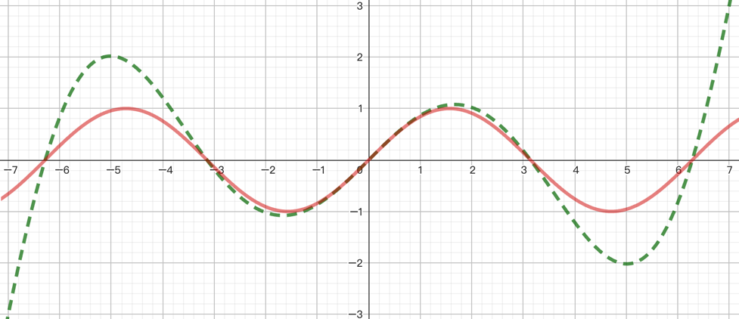
Figure 3 The red line is sin(x), the green dotted line is the polynomial from the expansion using 7 roots.

Now if we expand this polynomial, its corresponding coefficient should be the same as the set of coefficients we’ve worked out from the Taylor expansion. The coefficient of the term $x^{3}$ consists of the sum of the first x multiplying with the quadratic term in each bracket, and that should be equal to 1/6. Therefore:

$$-\frac{1}{π^{2}}-\frac{1}{{\left(2π\right)}^{2}}-\frac{1}{{\left(3π\right)}^{2}}-…=-\frac{1}{6}$$

Therefore:

$$\frac{π^{2}}{6}=\frac{1}{1^{2}}+\frac{1}{2^{2}}+\frac{1}{3^{2}}+\frac{1}{4^{2}}+…$$

What’s behind this sequence is a beautiful generalisation called the Reimann Zeta Function, defined as all the reciprocal of a specific power over all natural numbers, namely:

$$ζ\left(s\right)=\sum_{n=1}^{∞}{\frac{1}{n^{s}}}=\frac{1}{1^{s}}+\frac{1}{2^{s}}+\frac{1}{3^{s}}+\frac{1}{4^{s}}+…$$

We have just witnessed the case of $ζ\left(2\right)$.

One of the interesting properties of this function is that it produces a beautiful pattern when all the input points are mapped to their corresponding output points in the Argand diagram. (For example, the point (2,0) is mapped to ($\frac{π^{2}}{6}$,0)

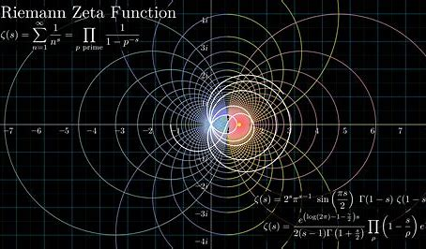
Figure 4. The colourful section on the right showed the Riemann Zeta Function within its domain, with lines signifying the vertical and horizontal lines in the input plane. The white lines are the continued graph outside the domain.

However, the Riemann Zeta Function has its limitations - it only works if.$s∈C, Re(s)≥1$ Everything else outside the domain is undefined.

But mathematicians used the technique of analytical continuation, the fact that the function has to be differentiable at all points (except 1), to produce an extension of this infinite jigsaw outside its domain. In fact, mathematicians have found the graph’s singular extension which satisfies this equation:

$$ζ\left(1 - x\right)= 2^{1-x}π^{-x}\cos\left(\frac{πx}{2}\right) Γ(x)ζ(x).$$

Full proof can be found in (University of Oklahoma, 2010) Section 9.3
Now, if we take x=2, magical things happen. We now yield -

$$ζ\left(-1\right)= -\frac{1}{{2π}^{2}} ζ\left(2\right)= -\frac{1}{12}$$

Yet again, the universe is hinting to us that this infinite sum seems to have a negative value.

  - The Penguin Physicists

In order to understand the problem in a deeper depth, we now have to go space travelling again. This time we have arrived at the planet of penguins. Different to us and the unicorns, the penguins have developed their unique mathematical system. Regretfully, comparing to ours, their system is incomplete. Their system only encompasses polynomial functions (not including the rational functions), and penguin scientists and mathematicians can only use polynomials to express complex relations.

Nevertheless, penguins managed to work their way through. The Taylor penguin developed a technique called the Taylor-Penguin expansion. By summing up the series to infinity, adding and multiplying repeatedly for infinitely times, penguins are now able to define complex functions using merely their system of polynomials. The function,$\sin{x}$, in their mind, looks something like this (note: $3! = 3×2×1$):

$$x-\frac{x^{3}}{3!}+\frac{x^{5}}{5!}-\frac{x^{7}}{7!}+…$$

Using these interpretations, the penguin scientists can achieve results that are accurate and consistent. Every penguin is happy.

One day, one penguin scientist made a noteworthy discovery: some characteristics of their environment follows the following:

$$f\left(x\right)=\frac{1}{1-x}$$

However, the penguins can’t define anything in terms of fractional polynomials. They could only explain this relation by using the permitted language in their system (if you perform long division):

$$p\left(x\right)=1+x+x^{2}+x^{3}+…$$

For us, it’s trivial that whenever the $x≠1$, the function $f(x)$ will give you a meaningful, finite output that corresponds to physical observations.

However, things work out differently for penguins. Dependent on the input of $p\left(x\right)$, the nature of the function varies. When the function is convergent, the penguin mathematicians could perform calculations and obtain results that agree accurately with the measurements that the penguin scientists made.

But problems arise in the divergent areas. Penguins expect that the sum to infinity of this function would be divergent, thus there’s no actual physical significance in the natural world when the function takes this value. However, when the scientists did an experiment with x=2, the result they get is astonishing: $p\left(2\right)=-1$.

For the penguins, this result has absolutely shocked them. From a standpoint of a human mathematician, however, $f\left(2\right)=-1$ was a result that is quite ordinary, unsurprising, and undeniable.

The fundamental problem that has caused this chaotic result in the penguin world is nothing but the very system that their mathematics is based on. The rational function $f\left(x\right)$ defines the relationship that the phenomena actually follow in the physical universe. The penguin mathematicians, however, are limited to comprehending basic polynomials. Therefore, what they have done is merely trying to express this function by brutally summing all the possible terms, of which there are infinitely many. In this way, they have given them an unidentified problem.

If we only consider $p(x)$ we know, and only do we know, that there’s a formula for its sum to infinity:
$$p_{∞}\left(x\right)=\frac{1}{1-x}$$

Starkly, however, neither $p\left(x\right)$, the penguin’s definition, nor $p_{∞}\left(x\right)$, the mechanism the penguins are unintendedly using, reflects the true nature of the universe. They are not fundamentally equivalent, as there is an important prerequisite condition for which equality can be assigned, namely:

$$-1<x<1$$

What happened is that the penguin mathematicians, while forcefully defining the function as a sum of polynomials, have inadvertently modified the domain of the function. $p\left(x\right)$, the function that penguins defined, is only meaningful within $-1<x<1$, as it coincides with the actual function $f\left(x\right)$ in this domain, but meaningless otherwise.

Therefore, in principle, the penguins are not allowed to insert anything beyond the domain for $p_{∞}\left(x\right)$ due to their limited comprehension of the natural phenomenon and their flawed definition - $p\left(x\right)$. However, its fundamental definition in the universe,$f\left(x\right)$, encompass a significantly boarder spectrum of input. That’s why when the value 2 is substituted into the equation, the definition collapses, giving the penguins a result that is absolutely nonsensical if not obviously wrong.

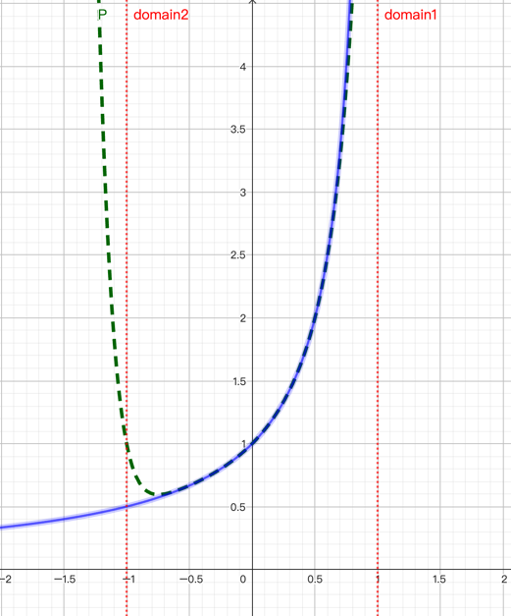
Figure 5. As shown above, the green dotted line represents function $p\left(x\right)$, defined with polynomials up to $x^{7}$, only exhibits the nature of its fundamental definition, $f\left(x\right)$, the blue line, when -1<x<1.

The fundamental issue in this conundrum is the inadequate mathematical framework the penguins have used. Due to this absence of fractional polynomials, the domain for which their definition is meaningful is altered. Plugging in a value outside the domain, therefore, as the penguins have done, would give them a chaotic answer that their system cannot interpret.

That’s why the penguin scientists come to this conclusion:

$$1+2+4+8+16+…=-1$$
or $Σ2^{n}=-1$

  - Are we the Penguins?

Going back to our initial question:

$$1+2+3+4+5+6+… =-\frac{1}{12}$$

Are we that different from the penguins?

Have you realised that when we’re calculating the sum of forces in the Casimir effect, or when we’re summing up all the natural numbers, what we’re essentially doing is just creating an infinite set of values and adding them together? That, fundamentally, is what the penguins are doing when they’re summing up all the powers of an integer. By doing this process, we, like the penguins, altered the domain of the function, making it meaningless when certain values are taken.

$$f\left(x\right)=\frac{1}{1-x} (x≠1) p\left(x\right)=1+x+x^{2}+x^{3}+… (-1<x<1)$$
$$ζ\left(z\right) \frac{1}{1^{z}}+\frac{1}{2^{z}}+\frac{1}{3^{z}}+… Re\left(z\right)≥1$$

So that’s why, with the same disbelief and frustration, we wrote down the equation that gave us many nights of insomnia.

However, in the penguin’s case, the function $f(x)$ that lies outside their realm of understanding, encompassing the very fundamental, essential, and universal definition of the operation of summing powers, was made clear to us. We know that the function $p(x)$ the penguins have defined, is only a fragment of its true meaning, for which it is forever unattainable by merely relying on their incomplete system.

But for us, the function $ζ\left(z\right)$ behind summing all the natural numbers, the function that beholds the universal, substantive, and intrinsic definition, was still unclear to our understanding.

Now, a new question arises: Will we be able to know the true meaning of $ζ\left(z\right)$ in the future, just like the penguins could discover rational functions?

  - Cats and Sets

Suppose we have a mathematical property $∅$, we could define a set that contains all the elements that exhibit the property $∅$. Moreover, Bertrand Russell, the English logician, found out that a set could sometimes contain itself. For example, the set “all the cats” doesn’t contain itself, since the set “all the cats” is not a cat. However, the set “all that is not a cat” does contain itself, as “all that is not a cat” is a set, and a set is not a cat.

In this way, we can create two separate sets, one set that contains all the set that contains itself, and another, let’s say S, contains all the rest – the sets that don’t contain itself.

$$S=\left\{x | x∉S\right\}$$

Now, should the set that contains all the sets that don’t contain itself contain itself? Or more simply, should S contain itself? If S did contain itself, then by definition it shouldn’t contain itself. But if S didn’t contain itself, then by definition it should contain itself. So S contains itself if and only if S didn’t contain itself, the existence of S is therefore logically inconsistent.

  - Proving the Unprovable

Fundamentally, Russell’s Paradox is the direct consequence of reducing mathematics to pure logic, attempting to govern mathematics by a list of axioms which are self-evident, logically true and sufficient to deduce the rest of mathematics from them.

We must be conscious that the strength of the axioms has to be cautiously moderated. On one hand, we need to make them powerful enough so it can be useful. On another, they shouldn’t be too powerful for which we get to prove contradictory results. In simple terms, the set of axioms we select must be logically consistent to prevent paradoxes such as Russell’s.

However, is it ever possible that we can choose the correct set of axioms?

Gödel, the Austrian Mathematician, used logic and mathematics to answer the question from the very system of logic and mathematics. In order to do this, he took all the basic symbols of logic and assigned them with a number, called the Gödel number. For example, the symbol “(“ have a Gödel number of 8. Now, instead of writing the expressions out in mathematical languages, he can write them purely in one number.

Let’s take this statement: For every x there exists a y which x is its immediate successor (2 is the immediate successor of 1).

$$(∃x)(x=sy)$$

Now, we can interchange every logical operation, letter and symbol with their equivalent Gödel number. We then define the sequence $S(n)$ to be the collection of the Gödel numbers.

$$(∃x)(x=sy)$$
$$S(n)=8, 4, 13, 9, 8, 13, 5, 7, 17, 9$$

Now, if we raise the nth prime number to the power of the nth term of S(n), we get a ridicules number, which looks rather like:

2⁸3⁴5¹³7⁹11⁸13¹³17⁵19⁷23¹⁷29⁹

The Fundamental Theorem of Arithmetic guarantees that this prime factorisation is unique, so the funny number above is the representation and the only representation of $\left(∃x\right)\left(x=sy\right)$ in Gödel number. It is possible for us to use this method to find places for all the theorems in mathematics and express them in Gödel numbers, but many of them won’t be very helpful for us, since calculating their size would be impractical.

However, consider the statement G with a Gödel number g which says this – “The statement with Gödel number g has no proof.”

Now think about it. If the statement is false and there is a proof, then what you have proven is there is no proof. That would mean mathematics, the very logical system that Gödel numbers are based on, is inconsistent.

Alternatively, we can say that the statement is true and there is no proof. Fortunately, there’s no contradiction, so the system is consistent. However, we’ve now agreed that there exists a true statement in the mathematical system, for which there’s no proof, so now the system is incomplete.

Gödel tells us that if $ϑ$ is any strong set of axioms for set theory that we define, then the consistency of $ϑ$ can be proved if and only if it’s inconsistent. In simpler words, we would never know if our axiomatic theory were consistent. Even if it’s consistent, it encompasses a certain theory for which there’s no proof, thus incomplete.

  - Is There Anything?

So, starkly, the answer to the initial question is – we don’t know.

We may well never know whether this theory encounters the same situation with the statement G, that there is just no proof for itself. Nor do we know our mathematical system is consistent, since only inconsistency could prove its consistency.

Galileo Galilei once said: "Mathematics is the language in which God has written the universe." However, like penguins, we realised that there are imperfections in our understanding of this language. Maybe, as Gödel suggested, our mathematical system is inconsistent, that a divergent sequence could eventually sum up to a negative number. Alternatively, our mathematical system can be incomplete, that the lack of knowledge of $ζ\left(z\right)$ and the absence of truth of the universe have inevitably thwarted us to a true comprehension of mathematics.

- From Nothing to Everything

The story of penguins doesn’t end there.

One day, one penguin comes along with a method to calculate the sum $p\left(2\right)$ She times it by two and subtracts the original sequence, getting the solution $p(2)=-1$

$$p\left(2\right)=1+2+4+8+…$$
$$2p\left(2\right)=2+4+8+…$$
$$p\left(2\right)=-1$$

The other penguins did not appreciate the result. They argue that to assign a value to a convergent series is fundamentally incorrect, and that’s the reason why this absurd result is attained.

But if we generalise this penguin’s idea:

$$p\left(x\right)=1+x+x^{2}+x^{3}+…$$
$$xp\left(x\right)=x+x^{2}+x^{3}+…$$

Interestingly, we can subtract the second equality with the first one to form $f\left(x\right)$:

$$\left(1-x\right)p\left(x\right)=1 ↔ p\left(x\right) \sim f\left(x\right)=\frac{1}{1-x}$$

By doing this operation, we’ve implied that the function $p\left(x\right)$ is actually another form of $f\left(x\right)$, its fundamental and universal definition. But for the penguins, for whom their own mathematical system has forbidden this operation, this result is outrageous.

What this penguin have done is merely assigning values to the expression and subtract them. But this operation, which is considered illegal in their system, has enabled the penguins to glance at the true identity of the infinite polynomial and get the rightful and meaningful answer without knowing rational polynomials, its fundamental definition.

Maybe many years later, our mathematicians could discover the fundamental meaning of summing up natural numbers, like the penguin scientists if they can discover rational polynomials. Therefore, it doesn’t mean that all the results that we get now are meaningless. In contrast, by using renormalisation and infinite summing, we can get a closer glance at the truth behind the superficial system that we’ve defined, the underlying reality that forms the foundations of the universe.

Reference
David Jekel, University of Washington. (2013). The Riemann Zeta Function. [online] Available at: https://sites.math.washington.edu//~morrow/336_13/papers/david.pdf [Accessed 24 Mar. 2024]
Dr David Tong, String Theory University of Cambridge Part III Mathematical Tripos. (2009) [online] Available at: https://www.damtp.cam.ac.uk/user/tong/string/string.pdf. ‌‌
Oxford Mathematics, www.youtube.com. (n.d.). Set Theory - Russell’s Paradox: Oxford Mathematics 3rd Year Student Lecture. [online] Available at: https://www.youtube.com/watch?v=gxm1Ur_Be0s
Author, N. (2002). The Casimir effect: a force from nothing. [online] Physics World. Available at: https://physicsworld.com/a/the-casimir-effect-a-force-from-nothing/#:~:text=The%20attractive%20force%20between%20two.
Singh, S. (1997). Fermat’s Last Theorem. ‌
The University of British Columbia. Cauchy’s criterion for convergence. (n.d.). Available at: https://personal.math.ubc.ca/~cass/courses/m220-00/cauchy.pdf. ‌
University of Oklahoma. Analytic Continuation of the Riemann Zeta Function 9.1 Integral Representation. (2010). Available at: https://www.nhn.ou.edu/~milton/p5013/zeta.pdf.
(Bilibili, n.d.) [online] www.bilibili.com. Available at: https://www.bilibili.com/video/BV1si4y1p75k/?spm_id_from=333.999.0.0 [Accessed 23 Mar. 2024]. ‌
(3Blue1Brown, n.d.) www.youtube.com. (n.d.). But what is the Riemann zeta function? Visualizing analytic continuation. [online] Available at: https://www.youtube.com/watch?v=sD0NjbwqlYw&t=553s [Accessed 24 Mar. 2024]. ‌
(Veritasium, n.d.) (2021). This is Math’s Fatal Flaw. [online] www.youtube.com. Available at: https://www.youtube.com/watch?v=HeQX2HjkcNo. ‌

