Bachian Mathematics
Gaayathiri Srikanthan
The Henrietta Barnett School for Girls

“It turns out that an eerie type of chaos can lurk just behind a facade of order - and yet, deep inside the chaos lurks an even eerier type of order.”
― Douglas R. Hofstadter, Metamagical Themas, Questing for the Essence of Mind and Pattern

In his apology, the aging Hardy famously stated, “The mathematician’s patterns, like the painter’s or the poet’s must be beautiful; the ideas like the colours or the words must fit together in a harmonious way. Beauty is the first test: there is no permanent place in the world for ugly mathematics.” At its crux, Hardy argues that the real virtue of pure mathematics is not its potential application but its ubiquity and elegance; its omniscient presence in fields such as music and art and its recurrence in nature. In a period of seismic political, religious and economic upheaval in seventeenth century France, theologians and philosophers Antoine Arnauld and Pierre Nicole state that studying mathematics “cultivates epistemic virtues” and “deepens piety” in their heavily influential ‘Logic or the Art of Thinking’ which was a response to the Catholic Jansenist movement.
A man who undoubtedly understood both piety and discipline was none other than Johann Sebastian Bach whose music is often regarded as ‘mathematical’ due to its impeccable structure and symmetry. J.S. Bach was a German composer of the Baroque period and is arguably the greatest composer of all time. As Ramanujan credited his substantial mathematical capabilities to the divine, Bach’s devout relationship with God could be encapsulated by his own words as he famously said, “The aim and final end of all music should be none other than the glory of God and the refreshment of the soul," which bears a great deal of similarity with Arnauld and Nicole’s understanding of why one pursues mathematics. At the end of his compositions, Bach would inscribe the letters “S.D.G” (Soli Deo Gloria- “Glory to God Alone” and in the margin of, what some consider to be ‘the most significant piano work of the millennium’, the six-voiced Ricercar from Bach’s A Musical Offering, he wrote, “As the modulation rises, so may the King’s Glory”.
On that note, ‘A Musical Offering’, dedicated to King Frederick II of Prussia, is a collection of canons and fugues which are based on The Royal Theme.
The Royal Theme

A canon is a musical form and executed by playing an initial melody, which is then followed by an imitation of the melody after a set duration whereas a fugue is a musical composition in which one or two themes are repeated or imitated by successively entering voices and contrapuntally developed by interweaving the voice parts.
The ‘Musical Offering’ consists of 10 canons and is considered some of his most intricate and complex canons and Bach never wrote them out in full and left it was a puzzle for King Frederick to put together. Canons could vary in starting note and length, often overlapped and even sometimes played backwards (this is known as a retrograde copy), highlighting the sheer genius of Bach. In Hofstadter’s notable ‘Gödel, Escher, Bach’ he likens these canons to isomorphisms as canons are transformations of each other whilst preserving the primary information. In mathematics, we encounter isomorphisms in mathematical fields such as group theory, topology and graph theory; however we can extend these ideas and apply them to much more abstract concepts. One can see, here, that it is not strictly mathematics which is present in these canons but mathematical thinking and approaches, such as the heavy dependence on structure and symmetry. Making significant contributions to matrix theory and combinatorics, English mathematician, JJ Sylvester summarises this in his own words stating “May not music be described as the mathematics of sense, mathematics as the music of reason, the soul of each the same?”

In order to demonstrate how inextricably intertwined mathematics and music truly are, it is crucial to grapple with the very foundations of harmony and the underlying mathematics in what is understood as Western music. Credited with being the ‘Father of Mathematics’ and the ‘Father of Music’, it is safe to say that not only Pythagoras but also his philosophy were pivotal in forging this marriage between mathematics and music. As Aristotle put it, the Pythagoreans thought “the whole heaven to be a musical scale and number,” and this can be seen in the ratios which are believed to produce consonant sounds. By discovering that plucking a taught string and then plucking another with half its length produces two notes which are an octave apart, the Pythagoreans developed this to come to the conclusion that string lengths in the ratio of 2:1, 4:3 and 3:2 produce harmonious intervals of an octave, a fourth and a fifth, respectively. These 3 intervals are the very foundations of the Western understanding of harmony and Pythagoras himself went onto believe that as the numbers 1,2,3 and 4 sum to 10, the number 10 was the key to developing a theory of the universe and understanding nature. In his ‘Classic History of Ancient Math’, Dutch mathematician B.L. van der Waerden wrote, “Pythagoras freed mathematics from these practical applications,” which reminiscent of Hardy’s understanding of mathematics’ importance. He also states that “The Pythagoreans pursued mathematics as a kind of religious contemplation, as a way to approach the eternal Truth,” and I draw your attention to the words “religious contemplation,” which brings us back to the devout and pious Bach.
As Pythagoras believed 10 to be a sacred number, J.S. Bach took advantage of the advantage of the mathematical and musical properties of the number 14. It is believed that his attachment to 14 may have come about by the practice of Gematria, an ancient tradition dating back to Sargon II of Assyria in the 8th century BC, where one substitutes letters for numbers from 1 to 26 (A=1, B=2 …Z=26). If you sum the digits which spell out Bach (2,1,3,8) you are left with 14. Going back to the idea of canons, Bach in fact wrote 14 canons which he titled in German “Verschiedene canones über die ersteren acht Fundamental Noten vorheriger Arie aus den Goldberg-Variationen,” or “Various Canons on the First Eight Bass Notes of the Preceding Aria”. If we look at Canon 5 of the 14, we can see that one is a reflection of the other and has been shifted left. (Almost like a graphical transformation!)

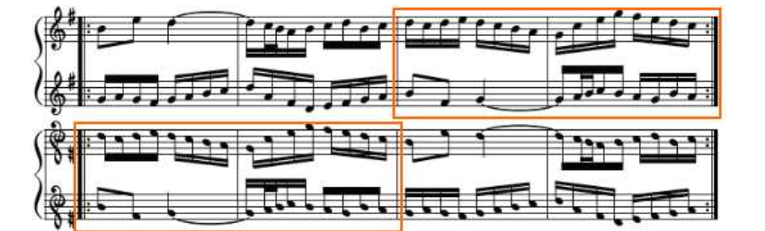

Top voices of Canon 5

Where things get even more bizarre, is when encoding these canons on a Möbius strip. A Möbius strip is defined as a surface that can be formed by attaching the ends of a strip of
paper together with a half-twist.

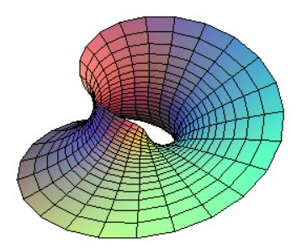

Möbius Strip

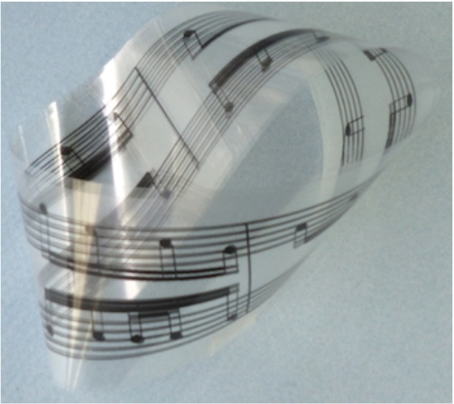
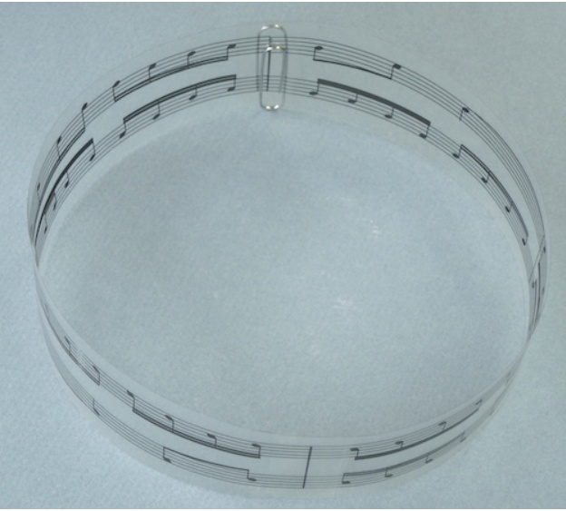

The score of the two upper voices of
Canon 5 printed on a cylinder
The cylinder wrapped twice on itself, with a twist, to form a Möbius strip.

.

The miraculous thing is, that the notes on one side are the same on the other and one can play this whilst running round the Möbius strip, and when you get to the other side of the strip, you would be playing the reflection, (the reflected canon) creating a harmonious tune. Similarly, one can do the same with his ‘Crab Canon’. In the Musical Offering, mentioned prior, Bach provides the player instructions and can be seen as a set of puzzles to solve. For example, the Crab Canon presents an eight-note Goldberg motive and instructs the player to play it forwards and backwards simultaneously (denoted by the inverted soprano clefs present at the start and end) and the player must figure out when the second voice should be introduced to make the canon make sense.
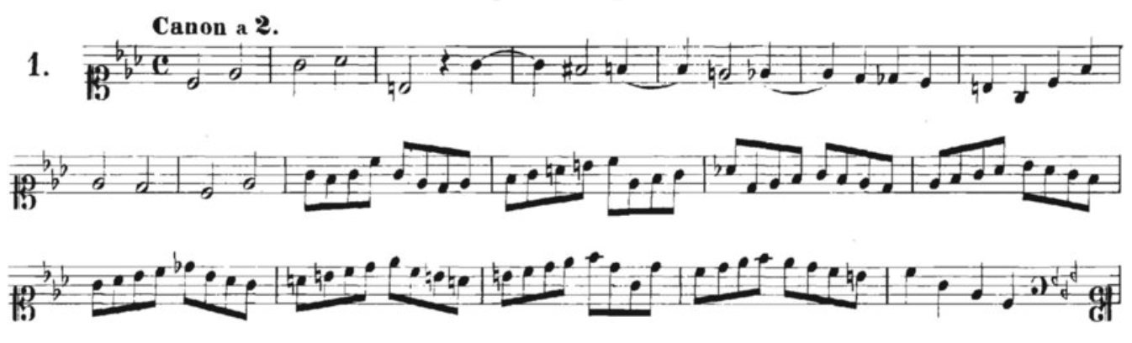

The original music score of the ‘crab canon’ from the musical offering of J. S. Bach BW1079.

For Bach to be able to construct such a puzzle, requires him to almost hear both the forward and backward motive at the same time which is prominent sign of his genius and the wizardry of his canons. Both the Möbius strip and Bach’s canons share the property of symmetry and reflection; if a two-dimensional object slides one time around the strip, it returns to its starting position as its mirror image, which somewhat explains this phenomenon. It would be wrong to dismiss these subtleties as mere coincidences and in fact studying his work reveals that there is an almost overwhelming amount of depth in the decisions Bach makes from each inversion, retrograde and shift. By making the connection between the topological properties of a Möbius strip and the intricate orientations of his canons, we are able to appreciate the sheer intellect, erudition and skill possessed by J.S. Bach and is a fine demonstration of how his work not only reveal musical patterns but also mathematical ones.

“Music is a hidden arithmetic exercise of the soul, which does not know that is counting” – Gottfried Leibniz.
When one considers the ubiquitous property of mathematics in nature and art, the first thing that comes to mind it the golden ratio.
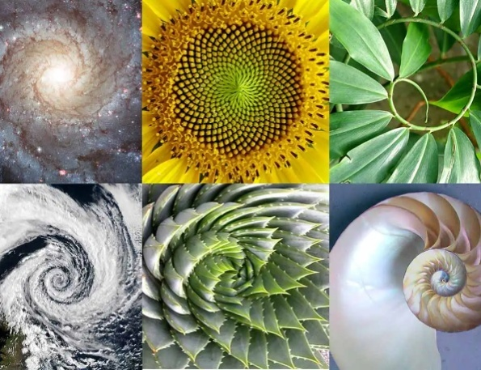
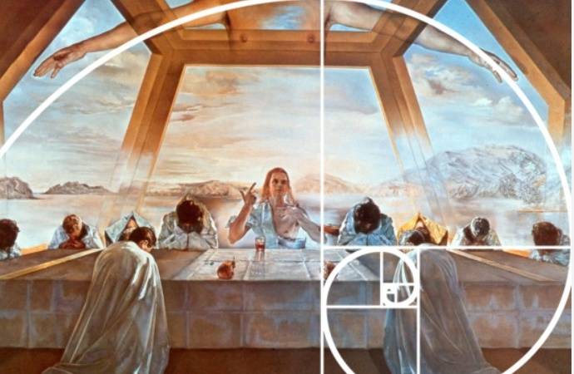
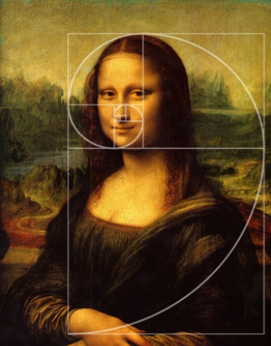
The golden ratio is derived from the Fibonacci sequence; a sequence, established by Leonardo Fibonacci in 1202, where each successive term is constructed by adding the previous terms and is often used to reflect geometric harmony found in nature.

0,1,1,2,3,5,8,13,21,34,55,89
First few terms of the Fibonacci Sequence
When dividing terms by the term prior, for example:
1/1 = 1
2/1 = 2
3/2 = 1.5
5/3 = 1.667
13/8 = 1.625
21/13 = 1.61538
34/21 = 1.619047
55/34 = 1.61765
89/55 = 1.61818

We can see that the answer tends to 1.618 which is considered as the golden ratio. The Fibonacci sequence can also be written as a quadratic: x²-x-1=0 which has solutions (1 ± √5)/2 and (1 + √5)/2 ≈ 1.618. Interestingly, we find this ratio scattered across Bach’s music and in what famed musicologist Charles Rosen considers ‘the most significant piano work of the millennium’, The Art of Fugue, is the subject of Loic Sylvestre and Marco Costa’s research into this sensation. To understand this research one must understand counterpoint which is a compositional technique in which two or more melodic lines or voices complement one another but act independently and musicians consider J.S. Bach to be the ‘King of Counterpoint’ as it is his abundant use of counterpoint which makes his music so rich and intricate. If we divide the 14 fugues into 7 the first 1-7 and the 8-14, the first subset contains 602 bars and the second subset consists of 988 bars.

988/602 = 1.641….

Furthermore, the first 7 fugues have a total of 602 counterpoints and the total number of canons of the 14 fugues is 372.
602/372 = 1.618…

On top of this, the sum of the number of counterpoints in all 14 fugues is 1590 and the sum of the number of counterpoints in the second subset is 988.

1590/988 = 1.609

All of which are eerily close to the golden ratio! Research also shows that many of Bach’s works, such as his famous Prelude no.1, reach their climax, in terms of harmony or rhythm, in accordance to the golden ratio, by taking the number of bars and multiplying by (1 -√5)/2 (0.618). The golden ratio is not just found in Bach but also in Beethoven’s Fifth Symphony and Handel’s Messiah, proving its omnipresence and regardless of whether this ratio is present by coincidence or not, it is certainly worth appreciating.

To conclude, it is clear that J.S. Bach’s work is riddled with mathematics, and the mathematical nature of his work is substantial reason as to why it is so captivating and disciplined, simultaneously. Bach’s devotion to God is embodied in his music and it is in his work which he was able to express his piety; exploring what matters most to him with music as his medium. I argue that mathematicians, similarly, try to make sense of what is around them through the medium that is mathematics and at its heart, the universe is a mathematical construct. Mathematics is not necessarily about the crunchy numbers and at its core, there is something far more supreme; the mathematical skills and deep rooted appreciation for connections and patterns. Pythagoreans believed that the world could be understood with numbers and hoped that reality and models of reality would in fact be somewhat ‘isomorphic’ however as Einstein states, “It would be possible to describe everything scientifically, but it would make no sense. It would be a description without meaning—as if you described a Beethoven symphony as a variation of wave pressure.” We see that these two distinct worlds (J.S. Bach’s music and mathematics) can be joined by mathematical principles and thinking, shedding light on its power. The beauty of mathematics is its utility in grappling with the mysteries of our world and it is a vessel which enables us to explore the harmony in infinity and beyond.

References:
A Mathematician’s Apology- G.H. Hardy (1940)

Logic or the Art of Thinking- Antoine Arnauld and Pierre Nicole (1662)

Gödel, Escher, Bach- Douglas R. Hofstadter (1979)

Geometry and Algebra in Ancient Civilizations - B. L. van der Waerden (1983)

Bach as a Mathematician- David H Bailey (2021)-
https://mathscholar.org/2021/06/bach-as-mathematician/

The Mathematician’s Patterns, like those of the Composer, Must Be Beautiful - Peter Lynch (2017)
https://www.irishtimes.com/news/science/the-mathematician-s-patterns-like-those-of-the-composer-must-be-beautiful-1.3096020

Music on a Clear Möbius Strip - Marcus Du Sautoy (2021)
https://www.youtube.com/watch?v=sToqbqP0tFk&embeds_referring_euri=https%3A%2F%2Fwww.openculture.com%2F&source_ve_path=MjM4NTE&feature=emb_title

Bach’s Favorite Number- Claire Rubio (2022)

https://veritasjournal.org/2022/12/15/bachs-favorite-number/

Surface Topology in Bach Canons, I: The Möbius strip- Tony Phillips (2016)

http://www.ams.org/publicoutreach/feature-column/fc-2016-10

The Mathematical Architecture Of Bach's "The Art Of Fugue" - Loïc Sylvestre and Marco Costa (2010)

https://www.jstor.org/stable/43030058?seq=1

How Pythagoras turned math into a tool for understanding reality - Tom Siegfried (2023)

https://www.sciencenews.org/article/pythagoras-math-reality-music-spheres

