The Platonic Solids
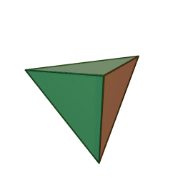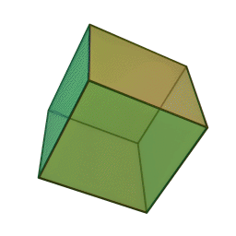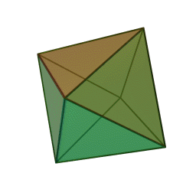
Tetrahedron Cube Octahedron
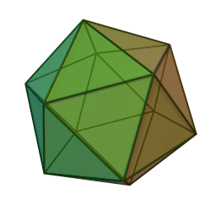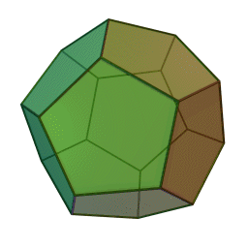
Dodecahedron Icosahedron

The Platonic solids (the Tetrahedron, Cube, Octahedron, Dodecahedron, Icosahedron) have long captured the human imagination. The history of the Platonic solids began with their namesake, Plato. In his dialogue Timaeus, he associated each of the Platonic solids with a classical element, which were once thought to be the building blocks of the universe. The Tetrahedron, with its sharp points and defined edges, were associated with the dynamic nature of fire. The stable Cube was associated with the steady Earth element while the open and smooth geometry of the Octahedron was related to the element of Air. The Fluid shape of the Icosahedron reflected in the element Water. Of the Dodecahedron, Plato himself proclaimed that "...the god used [it] for arranging the constellations on the whole heaven".
The theory of the Classical Elements has long declined in scientific thought, superseded by more rigorous explanations of Matter and Energy. While the Platonic solids may not have the divine properties that the Ancient Greeks once bestowed upon them, they still hold significance as a representation of Geometric beauty and harmony. They have also found new applications due to their highly symmetrical nature. They remain foundational in understanding Three-Dimensional geometry, aid in modelling molecular structures, biological structures, crystal formation and will surely continue to find other applications in the future.

Platonic solids are a subset of Polyhedrons, A three-dimensional shape where all the surfaces of the shape are Polygons. However, Platonic solids have the additional conditions of being convex regular Polyhedrons, where Regular Polyhedrons can be described as Polyhedrons that are congruent to each other at each “part”.

The rules for polyhedrons/platonic solids are as follows:
- All edges of the Polyhedron are congruent
- All angles formed between two edges are congruent
- All vertices have the same number of edges meeting at that vertex
- All angles formed from faces which share an edge are congruent
Regular Polygons have sides and angles that are congruent to one another (eg. A congruent equilateral triangle has 3 equal angles and 3 equal sides). The conditions that all the edges are congruent, and all angles formed between 2 edges implies that the faces of regular Polyhedrons are congruent, regular Polygons. The Tetrahedron, Octahedron and Icosahedron are all formed from equilateral triangles. The Cube consists of Squares. The Dodecahedron is built from regular Pentagons.
Fulfilling the above criterion, the five regular convex Polyhedrons are indeed Platonic Solids. Yet, as we explore the geometrical properties of these Polyhedrons, one question remains. Are there any other Platonic Solids?
Euler’s Polyhedral Formula
To look for other convex regular polyhedrons, we use Euler’s Polyhedral formula. The formula states that for any convex Polyhedron, with the number of vertices (V), edges (E) and faces (F):
V – E + F = 2

Polyhedron | V | E | F | V – E + F
Prism | 6 | 9 | 5 | 2
Cube | 8 | 12 | 6 | 2
Pyramid | 5 | 8 | 5 | 2
Tetrahedron | 4 | 6 | 4 | 2
Icosahedron | 12 | 30 | 20 | 2
Dodecahedron | 20 | 30 | 12 | 2
Stellated Icosahedron | 32 | 90 | 60 | 2

To prove Euler’s Polyhedral Formula, we represent a Polyhedron as a Planar Graph (G). Under the Graph Theory, “Graphs” become a collection of vertices and lines that are used to model the relation between objects.
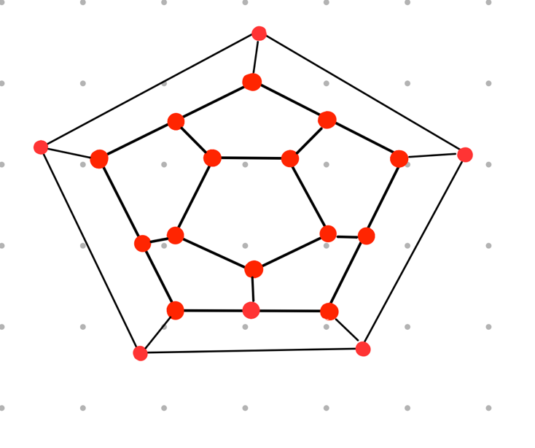
In this case, we use a Planar Graph to model a Dodecahedron. After “removing” one face of the Dodecahedron and flattening the remaining structure A planar graph is formed out of dots, lines and regions between the lines, where dots are equivalent to vertices (V), lines to edges (E) and regions as faces (F) of the Dodecahedron. The area “outside” of the Planar Graph can be thought of as the face that has been “removed” in the first step.
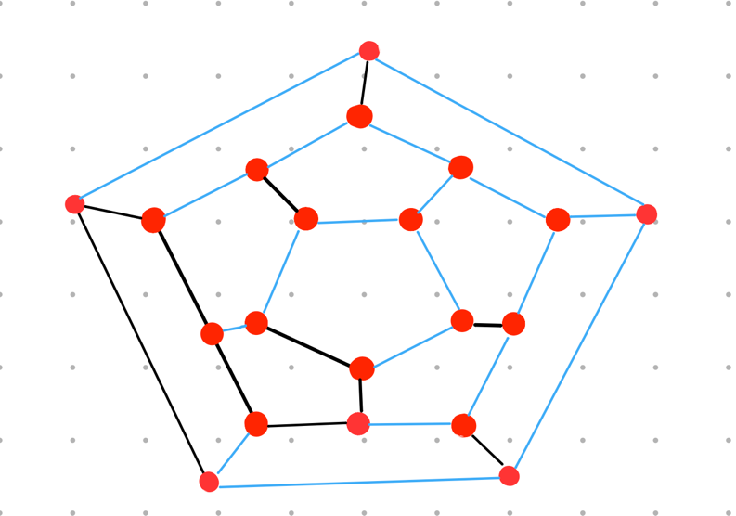
Next, we form a spanning tree. A spanning tree is a connected graph that connects all vertices and has no circuits (which can be thought of as a closed loops of edges). Starting from any of the vertices, “trace” out the minimum number of edges that would connect the dot to all other dots in the Planar Graph. Tracing out the minimum number of edges implies that no additional edges can be traced between two points that are already connected in the spanning tree, so there are no closed loops formed in the spanning tree. The spanning tree is traced out in blue in the diagram

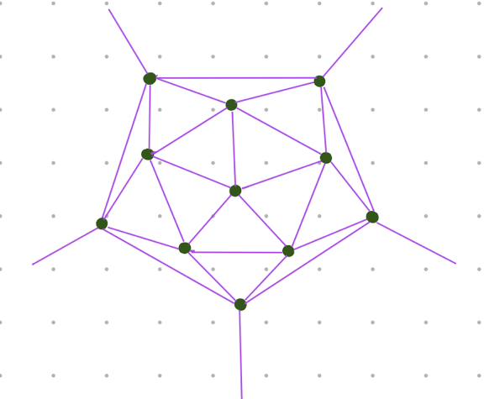
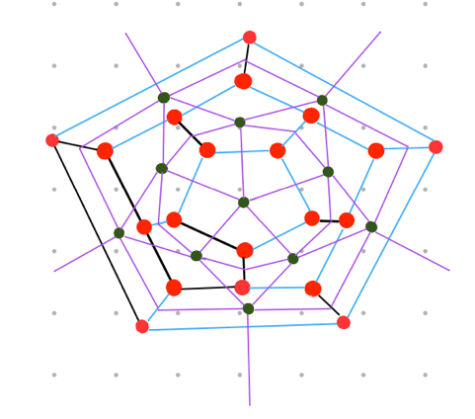
Now, we draw the Dual Graph of the Planar Graph (G), let the Dual Graph be (G’). The Dual Graph of the Planar Graph (G) is a Planar Graph that has a vertex for every face in (G) and a face for every vertex in (G). Draw a vertex in the centre of each of the faces of the Planar Graph. Connect the vertices by drawing edges, with each edge crossing over each edge in the original planar graph. In the new Dual Graph formed, the vertices of the dual graph represent the faces (F), the edges represent the edges (E) and the faces now represent the vertices (V).

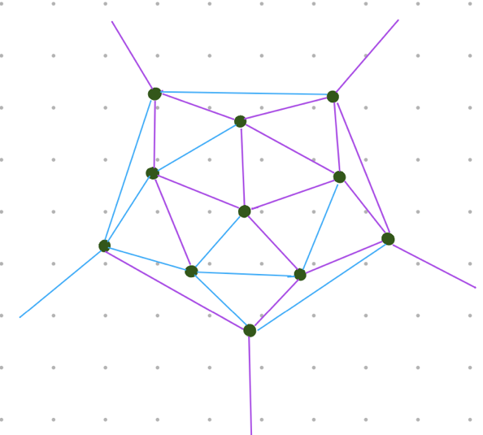
With the Dual Graph formed, we can form another spanning tree by connecting the dots on the Dual Graph to one another. We restrict the new spanning tree to be unable to cross over any of the lines in the spanning tree of the original Planar Graph. As it turns out, the new spanning tree is always able to be formed without crossing over the lines of the spanning tree of the Planar Graph. This is because the spanning tree does not form any closed loops. Thus,

The total number of lines of the Planar Graph (E) = The total number of lines in the first spanning tree and the second spanning tree
as each line of the Planar Graph is either traced over by the lines of the first spanning tree or crossed over by the spanning tree of the Dual Graph.

Beginning with one vertex and no edges, with each additional vertex connected to a spanning tree, an additional edge is added to the tree. After all the vertices have been connected,
The number of vertices in a spanning tree = The number of edges in the spanning tree + 1

From the first spanning tree,
V = number of edges in the first spanning tree + 1
From the second spanning tree,
F = number of edges of the second spanning tree + 1
Summing the results,
V + F = E + 2
Thus,
V - E + F = 2

Other Platonic Solids?
Armed with Euler’s Polyhedral formula, we can prove the that the five Platonic solids are an exhaustive list. We introduce the Schläfi Symbol of polyhedrons {n,r}. Every face of a Platonic Solid are regular Polygons, n stands for the number of sides on each face of a solid. The number of edges at each vertex is the same at every vertex for a Platonic Solid, r stands for the number of edges that meet at each vertex.

Polyhedron | V | E | F | n | r
Tetrahedron | 4 | 6 | 4 | 3 | 3
Cube | 8 | 12 | 6 | 4 | 3
Octahedron | 6 | 12 | 8 | 3 | 4
Dodecahedron | 20 | 30 | 12 | 5 | 3
Icosahedron | 12 | 30 | 20 | 3 | 5
For a platonic solid, we draw a Planar Graph and draw a “tick” on each edge surrounding a vertex. Below, we use the Planar Graph of the Octahedron as the example.
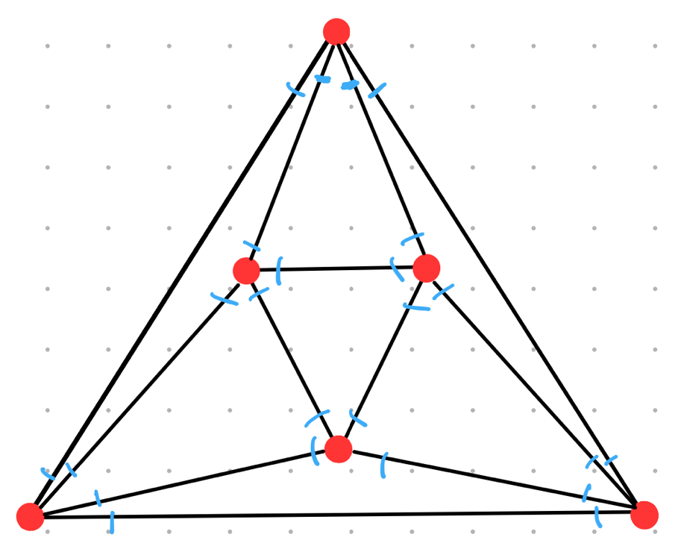
In the diagram, each edge contains 2 ticks as there is a tick at each of the end points of an edge. We also place r ticks at each vertex as each vertex has r ticks for every edge meeting at that point. By equating the total number of ticks,
2E = rV

Now, on the same diagram, draw a tick on each vertex surrounding each face (do not forget that the region surrounding the Planar Graph is also a face)
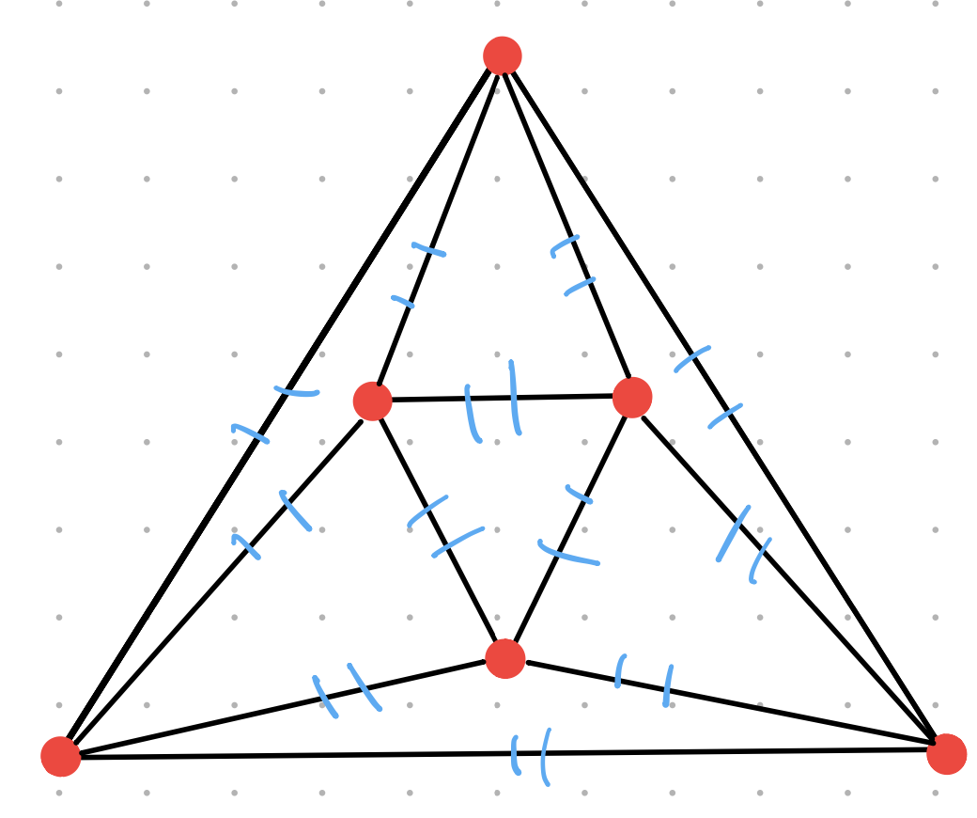
In the diagram, each edge contains 2 ticks as every edge is shared by 2 faces. As discussed There are F faces in the diagram and n ticks surrounding each face, as each face is surrounded by n edges. By equating the total number of ticks,
2E = nF
We now substitute the two equations into Euler’s Polyhedral Formula,
V – E + F = 2
${2E}/r$ – E + ${2E}/n$ = 2
$1/r$ – $1/2$ + $1/n$ = $1/E$
$1/r$ + $1/n$ = $1/E$+ $1/2$
Since $1/E$+ $1/2$ $>$ $1/2$,
$1/r$ + $1/n>$ $1/2$
This relationship implies that r and n cannot be too large. For large values of r and n,
$1/r$ + $1/n<1/2$
n and r also are also greater than or equal to 3. The Faces of Polyhedrons are Polygons, of which the triangle has at least 3 sides. Thus, n $≥$3. r $≥$3 too, if r = 2 the solid formed would be a 2 dimensional.
For n = 3,
$1/3$+ $1/r$ $>$ $1/2$
$1/r$ $>$ $1/6$
$6$ $>$ $r$
For n = 3, the possible values of r are 3,4 and 5.
For n = 4,
$1/4$+ $1/r$ $>$ $1/2$
$1/r$ $>$ $1/4$
$4$ $>$ $r$
For n = 4, the only possible value for r is 3.
For n = 5,
$1/5$+ $1/r$ $>$ $1/2$
$1/r$ $>$ $3/{10}$
${10}/3$ $>$ $r$
For n = 5, the only possible value for r is 3.
For n $≥$6
$$1/n≤1/6$$
$1/n$+ $1/r$ $>$ $1/2$
$1/r$ $>$ $1/3$
$3$ $>$ $r$
Thus, for n$≥$6, there are no possible values of r as r $≥$3
The only possible Schläfi Symbols are thus {3,3}, {3,4}, {3,5}, {4,3} and {5,3}. {3,3} represents the Tetrahedron, made up of equilateral Triangles with 3 edges that meet at each vertex. {3,4} corresponds to the Octahedron, which consists of equilateral Triangles with 4 edges that meet at each vertex. {3,5} is the Icosahedron, also made up on equilateral Triangles with 5 edges that meet at each vertex. {4,3}, the Cube is made up of Squares, with 3 edges that meet at each vertex. Lastly, the Icosahedron {5,3} is made up Pentagons, with 3 edges at each vertex.
Therefore, we have answered the question of “How many Platonic Solids there are”. With Euler’s Polyhedral Formula and some Algebraic Manipulation we have proven that there are only 5 Platonic Solids. Although small in number, the Platonic Solids will always continue to capture the human imagination because of their unique geometry and symmetry.

Appendix
GfG. (2023, October 13). Spanning Tree. GeeksforGeeks. https://www.geeksforgeeks.org/spanning-tree/
Platonic solids - definition, properties, types, examples, faqs. Cuemath. (n.d.). https://www.cuemath.com/geometry/platonic-solids/
Scheinerman, E. R. (2021). The mathematics lover’s companion: Masterpieces for everyone. Yale University Press.
Wikimedia Foundation. (2024, March 17). Platonic solid. Wikipedia. https://en.wikipedia.org/wiki/Platonic_solid
YouTube. (2015, June 21). Euler’s formula and graph duality. YouTube. https://www.youtube.com/watch?v=-9OUyo8NFZg&ab_channel=3Blue1Brown

For the region that surrounds the Planar Graph, imagine that the edges of the Dual Graph travel to infinity to meet the vertex that corresponds to this region

