Unveiling perspective: Exploring Projective Geometry
Katerina Stone

Geometry is the study of shape and space. It is my favourite topic because it is very visual, and I think it is incredible how mathematicians can describe shape and space solely using numbers and equations. Excitingly, geometry, a tool that can construct a space, can also construct how we view that space. This is known as projective geometry. In this essay, I hope to explain how and why projective geometry works.

- The basics

There are many geometries.

One of these is Euclidean geometry, named after Euclid, which concerns how geometric figures (lines and circles) can be constructed in the 2D plane, with a straightedge and compass alone. It is the earliest geometry, and its foundation lies on 5 rules, also known as axioms or postulates.

Until the 19th century, Euclidean geometry was expected to underpin every other geometry. This meant that every geometry should, without fail, follow the postulates that Euclid set out.

Then special geometries that broke some of these 5 postulates were discovered, referred to as non-Euclidean geometries. For instance: hyperbolic geometry, which concerns construction of geometric figures on a curved, hyperbolic plane. Mathematicians realised that it was improper to expect Euclidean geometry to support all other geometries, because it couldn’t and didn’t. Hence Euclidean geometry does not underpin all geometries.

However, all geometries after Euclid’s, even the non-Euclidean ones, arose as deviations of Euclidean geometry. This means that although these geometries all follow their own unique axioms, these axioms are just modifications or inspirations of Euclid’s postulates. Therefore, in order to understand the axioms of projective geometry, we must first meet its ancestors: the 5 Euclidean postulates.

They are as follows:

- Any two points will have a unique straight line that will go through both points
- A straight line can be extended infinitely in both directions
- A circle can be drawn at any given point with any given radius
- All right angles are congruent
- For any line and any given point not on the line, there is exactly one other line that goes through the point and doesn’t meet the line (i.e. parallel lines exist)

Postulates and axioms are statements of absolute truth. You can completely rely on them to build any proof or inference because they are self-evident.

The influence of these postulates is great. The first three alone allow you to construct the equilateral triangle, the most basic regular polygon, and the most important polygon, because any polygon can be built from triangles.
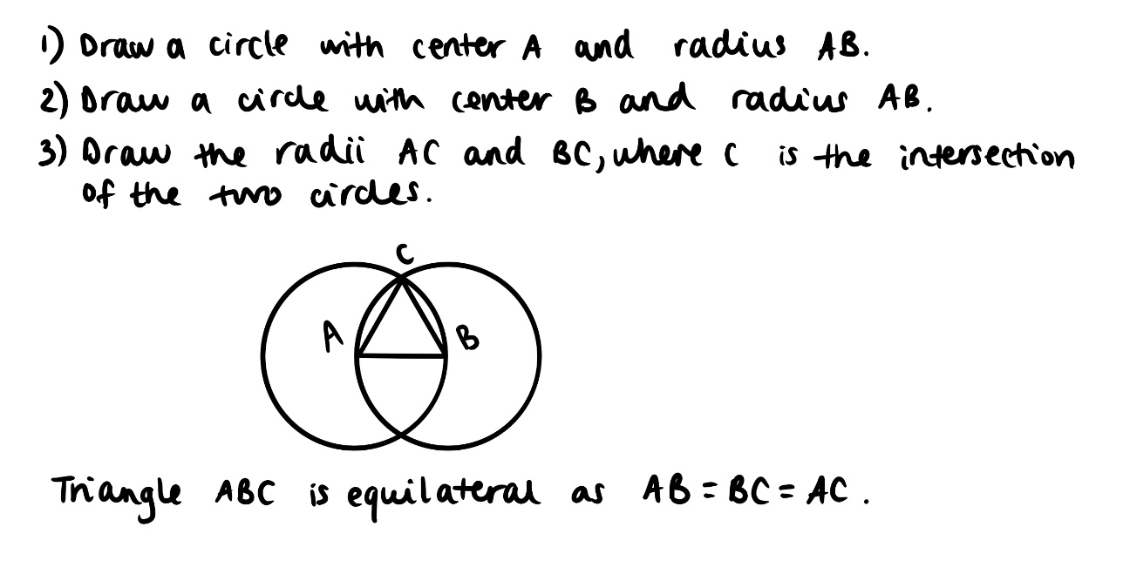

Thus, it can be observed that the presence of these postulates is critical. You can imagine how far you can go with them when you start combining the raw postulates with derived concepts, like the equilateral triangle, to obtain more axioms with you can use to prove more concepts which lead to more theorems and henceforth.

- Preparation to understand projective geometry

Like any other geometry, projective geometry has its own axioms. We will modify Euclid’s postulates to obtain these, just like with any other geometry.

Additionally, we need a few other tools, and we will obtain these in two steps: firstly, something John Stillwell refers to as the ‘arithmetisation of geometry’, and secondly, meeting the Desargues Theorem. Understanding of these tools will greatly help to later explain why projective geometry works.

2.1 Modification of axioms

To tackle this, we need to clearly define the distinctions between Euclidean and projective geometries.

Euclidean constructs geometric figures. Projective constructs how we perceive those same figures. It constructs how a person actually in the scene would view it. Hence, Euclidean does concern length and angle measure, whilst projective doesn’t. Projective geometry has no concept of distance because there is no need to draw figures of a particular length or of equal size, we only need to draw figures that look like they are of a particular length or of equal size.

This also neatly explains why Euclidean geometry uses straightedge and compass for construction whereas projective geometry uses straightedge alone. In Euclidean geometry, it is only the compass that is a store of length because you can redraw radii of a chosen length by not changing the angle of the compass. The straightedge is not a ruler and cannot contain numerical lengths. Therefore, as projective geometry has no need for distance or length, the compass is not used. Projective geometry is intrinsically non-metrical.

The projective geometry axioms, and their modification from Euclid’s postulates and subsequent reason for it, are as follows:

- Any two points are contained in a unique line.

Modification: none, same as Euclid’s first postulate.

- Any two distinct lines have at least one point in common.

Modification: Euclid’s fifth parallel postulate is modified because now all lines have another line with which they share at least one point, there are no exceptional pairs of lines, and hence parallel lines also meet at a common point.

Reason: Despite seeming counter-intuitive at first, from human perspective, no lines will ever be parallel because they all meet at a special line called the horizon. Imagine a train track as below:


We can see that the tracks are parallel, and yet they meet at a point on the horizon. Note that despite being singled out, the horizon line behaves as any other line would and is subjected to all the same laws. Mathematicians call the horizon the ‘line at infinity’ and the common point at which the parallel lines meet is the ‘point at infinity’ (artists call this the vanishing point).

- There is a set of four distinct points, no three of which are collinear.

Modification: none, it is a new axiom.

Reason: This ensures that there are enough points for our construction to be ‘interesting’. If we let the four distinct points be the four vertices of a quadrilateral, for instance, we can interpret it to be the plane on which we construct a design in perspective, such as a tiled floor pattern. Moreover, by stating that there exists a set of three non-collinear points, we ensure that we work in a finite scheme, not in a continuum like the Euclidean plane, because the real world is not an infinite continuum.

Notice how Euclid’s third axiom about construction of a circle has been omitted as projective geometry only concerns straightedge constructions. Also notice how Euclid’s fourth axiom about right angle congruence has been omitted as projective geometry is involved with no angle measurement (or length for that matter), therefore concepts and axioms regarding congruence or similarity are inapplicable.
In all fairness, different mathematicians over time have discovered different approaches to setting up projective geometry axiomatically, and all the approaches vary slightly in their axioms. This happens because projective geometry is much more relaxed than Euclidean in terms of rules, since distance and length have been removed, and therefore points at infinity (on the horizon) have the same status as any other point i.e. the points at infinity being an infinite ‘distance’ away no longer matters. For the purposes of this essay, however, I will take the three aforementioned axioms as the projective geometry axioms.

2.2 Additional tools

2.2.1 ‘Arithmetisation of geometry’

Descartes, alongside everyone else in the 17th century, believed that all geometry was precisely as Euclid described it, and that numbers only assist in studying geometric figures by assigning temporary values to them so that it is easier to grasp a concept. But, as the non-Euclidean geometries were discovered, objects in these geometries with non-Euclidean properties were also discovered. To make sense of this, assigning numerical values to geometric figures suddenly became advantageous as the numbers could be used to define lines, points, space etc. to then prove whether or not they satisfy Euclid’s postulates, and hence determine whether or not the objects possessed Euclidean properties. This resulted in the discovery of the co-ordinate system, with the x-axis and y-axis forming the Cartesian plane, named after Descartes.

So, very satisfyingly, the Cartesian plane proves Euclid’s axioms which prove the Cartesian plane, resulting in a cycle that reassures us that we are going the right way.

This is a crucial step in our discovery of projective geometry because assigning numerical values will, just like with the other geometries, prove that our modified projective geometry axioms above are valid, alongside helping us grasp the abstraction of the concept better.

In conclusion, this step basically introduces the co-ordinate system as we know it to geometry so we can assign numerical values to our constructions as a test of the validity of our axioms.

2.2.2 The Desargues Theorem

(This will help explain why projective geometry works in the following section.)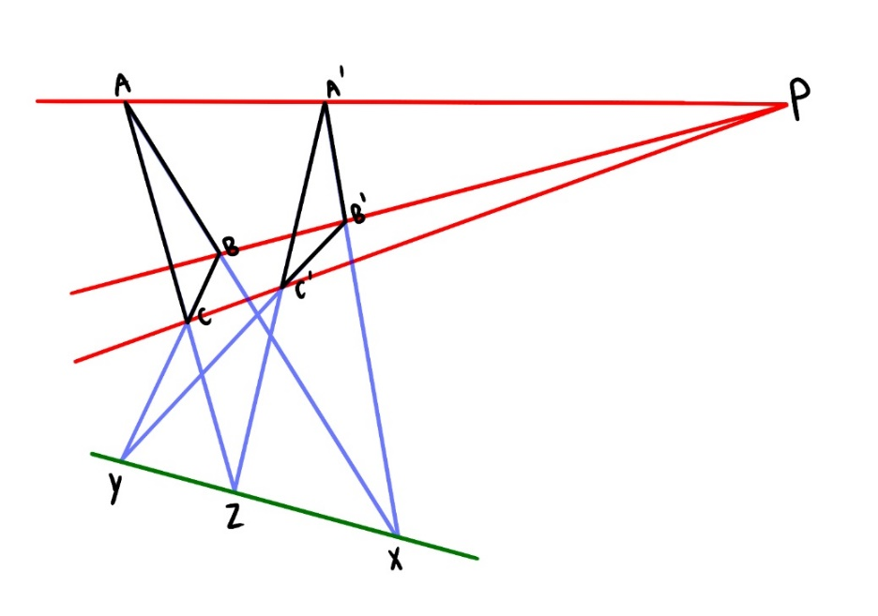
If you have two triangles whose lines through their vertices meet at a perspective point P, the intersection of the extended pairs of sides X, Y, Z all lie on the same straight line.

Another diagram displaying the same idea:

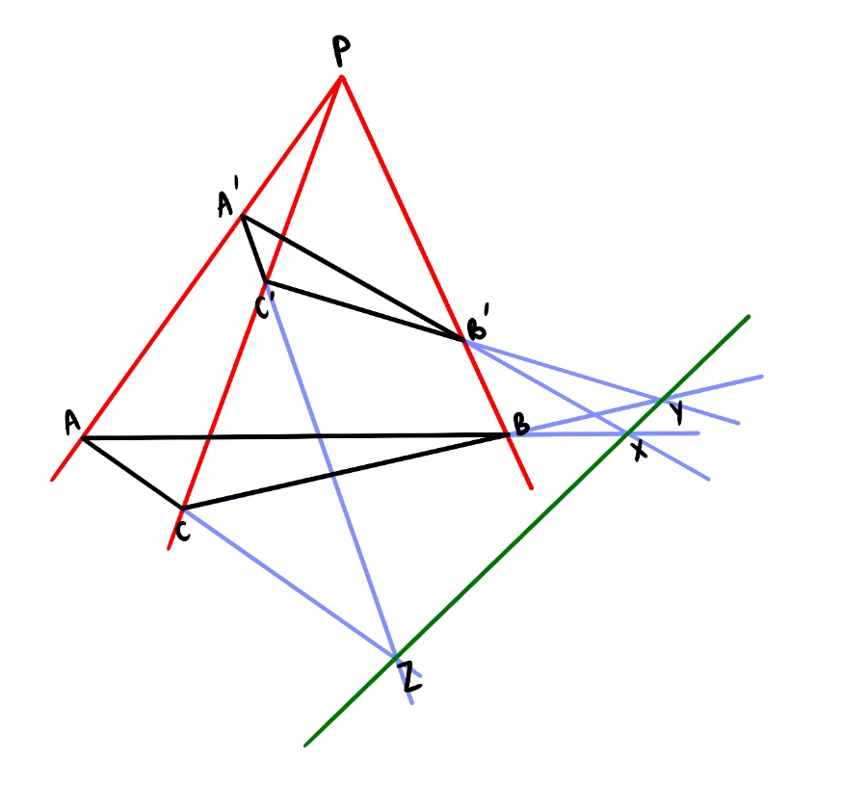

There is also an extension of this theorem, known as The Little Desargues Theorem.

This occurs when the line on which X, Y, Z lie also goes to perspective point P.

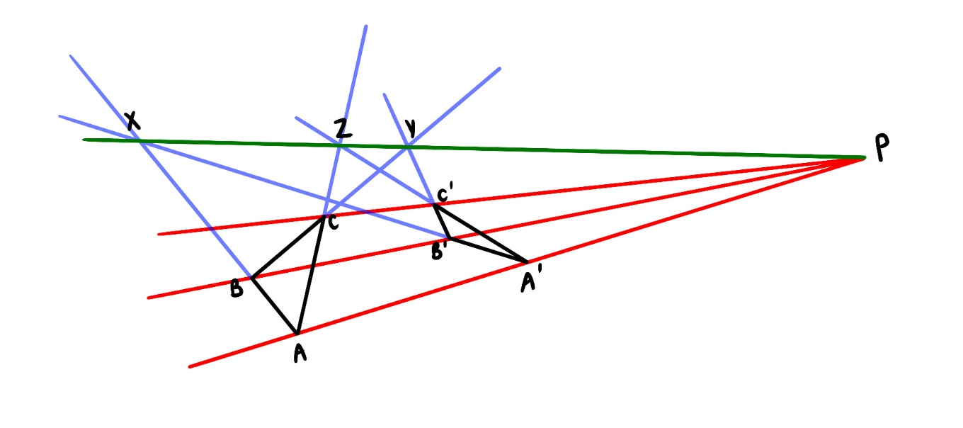

- Projective geometry

Armed with our modified axioms, our acquaintance with the coordinate system and our knowledge of the Desargues theorem, we can finally launch into the world of projective geometry, literally our world as we see it.

Firstly, let us address the line at infinity: all parallel lines will meet at a point on this line, as stated in the projective axioms. The line at infinity is the horizon, and can also be viewed as a circle of infinite radius as that is basically a line.

For every direction D, there is a point P at infinity. Lines pointing in direction D will meet at point P.

Projective geometry developed as artists faced the problem of perspective in painting. The below shows how far understanding of perspective took artists before they discovered projective geometry.


From a manuscript of John Lydgate’s ‘Life of Edmund’.

Clearly the perspective wasn’t very realistic. And Renaissance artists were the ones to realise it wasn’t. The desire to portray a scene the way someone who was actually there would see it lead to advancements in projective geometry. Eventually, artists would learn how to draw realistically in perspective, shown below:

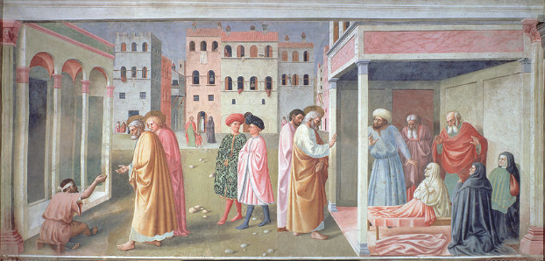
St. Peter healing a cripple, c.1427 by Masolino da Panicale

Let’s imagine a floor made up of equal square tiles.

As projective geometry concerns no lengths or angle measurements, we can never construct a tiled floor with tiles that are all of equal length and area in projective geometry. But we didn’t want to do that anyway. What we can do and what we do want to do is draw a tiled floor with tiles that look equal.

Draw the line at infinity. Add a point below the line and connect to form a triangle.
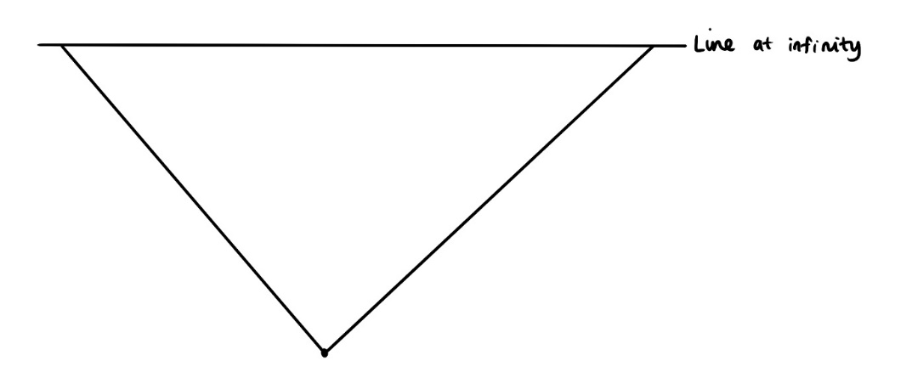

Draw two lines that meet at the two points at infinity. This is our first tile!

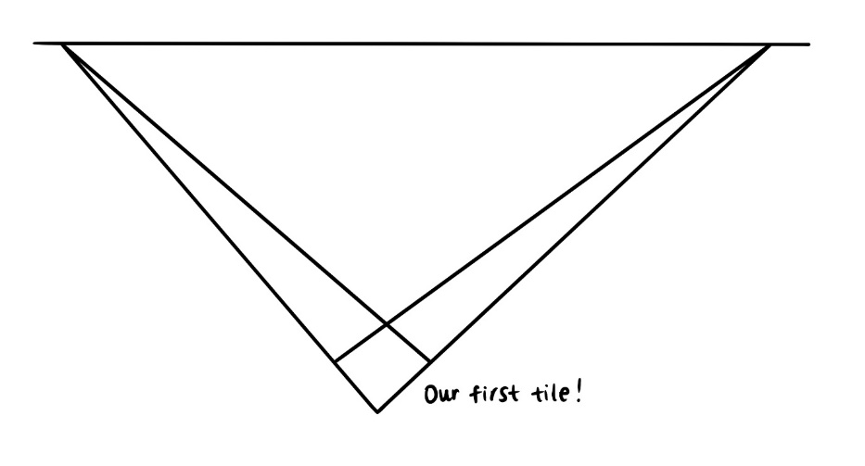

Draw the diagonal of the first tile and extend it to the horizon.

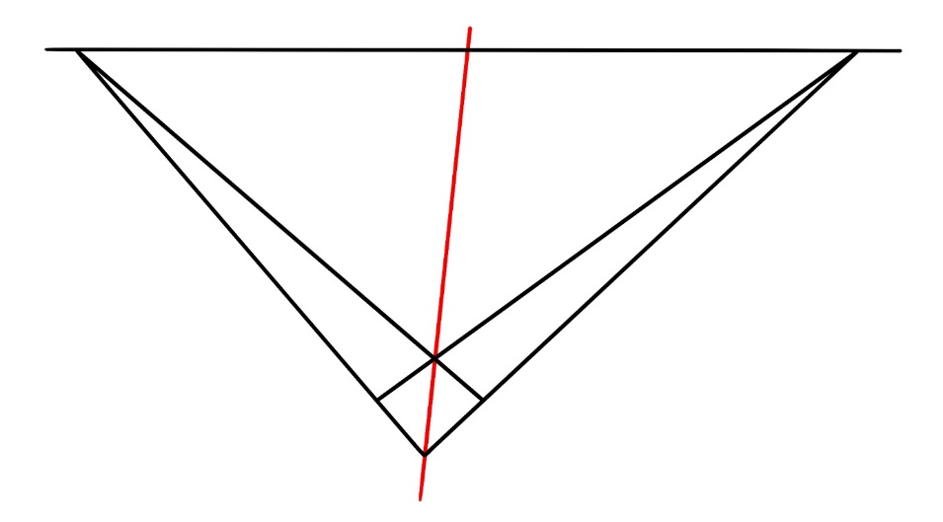

Repeat this extension of diagonals for the second tile.

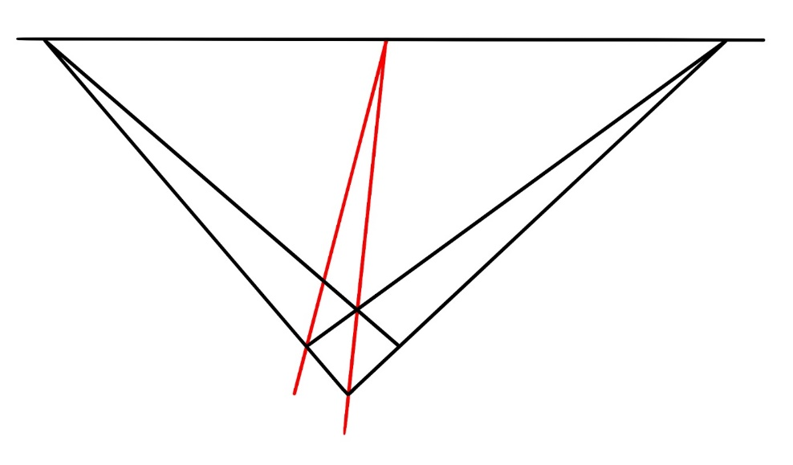

Draw the side of the second tile through the intersection.

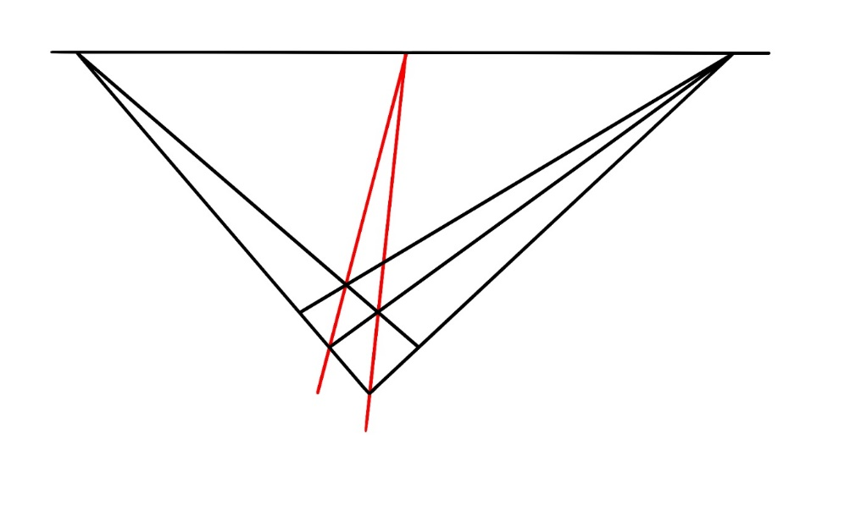

Repeat for the other side and until the floor is finished.

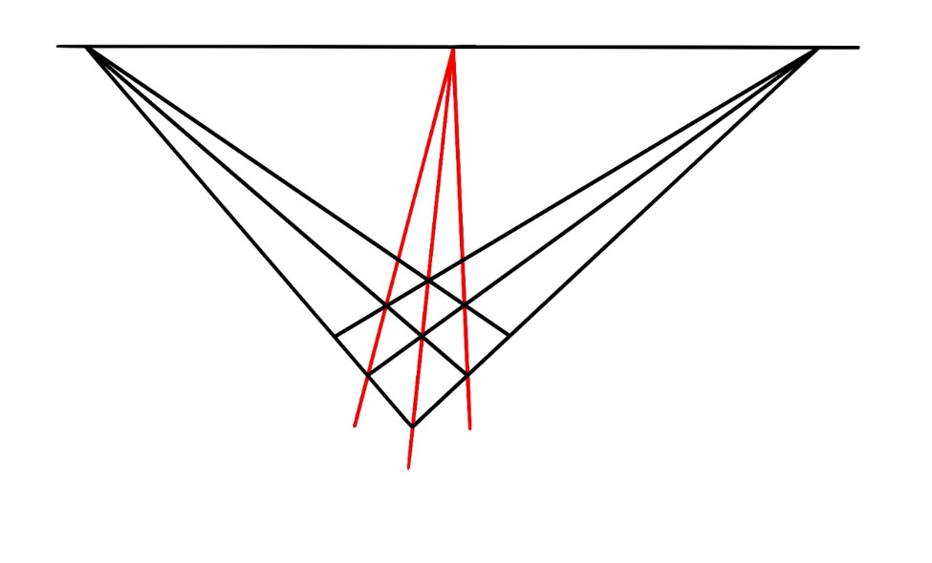
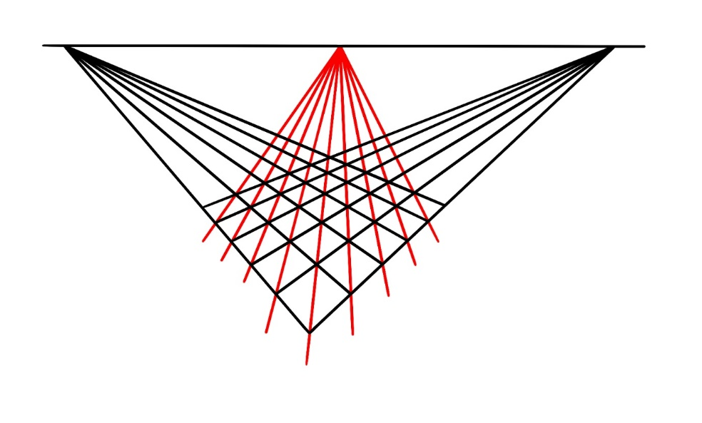
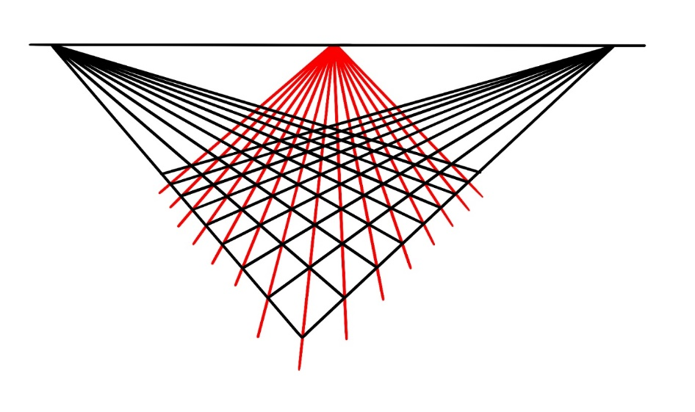
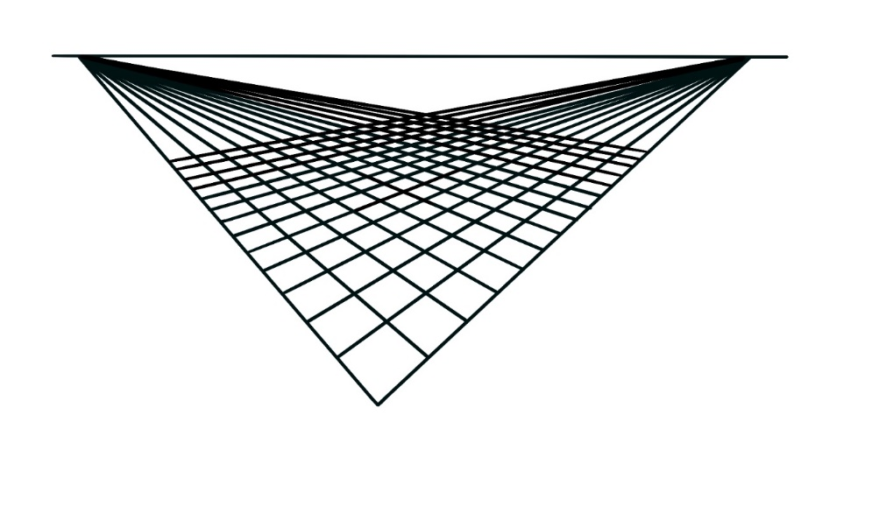

This is an example of how, using straight edge alone, we can construct a scene of what we would actually see if there was a tiled floor in front of us right now. This is projective geometry.

But why does this work?

The Little Desargues theorem!

In projective space, according to the axioms, if lines meet at the horizon, they will look parallel from a different perspective, because they are parallel.

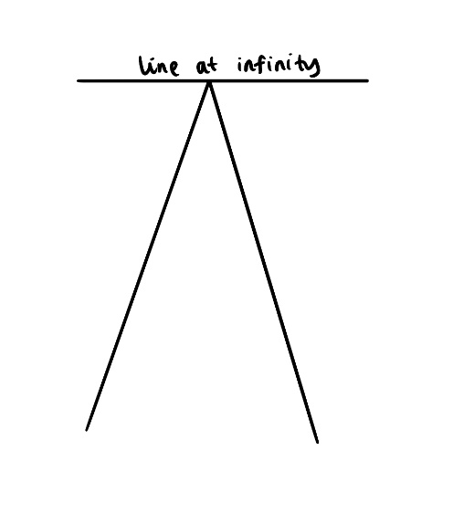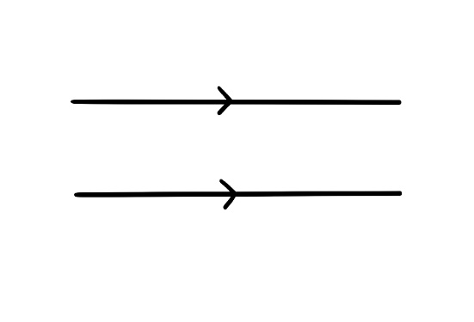

=

We can hence redraw the Little Desargues theorem as follows, where we cannot see perspective point P since we are looking at the scene from a different perspective, but it is still there.

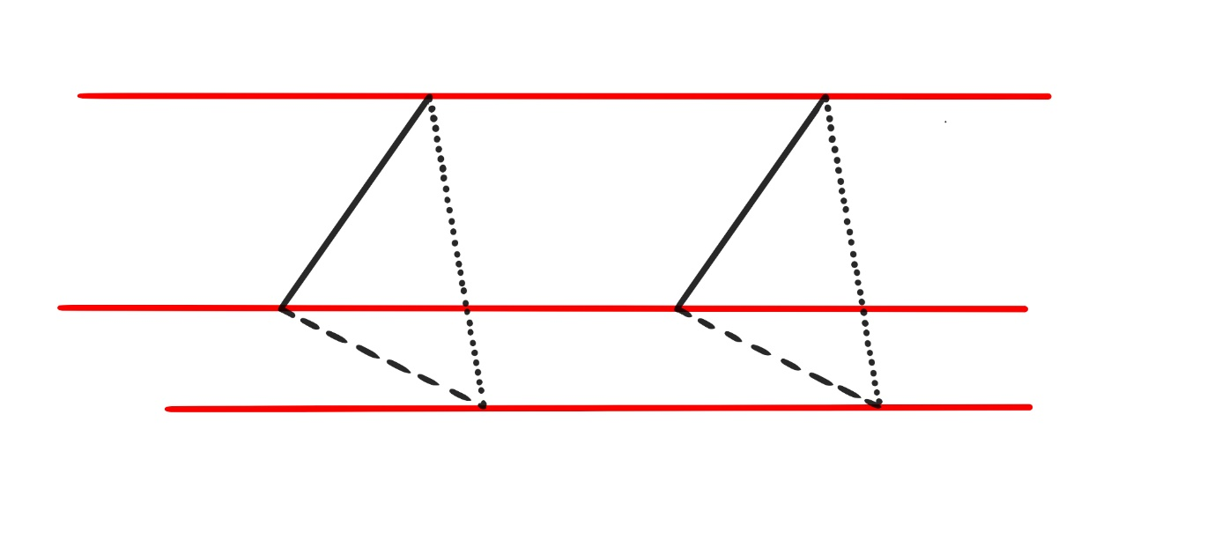

From this perspective, it is easy to confirm that if the black and dashed sides are parallel, the dotted sides must also be parallel.

Applying this to the tiled floor from above, when it is drawn parallel in a traditional way, we know that we can prove that the green line is parallel to the red lines (i.e. we are proving that the diagonals of the tiles are parallel to each other and meet at the point at infinity):

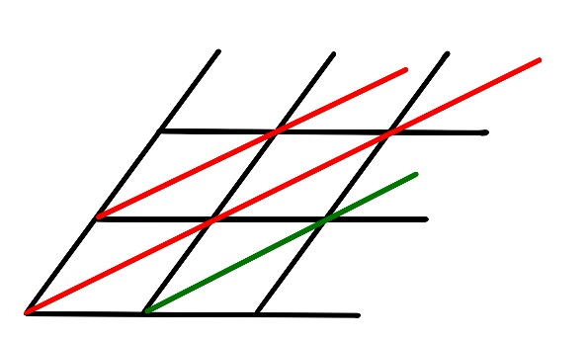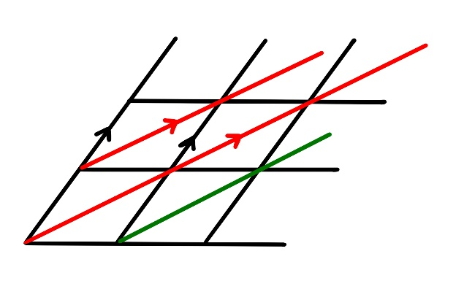

If we draw the blue triangles, we know that the red and black sides are parallel as it is the way we drew the tiled floor.

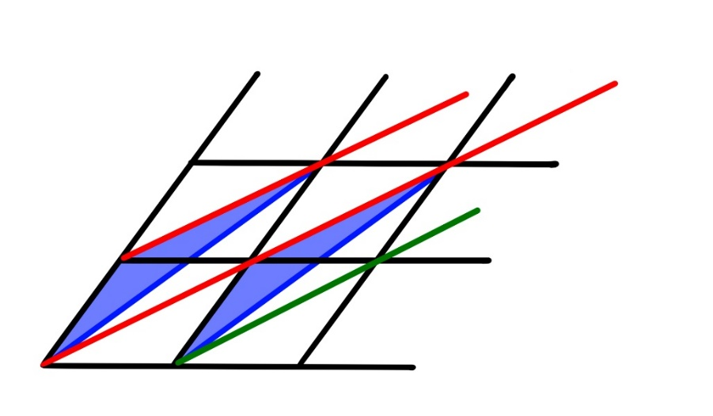

Hence, the blue sides will also be parallel as the Little Desargues Theorem states that if two pairs of sides are parallel, the third pair will also be parallel (in the context of the other lines meeting at the perspective point and the intersections of the sides being collinear etc).
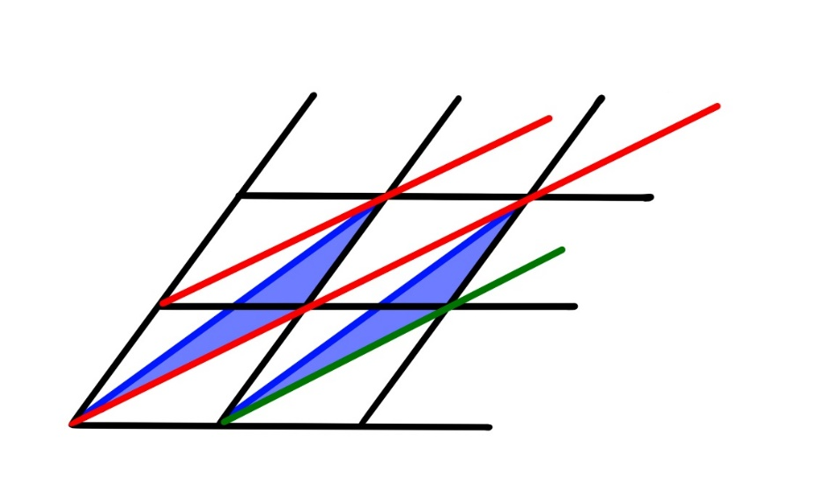
If we redraw the blue triangles, with the confirmation that the blue sides are parallel and the knowledge that the black sides are parallel, we know that the green line must be parallel to the red lines as the green side is parallel to the red side!

Therefore, we have proved why the parallel lines, that are the diagonals of the square tiles, meet at a point on the line at infinity. This moreover aligns with the axioms introduced earlier, which state that parallel lines will also meet at a point at infinity, serving as further reassurance of our axioms. We subconsciously knew that the lines were parallel by looking at the tiled floor, but now we have proved it mathematically.

- Continuation

There is still much more to be explored about projective geometry, hereto forth we have only scratched the surface. It would be impossible to expand on every topic of relevance regarding projective geometry, however I believe the following to be important enough to be mentioned so that the reader can consider how to continue discovering projective geometry for themselves.

4.1 New thinking in projective geometry

What we have explored thus far has taken place on a 2D Cartesian plane, with numbers being elements of the Real numbers set ℝ. This makes the Cartesian plane an ℝ² space. However, modern projective geometry is typically thought of as a 3D coordinate system (with x, y, z axis), thus occurring in the ℝ³ space, where a projective plane is the set of all lines which pass through the origin (0, 0, 0).

4.1.1 The introduction of three dimensions

Lines and planes in ℝ³ going through the origin O capture the idea of viewing with an all-seeing eye. The point O is the position of the eye, and the lines through O connect the eye to points in the plane.

The diagram below demonstrates how the eye sees the line L on plane z = -1 :

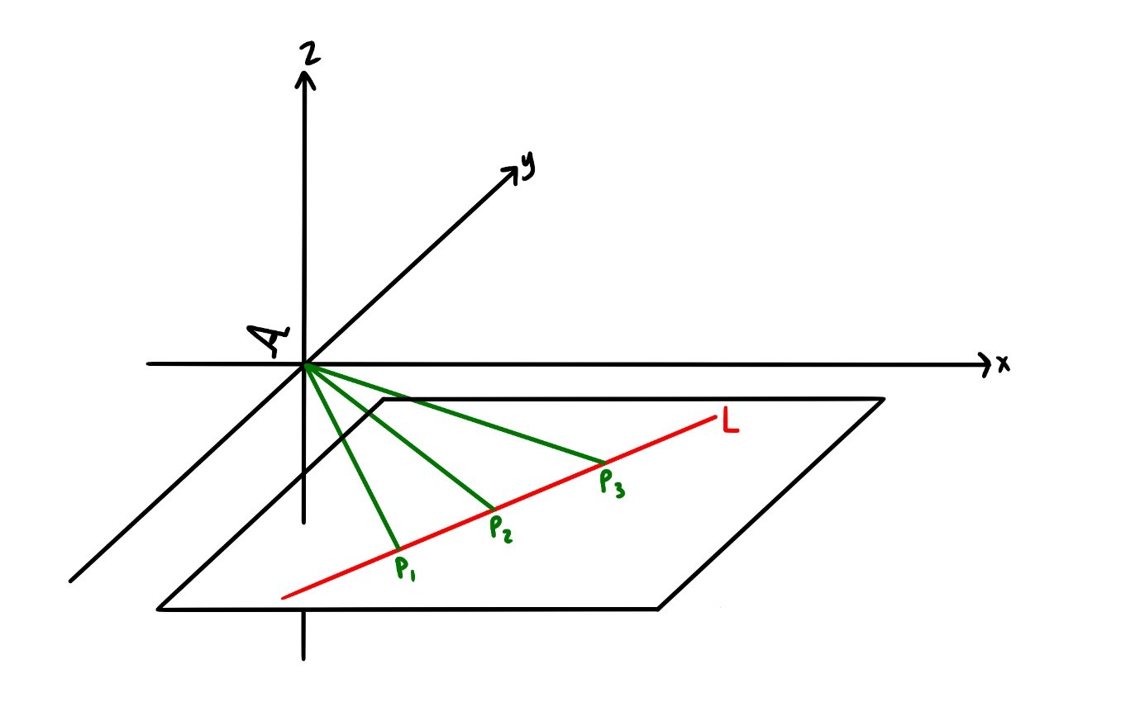

The Desargues theorem is still of significance in the 3D system; the theorem assures that just like two lines can meet at a perspective point, so can two planes in the projective space ℝ³ meet at a perspective line.

    - Homogenous coordinates

This is a coordinate system for projective spaces. It is used because it can express points at infinity, the importance of which can be realised when one recalls that projective geometry contains no lengths or measurements.

Lines going through O in ℝ³ are not given by a single triple (x, y, z), but by the set of its nonzero multiples in the form (tx, ty, tz), where t ≠ 0. These triples are referred to as homogenous coordinates. Homogenous coordinates essentially define a line in ℝ³. Such a line will have a linear equation of the form ax + by + cz = 0, known as a homogeneous equation. This is similar to how lines on a Cartesian plane have a linear equation of the form ax + by = 0.

  - The Fano Plane

Fields for projective planes are not limited to the real number set ℝ. They could be rational numbers ℚ, natural numbers ℕ, or complex numbers ℂ. The field could even be a finite one, 𝔽 (the plane is not infinite anyway, as previously mentioned, since a scene in the real world does not exist in an infinite continuum, however a finite field refers to one where the limit is set and known). The simplest example of such a field is 𝔽₂, whose members are 0 and 1. The projective plane of 𝔽₂ hence contains the following seven points:

(1, 0, 0), (0, 1, 0), (0, 0, 1), (1, 1, 0), (0, 1, 1), (1, 0, 1), (1, 1, 1)

This makes sense as for each coordinate, we have two possibilities (0 or 1) for each x, y, z. Therefore, we will have 2x2x2 = 8 possible points, but we subtract 1 because the point (0, 0, 0) has been included and we know that the origin is the ‘position of the eye’ in projective geometry, so it cannot be counted.

𝔽₂ is the smallest projective plane and it is shown below. It is referred to as the Fano plane.

(Please note that the symbol for finite field, the blackboard bold F, may appear as a square on Google Drive.)
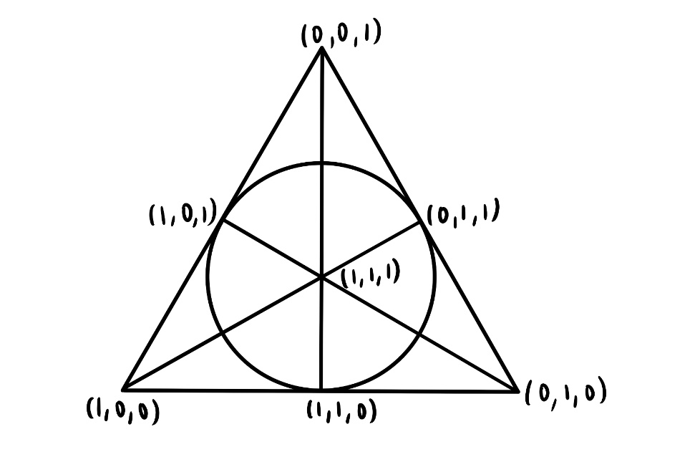

Despite its size, it is still well-behaved. It abides all the axioms of projective geometry set out earlier, and its lines satisfy linear equations.

- Discussion

Projective geometry is so captivating in that it manages to capture the nuance of how we view things with the accuracy, precision and reliability of the mathematical language.

Although initially introduced for the purpose of art and conceived as a deviation of Euclidean geometry, projective geometry actually has significant influence in Euclidean geometry. For instance, the Desargues theorems, which are evidently so intrinsic to projective geometry, are also of interest in traditional geometry, because the Euclidean plane can be extended into a projective one.

I think the existence of projective geometry in mathematics is an incredible example of how mathematicians can reason abstraction, and still approach it logically and axiomatically. Eugenia Cheng describes abstraction as “when we forget some details about a situation in order to consider an ‘idealised’ version, which is not the same as concrete (real-world) version”. And this is precisely what mathematicians did when discovering projective geometry as they temporarily ignored the seemingly monumental details such as distance, length, and the fact that the real world does not contain points of infinite lengths away.

I sincerely hope that this essay can serve as a demonstration of the extent of mathematics as a language: maths can describe even the most sensitive of concepts in our world, such as how our mind perceives the world. It is incredible that we can apply the rigour and certainty of mathematics even to the most complex, intricate and subconscious of occurrences.

Galileo Galilei is attributed to stating that mathematics is the language of the universe. I used to think that such a statement was slightly extravagant, but as I delve further into the realm of mathematics, I realise the absolute truth of such a claim. I hope that this journey into projective geometry has been as enlightening about the power of the mathematical language for you to read as it was for me to write.

Sources

Books:

The Four Pillars of Geometry by John Stillwell

Is maths real? by Eugenia Cheng

A History of Mathematics (third edition) by Uta Merzbach and Carl Boyer

Websites:

https://www.homepages.ucl.ac.uk/~ucahbdo/FiniteProjectivePlanes.pdf

Fano plane - Wikipedia

Homogeneous coordinates - Wikipedia

6.1: Axioms for Projective Geometry - Mathematics LibreTexts

Early astronomers: ‘Mathematics is the language in which God has written the universe’ – World Tribune Life

YouTube videos:

Projective Geometry 5 Axioms, Duality and Projections (youtube.com)

Putting Algebraic Curves in Perspective (youtube.com)

Projective Geometry and the Little Desargues Theorem (youtube.com)

Homogeneous Coordinates - 5 Minutes with Cyrill (youtube.com)

