
The Way of the Shinobi
忍者の道
In the
“Math fans Way”

“You don't have to be a mathematician to have a feel for numbers.”

The most interesting thing about students is their ability to divert their minds in the weirdest manner in a history lecture. The murmurs of stories of cities, dynasties, forts and all being captured and battles being fought, somehow magically provide such curiosity and zeal to understand anything but the lecture. Something like this happened to me as well. The lecture was about the French revolution and everyone awaited the class to end. Me and my friends had a discussion on the way Naruto sprinted earlier that morning. We discussed the amount of air a normal sprinter would displace compared to a Ninja, the velocity achieved, the estimate speed and all that. This discussion would continue for days, never to come to a conclusion until now. I have worked out the math with my friends at school. And I have decided to write a detailed essay on some of the Shinobi techniques and the math behind them. Enjoy!

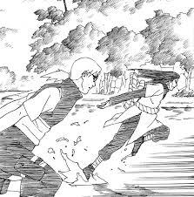
“Naruto run”
Introduction
忍 (“Shinobi”) is the Japanese word for Ninja and can be pronounced the same way as well.
Many techniques and skills have to be mastered by a person training as a Ninja. Many of these are practiced in a famous anime, Naruto. A Ninja should master the art of stealth and using weapons – just like the characters in Naruto. To master these, Ninjas have to become skilled sprinters and masters of hide and seek. This essay is for “Math fans” to become Ninjas which requires proper understanding of all of the methods used by the other Ninjas “mathematically”. This guide is also for young learners like me trying to understand the world in the beauty of math. So let us cast our shuriken into this topic.

Contents
- How to Naruto run?
- How to use a Shuriken?

How to Naruto run
Naruto run is perceived as the fastest running technique in anime and manga. In the real world, it is impossible to run as fast as the characters in Naruto sprint because that surpasses our fastest supercars!
For example, when Naruto is called to the battlefield to assist the allied shinobi forces. Naruto was in Konoha (the hidden leaf village) that was about 500 - 1000 km (estimate) far from the battlefield.

Naruto took about 6 minutes i.e. 0.1 hours to reach the destination.
That means Naruto’s speed would be equal to: 1000/0.1 = 10,000 km/h!
This is faster than the fastest supercar we know (Bugatti Chiron Super Sport 300+) has achieved the top speed of just 489 km/h.
Unfortunately, we are not superhumans and cannot achieve such a speed. But at least we can try to run faster by understanding the pros and cons of the Naruto run and how is it “mathematically” better or worse than the other running techniques.
Naruto running is a technique of sprinting in which a person leans forward and lets their arms extend backwards.
There are certain factors that affect running. And one of them is drag.
Drag force is the force that slows down an object moving through a fluid.

Drag: D = Cd * A * .5 * r * V^2

Here:
- D is the drag force(newtons),
- Cd is the drag coefficient (this depends on the ability of the object to displace air, depends on the shape of the object)
- A is the cross-sectional area (how big the object is in the direction of movement)
- r is the density of the fluid [air is also a fluid]
- V is the velocity of the object.

Here what actually matters is the Cd, the drag coefficient. The lower the Cd, the lower is the drag (Cd ∝ D).
An object that will displace more air will have a lesser Cd thus a lesser drag. That means a paper plane has a lesser drag compared to a sheet of paper.

In a Naruto run, the runner leans forward and extends their arms backward to form a wedge-like structure. This decreases the drag coefficient and decreases the overall drag. That makes Naruto run fast.

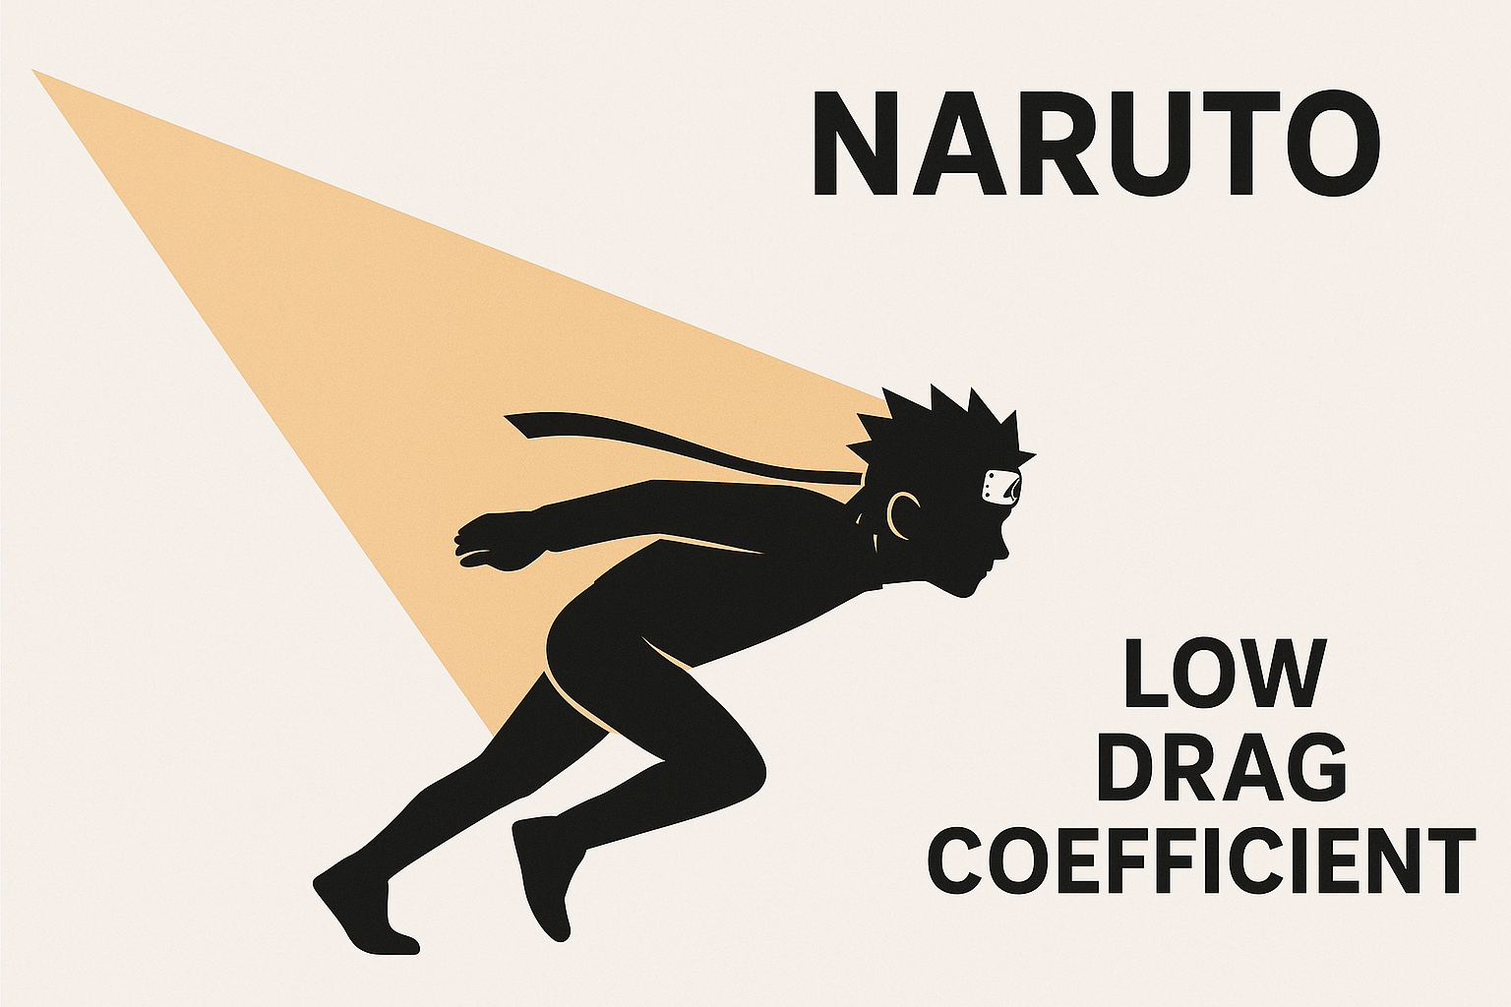
Wedge-like Naruto

The drag force in a Naruto run is ≈ 28 % less compared to the drag force in a normal sprint. (as per my calculations)
Taking this factor into consideration, the Naruto run wins. But there are other factors as well.
- The Naruto run decreases the “stride length”. Where the Naruto run decreases the drag slightly it also decreases the stride length. In normal sprinting, the sprinter accelerates themselves by pushing against the ground with all their strength at each step. Which becomes hard because the knees cannot lift and drop properly. This happens because of the posture resulting from taking smaller steps.

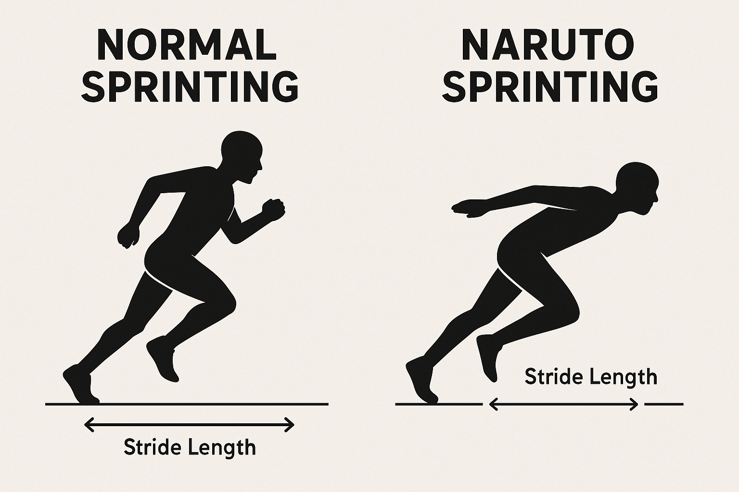

- Naruto run also creates a lack of balance and momentum. Arm swinging helps in balancing the body, changing direction, and to gain a better reaction time. Naruto run eliminates all these, especially at higher speeds.

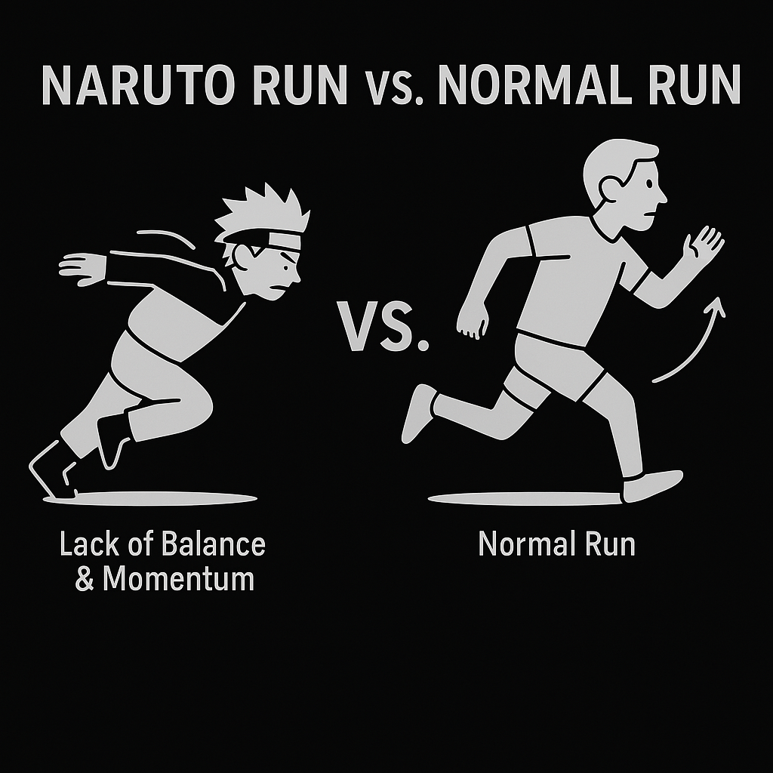
A notable experiment featured an Olympic Gold medalist, Jeneba Tarmoh who performed a 50-meter run with both the styles and was ~3% slower in the Naruto run. She also faced a lack of balance and more energy consumption.

- Naruto run consumes more energy compared to normal sprinting in maintaining posture and balance.
Taking these factors in consideration, our Ninja team has come to the conclusion that Normal sprinting is better than the Naruto run. Naruto run might seem cooler but is inefficient in real life and can be more injurious and tiresome. Achieving superhuman speeds like that of Naruto, that are almost 3 times faster than the speed of sound, are impossible. So let us practice “arm swinging” and become true Ninja.
Fun fact
Naruto runs at a velocity of 2,777.78 m/s. That means he can cross a football field (100m) in ~ 0.036 seconds that is even less than a second! Please don’t try this at home.

How to use a Shuriken
手裏剣 (“Shuriken”) are the so called “Ninja stars” that were used by Ninjas for hidden combat, low range and high range attacks.
I remember me as a 5-year-old would think only of Shuriken whenever the thought of Ninjas came into my mind. Because that is the coolest thing about Ninjas. Their greatest stealth weapons.
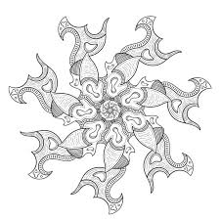
Words can’t explain these beautiful weapons but numbers surely can.

So let us learn about the spinning and casting of Shuriken:
This is the fanciest shuriken I could find

A shuriken starts spinning towards the enemy when it is cast towards them. To become master casters, we have to learn how a shuriken moves.

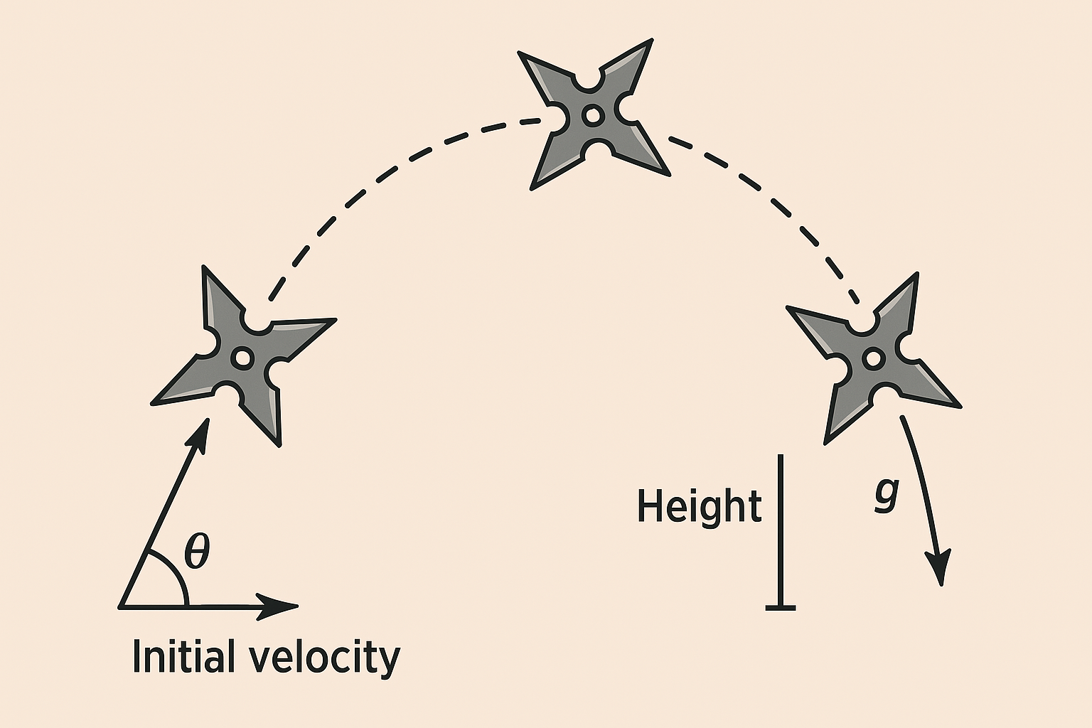
The shuriken moves in a parabolic arc. It is released by the Ninja. It rises up and slows down at the top. It starts to fall due to the gravity. It takes a movement structure of a Parabolic arc and strikes the enemy in its path.
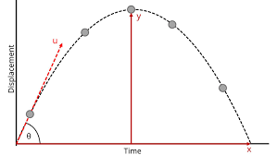

Motion in a parabolic arc is somewhat like throwing a ball. The ball rises, slows down at the top and drops due to gravity.

As we are Ninja, let us understand the best way to throw our shuriken so the weapon is fast and steady.
There are two things that we have to keep in mind,
- Movement of Inertia
- Drag

- Movement of inertia measures the extent to which an object resists rotational acceleration about a particular axis. This means the farther the relation happens from the center of mass (that forms a circle), the harder it is to change it. So the more the movement of inertia, the more stable a rotating object is i.e. it is hard to change its direction, slow it down and speed it up.

Formula of movement of inertia:
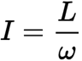

( ω=θ/t​, where t is time taken and θ is the angle rotated in radians)
(L=I*, where I is movement of inertia and is angular velocity)

where:
(I) is the movement of inertia
(L)is the angular momentum (it is the measure of motion in a rotating object just like linear momentum is measured in an object moving in a particular direction, it is measured as kg⋅m2/s)
()is the angular velocity(angular velocity tells us how fast an object is moving and is measured as rad/s).
In simple words, depending on the shape and the axis taken in consideration determines movement of inertia.
( I ∝ 1/change in rotation)

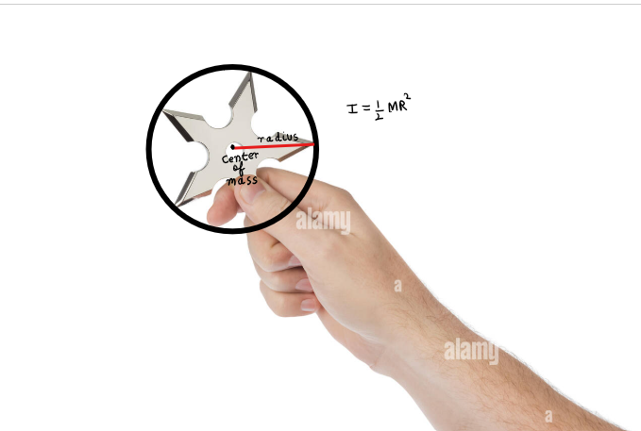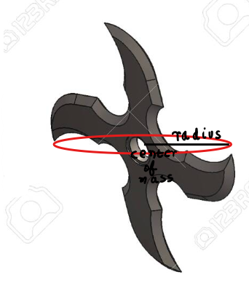
X axis Y axis (pistol grip)

A Shuriken has a higher movement of inertia when thrown horizontally(right) as the radius is more compared to thrown vertically(left).

The throw with more movement of inertia can be used for far ranged attacks but would need practice to achieve accuracy.
- Drag has already been discussed. It is the resistance faced by an object moving through a fluid.

Let us measure the drag on a shuriken when thrown vertically and horizontally.

We know that D = Cd * A * .5 * r * V^2,

X axis:
(here) Cd~1.5(Taking the overall shape and posture of the shuriken),A~0.0047 m squared,r~1.225kg/m cubed(on sea level),V = 20m/s(assumption)
∵ D~1.73N.
Y axis:
(here)Cd~0.8(edge-on posture),A~0.0007 m squared,r~1.225kg/m cubed,v = 20 m/s(assumption)
∵ D~0.137N.
(these calculations have been done using the parameters of my shuriken, you can redo them by using yours)
It is clearly observed that the drag on a vertically thrown shuriken is less than a
horizontally thrown shuriken. This means the speed and accuracy of a vertically
thrown shuriken for short range attacks is more than a horizontally thrown shuriken.

In conclusion, a horizontally thrown shuriken is better for far ranged attacks and a vertically thrown shuriken is better for close combat.
So my fellow Ninjas, we have used our power of understanding a small phenomenon mathematically to unravel the secrets of these ancient weapons. So let us start casting our shuriken the right way.

Fun fact
In this essay, only one type of shuriken has been discussed "Hira-shuriken" (平手裏剣), there are many more. The Bō-shuriken (Straight throwing spikes), Senban-shuriken (Square blade shuriken), Kunai (Not technically a shuriken, but used similarly) and others.

Now we are ready for our mission: Unravel the world using Math!
Conclusion
Just like Ninjas hide in the shadows, so does math. The only thing that we can use to see it is “Curiosity”. All great physicists and mathematicians have one thing in common and that is curiosity. When you become curious about something, you start to love it and the more you love it the more you know it. So if math is hard for you, just be curious.My essay might not have as much math as expected but it has curiosity in each word.

My message to Dr. Tom Cawford
Thank you sir for organizing such competitions tirelessly over the years and for being my idol in mathematics. Thank you sir for all those videos to spark up my curiosity.
About the Author
My name is Rayhan Zargar, a 13 year old curious Math fan. I love Math and physics. I love programming, books and manga. I want to become a quantum physicist. I am from India. I am a potterhead.

Thank you for patiently reading!

