Iyenosi Obomighie
Does moving major sports events to different locations increase their popularity?
Introduction:
As an avid Olympics watcher, I go to great lengths to experience the excitement of major sporting events. Last Summer, I travelled to France to watch events in person and while at home I streamed on two screens to see multiple events at one time. I have even already started planning my visit to the 2036 Australian Olympic Games. This passion for global sports has led me to a key question: Why do major events like the Olympics, World Cup, and Euros change location, and does this impact their popularity?
Rather than relying on opinions, I want to answer this question with maths and data analysis. To investigate, I will apply simple correlation, regression, and trend analysis and multiple linear regression to quantify the effect of location changes. I will use MATLAB for visualization and data analysis, examining data from four major sporting events: Wimbledon, Super Bowl, World Cup and F1. So, let’s take a journey through some of the world’s biggest sporting events—not to relive their thrilling or even heartbreaking outcomes, but to answer a fundamental question: Does location matter for a sport’s popularity?
Why Does Location Matter in Sports Popularity:
There are 2 major reasons why major sports events change location: economic boost for host countries, global reach for these sports.
- Firstly, hosting events like the World Cup or Olympics can bring billions in tourism, infrastructure investments and jobs. Brazil 2014 World Cup generated $15 billion;14 million jobs created in 4 years leading up to the tournament and a 52% capacity increase in aviation infrastructure. In the long run, these investments caused by the sporting events will benefit the host country economically. However, Brazil also experienced an increase in unemployment as during game days business declared holidays or workers picked football over work contributing to the mixed economic impact the World Cup had on Brazil. Tax increases to fund hosting and high government expenditure angered many citizens (61% of Brazilian adults were against hosting in 2014) which may have dampened the love of football within the country due to the increased poverty, unemployment and political disruption caused by the sporting event.
- Secondly, events move to new regions to grow the sport’s popularity. F1 in Las Vegas (2023) is a representation of F1 testing a new market for American motorsport fans. The road to expansion for the F1 was discovered with the release of the documentary “Drive to Survive” which reached 1.3 million viewers in the USA for season 1 highlighting to F1 officials the potential market for F1 within the USA showing the need to move to new locations to increase popularity. However, some events stay in one place for stability and tradition like Wimbledon. The lack of leftover unused facilities caused by fixed location events prevents the potential for bad publicity allowing the popularity to grow without disruption and building a stronger legacy. The new hosts of sporting events with changing location may only have temporary excitement.For example, South Africa 2010 World Cup had record viewership, but football interest dropped afterward. This is not always the case because the 1994 world cup in America led to the growth in MLS. So, which is best for long-term popularity, tradition or change? This is why maths and data are needed as viewership fluctuations may not be random, and data analysis can reveal these patterns. My study will test whether location has an impact on popularity.
Mathematical Concepts:
To answer whether hosting affects popularity, we will apply three key mathematical techniques: correlation, trend analysis, and regression.
Correlation is a statistic that measures the relationship between 2 or more variables. The correlation coefficient will convey the relationship between changing host locations and viewership. A positive correlation (closer to 1) would suggest that moving events to new locations increases popularity, while a negative correlation (closer to -1) would suggest the opposite. A value near 0 would indicate no relationship. I will use Python to compute correlation coefficients and visualize the results.
Trends analysis is a technique to identify patterns or changes in data over time and extrapolate those past growth trends to predict future outcomes. By tracking viewership over multiple tournaments, I will see if changing locations leads to an increase in popularity or if trends remain stable regardless of location. If spikes in viewership occur only when events are hosted in new locations, this suggests that location plays a key role. MATLAB will be used to visualize these trends with graphs.
Multiple linear regression is a statistical technique used to predict the value of a dependent variable based on one or more independent variables. I will build a simple multiple linear regression model to see whether hosting a sporting event does statistically increase viewership directly. In my model, the dependent variable will be viewership and attendance, while the independent variables will be the year. The model equation is $y=β_{0}+β_{1}X_{1}+β_{2}X_{2}+⋯β_{k}X_{k}+E$.
$β_{0}$ is the intercept and $β_{1}$, $β_{2}$, …Bk are the coefficients representing change in Y for one unit change in X with other Xs being constant. Then, E is the error term. The error term (e) was omitted from each regression equation for simplicity, as the focus is on estimating and interpreting the coefficients. I will use the matrix formulation of the multiple regression model as calculating coefficients will be easier as coefficients will potentially be, argue numbers so using matrices will be more efficient.
$B={\left(X^{T}X\right)}^{-1}X^{T}Y$
Both linear regression and multiple linear regression will use ordinary least squares methods to minimise the sum of the squares differences between the observed values and values predicted by the regression model.
I will use MATLAB to visualize data using line graphs.
Case Studies:
- Fixed: Wimbledon Final and Super Bowl
- Rotating: World Cup Final
- New vs Old: F1 races
Methodology:
My data collection included:
- World Cup - Total Attendance, Average Attendance, Search Interest, YouTube Highlight Views for Finals
- F1 - Total Attendance, Search Interest, Weekend Attendance for each location (Miami, Saudi, Silverstone and Monza), YouTube Race Highlight Views for each location
- Superbowl - Search Interest, Game highlight views, Average TV viewership for season Games, Total Attendance
- Wimbledon - Men’s Final Highlight Views, Total Attendance, Search Interest
All data collected is for the last 10 events that have occurred. Data during Covid will be recorded but ignored during calculations as data has been disrupted. In total, the dataset includes 11 entries for all sport events. However, F1 only has 9 entries as data before 2016 has no legitimate numbers.
In the Multiple Linear regression models, the dependent variable was either total attendance or highlight views. Independent variables included the year of the event and a binary variable representing location. For example, in the F1 model, ‘new location’ was coded as 1, and ‘old location’ as 0. In the World Cup model, ‘European host’ was coded as 1, and ‘non-European host’ as 0. Years were subtracted from the oldest year of collection to make estimates more accurate.
To explore changes in popularity over time, I calculated the trend line over various variables by calculating the gradient and intercept. This was done using formula $m=\frac{∑\left(y-\overline{y}\right)\left(x-\overline{x}\right)}{{\left(x-\overline{x}\right)}^{2}}$ for gradient, measuring how attendance or views have changed over time. These gradients allowed me to compare the popularity of different events. While the intercept will be calculated using C = $\overline{y}$ - m x $\overline{x}$.

I performed multiple linear regression matrix algebra. I structured my data in the form Y=Xβ+ϵ where Y is the outcome variable (e.g., attendance), X includes an intercept, location, and year, and β represents the coefficients to estimate.
I calculated each matrix step by hand:
$B={\left(X^{T}X\right)}^{-1}X^{T}Y$to obtain the coefficient vector β. These coefficients were then interpreted to understand how location and time affect event popularity.
The analysis assumes a linear relationship between the dependent and independent variables. Due to limited data availability, a small sample size was used, and all observations were treated as independent events.

FIFA Men’s World Cup (Rotating Location)
The World Cup is the international men’s football tournament that changes location every four years. Being a host country of the World Cup can bring much attraction, tourism and popularity but changing the location is helpful to FIFA in increasing popularity.
Year | Total Attendance | Average Attendance | Search Interest | Final’s Highlights | Hosts
2022 | 3404252 | 53191 | 100 | 27M | Qatar
2018 | 2031768 | 47371 | 81 | 66M | Russia
2014 | 3429873 | 53592 | 87 | 8.8M | Brazil
2010 | 3178856 | 49670 | 79 | 13M | South Africa
2006 | 3359439 | 52491 | 78 | 6M | Germany
2002 | 2705197 | 42269 |  | 1.4M | Japan/South Africa
1998 | 2785100 | 43571 |  | 1.4M | France
1994 | 3587538 | 68991 |  | 5.2M | USA
1990 | 2516215 | 48389 |  | 0.447M | Italy
1986 | 2394031 | 46039 |  | 2M | Mexico
1982 | 2109723 | 40572 |  | 0.414 | Spain
Data from Wikipedia and checked with other sources. Search Interest from Google (out of 100). Highlight views are from YouTube and are only normal highlights for men’s final, not extended highlights.
Trend Analysis - Highlights:
Let X be Year event occurred ( $\overline{x}$ = 2002)
Let Y be Highlights in Millions ( $\overline{y}$= 11.96918182)
Gradient = 0.9671269
Intercept = -1924.21897
Y = 0.967X - 1924 (3sf)
The weak positive gradient suggests drawing interest in the World Cup over time could be harder each year as the gradient is less than 1.
(X - $\underline{x}$ ) | (Y - $\underline{y}$) | (Y - $\underline{y}$)(X - $\underline{x}$ ) | (X - $\underline{x}$)^2
20 | 15.0308 | 300.616 | 400
16 | 54.0308 | 864.493 | 196
12 | -3.1692 | -38.030 | 100
8 | 1.0308 | 8.2465 | 36
4 | -5.96918 | -23.8767 | 4
0 | -10.56918 | 0 | 0
-4 | -10.56918 | 42.4767 | 36
-8 | -6.76918 | 54.153 | 100
-12 | -11.52218 | 138.266 | 196
-16 | -9.96918 | 159.5069 | 324
-20 | -11.55518 | 231.1036 | 400

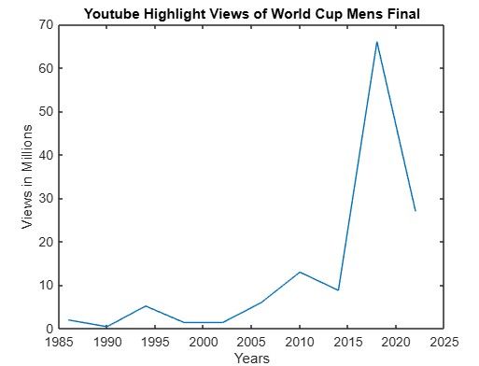
The trend line on the line graph generated by MATLAB supports that the growth in Highlight Views is slowing down.
Trend Analysis – Total Attendance:
Let X be Year event occurred ( $\overline{x}$ = 2002)
Let Y be Total Attendance ( $\overline{y}$ = 2863817.45)
Gradient = 17094.40852
Intercept = - 31359188.41
Y = 17094X - 31359188 (3sf)
This upward trend highlights that each new World Cup tends to attract more attendance than the last ones.
(X - $\underline{x}$ ) | (Y - $\underline{y}$) | (Y - $\underline{y}$)(X - $\underline{x}$ ) | (X - $\underline{x}$)^2
20 | 540434.55 | 10808691 | 400
16 | -832049.45 | -13312791.2 | 256
12 | 566055.55 | 6792666.6 | 144
8 | 315038.55 | 2520308.4 | 64
4 | 495621.55 | 1982486.2 | 16
0 | -158620.45 | 0 | 0
-4 | -78717.45 | 314869.8 | 16
-8 | 723720.55 | -5789764.4 | 64
-12 | -347602.45 | 4171229.4 | 144
-16 | -469786.45 | 7516583.2 | 256
-20 | -754094 | 15081880 | 400

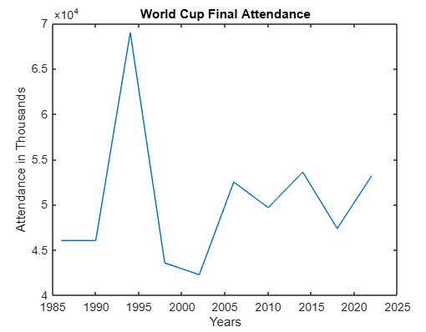
The trendline on this graph reveals a positive gradient aiding the regression analysis, which has found increased attendance that could be due to the rotating nature of the World Cup.
Multiple Linear Regression:
Independent variable(L) = Location (not in Europe = 0, in Europe = 1)
B = vector of coefficients = ${\left(X^{T}X\right)}^{-1}X^{T}Y$
X =
1 | 0 | 40
1 | 0 | 36
1 | 1 | 32
1 | 0 | 28
1 | 0 | 24
1 | 1 | 20
1 | 0 | 16
1 | 1 | 12
1 | 0 | 8
1 | 1 | 4
1 | 0 | 0
Views = $β_{0}$ +( $β_{1}$ x European) + ($β_{2}$ x Year)
Dependent variable = Highlight views in Millions
If Y is Highlights in Millions =
27
66
8.8
13
6
1.4
1.4
5.2
0.447
2
0.414

B =
-3. 984628313
-7.564107011
0.9352197249
The intercept is the $β_{0}$. $β_{0}$= -3.98M (3sf) which represents the estimated number of highlight views when the World Cup was held outside Europe in 1984.
$β_{1}$ is the Europe coefficient which displays the additional highlight views generated when the World Cup is held in Europe. As $β_{1}$= -7.56 (3sf) suggests European hosts attract on average 7.56M less views than non-European hosts, all else being equal.
The year coefficient measures how highlight views change over time. The positive value of 0.935(3sf) means viewership increases annually.
Average Attendance = $β_{0}$ +( $β_{1}$ x European) + ($β_{2}$ x Year)
Dependent variable = Average Attendance
If Y = average attendance
53191
47371
53592
49670
52491
42269
43571
68991
48389
46039
40572

B =
44385.61255
5590.774908
161.550738

$β_{0}$ = 44385 to the nearest whole number means that a non-European World Cup in 1994 would be expected to get 44385 average attendances, assuming no other influencing factors.
$β_{1}$quantifies the European effect as 5590 more in average attendance for World Cups located in Europe.
$β_{2}$ reflects the long-term growth trend of the World Cup average attendance to be growing as 162 extra on average per year.
Total Attendance = $β_{0}$ +( $β_{1}$ x European) + ($β_{2}$ x Year)
Dependent variable = Total Attendance
If Y = total attendance
3404252
2031768
3429873
3178856
3359439
2705197
2785100
3587538
2516215
2394031
2109723

B =
2346070.813
351716.738
19492.4823
The intercept ($β_{0}$) shows the baseline popularity for a non-European World Cup in 1994 would be 2346071 in total attendance (to the nearest whole number)
As $β_{1}$= 351717 (to the nearest whole number) implying that European hosts attract, on average, 351717 more in attendance than non-European hosts, all else being equal.
The positive $β_{3}$figure implies that every additional year increases expected highlight views by 19,492 compared to the previous year.
World Cup Findings:
The trendline for Highlights and Total Attendance both showcase an incline overtime presenting the strong extension in popularity, the world cup has and most likely will experience in the future. This suggests that the model of rotating locations has created a secure global interest that seems to only be increasing in every aspect. This could be because with every new location interest heightens every tournament as fans get to experience a new culture every time. This strengthens the assumption that new locations alone can drive engagement.
The multiple linear regression shows that European-hosted tournaments result in higher average attendance and total attendance. In contrast, the highlight views are lower for World Cups hosted by European countries which may be due to the lack of eagerness around the 2 teams playing in the final as which players are present during the match will have a significant impact over the number of views. For if match is views as less iconic or lacklustre fans won’t go back and watch it on YouTube. However, the total attendance and average attendance together being positive indicate that both time and location influence popularity with European settings.
Limitations:
The World Cup is only hosted every 4 years meaning my data is very old. Some tournaments are older than YouTube itself limiting the power and reliability of any trendline or regression results as these older tournaments can significantly affect the outcome. For older data may be less accurate so not fully comparable to recent data.
In addition, since every tournament is hosted in a different country, its is difficult to directly compare the impact of location changes in isolation, making it harder to separate the effect of location from other variables like regional interest or global events.
Regional interest can obscure my results as football is already extremely popular in Europe and South America. Hosting a tournament in these regions where football isn’t the top sport will naturally lead to lower engagement, not due to location but local sporting culture. Next time, I could also consider non- South American and South American hosted World Cups.

Formula 1 (New vs Traditional Races)
Formula 1 is the highest league of international racing and considered the pinnacle of motorsport. F1 circuits each year are in the same places across several countries but have recently expanded to new locations with the aim of attracting new fans in places such as Miami and Saudi Arabia. This allows me to naturally investigate if these new locations build the overall interest of F1 or was the impact minimal.

Year | Total Attendance | Search Interest | Miami Weekend Attendance | Miami Highlight | Saudi Highlight | Saudi Weekend Attendance | British Weekend Attendance | British Highlight | Monza Attendance | Monza Highlight
2024 | 6.35M | 66 | 275k | 7.7M | 6.7M | 150k | 480k | 7.7M | 335k | 7M
2023 | 6M | 75 | 270k | 6.8M | 8.4M | 150k | 480k | 6.1M | 304.1k | 6.2M
2022 | 5.7M | 91 | 243k | 8.8M | 9.5M | 142k | 401k | 11M | 337k | 6.9M
2021 | 2.69M | 100 |  |  | 9.5M | 143k | 356k | 9.4M | 20k | 9.6M
2020 | 0 | 48 |  |  |  |  | 0 | 7M | 0 | 8.7M
2019 | 4.16M | 41 |  |  |  |  | 351k | 7.5M | 200k | 9.5M
2018 | 4.09M | 40 |  |  |  |  | 340k | 10M | 185k | 5.1M
2017 | 4.07M | 51 |  |  |  |  | 344.5k | 4.4M | 147k | 4.3M
All data is from Black Book Motorsport, but search interest is from google trends. Highlights views were sourced from YouTube and only include race highlights, not trials highlights.
Trend Analysis – Search Interest:
Let X be Year event occurred ( $\overline{x}$ = 2020.5)
Let Y be Search Interest ( $\overline{y}$ = 64)
Gradient = 5.74
Intercept = - 11529.82
Y = 5.74X - 11500 (3sf)
The strong positive gradient displays there is a rise in number online searches presenting an increase in interest.
(X - $\underline{x}$ ) | (Y - $\underline{y}$) | (Y - $\underline{y}$)(X - $\underline{x}$ ) | (X - $\underline{x}$)^2
3.5 | 2 | 7 | 12.25
2.5 | 11 | 27.5 | 6.25
1.5 | 27 | 40.5 | 2.25
0.5 | 36 | 18 | 0.25
-0.5 | -16 | 8 | 0.25
-1.5 | -23 | 34.5 | 2.25
-2.5 | -24 | 60 | 6.25
-3.5 | -13 | 45.5 | 12.25

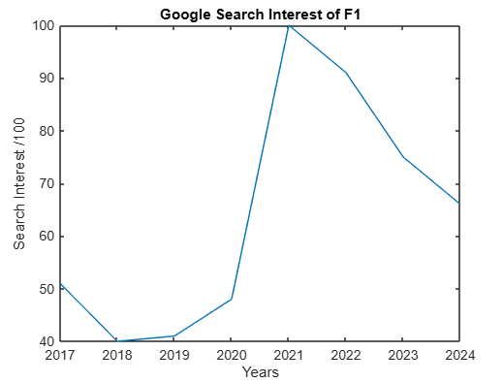
The steep incline of trend line supports the string positive gradient calculated in my trend analysis further supporting the idea that F1 is experiencing a growing interest.
Trend Analysis – Miami Highlights:
Let X be Year event occurred ( $\overline{x}$ = 2023)
Let Y be Miami Highlights in Millions ( $\overline{y}$ = 7.87)
Gradient = -0.4
Intercept = 817.07
Y = -0.400X + 817 (3sf)
The declining trend suggests that interest in F1 Miami is gradually decreasing although it was newly introduced.
(X - $\underline{x}$ ) | (Y - $\underline{y}$) | (Y - $\underline{y}$)(X - $\underline{x}$ ) | (X - $\underline{x}$)^2
1 | 0.13 | 0.13 | 1
0 | -1.07 | 0 | 0
-1 | 0.93 | -0.93 | 1

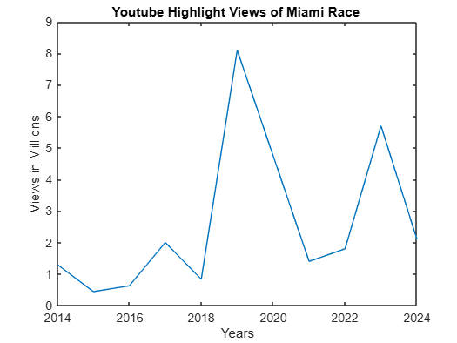
The slope of the line of best fit on the line graph is not a negative gradient but slightly positive implying that Miami could experience and promote more interest in the long term.
Trend Analysis – British Highlights:
Let X be Year event occurred ( $\overline{x}$ = 2020.5)
Let Y be British Highlights in Millions ( $\overline{y}$ = 8)
Gradient = 0.196
Intercept = –388.88
Y = 0.196X - 389 (3sf)
While the British Race has an abundance of history, the smaller gradient suggests a more stable and less explosive viewership in YouTube.

(X - $\underline{x}$ ) | (Y - $\underline{y}$) | (Y - $\underline{y}$)(X - $\underline{x}$ ) | (X - $\underline{x}$)^2
3.5 | -0.3 | -1.05 | 12.25
2.5 | -1.9 | -4.75 | 6.25
1.5 | 3 | 4.5 | 2.25
0.5 | 1.4 | 0.7 | 0.25
-0.5 | -1 | 0.5 | 0.25
-1.5 | -0.5 | 0.75 | 2.25
-2.5 | 2 | -5 | 6.25
-3.5 | -3.6 | 12.6 | 12.25

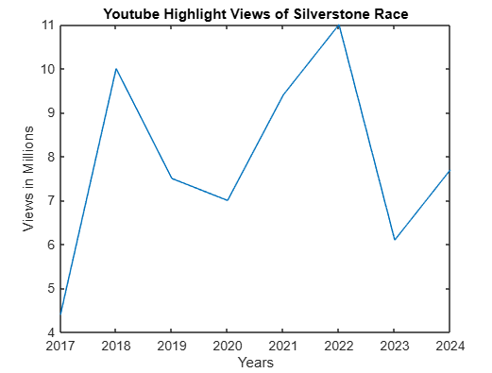
The trendline shows the clear upward growth in popularity that is less intensive.
Trend Analysis – Total Attendance:
Let X be Year event occurred ( $\overline{x}$ = 2020.5)
Let Y be Total Attendance ( $\overline{y}$ = 4.722857143)
Gradient = 0.3364927289
Intercept = –675.1607
Y = 0.336X - 675 (3sf)
The smaller gradient further suggests a more stable and steady growth in F1 attendance.
(X - $\underline{x}$ ) | (Y - $\underline{y}$) | (Y - $\underline{y}$)(X - $\underline{x}$ ) | (X - $\underline{x}$)^2
3.5 | 1.627142857 | 5.695 | 12.25
2.5 | 1.277142857 | 3.192857143 | 6.25
1.5 | 0.9771428571 | 1.465714286 | 2.25
0.5 | -2.032857143 | -1.016428571 | 0.25
-1.5 | -0.5628571429 | 0.8442857143 | 2.25
-2.5 | -0.6328571429 | 1.582142857 | 6.25
-3.5 | -0.6528571429 | 2.285 | 12.25
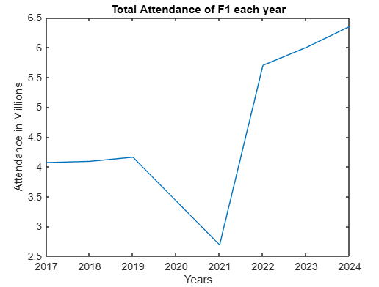
The trendline on the line graph supports the positive gradient in my trend analysis but does not suggest a stagnant trend but a sharper one. This could be showing that the new circuits have supported and aided in the intense growth in interest for F1.
Multiple Linear Regression:
Independent variable = Location (old race = 0, new race = 1)
B = vector of coefficients = ${\left(X^{T}X\right)}^{-1}X^{T}Y$
X =
1 | 1 | 7
1 | 1 | 7
1 | 0 | 7
1 | 0 | 7
1 | 1 | 6
1 | 1 | 6
1 | 0 | 6
1 | 0 | 6
1 | 1 | 5
1 | 0 | 5
1 | 0 | 5
1 | 0 | 5
1 | 0 | 4
1 | 0 | 4
1 | 0 | 4
1 | 0 | 2
1 | 0 | 2
1 | 0 | 1
1 | 0 | 1
1 | 0 | 0
1 | 0 | 0
Weekend Attendance = $β_{0}$ +( $β_{1}$ x New Track) + ($β_{2}$ x Year)
Dependent variable = Weekend attendance
Y =
275000
150000
480000
335000
270000
150000
480000
304100
243000
142000
401000
337000
143000
356000
20000
351000
200000
340000
185000
344500
147500
B =
223747.1473
-158877.4259
22972.79874
$β_{o}$ = 223747.1473 = Intercept. This is the predicted attendance if the race is at an old location in 2017.
$β_{1}$ = -158877.4259 = Location coefficient. The negative coefficient for new locations means that, holding the year constant, newer F1 tracks tend to attract fewer fans than traditional circuits. This supports the idea that established races with more history and easier access (like Silverstone) draw more spectators.
$β_{2}$= 22972.79874 = Yearly Trend. The year coefficient being positive means there is an increasing trend in attendance over time.
Highlight Views = $β_{0}$ +( $β_{1}$ x New Track) + ($β_{2}$ x Year)
Dependent variable = Highlight Views
If Y = highlight views
X =
1 | 1 | 7
1 | 1 | 7
1 | 0 | 7
1 | 0 | 7
1 | 1 | 6
1 | 1 | 6
1 | 0 | 6
1 | 0 | 6
1 | 1 | 5
1 | 0 | 5
1 | 0 | 5
1 | 0 | 5
1 | 0 | 4
1 | 0 | 4
1 | 0 | 4
1 | 0 | 3
1 | 0 | 3
1 | 0 | 2
1 | 0 | 2
1 | 0 | 1
1 | 0 | 1
1 | 0 | 0
1 | 0 | 0
Y =
7.7
6.7
7.7
7
6.8
8.4
6.1
6.2
8.8
9.5
11
6.9
9.5
9.4
9.6
7
8.7
7.5
9.5
10
5.1
4.4
4.3

B =
7.123046875
0.420703125
0.11484375
The Intercept ($β_{o}$) being 7.123046875 estimates that in 2017 the Race highlights of an old location. This number acts as an anchor and starting value in my model.
According, to the model, newer races attract 0.420703125 M more views than established ones. This suggests that simply adding new locations may guarantee higher online interest.

$β_{2}$= 0.11484375. The positive coefficient for the year variable suggests that highlight views have generally increased over time, regardless of location. This may reflect growing interest in F1 globally, improvements in broadcasting, or the popularity of figures like Lewis Hamilton."
F1 Findings:
The trendline for highlights at the British Grand Prix shows steadiness over time and consistency while Miami’s trendline is slightly declining. This displays the idea that new locations like Miami don’t always guarantee an increase in popularity. Miami’s unexpected decline may stem from poor fan reception of the circuit or its inaccessibility within a large country. These findings suggest that newness alone doesn’t guarantee higher popularity as fan experience and tradition may play a larger role. However, the trend lines for search interest and total attendance are positive implying that the overall popularity of F1 is increasing which could be credited to be because of F1 officials adding new locations like Miami and Saudi. Next time, I could look at total attendance with the removal of newer tracks to see if the addition had a significant impact on interest.
My multiple linear regression model presented that older races attract more attendees than newer circuits. While newer circuits had more online engagement than older races. This unexpected result may be due to more people watching newer races online as more inclined to travel for new tracks but willing to travel for old circuits due to history and atmosphere.
Limitations:
My F1 dataset includes only a few years per track, which limits how reliable the trendline and OLS regression are (Miami only has 3 years). A larger dataset across more years and more circuits would provide stronger evidence.
Some of the data was affected by external factors like COVID restrictions in 2021, especially for Monza which had a capped attendance of 25,000. This skews the trendline and may underestimate true interest in those years.
The OLS model assumes that location (new vs. old) is a key factor, but other variables like ticket prices, fan accessibility, local motorsport culture, or even the race calendar may also influence attendance.

Wimbledon (Fixed Location in London)
Wimbledon is a grass court tennis tournament and the oldest tennis tournament in the world. The annual competition is the 3rd of the grand slams to occur and has only ever been located in Wimbledon, London.
Year | Men’s Final Highlight Views | Total Attendance | Search  Interest
2024 | 2.1M | 526455 | 80
2023 | 5.7M | 532651 | 100
2022 | 1.8M | 515164 | 84
2021 | 1.4M | 301837 | 54
2020 | cancelled | cancelled | cancelled
2019 | 8.1M | 500397 | 96
2018 | 0.835M | 473169 | 62
2017 | 2M | 473372 | 81
2016 | 0.628 | 493928 | 58
2015 | 0.441M | 484391 | 63
2014 | 1.3M | 491084 | 32

Data has been sourced from statista.com for total attendance. Men’s final highlights have been sourced by YouTube and do not include extended highlights. Search interest is from google.
Trend Analysis - Highlights:
Let X be Year event occurred ( $\overline{x}$ = 2018.9)
Let Y be Highlights in Millions ( $\overline{y}$ = 2.4304)
Gradient = 0.2658163453
Intercept = -534.226
Y = 0.266X - 534 (3sf)
The weak positive gradient indicates that the extending interest in Wimbledon is gentle and possibly sluggish.
(X - $\underline{x}$ ) | (Y - $\underline{y}$) | (Y - $\underline{y}$)(X - $\underline{x}$ ) | (X - $\underline{x}$)^2
5.1 | -0.33 | -1.68 | 26.01
4.1 | 3.27 | 13.4 | 16.81
3.1 | -0.63 | -1.95 | 9.61
2.1 | -1.03 | -2.16 | 4.41
0.1 | 5.67 | 0.567 | 0.01
-0.9 | -1.595 | 1.44 | 0.81
-1.9 | -0.430 | 0.818 | 3.61
-2.9 | -1.80 | 5.23 | 8.41
-3.9 | -1.989 | 7.76 | 15.21
-4.9 | -1.13 | 5.54 | 24.01

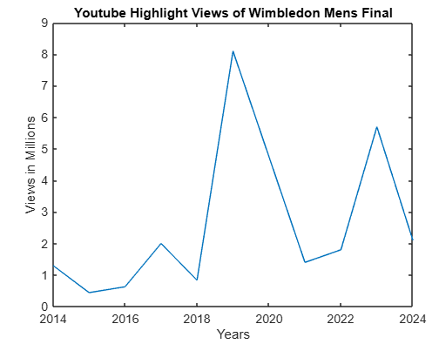
Trend Analysis – Search Interest:
Let X be Year event occurred ( $\overline{x}$ = 2018.9)
Let Y be Search Interest ( $\overline{y}$ = 71)
Gradient = -3.368
Intercept = 6871.115
Y = -3.37X + 6870 (3sf)
The negative gradient indicates a possible saturation effect, where audiences may feel less excitement due to its annual nature of Wimbledon.
(X - $\underline{x}$ ) | (Y - $\underline{y}$) | (Y - $\underline{y}$)(X - $\underline{x}$ ) | (X - $\underline{x}$)^2
5.1 | 9 | 45.9 | 26.01
4.1 | 29 | 118.9 | 16.81
3.1 | 13 | 40.3 | 9.61
2.1 | -17 | -35.7 | 4.41
0.1 | 25 | 2.5 | 0.01
-0.9 | -9 | 8.1 | 0.81
-1.9 | 10 | -19 | 3.61
-2.9 | -13 | -37.7 | 8.41
-3.9 | -8 | -31.2 | 15.21
-4.9 | -39 | 191.1 | 24.01

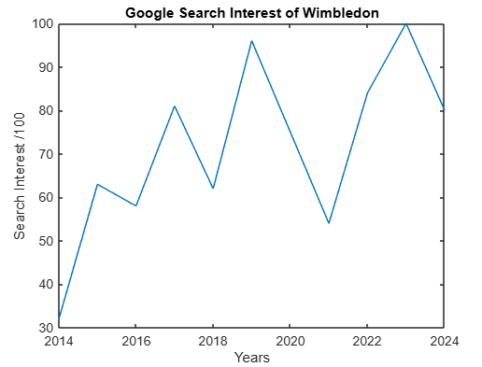
The direction of the trend line opposes the negative gradient found in my calculations so the population may not have dying excitement but an increasing one.
Trend Analysis – Total Attendance:
Let X be Year event occurred ( $\overline{x}$ = 2018.9)
Let Y be Total Attendance ( $\overline{y}$ = 479245)
Gradient = 887.1331497
Intercept = -7733.930211
Y = 887X - 7730 (3sf)
The strong increasing gradient suggests growing interest in the Wimbledon over time.
(X - $\underline{x}$ ) | (Y - $\underline{y}$) | (Y - $\underline{y}$)(X - $\underline{x}$ ) | (X - $\underline{x}$)^2
5.1 | 47,210 | 240771 | 26.01
4.1 | 53,406 | 218964.6 | 16.81
3.1 | 35,919 | 111348.9 | 9.61
2.1 | -177,408 | -372556.8 | 4.41
0.1 | 21,152 | 2115.2 | 0.01
-0.9 | -6,076 | 5468.4 | 0.81
-1.9 | -5,873 | 11158.7 | 3.61
-2.9 | 14,683 | -42580.7 | 8.41
-3.9 | 5,146 | -20069.4 | 15.21
-4.9 | 11,839 | -58011.1 | 24.01
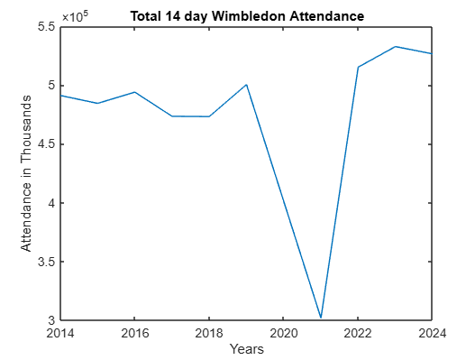
The line of best fit supports the idea that Wimbledon has a rising popularity, but the line may not support the strength of the gradient.
Wimbledon Findings:
Wimbledon’s trendline for total attendance was higher than expected showing that tradition could bring more than stability but also rapid interest. However, in contrast, the search interest being negative suggest otherwise. This could be due to lack of online searches as Wimbledon is already so established. The highlights also having a positive gradient further indicates that tradition plays a crucial role in a sport events popularity.
Limitations:
Search interest for Wimbledon may reflect spikes due to specific players (e.g., a popular British finalist like Andy Murray) rather than general interest in the event itself. This makes it harder to separate location-related effects from personality-driven attention.
Wimbledon is held every year, which may reduce excitement or the sense of novelty over time. This consistency could create a “familiarity effect” where interest levels off or declines—not because the event is less important, but because it's less rare compared to events like the World Cup (every 4 years). That might skew the results of both trend analysis and search interest.
One major limitation is that Wimbledon’s attendance is naturally capped by the size of its grounds, which can only accommodate around 42,000 spectators at one time. Unlike larger venues used for the World Cup Final or F1 races, Wimbledon can’t physically increase its attendance much, even if global interest rises. This could make the trendline appear flat or declining, even if demand is actually increasing. Next time, I could look at attendance as a percentage of the total capacity to truly see how popular the events are.
Superbowl (Fixed Location in America)
The Superbowl is the annual league championship of the National Football League. Winning teams are awarded the Vince Lombardi Trophy, which is regarded as prestigious by Americans, but would the Superbowl be more attended and viewed if they changed location every few years?

Years | Highlights | Search Interest | Average TV Season Viewership | Attendance
2024 | 9.1M | 100 | 17.5M | 61629
2023 | 12M | 68 | 17.9M | 67827
2022 | 13M | 70 | 16.7M | 70048
2021 | 10M | 55 | 17.1M | 24835
2020 | 14M | 43 | 15.6M | 62417
2019 | 15M | 51 | 16.5M | 70081
2018 | 7.7M | 53 | 15.8M | 67612
2017 | 16M | 52 | 15M | 70807
2016 | 20M | 61 | 16.5M | 71088
2015 | 4.5M | 48 | 18.1M | 70288
2014 | 5.8M | 44 | 17.6M | 82529

Superbowl data for average TV season viewership and Superbowl attendance has been sourced by Statista. Highlights views are from YouTube and search interest is from Google trends.
Trend Analysis - Highlights:
Let X be Year event occurred ( $\overline{x}$ = 2019)
Let Y be Highlight Views ( $\overline{y}$ = 11.5545454)
Gradient = 0.18
Intercept = -351.865
Y = 0.180X -352 (3sf)
The gradient being less than 1 shows the Superbowl highlight views has a slower growth in interest over time.
(X - $\underline{x}$ ) | (Y - $\underline{y}$) | (Y - $\underline{y}$)(X - $\underline{x}$ ) | (X - $\underline{x}$)^2
5 | -2.4545454 | -12.272727 | 25
4 | 0.4454546 | 1.7818184 | 16
3 | 1.4454546 | 4.3363638 | 9
2 | -1.5545454 | -3.1090908 | 4
1 | 2.4454546 | 2.4454546 | 1
0 | 3.4454546 | 0 | 0
-1 | -3.8545454 | 3.8545454 | 1
-2 | 4.4454546 | -8.8909092 | 4
-3 | 8.4454546 | -25.3363638 | 9
-4 | -7.0545454 | 28.2181816 | 16
-5 | -5.7545454 | 28.772727 | 25

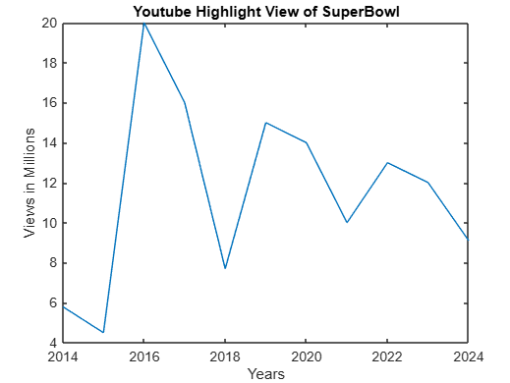
The steep incline of the trend line does not support the gradient found in my calculation. This may be due to the graph not starting at 0 or an incorrect drawing of the trendline.
Trend Analysis -Search Interest:

Let X be Year event occurred ( $\overline{x}$ = 2019)
Let Y be Search Interest ( $\overline{y}$ = 58.64)
Gradient = 3.48
Intercept = -6643.120001
Y = 3.48X - 6640 (3sf)
The strong ascending trend showcases that each new Super Bowl attracts more google searches for the term “Super Bowl” than the previous one.
(X - $\underline{x}$ ) | (Y - $\underline{y}$) | (Y - $\underline{y}$)(X - $\underline{x}$ ) | (X - $\underline{x}$)^2
5 | 41.36363636 | 206.8181818 | 25
4 | 9.363636364 | 37.45454545 | 16
3 | 11.36363636 | 34.09090909 | 9
2 | -3.636363636 | -7.272727273 | 4
1 | -15.63636364 | -15.63636364 | 1
0 | -7.636363636 | 0 | 0
-1 | -5.636363636 | 5.636363636 | 1
-2 | -6.636363636 | 13.27272727 | 4
-3 | 2.363636364 | -7.090909091 | 9
-4 | -10.63636364 | 42.54545455 | 16
-5 | -14.63636364 | 73.18181818 | 25
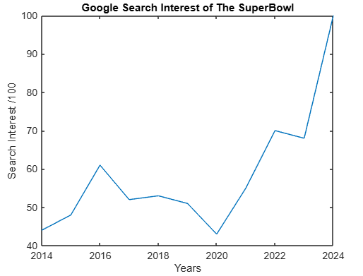
The strong upward trend of the line shows a strong positive line which aligns with the positive gradient reflecting a consistent and possibly fast rise in interest for the Superbowl.
Trend Analysis - Attendance:
Let X be Year event occurred ( $\overline{x}$ = 2019)
Let Y be Attendance ( $\overline{y}$ = 65378.2727)
Gradient = -1950.936364
Intercept = 4004318
Y = -1950X - 400000 (3sf)
The negative gradient suggests a declining interest in the Super Bowl
(X - $\underline{x}$ ) | (Y - $\underline{y}$) | (Y - $\underline{y}$)(X - $\underline{x}$ ) | (X - $\underline{x}$)^2
5 | -3749.2727 | -18746.3635 | 25
4 | 2448.7273 | 9794.9092 | 16
3 | 4669.7273 | 14009.1819 | 9
2 | -40543.2727 | -81086.5454 | 4
1 | -2961.2727 | -2961.2727 | 1
0 | 4702.7273 | 0 | 0
-1 | 2233.7273 | -2233.7273 | 1
-2 | 5428.7273 | -10857.4546 | 4
-3 | 5709.7273 | -17129.1819 | 9
-4 | 4909.7273 | -19638.9092 | 16
-5 | 17150.7273 | -85753.6365 | 25
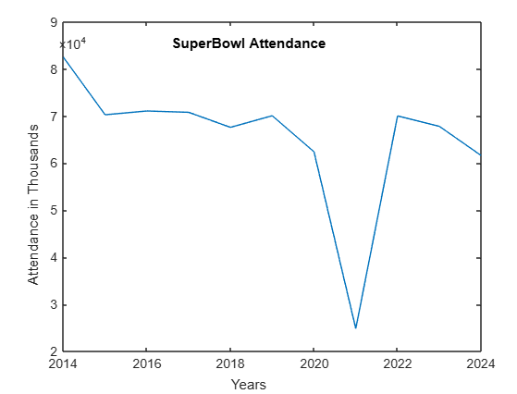
The trendline on the line graph further shows a clear downward trajectory indicating the diminishing popularity.
Superbowl Findings:
The trendline for highlights and search interest at the Superbowl shows an incline over time. This can challenge the claim that changing location may not be the best option but keeping a fixed location can ensure popularity growth. Superbowl’s unexpected decline in Attendance may be caused by higher ticket prices or fans disliking the final match. This strengthens impression that creating a new atmosphere through a new location could persuade fans to attend the Superbowl even if their own teams are paying, just for the experience.
Limitations:
Because the Super Bowl is mainly popular in the U.S., search trends may not reflect global interest, making comparisons with international events less consistent. In addition, spikes in interest could be driven by halftime performers rather than the event’s location or the game itself, making it hard to isolate the impact of venue.
While the Super Bowl is considered a fixed-location event in this study, it actually rotates between U.S. cities, which may still introduce variability in accessibility and local interest. This makes it less of a pure control case when comparing with global events like the World Cup.
Cultural traditions and national enthusiasm surrounding the Super Bowl likely contribute heavily to its popularity, but such qualitative influences are difficult to model numerically and may obscure the role of location.
Finding and Discussion:
My results for my trend analysis on highlight views provide partial evidence that changing location increases popularity. The World Cup Final had the strongest gradient (1.12) supporting the idea that rotating locations enhances engagement. However, the British Grand Prix Race highlights have a stronger gradient than Miami Grand Prix Race highlights ( -0.01 > 0.196) slightly discrediting the previous idea.
Miami’s negative gradient was unexpected, as F1 officials introduced Miami due to the sport’s growing popularity in the U.S but trend implies a loss of interest. This decline could stem from: Miami track conditions which are deeply disliked by F1 fans because of the dusty surface; low accessibility as many may have to fly in due to how large the USA is , unlike Silverstone, where most fans can just drive in, making attending cheaper and lack of cultural significance as for Britain there is a long-established F1 culture, amplified by Lewis Hamilton’s prominence and Silverstone’s historical significance as the site of the first F1 World Championship. These factors all contribute to the lower attendance.
Among all sports analysed, F1 has the highest gradient in search interest (5.74). The introduction of new races like Miami (2022) and Saudi Arabia (2021) aligns with search interest data. These global expansions likely influenced peak search interest scores (91 in 2022, 100 in 2021). This peak may be due to the promotion of the global expansion of F1 with Miami being the very first new addition and global F1 popularity rising. In contrast, Wimbledon having a negative gradient suggests that even prestigious tournaments can be viewed as boring overtime. This is surprising given that Wimbledon 2024 recorded its highest-ever attendance over 14 days. The decreasing gradient could be because of annual frequency which unlike the World Cup, Wimbledon is every year reducing excitement for viewers and limited seating with only one fixed location, growth is hindered.
The Super Bowl's strong positive gradient highlights how fixed location sporting events can have stable rises in interest overtime but perhaps less rapidly as changing location.
Finally for trend analysis, total attendance data for all sports further supports the point that new locations improve popularity, as World Cup and F1 display higher gradients than Wimbledon’s and Super Bowls. This is expected and most likely caused by lack of global reach for Wimbledon and Superbowl.
The multiple linear Regression results of the World Cup indicate with the estimated coefficient ($β_{1}$) that European hosts have 351717 more in attendance compared to non-European hosts conveying how significant location is to popularity. European Hosts would be expected to attract higher attendance as the deep historical roots and cultural significance of football to European countries would make the tournament more meaningful and significantly increase attendance.
My model estimates the highlight views of the 1986 World Cup Final would have 1.2M views while actual data shows 2M views, demonstrating a reasonable degree of accuracy. The higher European viewership aligns with expectations, as these countries have consistently had high football engagement.
For F1 races Multiple linear regression, ($β_{1}$) shows the effect of location which is that new F1 tracks have on average 158,877 fewer attendees compared to old locations. This aligns with expectations because older tracks have an established fanbase and newer circuits are less appealing to fans for F1 officials are trying to incorporate more street circuits which the shift in dynamics may alienate some long-term viewers.
The model’s baseline attendance prediction for older tracks in 2017 was 223,750, which aligns closely with the average attendance at British and Monza Grand Prix that year, 246,000.
Limitations:
There are many limitations within this study but 3 key ones. The use of total attendance for trend analysis does not consider stadium capacity such as Wimbledon only having 42,000 people at the ground at one time while the Qatar Final had an 88,966 capacity. My sample maximum sample size was 11 which is a small dataset. Finally, the biggest limitation was that some of my case studies were impacted by Covid such as Wimbledon being cancelled in 2020 and Monza having a maximum capacity of 25k in 2021.
The Multiple linear regression assumes a linear relationship and equal variance across years, which may not fully reflect reality. The true relationship between location and viewership might be more complex, involving interactions between region, year, and media availability.

Conclusion:
These findings suggest that while changing locations can boost popularity, local context, accessibility, and cultural history also play significant roles. The Multiple linear regression reinforces that European hosts attract higher World Cup viewership, while older F1 venues sustain greater attendance. However, further research with larger datasets and additional variables (e.g., ticket pricing, travel accessibility) is needed to refine these conclusions.

