GETTING SLOW BY GOING FAST - A POSSIBILITY FOR INTERGALACTIC TRAVEL

INTRODUCTION

Common sense and Newtonian physics have many things in common. One of them is the fact that space and time are absolute i.e. they progress independently of any perceiver, and can only be expressed through the language of numbers: mathematics. For a long time, it was believed that time was something that existed outside the sphere of relativity. Yes, speed and motion may be relative - the passenger sitting next to you on a train is stationary to you, but to a man on the platform, the passenger is speeding across with a great magnitude of velocity. This idea changed, along with several long-held notions about time and space, when Albert Einstein proposed his theory of relativity. In it, he refuted the belief that time was absolute and instead proposed - and proved - that time was relative to a frame of reference. Another shocking revelation surfaced - time was dependent not just on the observer, but also on speed.
TIME DILATION AND THE REAL WORLD
What Einstein theorized was later proved using highly accurate clocks, called atomic clocks^{[1]}. Scientists synchronized two perfectly accurate atomic clocks, and sent one on an aeroplane across the earth. When the aeroplane landed, the clock sent on the plane was a fraction of a second slower than the one that had remained stationary. This proved Einstein’s theoretical predictions - that time was relative to velocity, and further introduced a new concept to the world of physics - time dilation. In this research, we are going to explore time dilation and the mathematical factor that affects it, called the Lorenz factor.

^{[1]}Atomic clocks are a variety of extremely accurate clocks that rely on the orbital shifts of electrons to measure time, using chemical properties of certain elements and compounds encased within a vacuum chamber to achieve this accuracy.

THE LORENTZ FACTOR
Named after famed Dutch physicist Hendrik Lorentz, the Lorentz Factor is a coefficient of time dilation. It defines the degree to which a clock moving at a particular velocity will experience time dilation. It is expressed in simple mathematical terms as follows:
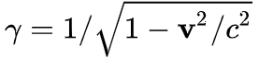^{[2]}
Here, ᵞ = Lorentz factor,
v = speed of relativistic object (in m/s), and
c = speed of light (3 x 10⁸ m/s)
Now, as expressed in the formula, the Lorentz factor is dependent on the speed of the relativistic object with respect to the speed of light i.e. the ratio of the square of the object’s speed to the square of the speed of light. Since the magnitude of the speed of light is so large, the Lorentz factor is almost negligible at most speeds known to humans. For example, an astronaut who spent 747.59 days in Earth orbit (the ISS has an average velocity of about 28,000km/h) aged only about 0.02 seconds (20 milliseconds) less than the average human being.^{[3]} However, the implications of the Lorentz factor only become truly astounding when we begin to approach the speed of light.
^{[2]} https://commons.wikimedia.org/w/index.php?curid=90916189
^{[3]} The astronaut is Sergey Avdeyev - https://en.wikipedia.org/wiki/Sergey_Avdeev
When we plot the Lorentz factor onto a graph, we begin to realise the potential of near-light speeds with respect to time. The graphed version of the Lorentz factor is as follows:
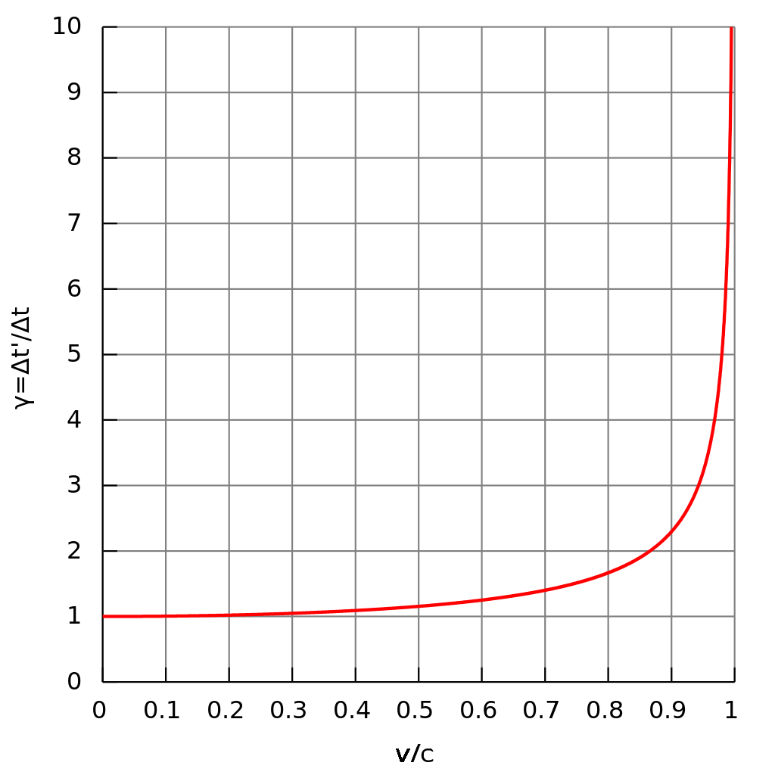^{[4]}
Here, we notice that a noticeable change in time dilation begins at around 0.35 times the speed of light, with the first increases in the graph being observed. More interestingly, above 0.9 times the speed of light, there is a drastic increase in time dilation, with the graph spiking sharply as it approaches the speed of light (where v/c = 1). At this juncture, it is important to understand the calculation of time dilation using the Lorentz factor, wherein:
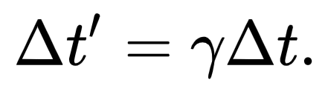^{[5]}
Let us take an example to understand this relationship, inspired by Einstein’s famous Twin Paradox. If one twin is sent to outer space at a speed such that ᵞ = 2, then, upon his return to
^{[4]} https://commons.wikimedia.org/w/index.php?curid=147133006
^{[5]} It should be noted that such a relationship does not follow for other physical quantities.
Earth 20 years later, the twin in space would have found that he would have aged 20 years, while his other twin would have aged 40. In essence, one second for the relativistic object will be experienced as 2 seconds (assuming that ᵞ = 2) by the inertial frame (i.e. the stationary object/person).
APPROACHING LIGHT SPEED
When the speed of the relativistic object nears 3 x 10⁸ m/s, the value of the Lorentz Factor becomes exponentially magnified. Here is a list of values for ᵞ, between [v/c = 0.8] and [v/c = 0.99995]: 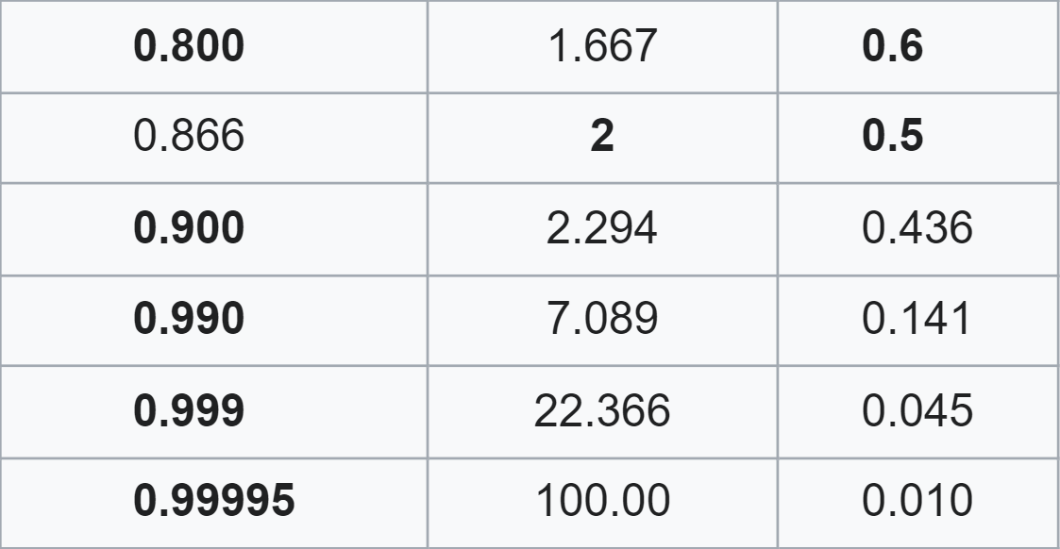
Here, the offset of ᵞ between [v/c = 0.8] and [v/c = 0.9] is approximately 0.627, however, the ᵞ offset between 0.9 and 0.9995 is 97.706, an increase of 15,583.09%!
A new revelation strikes when we consider time as experienced by light itself. Here, v=c, therefore, [v/c = 1]. We find that ᵞ increases unbound, essentially, ᵞ at [v/c = 1] is = ∞! So, in layman’s terms, light experiences an infinite amount of time before we experience even a second! Therefore, light does not experience time, relative to itself.
This is better explained if we consider the inverse of the Lorentz factor, termed ɑ. Graphing ɑ against the ratio of relativistic speed (v) to c, we obtain the following:
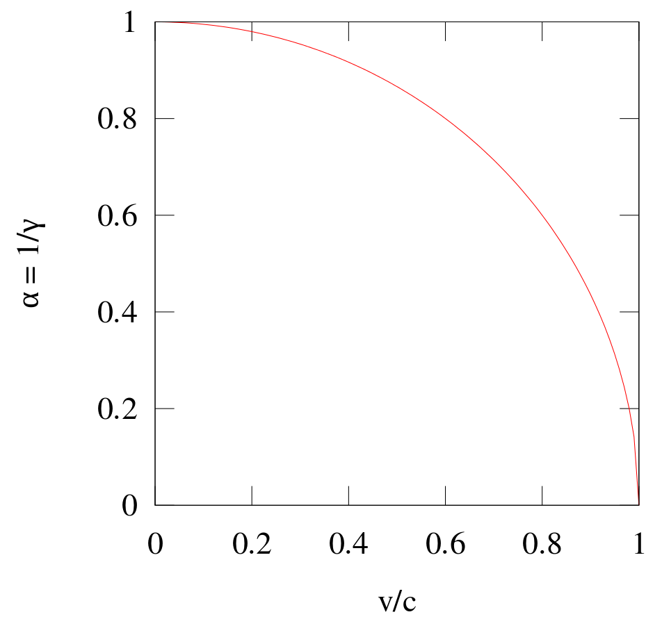^{[6]}
Here, we can clearly see that at [v/c = 1], ɑ = 0, resulting in the same conclusion - light does not experience time relative to itself.
THE POSSIBILITY OF INTERGALACTIC TRAVEL
However, exciting possibilities begin to arise when we consider this fact: not only is time not experienced by light, it is also not experienced by anything that travels at the speed of light.
Therefore, in the near or far future, if we humans were to discover a method of light-speed travel, then we ourselves would not experience time. Hence, what we consider to be “billions of light years” would be traversed in no time at all, were we to travel at light-speed. So, in theory, if we were to achieve light-speed travel, we would be able to visit any place in the solar system, the galaxy or even the universe, in, quite literally, no time at all!

Adithyan Diwakar Vidya

^{[6]} https://commons.wikimedia.org/w/index.php?curid=47804458

