-Ghosts of reality in the Blue city-
By: Haya Hasan.
March – 2025
Introduction:
We all know that in our mathematical world, we use something called imaginary mathematics, from complex numbers to quaternions, octonions and sedenions. However, why don't we take another look at this case? In this essay, we are going to study how the imaginary mathematics world within all of its concepts will describe the world of real analyses and calculus. Please notice; in this essay, I may be criticizing some concepts of real mathematics using other imaginary concepts.First I will explain some of the main imaginary concepts that I will use, apply them on the real concepts, and figure out their strange realities using some of my own theories.
-What can be hiding under the term of "real''?
-Is the term of ''imaginary'' just a way to simplify things by not pondering in them?
Let's find out!
I. Bridging realities: Dimensions of Discourse:
In the Blue city ^{*[1]} that stretches on an infinite plane, the landscapes are magnificent forms of complicated fractals. Julia and Mandelbrot sets are the most common places here in the world of multi-dimensional spaces. All the inhabitants of our city, from complex to hypercomplex numbers, live together holding hands among imaginary and real units, with rhymes of the artificial rotation of quaternions and the fascinating complexity of the abstract algebra creatures, all following the ethics of non-Euclidean geometry. One day, a rift tore our city, and some real numbers arrived. Unlike the polite real numbers in the forms of our numbers, these numbers were just one-, two-, and three-dimensional ignorant creature's .They described our world as being not logical and talked about the linear algebraic world, where the line is the main fundamental concept. they denied the beauty of our infinitely flowing world , describing it as '' imaginary!''; they froze in front of understanding the magic of loops , infinite fractals and transformations in the unit circle, isn't that hilarious ?! Besides , they hurt our dearest $i$ by telling him he doesn't exist …We had enough and asked the mind-advanced parts' numbers in our world to describe some concepts for them because they had the same visions once before they obtained the multi-dimensional vision , unlike these real numbers who think simplicity is nice!
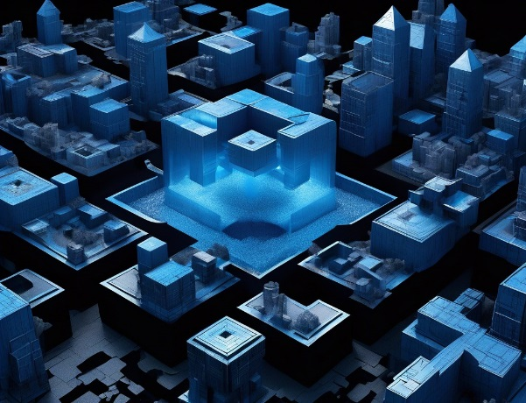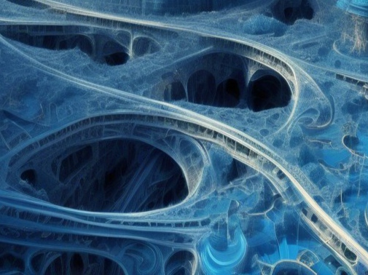

^{[1]}: I called it the Blue city because it refers to sky and infinity; and it is my favourite colour!

II. Fractals and the magic of infinity:
A common misconception is that fractals are defined as shapes that are definitely self-similar; but the correct definition of fractals is the following:
Fractals: shapes with a non-integer dimension but instead some fractional amounts, in a quantitative way we can say its shapes are rough and they stay rough as you zoom in. As the idea of the non-integer dimensions almost captures the idea of roughness. The reason why we will concider that fractals relate to the imaginary mathmatics world now is that they often show complex patterns that aren't easily describable using tradisional Euclidean geometry and also because self-similar fractals refer to infinity.
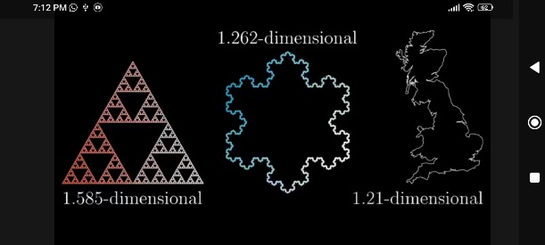
Well, I don’t have enough space to explain the fractals dimensions and how to measure them, but shortly: The fractal dimension D is a measure of how completely a fractal appears to fill space as one zooms down to finer scales. It can be difined using many ways, but this is the cleariest way: if you scale down the original shape which its length is L by any length scailing factor S the new length will be SL and if we scail down the mass which is $M$ by any mass scailing factor $S'$, then the mass of the new structure must be $S'×M$ and we have another expression for the new mass involving the length scailing factor S as $S^{D}×M$and now if we know what is the mass scailing factor (how many scailed shapes do we need to rebuild the original one) then we can simply apply:
$S'×M$ =$S^{D}×M ∴{\frac{1}{S^{'}}}^{}={\frac{1}{S^{D}}}^{} ∴D=\log_{\frac{1}{s}}{\frac{1}{s^{'}}}$ and D is the fractal dimension. Notice that since the scailing down factor is lesser than one we took the reciprocal of both sides of the equation to easily find $\log_{\frac{1}{s}}{\frac{1}{s^{'}}}$ .
Back to self-similar fractals, as they are the best way to understand infinity. In these fractals, every part is like the main structure, the exhibition of these parts, or these similar patterns at increasingly smaller scales is called self-similarity_ Self-similar fractals express the concept of infinity.
As an example look at the self-similarity of the Siepinski triangle:
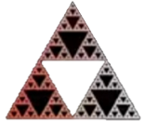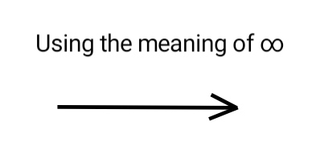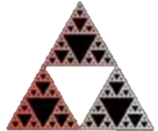

In addition, look at the successive magnification of the Mandelbrot set below:
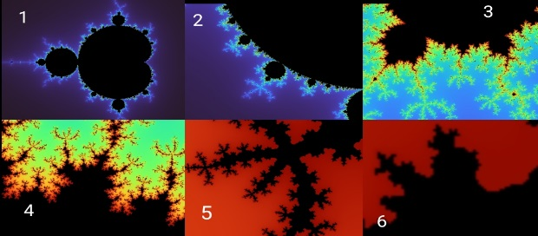

Although, the idea is clear, but the Mandelbrot set is still a major example to mention in the field of fractals; the fascinating detail of it is its intricate boundary, which is infinity complex, revealing self-similarity and intricate patterns at every level of magnification.
Now we are ready to see how infinity can face the arrogant arrivals in the debate hall!

III. Infinity against the real concepts- Collatz conjecture:
Collatz conjecture: for even numbers, divide by 2; for odd numbers, multiply by 3 and add 1; with enough repetitions, you will end up in a loop of one, two, and four …. Do all positive integers end up in this loop? Can you prove it? This debate has been running in the real mathematics world for years … But let us see if the concept of imaginary infinity has another point of view!
Imagine a fractal , a square with four painted angles , each one of these angles is painted as a square as well ; if you zoom into it , you can see another square with four angles, and keep zooming until infinity.
Now if we consider a number as a unit containing units of substances, this means all numbers can have infinite parts just like this square; for example: one square contains two triangles, each one includes two triangles and so on.
Therefore, we can say: Every number has a half … look at the number one:
1/2= 2(0.5)= 2(2(1.25)) =….$=\lim_{x→∞}{2^{x}x=2^{∞}(∞)=∞}$
In addition, logically one apple divided by two is infinite units of matter and atoms.
If we want to apply this method on Collatz conjecture, we will consider all odd numbers as being even because they are dividable by 2 as we considered, whether the answer was a natural number or not, we do not actually care here because we are in the world of imaginary mathematics … So, imagine!
Applying the conjecture according to the real number system : 3 goes to 10 goes to 5 goes to 16 goes to 8 goes to 4 goes to 2 goes to 1, back to 4 to 2 to 1 and we are stuck in the loop.
Applying the conjecture according to our consideration of infinite numbers: 3 goes to 1.5 goes to 0.75 goes to infinity, 2 goes to 1 goes to 0.5 goes to infinity as well as all other numbers , now if we consider the shape of movement between numbers as the x-axis presents the number and the y-axis presents the outcome we see:
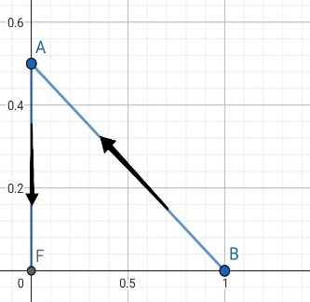
Here we can notice that the space between the dot A (0, 1) and the origin O(0, 0) equals infinity. If we draw the movement of all other positive numbers, we will find that every number ends up for infinity, as in the image bellow. The repetition of the lines forms a surface in the two dimensional plane:
This plane can stretch to infinity, but even in the most infinite part of it, it will not cover infinity but only half of it, which is still infinity$: \left\{ \frac{∞}{2}=∞\right\}.$
Here you can see the two final shapes in the second and third dimensional planes (the values can be increased till infinity).
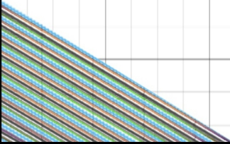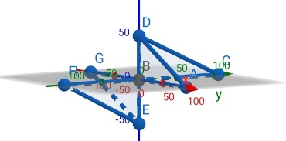
Well, that was a strong revenge from the imaginary mathematics world's numbers as they showed the arrivals how a small imaginary concept can change one of the real mathematics world's simple fixed concepts and still be logical like the whole previous idea '' the magic of infinity'' , it makes sense right! *_{[2]}
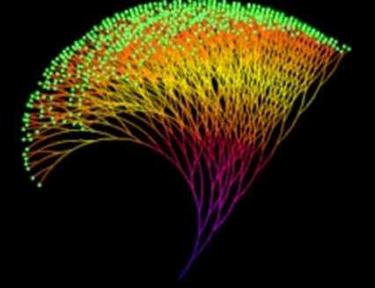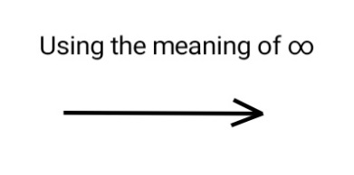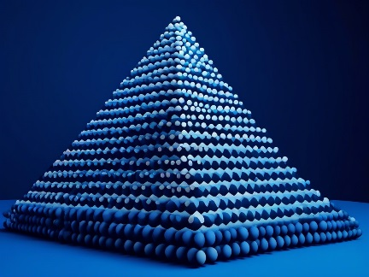

We should not deny the enormous growth of an idea!
Just like the Pigeonhole Principle, from this simple idea {if n items are put into m containers, with n > m, then at least one container must contain more than one item} to this application of the principle {normally, a person's head hair is counted to be around 500000 hairs. In a city containing 5000000 people, prove that there are at least nine people who have the same number of head hairs}!
Our idea of the infinite square was as simple as the previous principle but we saw the enormous applications!

^{[2]}: The second image shows the front view of the positive part of the 3D plane, as we are comparing with the first image of the conjecture.

$$IV.1+1=?2:$$
In order to continue their revenge, the imaginary mathematics world's number still aim to break the most fixed concepts of their opponents, the concept that 1+1=2 which all the system of measurements are based on.
Logically, one plus one actually equals a complicated form of exact infinite matter units.
According to the study of sets, we call card (A) the number of its components for example: A:{4, 0} ∴card (A) =2; now the power set of any set is the largest set of sets that we can create using the components of the main set, and there is a fixed rule for calculating, as we don’t care for order in the set:
$Card P\left(A\right)=2^{card(A)}$
In our previous example P(A) :{ø , {4},{0},{4,0}} ∴card P(A)=4=$2^{2}$as clearly we can see that card(A)=2.
Thus, as we previously considered that $1=2^{∞}×∞$
We can consider the number one as being a multiplication of two sets, one of them contains infinite number of components, and the other one is a power set of another set that contains infinite number of components!
Implies, one plus one equals another level of infinity!

V. complex numbers, are they complex?
As an introduction, a complex number is the number that can be written in the form of $a+bi$when (a, b) are real numbers and$i^{2}=-1$. In the complex number Z=a+bi, (a) is the real part and (bi) is the imaginary part. Complex numbers extend the real numbers by adding the imaginary unit (the root of negative one).
I actually cannot understand why understanding the roots of negative numbers is complex! It is hard to understand the root of -1, while it is just like understanding -1 itself.
Can you see, touch or feel negative numbers? No, but you are familiar with them because you use them a lot in calculating and you know their spacious applications, well the same thing applies for their roots, you can't see them but once you are familiar with their enormous applications whether in quantum physics or in signal processing, you know they are as simple as their complexity!
Complex numbers can be presented in the two-dimensional complex plane where the y-axis presents the imaginary part and the x-axis presents the real part of the complex number. According to the De Moivre's formula, consider a complex number z=a+bi then: $z=r(cosθ+isinθ)$ and$θ=\tan^{-}{×(\frac{b}{a} })$ and we can use this expression involving the modulus of the complex number:$z=\left|z\right|e^{iθ}$ as$e^{iθ}$ is a representation of the angle in terms of Euler's formula, which states that $: e^{iθ}=\cos\left(θ\right)+isin\left(θ\right)$^{[5]}
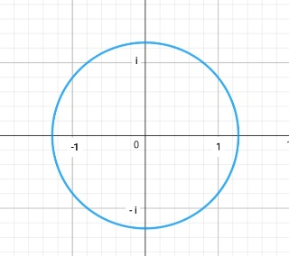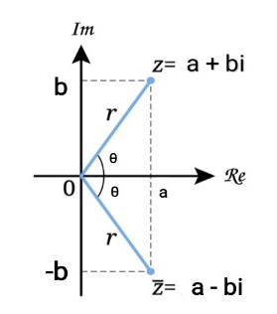
In the complex plane, multiplying has the same effect of pure rotation. There is a nice game to understand this, let us express the complex number z as z: |z|_$θ$ and another complex number u in the plane is expressed as u: |u|_ $φ$
Then$, z×u=|z|×|u|_(θ+φ)$
Therefore, if you multiply two complex numbers, the result will be a complex number whose modulus is the product of the moduli of the two numbers, and its argument equals the sum of their arguments. Thus, we rotated one number by the angle of the other one counter clockwise.
The unit circle in the complex plane is a circle centred at the origin O (0, 0) with radius of one. In terms of complex numbers, a point on the unit circle can be represented as:$z=e^{iθ}=\cos\left(θ\right)+isin(θ)$
Now we will use the symbol$R^{\begin{aligned}ϑ \\ \left(O,+90°\right)\end{aligned}}$ to refer to a pure rotation for any point $ϑ$ by 90º counter clockwise around O (0, 0), the results will be: (as$i= \sqrt{-1}$)$$R^{\begin{aligned}1 \\ \left(O,+90°\right)\end{aligned}}=i=1i, R^{\begin{aligned}-1 \\ \left(O,+90°\right)\end{aligned}}=-i=-1i, R^{\begin{aligned}-i \\ \left(O,+90°\right)\end{aligned}}=1=-ii, R^{\begin{aligned}i \\ \left(O,+90°\right)\end{aligned}}=-1=ii$$
Therefore, in the complex plane multiplying by$i$ have the same effect of rotating by $90°$ counter clockwise, because the results of rotation are the same if we multiply by the root of negative one.
Nevertheless, if we bonder in this case, both following statements are correct:
1. Multiplying by $i$ have the same effect of the isometry $R^{\begin{aligned}ϑ \\ \left(O,+90°\right)\end{aligned}}$ because $ii=-1.$
2.$ii=-1$, Because this is essential, to make sure the isometry$R^{\begin{aligned}ϑ \\ \left(O,+90°\right)\end{aligned}}$ has the same effect of multiplying by$i$.
The debate goes on. No one can deny the importance of complex numbers, but just after understanding some main concepts I think that everyone can believe they are not even complex, but their arrival back then was odd, and unfortunately, no one thought of changing this harsh name till now, but whatever, it is a great number set.
However, we are ready now to see their presentation in the debate hall, how can complex number affect a familiar concept in the real world if applied on it?

VI. A new look in the clock:
The rhyme of the clockwise…Have you ever been fascinated by this charming circle and the rotation of its clockwise around its centre; does this remind you with something? Exactly, the multiplication in the complex plane, imagine rotating 12 to 3 to 6 to 9 to 12, so why don’t we see how will this actually work if we use this rotation in the complex plane?^{*[3]}
Remember to forget about the clock for a while because now we will only deal with numbers.
Rotating counter clockwise means multiplying by$i$. Thus, rotating with clockwise means dividing by$i$. This is the tracks between numbers:
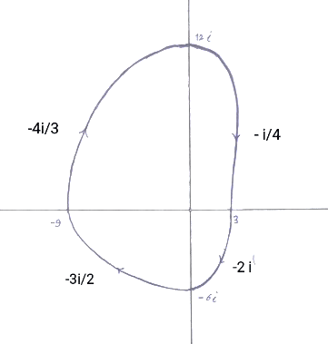
We will use the expression C(O,r) to refer to every circle centred at O(0,0) and has the radius r, so we can draw these circles: C(O,3) , C(O,6) , C(O,9) , C(O,12); these are enlarged circles compared to the unit circle C(O,1).
Now I will follow a particular method, I will divide each sides of the Y-axis (above and below O(0,0) limited by the tracks) into three areas using two limiting dots, accurately, (0,4i) and (0,8i) above the origin O(0,0) ; and (-2i,0) , (-4i,0) below the origin O(0,0).
Then, I will draw the projection of each limiting dot on the tracks according to their position (above and below the origin O(0, 0)). After that, I will call the new dots on the track according to numbers on the clock, so we will get this now:
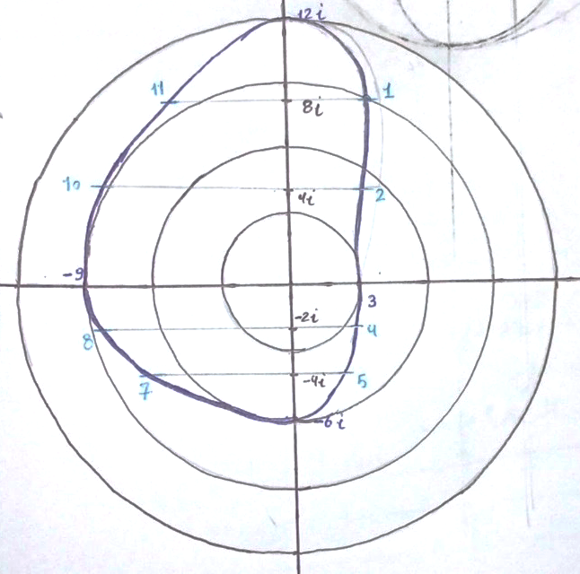
We can notice that the tracks follow a specific pattern, the track from 12i to 3 is externally tangent to$C(O,3)$; the track from 3 to -6i is externally tangent to $C(O,3)$then it intersects$C(O,6)$ ; the track from -6i to -9 is externally tangent to$C(O,6)$then it intersects $C(O,9)$; the track from -9 to 12i is externally tangent to$C(O,9)$then intersects C (O, 12); but at the point $(0,12i)$ the pattern is broken.
The pattern still runs between {3, 6, 9}; did we move on to Tesla's law?!
Okay, now let us connect the points {1, 4, 7, and 10} as they are the first points on each track, same for {2, 5, 8, and 11}; so what we get is an octagram as shown in the following image:
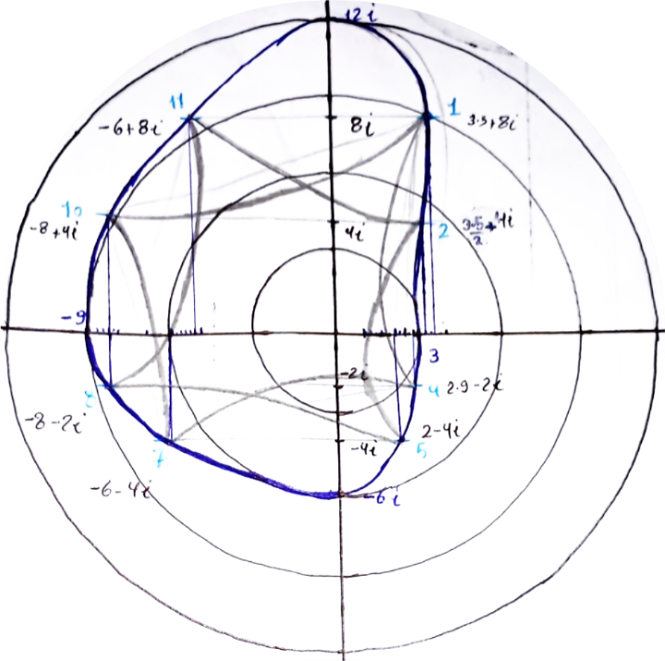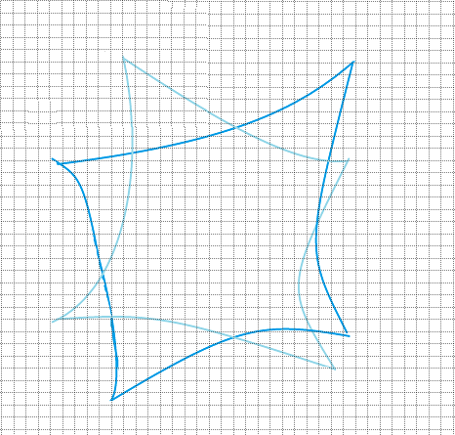

We will have a great discussion about the octagram, but first, we can simply notice that there are infinite Euler passes in any point of the octagram.
We can say that if we start the pass anywhere on the main {12, 3, 6, and 9} track we will end up on it; and if we start the pass anywhere on the inner track we will end up inside the main track.
Now, I need you to bonder in my hypothesis:
We use a particular time system, one hour includes 60 minute (an hour/60) includes 60 seconds (an hour/3600); if we divide the second into 60 parts (whatever was the name of this new measurement unit), can't we consider a new time system: {a minute includes 60 seconds (a minute/60) includes 60 units (a minute/3600)}, we can also consider another time system: {A second, includes (a second/60) units, include (a second/3600)}; and this goes on till infinity.
Back to our tracks, if you are in a particular time system, you cannot skip it; whatever was it the external track you choose, with the circles and tracks it will eventually lead you to the {12, 3, 6, 9} track.
We can notice something special; to rotate 12i to 3 we multiplied by –i/4, and to rotate -6i to -9 we multiply by -3i/2; ( -i/4)(-3i/2)=(-3/8) ; to rotate 3 to -6i we multiplied by -2i, and to rotate -9 to 12i we multiplied by -4i/3; (-2i)(-4i/3)=(-8/3), (-3/8)(-8/3)=1; one time system.
^{[3]}: We used the complex plane because we care about rotation, remember that rotation in the complex plane means multiplication; complex numbers make it easier to represent rotation in the plane$. e^{Iθ}$ represents a rotation by an angle$θ$; this is very useful for describing circular motion, which we need in what follows.

VII. Can it be?
If we wanted to describe a symmetrical octagram created by vertices on the unit circle, they will be given by $z_{k}=e^{\frac{iπk}{4}}$ for k=0, 1, …, 7 drawn in the skipping order, the vertices for the octagram on the unit circle are:
$z_{0}=e^{\frac{iπ0}{4}}=1, z_{1}=e^{\frac{iπ1}{4}},z_{2}=e^{\frac{iπ2}{4}}=i, z_{3}=e^{\frac{iπ3}{4}}, z_{4}=e^{\frac{iπ4}{4}}=-1,z_{5}=e^{\frac{iπ5}{4}}, z_{6}=e^{\frac{iπ6}{4}}=-i,z_{7}=e^{\frac{iπ7}{4}}$
Nevertheless, we can't be able to apply this on the octagram we got because it's clearly not symmetrical, but if we imagine a centre somewhere in this octagram and draw the radii, we will be reminded by something; you can simply notice that the two following images can match together:
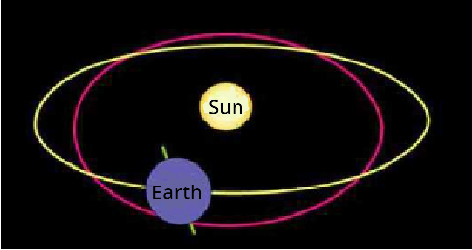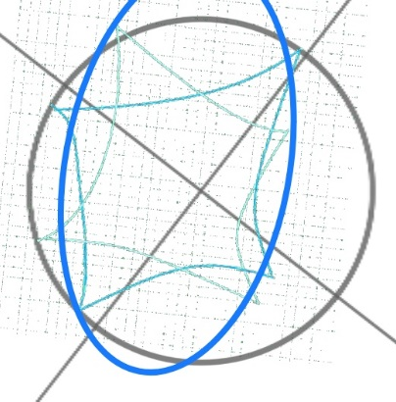

Take a deep look at those two pictures, if we create a mathematical relationship that describes the closest symmetrical octagram to our octagram some points may be represented out of the tracks but still limited in a bigger track, just like the Earth's cycle's track around the sun.
Thus, we will move on, find the relationship, and see if it will match with the Earth's cycle and the four seasons' exchange?
The main expression is $z_{k}=c+r*e^{\frac{πki}{4}}$ as c is the centre of the symmetrical octagram and r is its radius; k= 0, 1, …, 7.
We can approximately calculate the centre by dividing the sum of the points as complex numbers by 8.
C=$\frac{ 3.5+8i +1.75+4i +2.5-2i +2-4i -6-4i -8-2i -8+4i -6+8i}{8}=\frac{-18.25+12i}{8}= -2.28125+1.5i$Now to find the average radius we will calculate the distance (magnitude) from the centre to each given point, then we calculate the average of those radii.
$$R=\frac{r1+r2+r3+r4+r5+r6+r7+r8}{8}$$
$r1=\left|3.5+8i-\left(-2.28125+1.5i\right)\right|=\left|5.78125+6.5i\right|=\sqrt{{\left(5.78125\right)}^{2}+{\left(6.5\right)}^{2} }=\sqrt{75.6725815625}≈8.7$
$r2=\left|1.75+4i-\left(-2.28125+1.5i\right)\right|=\left|4.03125+2.5i\right|=\sqrt{{\left(4.03125\right)}^{2}+{\left(2.5\right)}^{2} }=\sqrt{22.5009765625}≈4.74$$r3=\left|2.5-2i-\left(-2.28125+1.5i\right)\right|=\left|4.78125-3.5i\right|=\sqrt{{\left(4.78125\right)}^{2}+{\left(3.5\right)}^{2} }=\sqrt{35.1103515625}≈5.9r4=\left|2-4i-\left(-2.28125+1.5i\right)\right|=\left|4.28125-5.5i\right|=\sqrt{{\left(4.28125\right)}^{2}+{\left(-5.5\right)}^{2} }=\sqrt{48.5791015625}≈6.97$
$r5=\left|-6-4i-\left(-2.28125+1.5i\right)\right|=\left|-3.71875-5.5i\right|=\sqrt{{\left(-3.71875\right)}^{2}+{\left(-5.5\right)}^{2} }=\sqrt{44.0791015625}≈6.6r6=\left|-8+2i-\left(-2.28125+1.5i\right)\right|=\left|-5.71875+0.5i\right|=\sqrt{{\left(-5.71875\right)}^{2}+{\left(0.5\right)}^{2} }=\sqrt{32.9541015625}≈5.74r7=\left|-8+4i-\left(-2.28125+1.5i\right)\right|=\left|-5.71875+2.5i\right|=\sqrt{{\left(-5.71875\right)}^{2}+{\left(2.5\right)}^{2} }=\sqrt{38.9541015625}≈6.24r8=\left|-6+8i-\left(-2.28125+1.5i\right)\right|=\left|-3.71875+6.5i\right|=\sqrt{({-3.71875)}^{2}+{\left(6.5\right)}^{2} }=\sqrt{56.0791015625}≈7.5$

$$R=\frac{r1+r2+r3+r4+r5+r6+r7+r8}{8}≈\frac{52.39}{8}≈67.54875$$

Now we can finally get the final formula that expresses the nearest symmetrical octagram to our octagram:$$z_{k}=\left(-2.28125+1.5i\right)+67.54875e^{\frac{iπk}{4}}$$
$$for k=0,1,…,7$$

Now imagine the Earth's cycle around the sun, the sun is like the centre, and Earth's position at any given time can be represented by a point on this cycle; and the formula $Z_{k}$ gives us this point. The part $\frac{e^{iπk}}{4}$ represents the rotation angle; k can represent time or a specific point in Earth's cycle around the sun. Whenever k increases, the angle increases; this means Earth moves along its orbit. Look at this simple application:
K=0, the starting point, assume it is the beginning of spring in the Northern Hemisphere.
K=2, after a quarter turn (45º*2=90º), it is summer in the Northern Hemisphere.
K=4, after a half turn (45º*4=180º), it is autumn in the Northern Hemisphere.
K=6, after three-quarters of a turn (45º*6=270º), it is winter in the Northern Hemisphere.
K=0 ( or K=8, because a cycle repeats itself), after a complete turn ( 45º*8=360º), we return to the starting point, and it is spring in the Northern Hemisphere.

Although this example is so simplified, it provides a general understanding of how mathematics commonly, and complex numbers specially, can describe this natural phenomenon.
However, there are other factors that we did not take in account like the elliptical shape of Earth's orbit, slight changes in the tilt of Earth's axis and the influence of the atmosphere.

So, can it be? Inside the clock lies a description of the change of seasons! Moreover, as we previously noticed that there is a particular pattern the keeps going between {3, 6, 9}; have I just solved the mystery of Tesla's law without noticing?!

VIII. Beyond infinity: Introducing the I-set:
I have been always fascinated with the concept of infinity. Thus, I came up with a ground breaking theorem, a new concept that proved its creativity when I figured out its applications!
Imagine that we introduce a new set of numbers; I called it the infinite numbers set (the I-set); not because it contains an infinite number of components, but because each component is called an infinite number.
I introduced the I-set as:
I :{$k∞+b ,as k,b∈R∪\{ai ,as a∈R \}$ }
Therefore, we have four forms of each infinite number:
$k∞+b ,as k,b∈R$ {Real-Real form} 1.
$2. k∞+bi ;as b∈R, k∈C( Specifically k=ai ,as a∈R)$ {Complex-Complex form}
$3. k∞+b ;as b∈R, k∈C( Specifically k=ai ,as a∈R)$ {Complex-Real form}
$4. k∞+bi ,as k,b∈R$ {Real-Complex form}
I will give you examples of each form:
1. The Real-Real form like: $4∞+2$
2. The Complex-Complex form like: $4i∞+2i$
3. The Complex-Real form like: $4i∞+2$
4. The Real-Complex form like: $4∞+2i$
We will deal with $∞$ as a value and forget the major rule { $a×∞=∞\}$ for a while, because if you imagine a square whose side's length is infinity, the area of this square equals $∞^{2}$ , obviously the area of this surface is much bigger than the side's length; so let's forget the rule{ $∞×∞=∞^{2}\}$ because we are treating infinity as an amount.
IX. The I-set numbers plane:
In order to study the operations on the I-numbers set, we need to study the plane that represents these numbers, which I called: the I-plane^{*[4]}.
On the X-axis, we present the Real-Real and Real-complex infinite numbers whose second part is zero.
On the Y-axis, we present the Complex-Complex and Complex-Real infinite numbers whose second part is zero.
And It is obvious why I will choose the origin O (0, 0) not$∞$, because there are about $∞$ between zero and$∞$; but if you bonder in the I-plane's image bellow you will notice something.
^{[4]}: By calling it the infinite plane, I do not actually mean it stretches to infinity, because this is an absolute property for any plane; but I actually meant it represents the I-set numbers.

The I-plane:
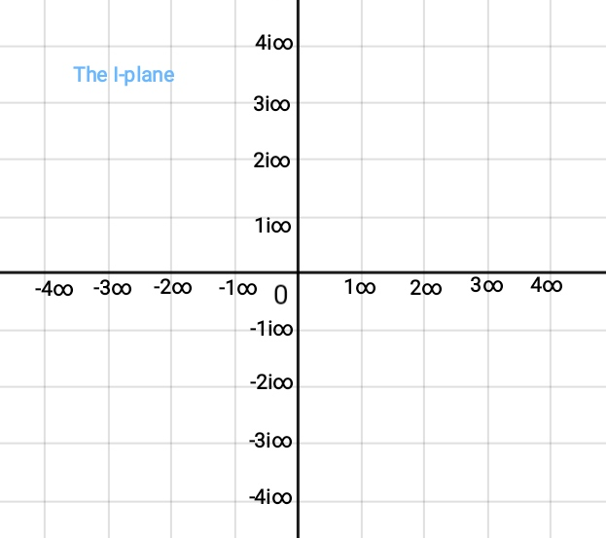

Remember the complex plane, I have always been wondering about something. If the root of negative one was a negative number, this implies that it is bigger than negative one; and if it was a positive number, this implies that it is less than negative one.
Although the two cases are impossible according to the real rules of signs multiplication; it is truly insane to consider the modulus from 0 to $i$ equalled to the modulus from 0 to 1 in the complex plane.While the both equal infinity, but at the very infinite point of them, the number of the infinite numbers from 0 to 1 is logically bigger(or less) than the number of infinite numbers from 0 to $i$. However, we still use the same distance, which is one.
This is a measuring point view, but in an imaginary linear point view: $i=1i=1×i=R^{\begin{aligned}1 \\ \left(O,+90°\right)\end{aligned}}=-1;$the modulus is$\left|-1\right|=1.$
I used the same method in the I-plane,$1i∞$ may be bigger or less than$1∞$ , but I used the same distance from zero, which is one, because linearly$1i∞=1i×∞=R^{\begin{aligned}1 \\ \left(O,+90°\right)\end{aligned}}×∞=-1∞;the modulus is \left|-∞\right|=∞$, or $1i∞=1\left(i×∞\right)=1×R^{\begin{aligned}∞ \\ \left(O,+90°\right)\end{aligned}}=1×(-∞);the modulus is \left|-∞\right|=∞$ .
You can simply notice that the familiar complex plane that we know forms the beginning of the I-plane! You can figure this out in the following image:
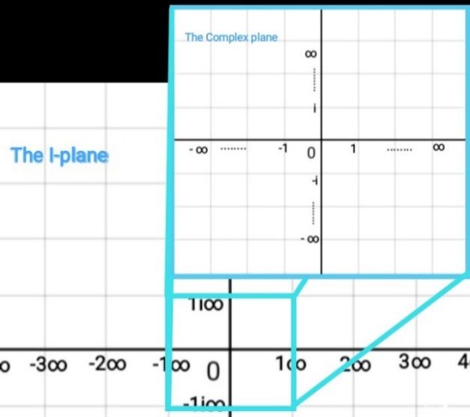

How can we represent the I-set numbers in the I-plane?
Actually, we have three ways:
1. C-C infinite numbers will be represented on the Y-axis, for example$4i∞+2i$; since $2i$ is an amount represented on the Y-axis (from 0 to $1i∞$ ).Thus, the previous point is represented on the Y-axis with the distance of $2i$ from $4i∞$.
2. R-R infinite numbers will be represented on the X-axis, for example $4∞+2$ ; since 2 is an amount represented on the X-axis (from 0 to$1∞$ ).Thus, the previous point is represented on the X-axis with the distance of 2 from$4∞$.
3. C-R and R-C infinite numbers will be represented in the I-plane not on any axis; a point (x,y) as y on the Y-axis is the Complex part and x on the X-axis is the Real part. For example:
A: $4i∞+2$ (C-R infinite number) is represented as the point$A(2,4i∞)$ .
B:$4∞+2i$ (R-C infinite number) is represented as the point $B(4∞,2i)$ .
Nevertheless, it will always be difficult to determine the position of points between infinities on the axis. Thus, we use approximated positions.
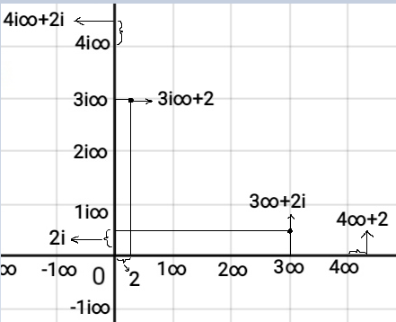

X. The operations defined on the infinite numbers:
1. Addition and subtraction:
As we considered the space between two consecutive points on any axis equalled to infinity, then we can follow this rule for C-C and R-R infinite numbers:
$\left(k∞+b\right)±\left(a∞+h\right)=\left(k±a\right)∞+(b±h)$
For example: $\left(4i∞+2i\right)+\left(2i∞+4i\right)=\left(4i+2i\right)∞+\left(2i+4i\right)=6i∞+6i$ which is represented on the Y-axis.
Another example:$\left(4∞+2\right)+\left(1∞+3\right)=\left(4+1\right)∞+\left(2+3\right)=5∞+5$ which is represented on the X-axis.
For the C-R and R-C infinite numbers added together, we can recollect the same parts, for example:
$\left(4i∞+2\right)+\left(4∞+2i\right)=\left(4i∞+2i\right)+\left(4∞+2\right)$, which equals a number that is represented as the point ($4∞+2,4i∞+2i$) in the I-plane.
And for other cases, like C-C infinite number + R-R infinite number, we keep using the recollecting method.
2. Multiplication and Division:
For multiplying two infinite numbers, we can use the rule: #
$\left(k∞+b\right)\left(a∞+h\right)=\left(ka\right)∞^{2}+\left(bh\right)$
But the main problem is that how can we represent the square of infinity in the plane?
As we previously decided not to use the rule$∞^{2}=∞$, and there is no square of infinity on any axis; how can we represent the square of infinity?
Okay, since${ ∞}^{2}=∞×∞$ , then we can consider $∞^{2}$ as the surface area of a square whose side's length is $∞$ .
Therefore, I will represent any infinite number that contains${ ∞}^{2}$ as a surface area of a square, triangle, circle or rectangular or any 2-dimensional suitable surface (not as a point).
For example,$\left(2∞+1\right)\left(2i∞+2i\right)=\left(4i\right)∞^{2}+\left(2i\right)$ which is the surface area of the rectangular whose sides lengths is$\left(2∞+1\right)$ and$\left(2i∞+2i\right)$.
Now if we are multiplying two C-C infinite numbers the result will be a R-R number; so one of the sides ( or radii for the circle's case) of the shape whose surface represents this 2D infinite number will be represented on the X-axis, and the same when multiplying two R-R infinite numbers.
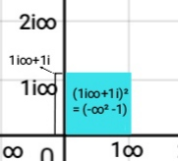
If we are multiplying a C-R infinite number with a R-C infinite number, we are getting a C-C infinite number, so one of the sides ( or radii for the circle's case) of the shape whose surface represents this 2D infinite number will be represented on the Y-axis
Now what if we multiply two R-C infinite numbers, or two C-R infinite numbers?
-When multiplying two C-R infinite numbers we are getting a R-R infinite number, for example:
$$\left(2i∞+1\right)\left(i∞+2\right)=\left(-2\right)∞^{2}+\left(2\right)$$
This number can be represented as the surface area of the rectangular whose dimensions' lengths are the projections of the moduli of the arrows from zero to each point on the suitable axis; or as the surface area of the square whose side's length is : ( $i\sqrt{2} ∞+ \sqrt{2}$ ).

-When multiplying two R-C infinite numbers we are also getting a R-R number, for example:
$$\left(2∞+i\right)\left(1∞+2i\right)=\left(2\right)∞^{2}+\left(-2\right)$$
This number can be represented as the surface area of the square whose side's length is the modulus of the arrow from zero to the point ( $\sqrt{2} ∞ , i\sqrt{2}$ ).
The following image explains the rectangular method:
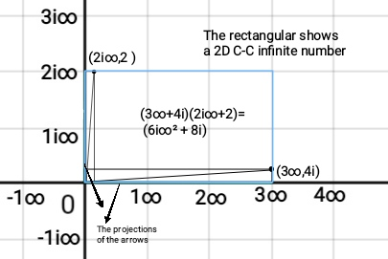

# For dividing an infinite number by another infinite number, we can simply use the rule:
$$\frac{\left(k∞+b\right)}{\left(a∞+h\right)}=\left(\frac{k∞}{a∞}\right)+\left(\frac{b}{h}\right)$$
For example: $$\frac{\left(i∞+2\right)}{\left(1∞+1\right)}=\left(\frac{i∞}{1∞}\right)+\left(\frac{2}{1}\right)=i+2$$
$$\frac{\left(-∞^{2}+1\right)}{\left(i∞+1\right)}=\left(\frac{-∞^{2}}{i∞}\right)+\left(\frac{1}{1}\right)=(i∞+1)$$

And if we want to divide an infinite number by a real number, if the infinite number is one-dimensional (represented as a point and it contains only $∞^{1}$ ) then we can divide the modulus of the arrow from zero to the point that represents it. If the infinite number is two-dimensional (represented as a surface area and it contains $∞^{2}$ ) we divide the surface's area by this number.
$$\frac{\left(i∞+1\right)}{\left(2\right)}=\left(\frac{i}{2}\right)∞+\left(\frac{1}{2}\right)$$
$$\frac{\left(2∞^{2}-2\right)}{\left(2\right)}=\left(\frac{2∞^{2}}{2}\right)-\left(\frac{2}{2}\right)=∞^{2}-1$$
In the first example the result of dividing this arrow is an arrow, the same in the second example as the result of dividing a square whose area represents the$(2∞^{2}-2)$ by 2,is another square whose area represents a number that equals the half of the main one.
When dividing an infinite number by $i$ we are rotating the point (or the surface) clockwise rotation.
$$\frac{\left(i∞+1\right)}{\left(i\right)}=\left(\frac{i∞}{i}\right)+\left(\frac{1}{i}\right)=∞+ R^{\begin{aligned}1 \\ \left(O,-90°\right)\end{aligned}}=∞-i$$Actually if you try this in the I-plane you will find that obviously${ R}^{\begin{aligned}i∞+1 \\ \left(O,-90°\right)\end{aligned}}=∞-i$
Example:
$$\frac{\left(2∞^{2}-2\right)}{\left(i\right)}=\left(\frac{2∞^{2}}{i}\right)-\left(\frac{2}{i}\right)=R^{\begin{aligned}2 \\ \left(O,-90°\right)\end{aligned}}∞^{2}- R^{\begin{aligned}2 \\ \left(O,-90°\right)\end{aligned}}={-2i∞}^{2}+2i$$ The number ($2∞^{2}-2$ ) is represented as the surface area of a square whose side length is$(\sqrt{2}∞-\sqrt{2})$ and the number (${-2i∞}^{2}+2i$) is represented as the surface area of a square whose side length is$(i\sqrt{2i}∞+\sqrt{2i})$.
Or as shown in the image bellow, the number$\left(2∞^{2}-2\right)$ is represented as a rectangular whose dimensions lengths are the projections of the moduli of the arrows from zero to the points$\left(∞+2i\right)$ and$\left(2∞+i\right)$, if we divide it by $i$ we will get a rectangular whose surface area represents the number${(-2i∞}^{2}+2i$); and the sides of this rectangular are the projections of the modules of the arrows from zero to the points$\left(2∞+1\right) and (-1i∞+2i).$
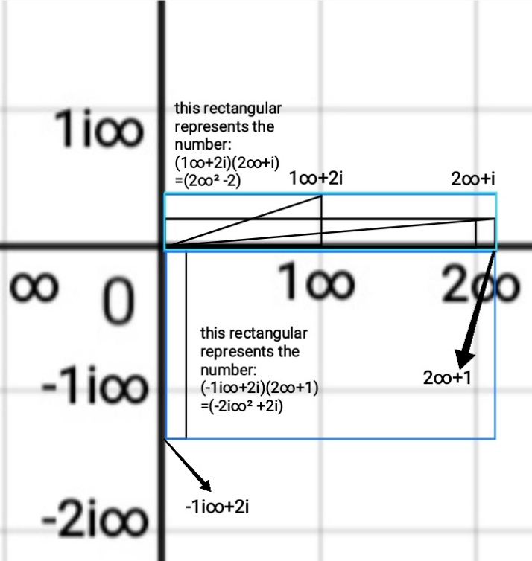
Actually, right now I prefer depending on the square surface method to represent a 2-dimensional infinite number (contains $∞^{2}$ ); because the rectangular method still needs studying , I am working on developing this idea but I wanted to introduce to you the basic concepts of my theory.

XI. The I-set: Reshaping science:
I have introduced the I-set, now I will show you how can this-seemingly simple modification to our understanding of infinity- has the potential to revolutionize several fields, including physics, cosmology and computer science.
I.Mathematically:
1. The concept of Limits is the most common concept in calculus, often involving the behaviour of functions as their input approaches infinity; the limit of a function as x approaches infinity is usually denoted as infinity. However, the I-set allows us to express limits with greater precision. For example, instead of: $\lim_{x→∞}{\{f\left(x\right)=x\}}= ∞ ; \lim_{x→∞}{\{g\left(x\right)=2x\}}= ∞$
Using the I-set, we will have: $\lim_{x→∞}{\{f\left(x\right)=x\}}= ∞ ;\lim_{x→∞}{\{g\left(x\right)=2x\}}= 2∞$
By considering different levels of infinity, we can reach to a more nuanced understanding of asymptotic behaviour and more accurate analytical techniques.
2. Fractal geometry and Chaos theory illustrates the chaotic infinitely complex nature of fractals, my I-set numbers could be used to redefine fractals; for example: the Mandelbrot set is defined through complex quadratic polynomials:$z_{n+1}=z_{n}^{2}+c$ if we used the I-numbers in the previous polynomial, we will be able to evaluate limits when evaluating at boundaries. Therefore, we will get a more accurate description of the fractals' level of scaling down.
II. Computational Complexity theory:
The Computational Complexity theory classifies problems based on how their computational time scales with input size; some problems are deemed unsolvable because their computational time approaches infinity. The I-set could refine this classification by differentiating between types of insolvability. For example: a problem with a computational complexity of $2∞$ might be fundamentally different from a problem with a computational complexity of$∞$, potentially opening up new avenues for tackling currently intractable problems.
III. Biology:
In biology, I-set numbers can be used to describe the behaviour of living organisms in certain environments. For example, in studying bacterial growth, we can use the form $a∞+b$ to describe the growth rate. If we consider that $a$ represents the reproduction rate, and $b$ represents the existing number of bacteria, we can formulate the growth equation as:
$N_{t}=N_{0 }×e^{a∞+b}×t$ , where${ N}_{t}$ is the number of bacteria at time $t$ , and${ N}_{0 }$ is the initial number, but here we have a problem because we are considering an infinite rate of growth in a finite time; but if we consider $t= a∞$, we are representing the different levels of the growth in different levels of infinite time, this consideration is due to the fact that time varies through time-systems (we talked about it previously), for example; the time you take to move you hand for you is a second, but according to an ant , your movement takes much longer than you consider. Infinite time that you can consider is different from the infinite time that bacteria consider in the growth process; using the I-set creates a more accurate understanding for the world and time-systems.

IV. Cosmology:
1.The Big-Bang theory postulates a singularity at the universe's origin, a point of infinite density. Current cosmological models struggle with the mathematical inconsistence inherent in describing such a singularity. The I-set offers a potential solution by representing the initial singularity not as a single point of infinite density, but as a distribution of densities represented by different I-set numbers. This approach could help resolve some of the mathematical difficulties associated with the Big Bang and pave the way for more sophisticated cosmological models. For example: different values of $a$ in $a∞+b$ could represent different energy densities at the very beginning of the universe, providing a framework for understanding the initial conditions that led to the universe's expansion. 2.We can use the I-set numbers to accurately evaluate the distances in the space; for example: if you consider a straight track that starts from the sun, the length is evaluated by infinity, but when we consider the length from Earth on the same track, it is inaccurate to evaluate it also as infinity; different levels of infinity give a more accurate description of the universe.

XII. Yes; but No!
There is a fun fact I forgot to mention about the complex plane.
We all know that in calculus $a\sqrt{b}=\sqrt{a^{2}b}$ , well now we have this nice complex number$-4i$, why don't we apply the previous rule on it:$4\left(-1\right)\sqrt{-1}=4\sqrt{{\left(-1\right)}^{2}\left(-1\right) }=4\sqrt{\left(1\right)\left(-1\right)}=4\sqrt{-1}=4i.$
Thus, does$-4i$ equal $4i$ ? Well yes; but no!
In the complex plane $-4i$ doesn't equal $4i$ ; because simply:
$$R^{\begin{aligned}-4 \\ \left(O,+90°\right)\end{aligned}}≠ R^{\begin{aligned}4 \\ \left(O,+90°\right)\end{aligned}}$$
This is a common mistake that people have when they first get to know complex numbers for the first time. However, this simple case deserves a moment of thought.

XIII. Negative lengths: The absence of Pythagorean Theorem:
Why don't we use negative lengths? Look at the following image: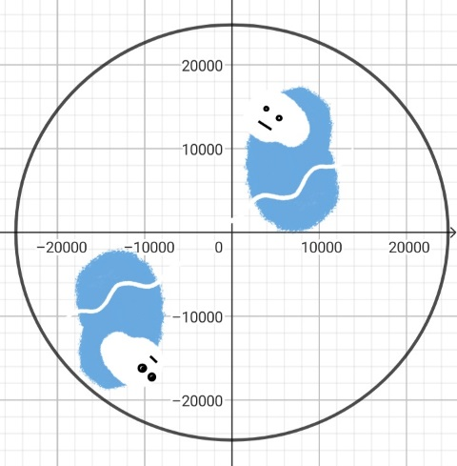
Now since the Earth is spherical, then the height you see and measure with positive lengths is just the opposite for the other pole, for them it is a negative depth.
Consequently, there are negative lengths that we see every moment like the height of the wall you stand in front of; which is a depth for the other pole.
But why do we always use the absolute value for lengths? Actually, the right question is how to explain the absence of the lengths' calculating theorems?
The most popular suspect, the Pythagorean Theorem, why can't we apply it on negative lengths? Now if we applied this theorem on a negative length, this means the negative numbers' roots must participate in the case too.
Now imagine a right triangle in the complex plane, whose sides are $i$and 1, by applying the Pythagorean theorem on it the hypotenuse will be:
$$h^{2}=i^{2}+1^{2}= -1+1=0 ∴h=0$$
By using the absolute value: $$h^{2}=|i^{2}|+1^{2}= 1+1=2 ∴|h|=√2$$
And as we see in the image, it's logically not zero.
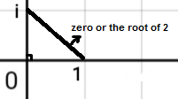
Using the negative lengths in calculus creates many troubles because we will get lengths of zero; which is impossible!
The hardest thing on the human brain is to imagine nothing, you can tell me about a point, its length is zero, but actually no, you are just looking so far; zoom in and you will find a circle, and so on!

Back to our story…
Complex numbers used their magic on the clock and found what it hides inside its glamorous divisions and infinity reshaped some concepts (enough to cause a heart attack for the real mathematics world numbers).
Eventually, the rift closed, leaving behind a lingering sense of wonder, the real numbers went back to their real mathematical word destructed and unable to grasp the beauty and complexity they had seen for some brief moments. And imaginary concepts, in the Blue city, continued to exist within their infinitely more fantastical reality, aware that the universe holds wonders that transcend the limits of any single, simplistic perspective.
Therefore, now you should put on your mathematical imagining glasses and start having another look at every '' real '' thing around you; because imaginary mathematics creates the real world, but we keep things simplified using the concept of real. Maybe the title of this essay has just became normal!.
I would like to express my heartfelt gratitude to my mom for her unweaving support and motivation; without her, I might have given up this journey a long time ago.
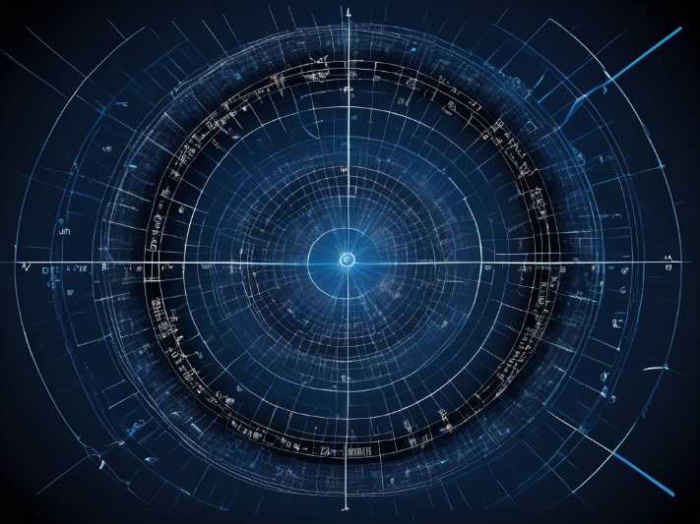

I hope you enjoyed this exciting journey to a different world; please notice that those ideas are so simplified and still there are some factors that should be taken in account.
Recourses: https://en.wikipedia.org/w/index.php?title=Complex_number&oldid=1277836451
https://en.wikipedia.org/w/index.php?title=Abstract_algebra&oldid=1277423463
http://youtu.be/d4EgbgTm0Bg?si=URZN-9vlM0gOFGcX
http://youtu.be/zjMulxRvygQ?si=tTlrVd3KolHFpqgR

