How do mathematical ratios underpin the structure of musical harmony?
By Iris Parsons
Glossary:
Octave | The interval between a note and another note that is double or half of its frequency. They are given the same letter name in Western musical tradition.
Perfect fifth | An interval comprised of a note and the note 7 semitones above it. It is the second most consonant interval, after the octave. Due to its consonance, it is used often in music, often in perfect cadences – a sequence of chords that make a musical phrase sound finished.
Consonance, consonant | Combinations of notes that create a stable and pleasing sound
Dissonance, dissonant | Notes that clash with each other, and create a sense of tension
Major third | The note four semitones above the root note
Semitone | The smallest step between notes in music – 1 step
Scale | A specific series of notes that form a progression between one note and its octave
Key | Guide to the notes that should be used to make music consonant or dissonant – they form the harmonic foundation of the music
Intervals | The distance between two notes
Chromatic scale | A scale comprised entirely of semitones

Mathematics has always shaped the field of music and the traditions within it. An example of this is how maths is used to form the modern, Western chromatic scale, so that it can be as accurate and pleasing to the ear as possible.
Pythagoras, famed for Pythagoras’s Theorem and his philosophy, had a cult-like Ancient Greek following. His followers were called the Pythagoreans, and many of the discoveries attributed to Pythagoras were probably actually discovered by the Pythagoreans. One of these discoveries is how the ratios between the two different lengths of string contributes to their consonance together.
The Pythagoreans suggested that simple ratios between frequencies makes notes sound more consonant together. They supposedly discovered this by hitting anvils; if their weights formed a whole-number ratio, the sound they produced together was more consonant. While they didn’t know about frequency at the time, we have later discovered the relationships between an object and the frequency that it produces. For example, the ratio between the weights of an anvil that makes a note and the anvil that makes the note the note 7 semitones higher than it is 2:3 – this is a simple ratio, so the notes are consonant. As it happens, these two notes are a perfect fifth apart.
These ratios can be calculated using maths. The frequencies of two notes that are an octave apart is 1:2. Therefore, you double the frequency of the lower note to get to the higher note. In a 12-note scale, you want equal steps between the notes so that all intervals, regardless of the starting note, are the same. Therefore, because frequencies have an exponential relationship, the frequency between a note and the note a semitone above it is $\sqrt[12]{2}$, or 2^{1/12}. Therefore, the frequency of the note n semitones above a note is the original frequency x (2^{1/12})^{n} = f x 2^{n/12}.
I calculated these values, and then approximated the ratio, and highlighted which frequencies sound most consonant, because their ratios are the simplest (as the Pythagoreans showed):
Number of semitones | Frequency multiple | 1dp | Approximate fraction | Ratio
1 | 1.059 | 1.1 | 21/20 | 20:21
2 | 1.122 | 1.1 | 28/25 | 25:28
3 | 1.189 | 1.2 | 6/5 | 5:6
4 | 1.260 | 1.3 | 5/4 | 4:5
5 | 1.334 | 1.3 | 4/3 | 3:4
6 | 1.414 (square root of 2) | 1.4 | 7/5 | 5:7
7 | 1.498 | 1.5 | 3/2 | 2:3
8 | 1.587 | 1.6 | 22/14 | 14:22
9 | 1.682 | 1.6 | 5/3 | 3:5
10 | 1.782 | 1.7 | 39/22 | 22:39
11 | 1.888 | 1.9 | 17/9 | 9:17
12 | 2 | 2 | 2/1 | 1:2

This may make you wonder why a simple ratio between frequencies causes consonance. After all, we know that the brain loves simplicity, but exactly how does this work?
It’s probably to do with how the sound waves interact with each other. A sound wave is a type of energy created when an object vibrates. It has a fixed frequency, which is the number of waves passing a fixed point every second. A sinusoidal wave (or a sine wave) is the wave that you first imagine when you think of a sound wave and is the simplest and purest form of sound. It looks like this:
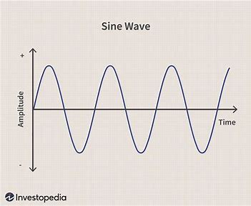
If we think about sounds at their simplest form, as sinusoidal waves with fixed frequencies for each note, you can model how they interact with each other. Below, I have drawn the interactions between a note, the major third, and the perfect fifth:
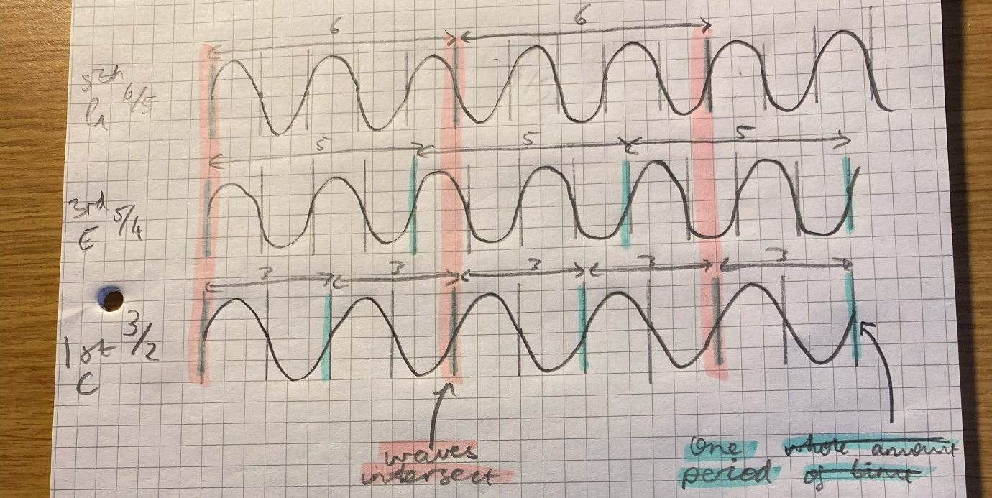
The pink highlighter shows when the waves intersect. Clearly, it happens quite often with these waves, which is pleasing to the ear. Therefore, our brain likes to listen to these intervals together.
Supposedly, tuning an instrument should be easy, if you’ve got such simple ratios between notes. If you’re creating a piano, for example, you make sure that the string of a note an octave above another is half the length of the first, and the strings of notes a perfect fifth apart have a ratio of 3:2 in length.
With Pythagorean tuning, the notes went up a fifth until you got back to the note you started on. For example, if you start on C, you go to G, D, A, E, B, F#, C#, G#, Eb (or D#), Bb (or A#), F and then back to C. Throughout this process, you will have increased by 7 octaves.
As we know that the frequency of a note doubles every time, we go up an octave, going up 7 octaves is multiplying the frequency by 2⁷ = 128. However, if we try to get to the same note by using our rounded perfect fifths, you end up doing original frequency * 1.5¹² = 129.75, not 128. This is because you must round the value of a perfect fifth ever so slightly to get to the ratio of 3:2. Therefore, in a 12-note scale, we cannot create a scale that has both perfect fifths and perfect octaves.
You may wonder why we use a 12-note scale then, if it is fundamentally flawed. I calculated the value for this – if ${\left(\frac{3}{2}\right)}^{x}=2^{y}$, what is the closest that we can get the values to each other, so that they sound the nicest together and the notes are rounded by a minimal amount? The value of x is the number of notes in the scale, because you just move all of the notes down to be in the same octave to form a scale. Below are my results:
Notes in scale - x | 1.5^x | 2^y | Percentage difference
2 | 2.250 | 2 | 12.50
3 | 3.375 | 2 | 68.75
4 | 5.063 | 4 | 26.57
5 | 7.594 | 8 | 5.34
6 | 11.391 | 8 | 42.39
7 | 17.086 | 16 | 6.79
8 | 25.629 | 32 | 24.86
9 | 38.443 | 32 | 20.13
10 | 57.665 | 64 | 10.99
11 | 89.498 | 64 | 39.84
12 | 129.746 | 128 | 1.36
13 | 194.620 | 256 | 31.54
14 | 291.929 | 256 | 14.03
15 | 437.894 | 512 | 16.92
16 | 656.841 | 512 | 28.29
17 | 1477.892 | 1024 | 44.33
18 | 2216.838 | 2048 | 8.24

We want this percentage difference in the last column to be as close to 0 as possible – ideally, the two values are equal. Therefore, a 12-note scale is by far the best option to promote both musical practicality and accuracy(under 18 notes) – the two values are actually very close to each other. Other scales where there are more than 18 notes in an octave could have a lower percentage difference than 1.36%, but in that case the notes get very similar to each other, so are not very distinguishable from each other.
In fact, we cannot do it in any scale: ${\left(\frac{3}{2}\right)}^{x}=2^{y}$ will never be possible, because a fraction multiplied by itself will never be equal to a whole number, regardless of how infinitesimally close it is to a whole number. Consequently, we round the notes that our tuned instruments play slightly (this is called equal temperament), so that they can play in any key and the intervals still sound the same.
Our ears are used to this now – equal temperament has been around for centuries, and almost all our music uses it; technically, all Western music is just a little bit out of tune due to the compromise that we have made in tuning. But, under the surface, a mathematical compromise between natural acoustic beauty and practicality across key signatures has shaped Western music inexplicably: music and mathematics have a complex and convoluted relationship, but will ultimately work together to improve each other’s fields.

