How the study of non-Euclidean geometry plays a major role in determining the shape of the universe.

Introduction
Euclidean geometry is the study of plane and solid figures on the basis of axioms (1). There are five axioms that Euclid proposed they are as follows (2):
- A straight line may be drawn between any two points
- Any terminated straight line may be extended indefinitely
- A circle may be drawn with any given point as the centre and any given radius
- All right angles are equal
- If two straight lines in a plane are met by another line, and if the sum of the internal angles on one side is less than two right angles, then the straight lines will meet if extended sufficiently on the side on which the sum of the angles is less than two right angles.
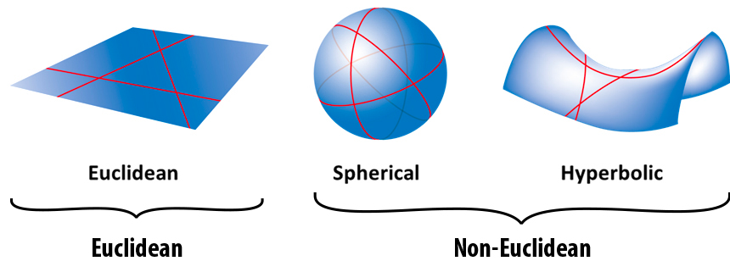
Hence non-Eucledian geometry is geometry that does not adhere to all of the five axioms such as spherical or hyperbolic geometries.
(3)

Spherical and hyperbolic geometry is non-Euclidean as the geometry violates the parallel postulate.
Now that we have established the concept of non-Euclidean geometry we can move onto the thrilling topic of how non-Euclidean geometry plays a major role in determining the shape of the universe.

Carl Friedrich Gauss explores the possible shape of the universe (4)
The universe is believed to have one of the possible three geometries:
- Spherical geometry with positive curvature (non-Euclidean)
- Hyperbolic geometry with negative curvature (non-Euclidean)
- Euclidean geometry with zero curvature (Euclidean)
The sum of the angles in a triangle add up to 180 degrees in Euclidean geometry. The sum of angles in a triangle add up to more than 180 degrees in Spherical geometry. The sum of angles in a triangle add up to a positive number less than 180 degrees in hyperbolic geometry.

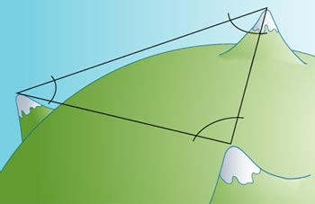
Carl Friedrich Gauss a German mathematician and astronomer came to understand in the first half of the 19th century that the universe may potentially be non-Euclidean. When in Germany he gathered the angles formed by three mountain peaks and concluded that the sum of their’ angles was 180 degrees within a suitable degree of uncertainty. This suggested that on the extremely small scale of his measurements the universe appeared to be Euclidean.

However despite the conclusion of this experiment we cannot apply this data to the universe as the scale of Gauss’ experiment is not nearly big enough to provide enough evidence for the grand size of our universe. As perhaps the universe is in fact spherical or hyperbolic but within the very small range we can observe it appears Euclidean.

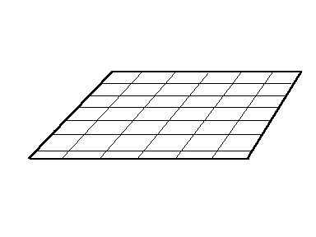
Potential Euclidean universes
A Euclidean universe with zero curvature would appear to look like a flat sheet of paper. In which a triangle is placed on the universe (Euclidean plane) with angles x,y and z where x+y+z=180 degrees. With straight lines having zero curvature.

(5)

In Einstein's theory of general relativity gravity is interpreted in terms of the geometry of spacetime, where the geometry of the universe depends on its density. A universe with critical density would have euclidean geometry. Critical density means it has the perfect amount of matter and energy.

The theory of general relativity supporting the potential of a non-Euclidean universe
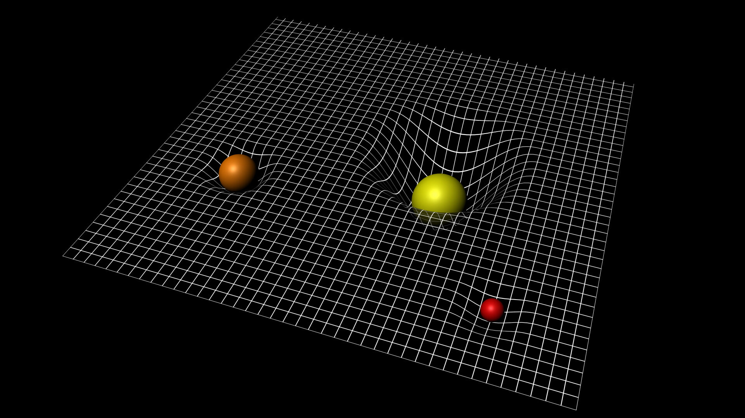
First of all let's properly establish what Einstein’s theory of General relativity actually is. The basis is that the theory of general relativity suggests that gravity warps space time. Meaning that according to the theory of general relativity the presence of mass and energy warps spacetime causing it to curve.

(6)
The plane in this image represents spacetime and the spheres represent the presence of mass of the fabric of spacetime. As you can see the masses cause spacetime to warp therefore curving. This curvature means that spacetime is therefore non-Euclidean, especially on a very massive scale. The geometry of the universe is determined by the distribution of mass and energy within it. As you can see from the image the plane appears to be flat making spacetime euclidean. However, it is only Euclidean locally. The curvature around the masses causes spacetime to be non-Euclidean globally. Which overall concludes the universe to be non-Euclidean if this was to be an accurate representation of spacetime. If we believe the universe to be Euclidean this could be because the curvature of spacetime is out of the observable universe, regardless we could still not conclude the universe to be Euclidean.

Schrödinger’s cat simplifying the concept of the local vs global universe
The previous concept of the global vs local universe may be quite a hard concept to grasp so I thought I could try and relate the concept to a probably familiar experiment.
I am led to believe that most people have knowledge of the Schrodinger's cat experiment but regardless I will recap.
The experiment involves a cat placed in a sealed container with a device containing a radioactive substance, a vial of poison and a hammer (7).
The radioactive substance has a 50% chance of decaying within a given time interval. If it does decay in the time interval it triggers the hammer to break the vial hence releasing the poison and killing the cat.
Until the box is opened and the state of the cat is observed and we do not know if it is dead or alive.
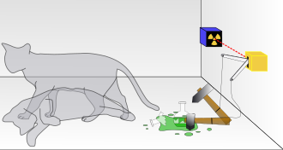

(8)

I believe this to be a sufficient way of thinking about the concept of the global universe.
The living cat being a Euclidean universe and the dead cat being a non-Euclidean universe. Going into the experiment we know that the cat is living (the observable universe being Euclidean). However when the cat is placed in a sealed box with poison we do not know the state (when the universe surpasses what we can see we do not know the state and whether gravity has caused the fabric of spacetime to warp). Until we can indefinitely prove the cat to be dead or alive we cannot make a final conclusion (until we can indefinitely prove the universe to be Euclidean or non-Euclidean we cannot make a conclusion for the global universe based on the local universe).

A potential non-Euclidean universe
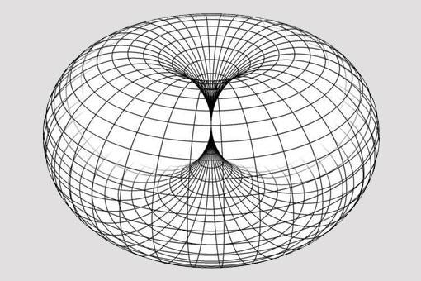
Finally we have reached a suitable place where we can begin to imagine a potential non-Euclidean universe.

(9)

A ring torus is a donut shaped universe that is non-Euclidean as clearly shown by the curved structure. A torus has a finite space but due to its topology it appears to be an infinite space as it would give you an endless line of sight. If you travelled in any one direction for long enough you would eventually end back where you started if the universe was to be a ring torus. There is a theory that the universe may not actually be expanding but instead dynamically flowing through the geometry of the taurus. This ultimately illustrates how a torus universe supports how time only flows in one direction. Making a torus shaped universe potentially plausible.

Final thoughts
I believe that a non-Euclidean shaped universe is highly plausible for a plethora of reasons. Not only does a non-euclidean universe give a convincing explanation as to how time only flows in one direction and how a finite universe can appear infinite. I believe it is the most probable shape of our universe. This is because we have no idea how massive the universe is, it could potentially even be infinite. So a rational conclusion to make would be that humans cannot observe every single part of the universe. All that we need to prove that the global universe is non-Euclidean is one scenario in which space time warps. There are many places in which the curvature of space time seems likely, especially near objects with unimaginable amounts of gravity surrounding them, for example supermassive black holes. Surely it would be reasonable to suggest that if Einstein's theory of general relativity holds true spacetime would warp around something like a supermassive black hole. Which would cause the universe to be non-Euclidean.

However ultimately this is all theoretical. Potentially we may actually never know the shape of the universe but the unknown is what keeps mathematicians going; the urge to provide clarity in complexity.

Thank you so much for reading!
Kind regards Charlotte Hall

References

- https://www.britannica.com/science/Euclidean-geometry
- https://www.math.brown.edu/tbanchof/Beyond3d/chapter9/section01.html
- https://wandb.ai/mostafaibrahim17/ml-articles/reports/Introduction-to-Geometric-Deep-Learning--VmlldzozODY5NTE1
- https://www.americanscientist.org/article/the-shape-of-the-universe-ten-possibilities
- https://faculty.etsu.edu/gardnerr/observatory/SOS-observatory/section3.htm
- https://www.esa.int/ESA_Multimedia/Images/2015/09/Spacetime_curvature
- https://www.techtarget.com/whatis/definition/Schrodingers-cat#:~:text=Schr%C3%B6dinger's%20cat%20is%20a%20famous,with%20the%20unaided%20human%20eye.
- https://en.wikipedia.org/wiki/Schr%C3%B6dinger%27s_cat
- https://evolvingsouls.com/blog/toroidal-universe/#:~:text=This%20article%20outlines%20a%20theory,no%20direct%20evidence%20of%20this.

