Hungry Hungry Hippos: In Search of An Optimum Guzzling Strategy using Game Theory
By Felix Laikin
Introduction
In April 2009, BoardGameGeek user ‘Pete’, proclaimed the following to his disciples:
OK...I admit it. I'm an overcompetitive jerk. I want to win all the games, even the silly ones.
Reading over the comments for Hungry Hungry Hippos, I found a number of entries that indicate that people think the best way to win this game is to "pound pound pound" on the lever as fast as possible. I can assure you that if you do this, you will most often lose.
Intrigued and shocked, a casual reader of the forum might be enticed into looking further. Indeed, Pete offers an alternative to the infantile “pound pound pound” (PPP) tactic:
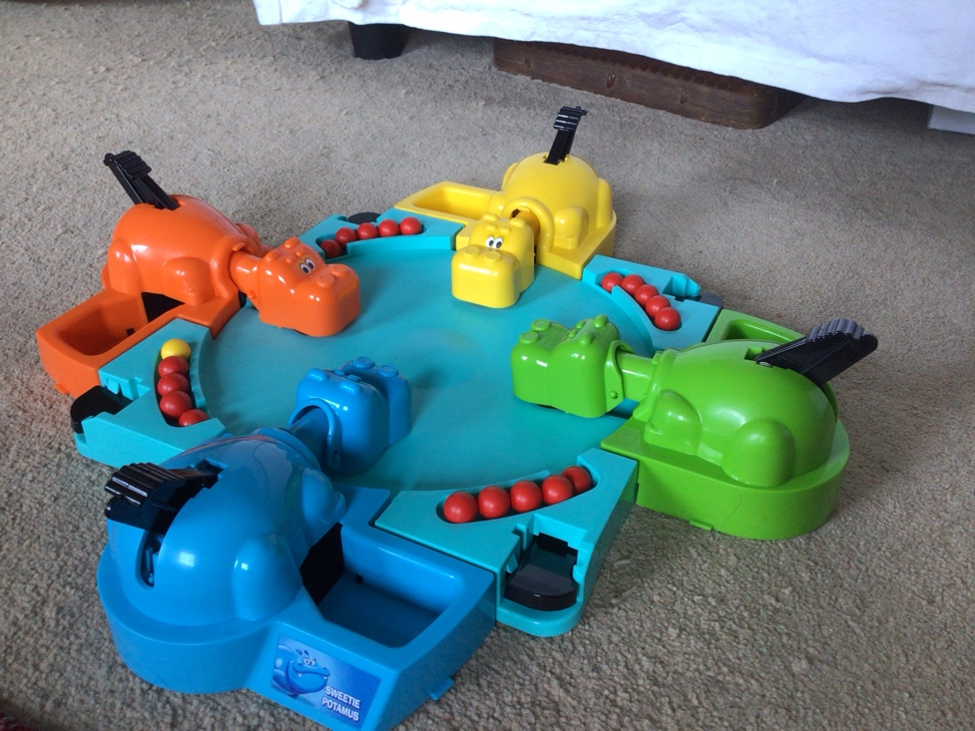
Keep your eyes and mouth open.
Master the art of keeping your hippo's mouth propped open. To do this, simply apply pressure onto the hippo's lever and hold it about 2/3 of the way down. Especially if others are using the "pound pound pound" method, a good number of stray balls will fall straight into your hippo's gullet if you just give them a chance.
Propping the mouth open also offers a practical advantage... your hippo has far less distance to cover than normal when a juicy white morsel comes into its feeding zone.

Figure 1: Sweetie Potamus (Blue), Veggie Potamus (Green), Bottomless Potamus (Yellow) and the uncreatively named Hungry Hippo (Orange) primed and ready to munch
It would be easy to dismiss Pete’s claim. No-one has bothered to comment on this post, leaving such a musing certain to be lost in the abyss of old internet forum posts. That is, until now. Pete deserves answers: he is not just a random user, but one of just 3567 recipients of the BoardGameGeek Golden Meeple, one of just 456 members of the Level 20 Forum Poster club, and his collection of 1859 (!) physical board games places him in approximately the top 1000 owners of all time. As a lawyer practicing near Northbrook, Illinois (this website does seem to reveal a disturbing amount of personal information…) and a self-proclaimed ‘Rules Lawyer’, Pete would surely want to get to the bottom of this case, but 16 years have passed and no progress has been made.
That’s it: Pete deserves justice. And I’m pretty hooked to find out how to beat all my friends at Hungry Hungry Hippos (known as H3 in the professional community). So through rigorous experimentation and game theory, I set out to find an optimum strategy.
What is Game Theory?
Hungry Hungry Hippos probably lies somewhere in between game and toy, which is an interesting distinction in itself. In our eyes, a game, like a toy, has to be something fun. But, unlike a toy, it needs to have a defined set of rules, and cannot just be an entertaining object.
Luckily, we don’t have to decide where H3 falls on that continuum, because in maths, ‘games’ are something completely different, with a whole branch of maths dedicated to studying them: Game Theory. Mathematicians have a much more general definition for a ‘game’:
A game is any interaction between multiple people in which each person’s payoff is affected by the decisions made by others.
This definition more or less includes all the interactions with other people that you have in daily life. A clear example is an auction, where understanding how other bidders will value an item can help you to optimise your own strategy. I was helped by game theory last week, when there were delays on the Victoria Line due to overcrowding. Understandably, the platform emptied as announcements directed people onto replacement buses- by which point the platform was no longer overcrowded, and I managed to get onto my train pretty quickly. However, if everyone started to cotton on to my strategy, then clearly it wouldn’t work, as the platform would remain overcrowded.
In the 1950s, when people were just starting to think about game theory, they came up with a now famous thought experiment: the Prisoner’s Dilemma. Imagine that Veggie Potamus and Hungry Hippo got arrested on suspicion of the minor crime of eating too many marbles and were sent to the local prison. However, the police suspected that at least one of them was involved in a much more major crime, a Hungry Hippo Heist, but don’t have enough evidence to convict them. At the police station, Veggie Potamus was told the following:
- If you admit that Hungry was involved in the heist, and Hungry doesn’t rat you out, then you can go free, and Hungry will spend 3 years in prison.
- If neither of you confess, then you’ll both spend just a year in prison for the minor crime.
- However, if both of you betray eachother, then you’ll both have to spend 2 years in prison.
Hungry, of course, was taken to a separate room and told vice versa. So, with perfect information, but no knowledge of the other hippo’s decision, what should Veggie do, assuming he is wholly rational and self-interested (as such a hardened criminal would be)?
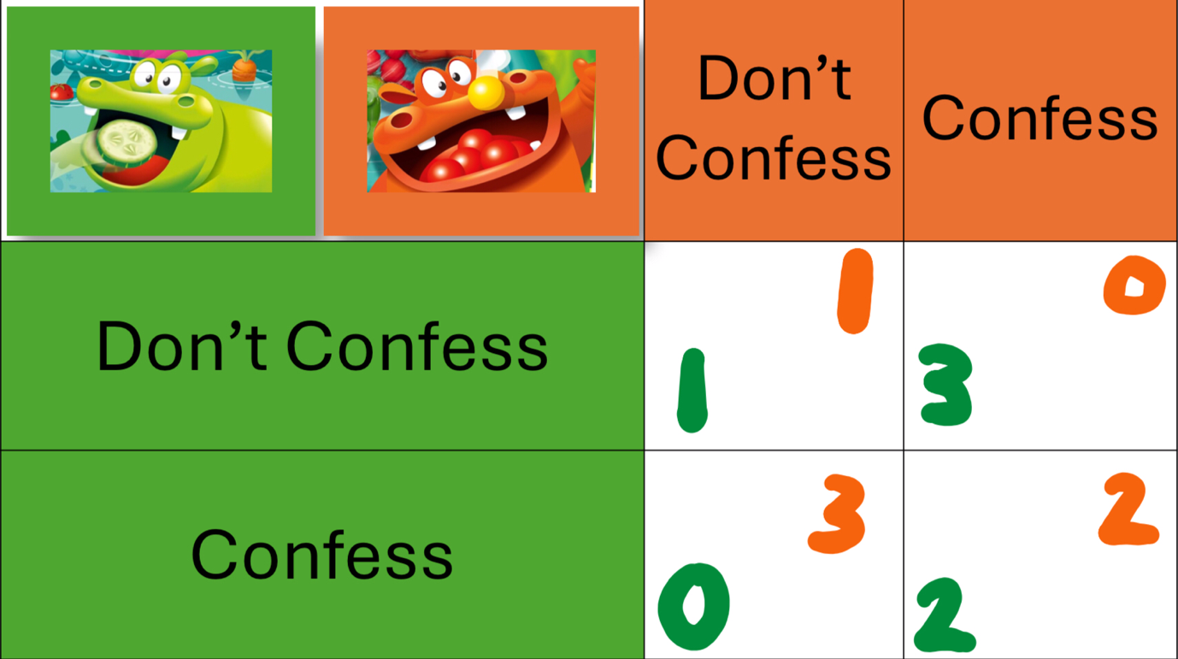
Figure 2: Veggie and Hungry’s predicament, represented by a 2 player, 2 decision payoff table
Well, the best situation for the both of them is to cooperate and not confess- that would leave their combined prison time at just 2 years. However, from Veggie’s perspective, regardless of whether Hungry confesses or not, he can always reduce his sentence by a year if he confesses. The same is true for Hungry- so, since they don’t know what the other hippo is going to do, they should both betray eachother and confess, leaving them with the highest combined sentence. This situation is known as a Nash Equilibrium:
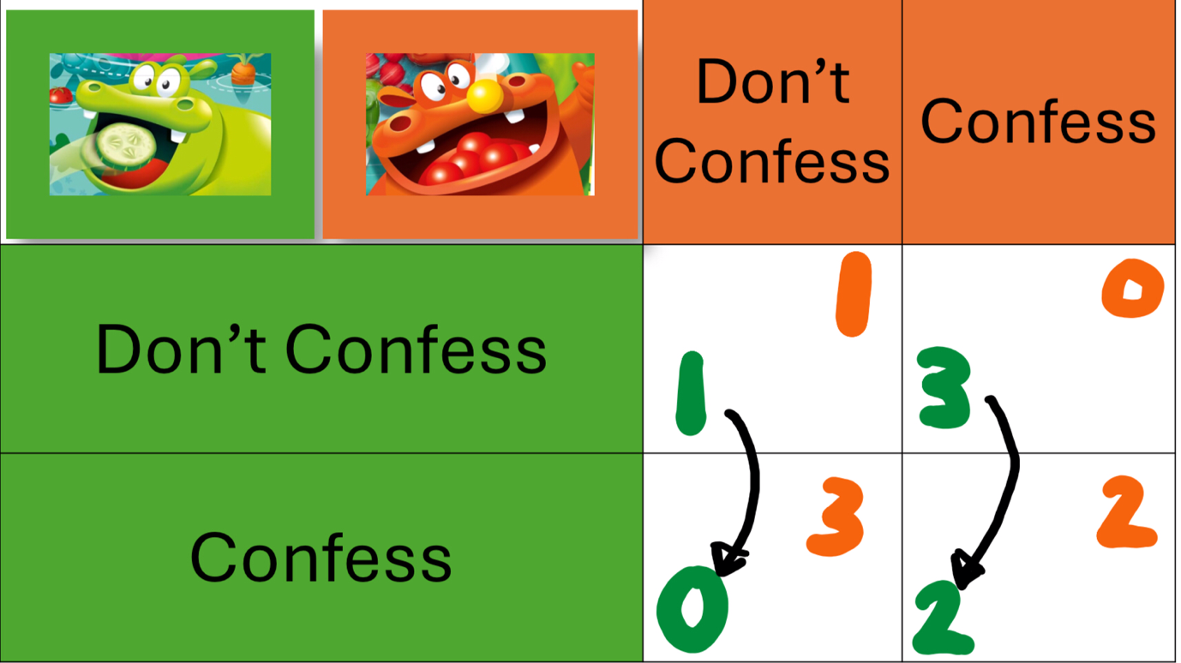
A player in a game has found Nash Equilibrium when they make the choice that leaves them better off no matter what their opponents decide to do.
Figure 3: Veggie’s decision- the arrows represent the one year sentence reduction guaranteed by confessing
Much like the Prisoner’s Dilemma, Hungry Hungry Hippos is not a cooperative game. Don’t let the smile on Sweetie Potamus’ face fool you- she stands to gain by betraying her fellow hippos. Further, H3 is theoretically, like the Prisoner’s Dilemma, a zero-sum game:
In a zero-sum game, one player can win something only by causing another to lose it
There is a limited supply of twenty marbles (N.B. The gold marble is considered to be one point in this study, as opposed to the game-shattering twenty points suggested by the ‘Bonus Game’ in the manual), and if you munch a marble, then no other hippo can have that marble. Your gain is necessarily someone else’s loss. Still, H3 is only theoretically a zero-sum game; in reality, since marbles fall out or get stuck in the middle, it is not a perfectly closed system
So, we can attempt to model H3 in a similar fashion to the prisoner’s dilemma, by mapping the respective payoffs implied by different strategies.
The Strategies
As Pete outlined, the traditional strategy is Pound Pound Pound (PPP). His strategy of choice is Always Open (AO). However, these strategies only account for munching tactics, not for release tactics. In each case, I have provided an ASAP and Gradual variation for release tactics, with the 5 marbles being released instantly in the ASAP variation, and every 8 seconds in the Gradual variation. This leaves us with four strategies (PPPA, PPPG, AOA, AOG).
I’ve also included one more: Pound In Zone, Zonal Admission (PIZZA). This reflects most closely how I would play the game, pressing down my lever only when marbles appear accesible in my munch zone, and trying to admit marbles to the arena when other players are distracted. This opportunistic approach will clearly differ between players, especially in judging when the best release time is, but in experimentation was sufficiently similar between players to ensure a fair test.
So the five strategies are:
Strategy 1: Pound Pound Pound, ASAP (PPPA)
Strategy 2: Pound Pound Pound, Gradual (PPPG)
Strategy 3: Always Open, ASAP (AOA)
Strategy 4: Always Open, Gradual (AOG)
Strategy 5: Pound In Zone, Zonal Admission (PIZZA)
But before we can model the interactions between some of these strategies, there are a couple of considerations to make:
- Hungry Hungry Hippos is a four player game- how can we represent that graphically?

- If we want to properly determine the payoffs for each strategy through experimentation, we would have to repeat the tests multiple times- and by multiple, I mean closer to 100 than 3
You’ll see below how to answer the first of those. The second is much more difficult to answer- well, I know what I’d have to do, but my family was barely willing to play 60 games of Hungry Hungry Hippos, let alone 6000. So for this essay, we’ll have to use some extremely inaccurate data.
Test 1: PPPA vs AOA
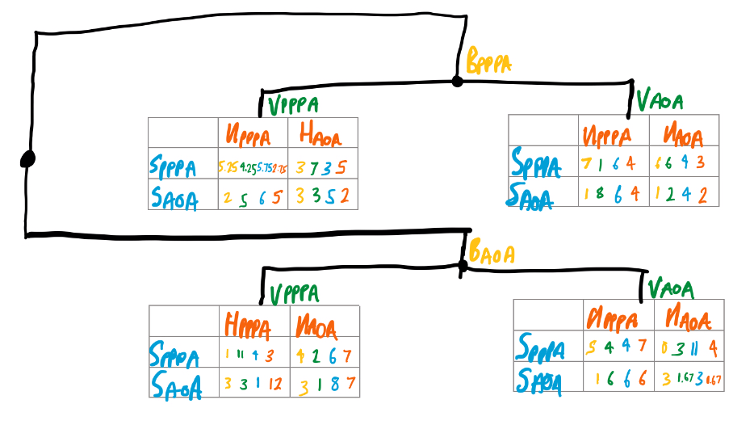
Figure 4: This is what a 4 player payoff table with 2 choices per player looks like. Note that the number of cells, 16, is therefore equal to 2⁴. The two choices here are PPPA and AOA, and each branching of the graph represents the decision of one of the four hippos to choose one strategy or the other.
For my first test, I wanted to test Pete’s hypothesis, that Always Open was superior to Pound Pound Pound, and more specifically, that it was especially superior when all the other players were using Pound Pound Pound. Using the experimental data compiled in the above payoff table, we can find the following:

Hippo | Ave. PPPA Score | Ave. AOA Score | % Increase
Bottomless | 6.41 | 2.50 | -61.0%
Veggie | 4.53 | 3.96 | -12.6%
Sweetie | 5.47 | 4.88 | -10.8%
Hungry | 5.47 | 3.83 | -30.0%

Figure 5: Difference in PPPA and AOA score by hippo- choosing Always Open invariably damages your score
Well, it’s not looking good for Pete’s case. Regardless of the skill of the player or quality of the hippo, the score decreased when switching to an Always Open strategy- an average decrease of 28.6% across all players. But let’s look more specifically at the cases where only one players was using AOA:

Hippo using AOA | Ave. Score among Hippos using PPPA | Score of sole hippo using AOA | % Increase
Bottomless | 6 | 1 | -83.3%
Veggie | 5.67 | 1 | -82.4%
Sweetie | 4 | 6 | 50%
Hungry | 3.25 | 5 | 53.8%
AVERAGE | 4.73 | 3.25 | -31.3%

Figure 6: An even more paltry showing when one hippo alone uses AOA
Pete, if you’re reading this, not all hope is lost. To conclude that AOA is not an effective strategy against PPPA based on just a handful of cases would be folly. And still, this is only for ASAP release, which is not the necessarily the usual way to go. In fact, let’s see what happens when we look at Gradual release instead.
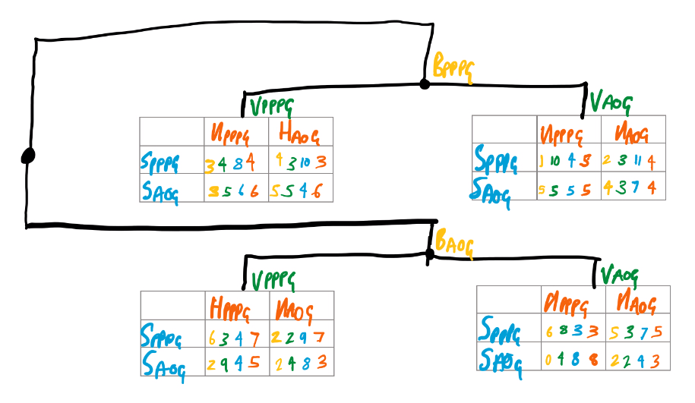
Test 2: PPPG vs AOG

Figure 7: Payoff diagram for the Gradual Release Strategies

Hippo | Ave. PPPG Score | Ave. AOG Score | % Increase
Bottomless | 3.38 | 3.13 | -7.4%
Veggie | 4.38 | 4.75 | 8.4%
Sweetie | 7 | 5.75 | -17.9%
Hungry | 5.38 | 4.38 | -18.6%
Figure 8: Difference in PPPG and AOG scores show more mixed results
Hippo using AOG | Ave. Score among hippos using PPPG | Score of sole hippo using AOG | % Increase
Bottomless | 4.67 | 6 | 28.5%
Veggie | 3.33 | 10 | 200.3%
Sweetie | 4.67 | 6 | 28.5%
Hungry | 5.67 | 3 | -47.1%
AVERAGE | 4.59 | 6.25 | 36.2%

Figure 9: Into the green with a comparison of hippos using AOG alone
There are much more mixed results to be found in the gradual category, with an average difference of only -8.9% between PPPG and AOG on the whole, and a 36.2% advantage gained by being the only hippo to keep your mouth agape. Think about a real game scenario: perceiving that the other players are all pounding vigorously while gradually releasing their marbles, you could gain an advantage by just keeping your mouth open. However, much like on the Victoria Line, if everyone , then it could turn into a losing strategy.
Still, Pete is somewhat vindicated by these more mixed results. But why? Why is Always Open so much more favourable in a Gradual Release game than in an ASAP Release game? It could be that when marbles release gradually, they enter at a lower speed, and are also less likely to collide with other marbles and ricochet to the edges of the board. Instead, they take direct rolling paths, which could favour the hippos who are just letting the balls roll in. Or it could just be a result of our small sample size.
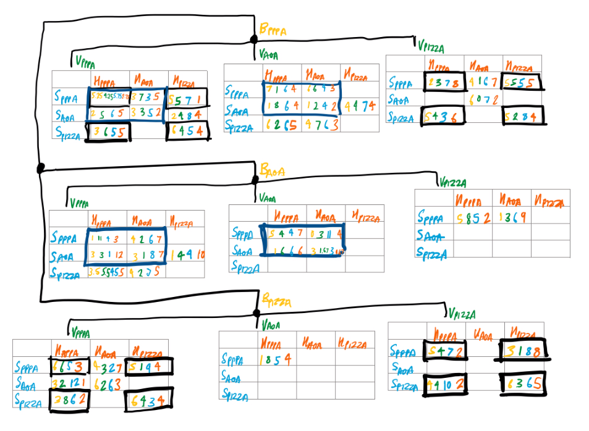
Bonus Test 3: What happens when you introduce more than two different strategies at a time?
Figure 10: An incomplete 4 player, 3 strategy (PPPA, AOA, PIZZA) payoff table, illustrating the increase in outcome complexity when including more strategies (16 -> 81 cells). The cells with a dark blue outline show where the payoff table from Figure 4 fits in. The cells surrounded by black represent the PPPA vs PIZZA payoff table

The figure above shows how game theory can get more advanced when adding more strategies. Similarly one can imagine that adding more players would also add more complexity. With 5 players and 5 strategies, there would be 3,125 cells; with 10 players and 10 strategies, there would be 10 billion.
Let‘s answer one last question before ending this cursory introduction to the soon-to-be-burgeoning field of Hungry Hungry Hippos Game Theory. Is even the best strategy we‘ve found so far, PPPA, any match to how I would play without thinking about it (PIZZA)?
Hippo | Ave. PPPA score | Ave. PIZZA score | % Increase
Bottomless | 4.53 | 4.75 | 4.9%
Veggie | 4.78 | 3.25 | -32.1%
Sweetie | 6.72 | 5.75 | -14.5%
Hungry | 3.84 | 4.38 | 14.1%
Figure 11: Using the data set enclosed in the black boxes of Figure 10, does PIZZA beat the Pound?
It‘s close, but PPPA remains on top, with a 6.9% margin of preference.
Conclusion
Many different strategies can be employed in Hungry Hungry Hippos: Pound Pound Pound, Always Open, Pound In Zone and their respective variants are just a few. However, among these and in the experimentation done for this essay, Pound Pound Pound, particularly with an instant release, has been the optimum. So there you go- all you have to do to optimise your chances in Hungry Hungry Hippos is to go ham on the lever. Sorry Pete.
But, hopefully, there are some more interesting takeaways from this essay. Firstly, despite its limitations, it does seriously open the floor for further research on Hungry Hungry Hippos- for example, just in observing the games, it appeared that certain strategies had a positive impact on the hippo directly opposite, but this hypothesis would need further inquiry.
Also, the familiar game can teach us a lot about the field of Game Theory as a whole and the role it plays in our daily life. This essay hasn‘t even touched on cooperative game theory and coalitions, iterative game theory, or the economic implications of game theory, but many basic principles are outlined: Nash Equilibria, zero-sum games etc.
Perhaps the most important conclusion from this study is about the challenges of experimental game theory. Often, game theory is studied in abstract thought experiments like the Prisoner‘s Dilemma, but the impact of the field on trade wars, government budgets and marketing make it vital to apply in real life. But, as this study has shown, a vast amount of data is needed to make accurate predictions about optimal strategies- we don‘t even come close to that for our simplified game, let alone for complex multi-party situations like those outlined above.
But ultimately, Pete, your questions have been answered, and your theories have been disproven, for now at least. Feel free to keep your hippopotamus jaw wide and open next time we battle on the arena; I, for one, intend to Pound Pound Pound.

