Mathematics of Hair

Bungshy Navtej Sharma

Introduction
The fascination with hair and its beauty has existed since time immemorial, spanning across centuries of human civilisation. Mimicking the waves of the vast ocean, each strand represents the uniqueness of human diversity. Hair has been the center of focus for many artists as well as entire art movements such as Da Vinci or the Pre-Raphaelite movement.
Hair has indeed various aesthetic and anthropological significances for multiple cultures worldwide. But what if I tell you that there are mathematicians devoted to the study of hair! Yes, who would have thought that the inter-mingling of mathematics and hair was possible? It seems odd at first glance but it is a field well studied.
This essay will explore the plethora of mathematical properties held by hair: its weight, volume, elasticity and curvature. We will discover how hair, especially, in a bundle exerts pressure and tension. The energy of hair bundles will also be discussed.
Basic properties of Hair
The average human has around 10⁵ head hairs with an elliptical cross section. The distribution of major axis diameters falls approximately between 40 to 140 µm with an average of 80-90 µm. Its average density falls about 1.3 g/cm³ while the linear density lingers about λ ≃ 65 µg/cm. As men hair is generally shorter and attracts less enthusiasm, women hair is going to be our main focus.
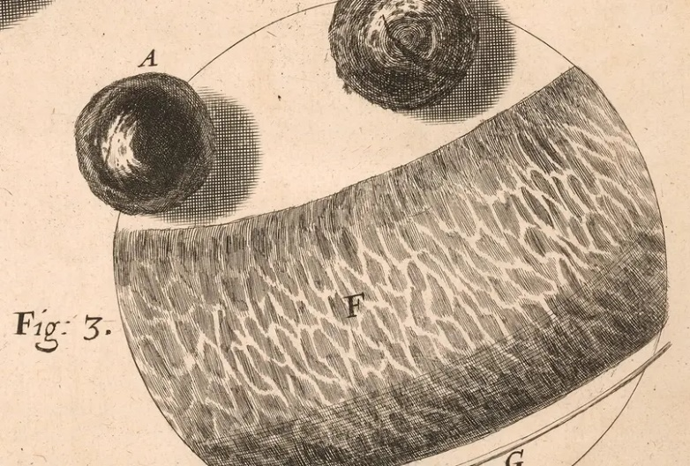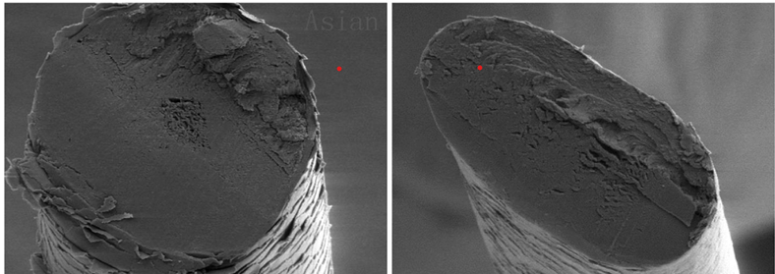
Microscopic hair samples from Hooke’s Micrographia Cross-section of hair under a microscope

Curvature of Hair
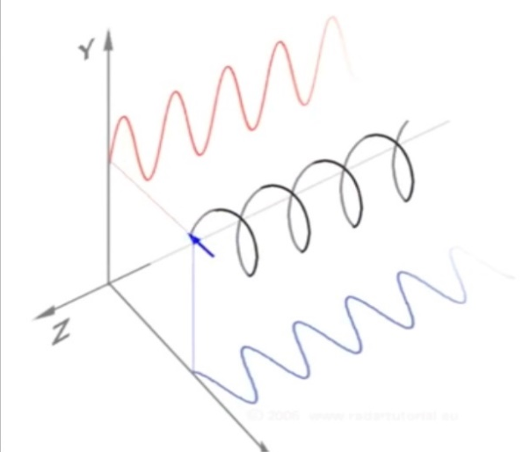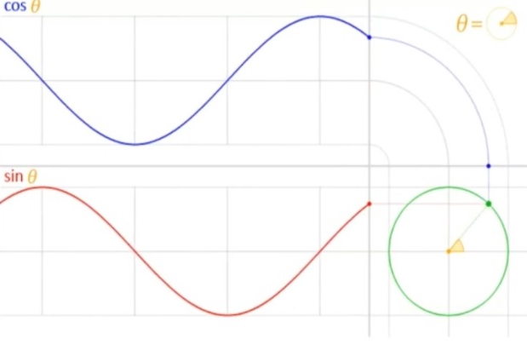
To make evaluation easier, let’s assume a curvy strand of hair in the form of a uniform wave. In a 3-D plane the curly hair would resemble a cosine wave in the x-axis, a sine wave in the y-axis and a circle in the z-axis. We can obtain details such as the amplitude of the hair-the maximum limit an individual strand can reach. The periodicity of a curl can also be studied, indicating the number of complete curls found in a sampled strand (For e.g. 1 curl=8cm, 24cm hair strand gives 3 curls).

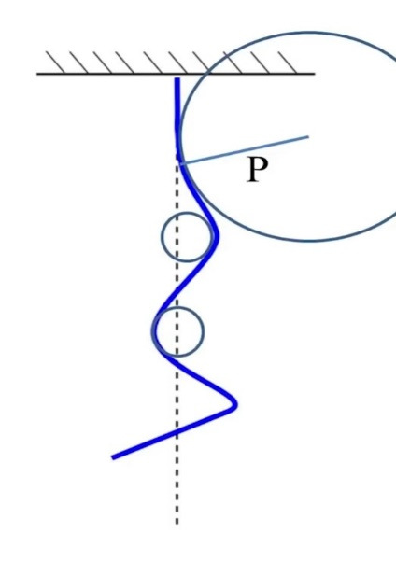
This diagram shows a curved hair strand over a circle with radius P. This radius provides the curvature κ of the hair filament as:

$$κ=\frac{1}{P}$$

Gravity and elasticity
Gravity influences the elasticity of hair.
The bulk modulus of hair is, E ≈ 4 GPa.
The bending modulus is calculated by:
$$A=\frac{Eπd^{4}}{64}$$

Take major axis diameter, d to be 80 µm and substitute the equation:
$A=\frac{(4 GPa)(π){(80μm)}^{4}}{64}$

Therefore, $A=8 ×{10}^{-9} Nm^{2}$
Gravity together with any external force can deflect and bend hair. According to the law of elasticity, the deflection is proportional to the overall force applied. The force is also equal to, $F=λlg$ where $l$ is a characteristic length-used to define the parameter of the physical system. In our situation deflection, D can also be the characteristic length as it represents scale of the bending that is the distance moved due to the applied force
$$D \sim \frac{{FL}^{3}}{A}$$
F=force applied A=bending modulus
g=gravitational field strength L=length of filament

By substituting F, we obtain a new equation:
$$D \sim \frac{λgL^{4}}{A}$$
Substituting D by $l$ and simplifying the equation gives us:
$$l={\left(\frac{A}{λg}\right)}^{\frac{1}{3}}$$
A noteworthy point is that the ratio of the filament’s length to the characteristic length gives the Rapunzel number, Ra. This ratio is used not only to understand hair mechanics but also to grasp the concepts of random curliness, materials and computer graphics.
$$Ra= \frac{L}{l}$$
Hanging hair
Hair, hanging on some kind of clamp or even on a human head, exhibits weight and tension.
w=0

gravity
a straight strand of hair (length, L)

The hanging hair has tension at w equal to its weight below:
$$T\left(w\right)=λg\left(L-w\right)$$
Tension is the highest at w and lowest as we go down.

Energy
According to the famous Euler and Bernoulli, the energy of an elastic filament per unit length is given by:
$$\frac{1}{2}Aκ^{2}$$
where A is the bending modulus and $κ$ is the curvature proportional to the circle’s radius.
Ponytail
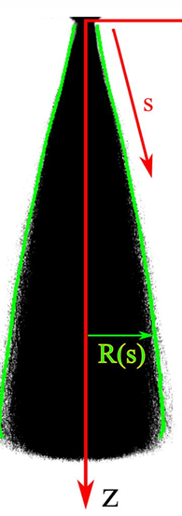
The diagram above shows a ponytail of fiber length density ρ(r) and the local mean orientation of the hairs is t(r).
The energy of this ponytail is given by:

$$ε\left[ρ,t\right]=\int{d^{3}r ρ\left(\frac{1}{2} Aκ^{2}+ φ\left(r\right)+〈u〉\right)}$$

$〈u〉$ represents all terms about disorder such as contacts and natural curvatures

Conclusion
Together we have seen the different aspects of hair-its waviness, its tension, the energy a bundle of it can carry. We have covered all the important and basic mechanics held by this unique and tiny topic of mathematics.
In this journey, I was enthralled by the complexities that such as small area of mathematics exhibits-the elasticity, the modulus or even its energy equation. I discovered new realms and wondrous avenues of the universe, how a single letter, a symbol alone itself can denote such huge mathematical properties. A thin hair falling in slow-motion on my table had sparked this idea: The Mathematics of Hair.

References:

Inspiration from Leonardo Rapunzel and the Mathematics of Hair by Professor Raymond E. Goldstein and Cross-section of hair under a microscope and curved hair diagram and ponytail diagram. https://www.gresham.ac.uk/watch-now/leonardo-rapunzel-and-mathematics-hair

Microscopic hair samples from Hooke’s Micrographia https://huntington.org/sites/default/files/styles/text_with_image_fp/public/2022-06/hair%20under%20a%20microscope%20RB487000_0930_Schem_V.jpg.webp?itok=mm2kUo7k

Diagrams on Curvature of Hair https://youtu.be/RJ-G9DFbcLA?si=QwvQz9t3nxX0NPz6

