The maths behind swing bowling – Taran Nichani
Introduction:
Growing up, watching Jimmy Anderson and Jasprit Bumrah jag the ball through the air, I have always wondered how does swing bowling actually work. How do these world-class cricketers make the ball magically move in the air, making it glide from left to right so effortlessly. Having played cricket for years myself (and having never really being able to swing a ball properly) I thought I would use this opportunity to research in more depth how swing bowling works. In this essay, I am going to attempt to explain one of cricket’s greatest mysteries by exploring the mechanics of swing via fluid dynamics and physical models as well as analysing the statistical trends in swing bowling performance. So, how can maths help us understand and model swing bowling?
What is swing bowling?
Swing bowling is when the ball curves through the air in order to deceive the batter. The amount the ball swings is influenced by a number of factors including the condition of the ball and the weather conditions.
The airflow will behave differently on each side of the ball and the rough side should swing into or away from the batsman depending on where it is positioned as shown below. As the bowler delivers the ball, a thin layer of air forms around it but cannot cover it fully, so this layer of air will separate at certain points. Where this separation takes places will determine the pressure of the ball which will lead to swing, if there is a pressure differential on either side of the ball. For this reason, the fielding team will treat the two sides of the ball very differently. For swing bowling to be most effective, one side of the ball needs to be really shiny while the other should be more ‘rough’. A ball can be made more shiny through polishing it, maybe by shining it on your trousers, or using your saliva (although this is frowned upon for obvious reasons). When there is a large difference between the two sides of the ball the amount the ball swings will be the largest.
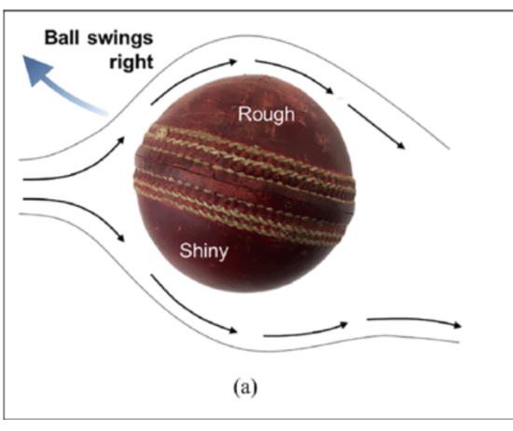
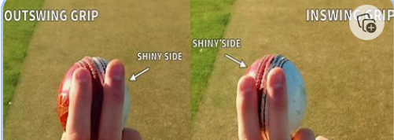

Modelling Swing Bowling with Maths:
Ok let us begin to go into more detail about how maths can actually explain swing bowling. Understanding how the ball swings revolves completely around the study of fluid dynamics which is how fluids (such as air) can move around solid objects. As the cricket ball travels through the air, the air flows around it but not in a symmetrical fashion which causes the ball to swing. As stated earlier, when the ball moves through the air, a thin layer of air sticks to the ball forming what’s known as a boundary layer. The flow of air on this boundary layer can either be laminar or turbulent. On the cricket ball, the shiny side will promote a laminar flow which means the flow is layered as the air moves at different velocities perpendicular to the direction of travel of the ball. In contrast, the rough side will promote turbulent flow which is much more irregular and random and is caused by chaotic changes in pressure and flow velocity. When we study the air around the cricket ball, the laminar flow will separate earlier than the turbulent flow which causes a low pressure on the turbulent side and a high pressure on the laminar side so the ball swings toward the rough side. This happens due to the Bernoulli principle which states, in a faster-moving fluid, pressure is lower. Because the airflow on the rough sides separates later, the air accelerates towards that side, lowering the pressure and pulling the ball towards it. While this is an example of the Bernoulli principle, the Bernoulli equation ($P+\frac{1}{2}pu^{2}=constant)$will not fully apply because of the turbulence but the reasoning still holds.

A key idea here is the difference between laminar and turbulent flows and there is actually an equation which helps determine whether a flow is laminar or turbulent. This is:
$Re=\frac{ρuL}{µ}$
Where Re is Reynolds number
p is the air density
u is the speed of the ball
L is a characteristic length (the ball’s diameter)
µ s the dynamic viscosity of air.
In general, a laminar flow occurs when Re < 2300 and turbulent flow happens when Re > 4000. In between these two values (2300<Re<4000) the flow is in a transitional regime. It starts as laminar but may develop instabilities which may turn into turbulence due to disturbances such as the seam angle.
If we substitute in values of
Р = 1.2kg/m^3 (at sea level)
u = 35m/s (About 125km/h which is a reasonably assumption for the speed of a cricket bowler)
L = 0.072m
µ = 1.8*10^-5 PaS
We get Re = 1.68*10^5.
Since Re is much greater than 4000 (upper limit for a turbulent flow) the flow will be very chaotic and as a result the ball will be sensitive to things like seam orientation and the condition of the ball. However, this Reynolds number is for the whole cricket ball so it does not force every part of the flow to be turbulent. It is still probable that the shiny side of the ball will remain laminar for a short distance before it separates while the surface of the rough side triggers the turbulence earlier because of how rough it is creating a pressure difference on that side. If the conditions were overcast and cloudy, the air density would increase so the Reynolds number would also increase encouraging more turbulent flow and therefore more swing.
So we have identified that the pressure difference between the smooth and rough side of the ball is what makes the ball swing. This concept is similar to the Magnus effect which explains how a spinning football or tennis ball curves. However, in cricket, the swing happens without spin but the idea of a pressure imbalance creating a force is the same. Now, we can quantify the magnitude of the swing using the equation:
$F\left(swing\right)=∆P*A$
Where ΔP = Pressure difference between the sides
A = cross-sectional area of the ball (πr^2)
This equation seems extremely useful however, for it to work, we need to know what ΔP is. Now if this was a physics essay, I’d just say to use technology such as wind tunnels, but I am going to explain how we can estimate the size of the swing force without the pressure difference using fluid dynamics. One way of doing this is using a lift coefficient to model the swing bowling. A lift force is a force that acts perpendicular to the direction of motion when an object moves through a fluid. In a cricket ball, it is caused by the difference in pressure on the opposite sides of the ball. So the swing force is essentially just another type of lift force. So we can model it as:
$F\left(L\right)=\frac{1}{2}pu^{2}CLA$
Where:
F(L) = Swing force (N)
р = Air density (1.2kg/m^3)
u = speed of the ball (35m/s)
CL = lift coefficient (0.2)
A = cross sectional area of the ball (m^2) - Radius of ball = 0.036 so area = 4.07*10^-3 m^2.
When substituting in these values we get an approximate swing force of 0.6N which will cause the ball to noticeably deviate. Now we have the net force, we can apply Newtons second law (F=Ma) to find the acceleration given that the mass of a cricket ball is approximately 0.156Kg.
$a=\frac{f}{m}$
= 0.6/0.156 = 3.8462 m/s^2
Now we can use speed = distance/time to find the total time the ball would swing for.
T = 20/35 = 0.5714s
And then finally use SUVAT, $s=ut+\frac{1}{2}at^{2}$to find the total distance the ball would swing
S = ?
U = 0
A = 3.8462
T = 0.5714
$s=\frac{1}{2}*3.8462*{\left(0.5714\right)}^{2}=0.62788m$
This is about 63cm of swing which matches real life observations of swing bowling so we can see this is a fairly accurate model.
In this equation, the lift coefficient is simply just a number which represent how well the shape of the object changes fluid motion into lift. It is normally between 0.1 and 0.3 however you’d need to do experiments in wind tunnels to find the exact value. If we increase the lift coefficient, we will increase the swing force, thus increasing acceleration and increasing the overall distance the ball would swing. But how do cricket players do this? They do this, through the angle of the seam. If the seam is angled slightly then it increase CL and therefore increases swing. This is because the seam acts like a ridge that makes the boundary layer become more turbulent on one side. So when the ball is angled, there will be less symmetry in the airflow and so there will be more swing. Another way to increase CL is to make one side really shiny and another side really rough in order to promote turbulent flow on the rough side while delaying the separation of the laminar flow on the shiny side thus increase the pressure difference. The lift coefficient also implicitly depends on the Reynolds number since that is what determines whether the flow around each side of the ball is laminar or turbulent. So if we increase humidity or air pressure then the lift coefficient will increase since air density is part of the Reynolds number equation. This is why swing bowlers thrive in cloudy overcast conditions since the Re will be higher! The lift force could also be calculated using the Kutta-Joukowski theorem however, this doesn’t fully apply to swing bowling because it models spinning balls.
So we can now use the equation, Pressure = force/area to find the pressure difference between the two sides. Since the swing force is about 0.6N and the area is 4.07*10^-3 m^2 we get ΔP = 147.42Pa.

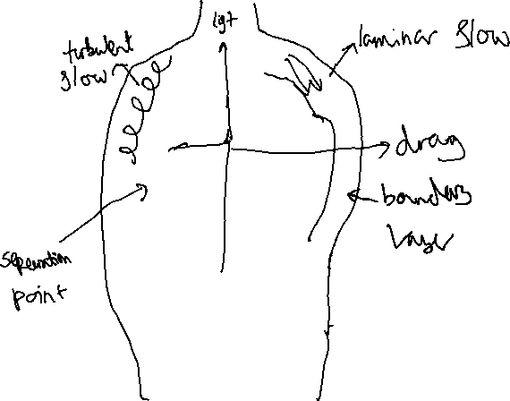
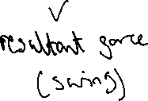
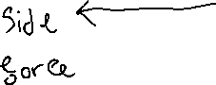
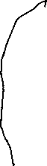
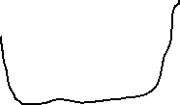
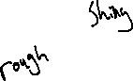
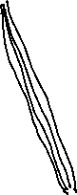
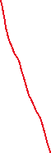

Now, I am going to try to explain how we can predict the motion of the ball using differential equations. Newtons second law states F=ma. In cricket, the force is caused by the pressure difference between the two sides of the ball so $a=\frac{ΔP*A}{m}$. Since acceleration is the second derivative of position, we can rewrite this equation as $\frac{d^{2}y}{dt^{2}}=\frac{ΔP*A}{m}$. Since all the terms on the right hand side are constant, we can easily solve this equation by integrating twice. If we take the integral of both sides, we get $\frac{dy}{dt}=\frac{ΔP*A}{m}t+C1$. If we assume that the ball has no initial sideways velocity because the airflow has not had time to separate, then C1 = 0. Now if we integrate again, we get $y\left(t\right)=\frac{1}{2}*\frac{ΔP*A}{m}*t^{2}$ +C2. Now if we assume that the ball doesn’t have any initial displacement, we know C2 = 0. We also know (if air resistance is considered negligible in this model) that the forward (x) motion is x = u*t. if we substitute t = x/u into the above equation we get $y\left(x\right)=((ΔP*A)/2mu^{2})x^{2}$. This is a quadratic which is similar to projectile motion and shows that the sideways displacement increases as the ball moves forwards which explains why the ball curves more the further it goes.
Evidently, swing bowling happens due to the boundary layer and where the flow around the ball separates. Now we can actually estimate how thick this boundary layer is using the equation: $δ\left(x\right)=\frac{5}{\sqrt{Re}}*x$
Where:
$δ\left(x\right)$ = Boundary layer thickness
Re is the Reynolds number.
Re can also be written as $\frac{ux}{v}$
Where:
u = airspeed
v= Viscosity of air.
If we substitute this back into the original equation for boundary thickness we get:
$$δ\left(x\right)=5\sqrt{\frac{vx}{u}}$$
From this equation we can see that the faster the ball moves, the slower the boundary layers forms, meaning there will be a thinner boundary layer which will delay the separation on the laminar side resulting in a higher pressure difference meaning more swing.
So far in this essay, the models used to predict swing have been very simple and have relied on many assumptions including the idea of ignoring air resistance and the idea of having constant pressure differences. In order to model how air moves around a cricket ball in the real world, we’d need to use the Navier-Stokes equations which are a set of partial differential equations. I have no way of solving these equations (after all, solving it in 3D is one of the Millennium prize problems) but they account for viscosity, turbulence and changing flow patterns which are all seen in cricket.

Reverse swing:
Ok so we now know why conventional swing works and how maths can explain it, but what about reverse swing? Reverse swing is just the opposite of conventional swing. Instead of the ball moving towards the rough side, it moves towards the shiny side. This can only happen at very high speeds (at least 85mph or 38m/s) because it increases the Reynolds number a lot (3*10^5) so that only turbulent flows form on both sides. This next part may seem somewhat counterintuitive, but the air around the smooth side separates earlier leading to a higher pressure on the smooth side so the ball swings towards it. Reverse swing works best with old balls because one side is very rough so teams utilise it towards the end of an innings.
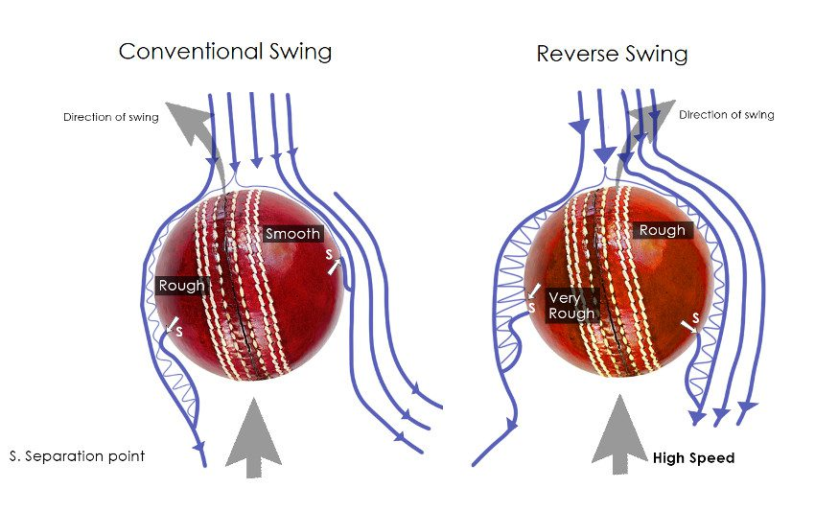
Conclusion:
To conclude, swing bowling can be modelled by mathematics but there are such a variety of uncontrollable factors which make it very unpredictable. The goal of swing bowling is to create chaos for the batsmen. Often neither the batsmen nor the bowler will know the magnitude of the swing which makes it very hard to face. If you want to make the ball swing more, try shining it on one side and keep the other side old and rough. Although the maths behind swing bowling is clear, it still seems like magic every time I watch it on TV.

