Mathematics in Architecture

Mariia Oleksiyenko

Mathematics and architecture may seem like different sciences, but they are deeply connected. From the proportions of the Parthenon to the designs of today’s futuristic buildings, mathematics serves as both a tool and a guiding principle in architectural design. It helps to structure the buildings, influences aesthetic proportions, and enables innovative forms through modern technology. In this essay, I will explore how geometry, algebra, symmetry, trigonometry, and more abstract mathematical ideas are essential to the art and science of architecture.

Geometry: The Foundation of Form
Geometry is the most fundamental mathematical tool in architecture. The earliest human shelters used basic geometric shapes: circles for huts, rectangles for enclosures. This is because these shapes are stable and easy to replicate. Ancient Egyptians and Greeks formalised geometric principles and incorporated them into architectural works, from pyramids to temples.
The Parthenon in Athens, for example, famously uses the golden ratio in its facade. This ratio, believed to be aesthetically pleasing, came from the Fibonacci sequence and appears frequently in nature. Greek architects applied this mathematical pattern to create harmony and balance.
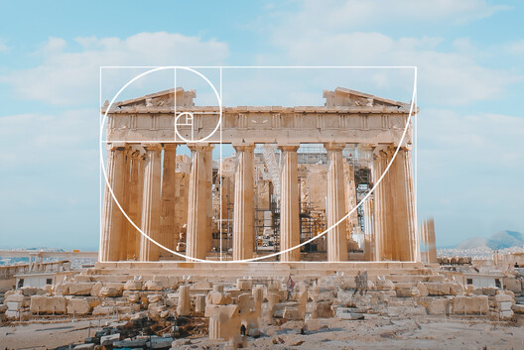

Islamic architecture also provides examples of geometric application. Islamic architects developed complex tiling patterns and muqarnas (ornamental vaulting) based on symmetry, tessellations, and non-periodic patterns. Some of these designs anticipated mathematical discoveries, such as Penrose tilings, which were only formally described in the 20th century.
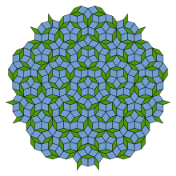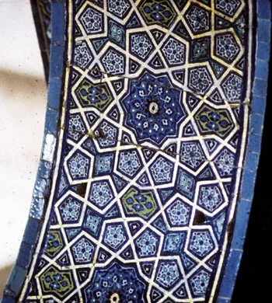
Penrose Tiling | Islamic Tiles

Proportion and the Human Scale
The concept of proportion is crucial in making architecture relatable to human experience. The Renaissance architect Leon Battista Alberti and later Leonardo da Vinci believed that the proportions of buildings should reflect those of the human body. This idea was most famously visualised in da Vinci’s Vitruvian Man, based on the writings of Vitruvius, a Roman architect who described ideal human proportions. Mathematically, this meant architects often used modular systems and grids to align elements in ratios. The Modulor, developed by 20th-century architect Le Corbusier, is a system of proportions based on the human body and the golden ratio, designed to bring harmony to architecture through consistent scaling.
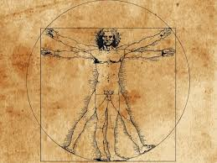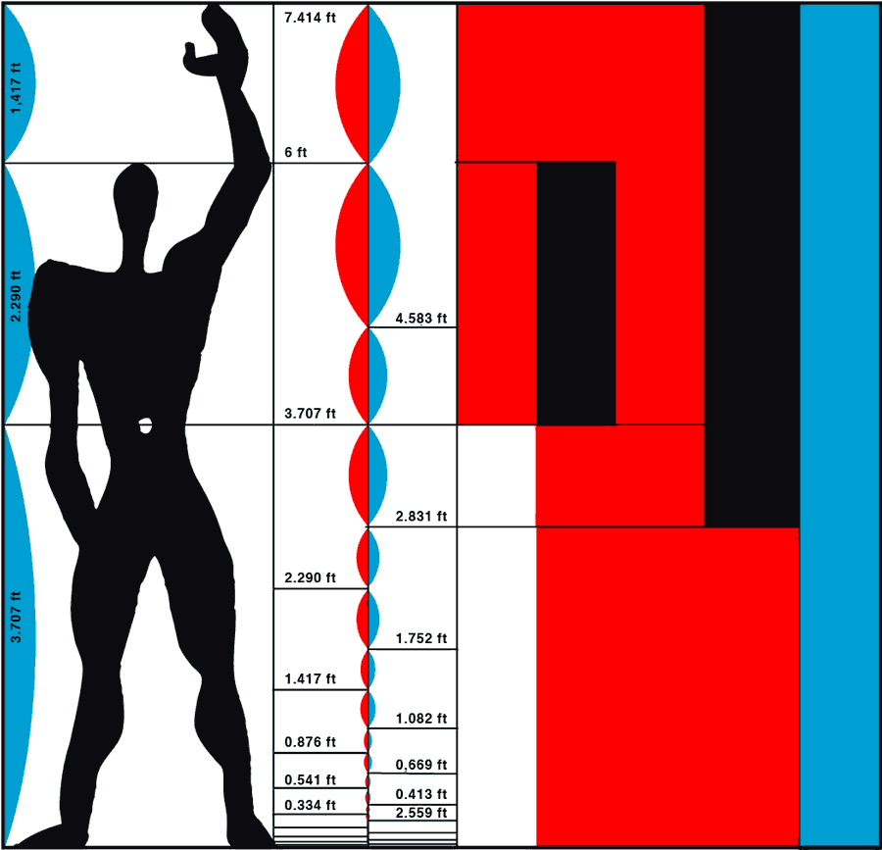

Vitruvian Man | The Modulor

Structural Engineering: Algebra and Trigonometry in Practice
The aesthetic appeal of a building is meaningless without structural integrity. Mathematical principles ensure that buildings remain standing under various loads, such as gravity, wind, earthquakes, and more. This is where algebra, calculus, and trigonometry come into play.
Consider the forces acting on a simple beam. Engineers use algebraic equations to calculate bending moments, shear forces, and stress distribution. Trigonometry is vital when dealing with angled components, such as rafters or arches. Calculations involving sine and cosine functions allow for precise determination of force directions and magnitudes.
In modern architecture, finite element analysis (a numerical method used to predict how structures respond to external forces) enables architects to simulate stresses in complex geometries. These models rely heavily on systems of equations and computational linear algebra, illustrating how theoretical maths directly supports real-world construction.

Symmetry and Aesthetics
Symmetry is often associated with beauty, and architectural design frequently draws on symmetrical patterns to create balance and elegance. Mathematically, symmetry involves transformations: reflection, rotation, translation, and glide reflection.
The Taj Mahal in India is an example of bilateral symmetry, with its minarets and domes mirrored across a central axis. In contrast, modern architecture sometimes uses asymmetry purposefully to create tension or interest. Both choices are mathematical: one is rooted in the predictability of reflectional symmetry, while the other plays with expectations through careful calculation.
Group theory, a branch of abstract algebra, underlies the study of symmetry. While originally a theoretical discipline, group theory has practical applications in architectural ornamentation and modular design systems.
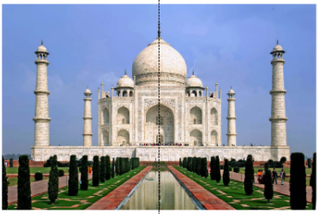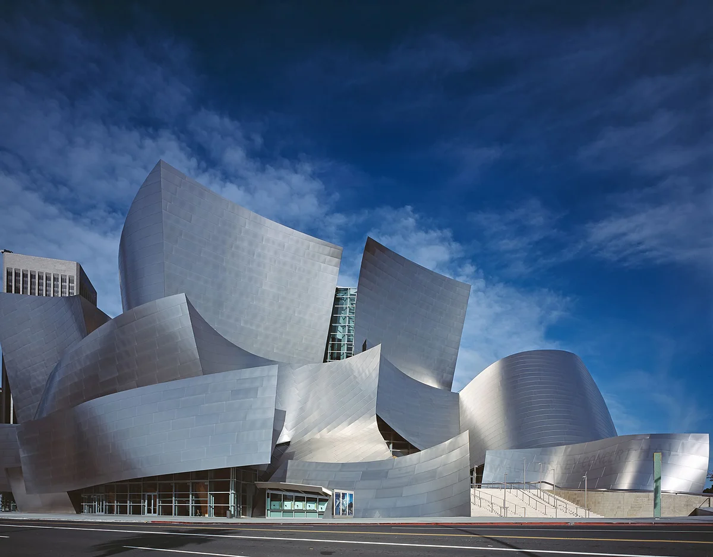

Symmetry of Taj Mahal | Asymmetry

Fractals and Complexity
Fractal geometry, where shapes repeat at different scales, has also found a place in architecture. Although fractals were formally defined only in the 20th century by mathematician Benoît Mandelbrot, fractal-like patterns have long existed in traditional architecture.
For instance, Hindu temples often use recursive patterns that get smaller and smaller toward the top, mimicking natural structures like trees or mountains. Today, architects like Peter Eisenman and Frank Gehry experiment with computer-generated fractal forms to create visually complex, dynamic buildings. These designs often rely on iterative algorithms, a mathematical process that repeats a sequence of operations, to generate their intricate, self-similar structures.
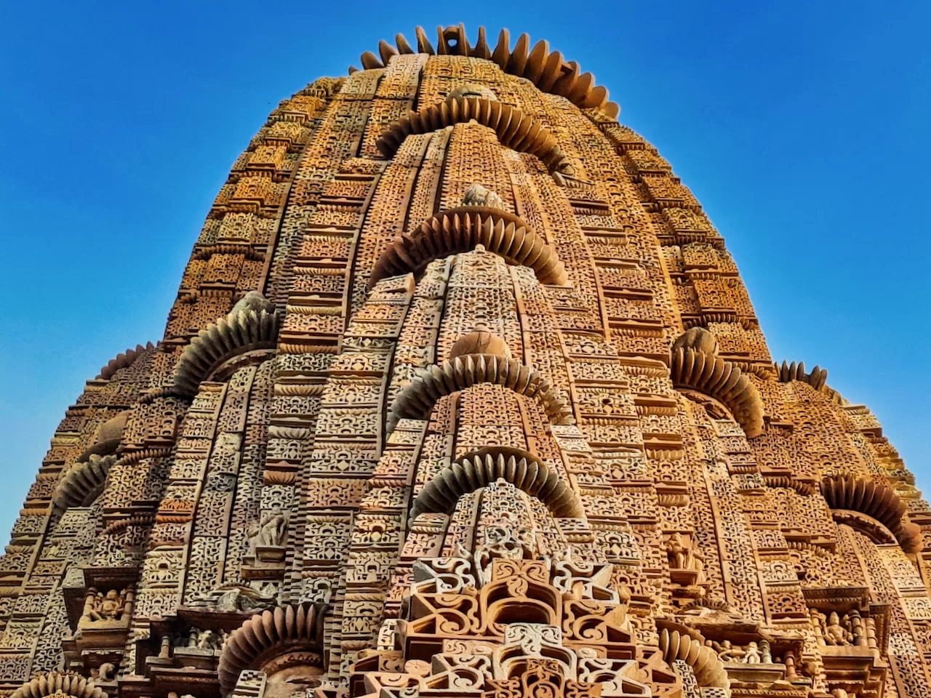

Fractal in Architecture

Computational Design: The Future of Mathematical Architecture
In the 21st century, architecture is increasingly shaped by algorithms. Parametric design allows architects to define a set of rules and parameters that the software then uses to generate forms. These parameters may include environmental data (like sunlight or wind), structural constraints, or aesthetic variables.
Mathematics is the language of these rules. Linear algebra, vector calculus, and differential equations are embedded in the algorithms that power design tools like Rhino’s Grasshopper or Autodesk Revit.
For example, the Beijing National Stadium (“Bird’s Nest”) by Herzog & de Meuron used algorithmic design to calculate the crisscrossing steel beams, balancing artistic chaos with structural order. The resulting form would have been impossible to create using traditional drafting methods.
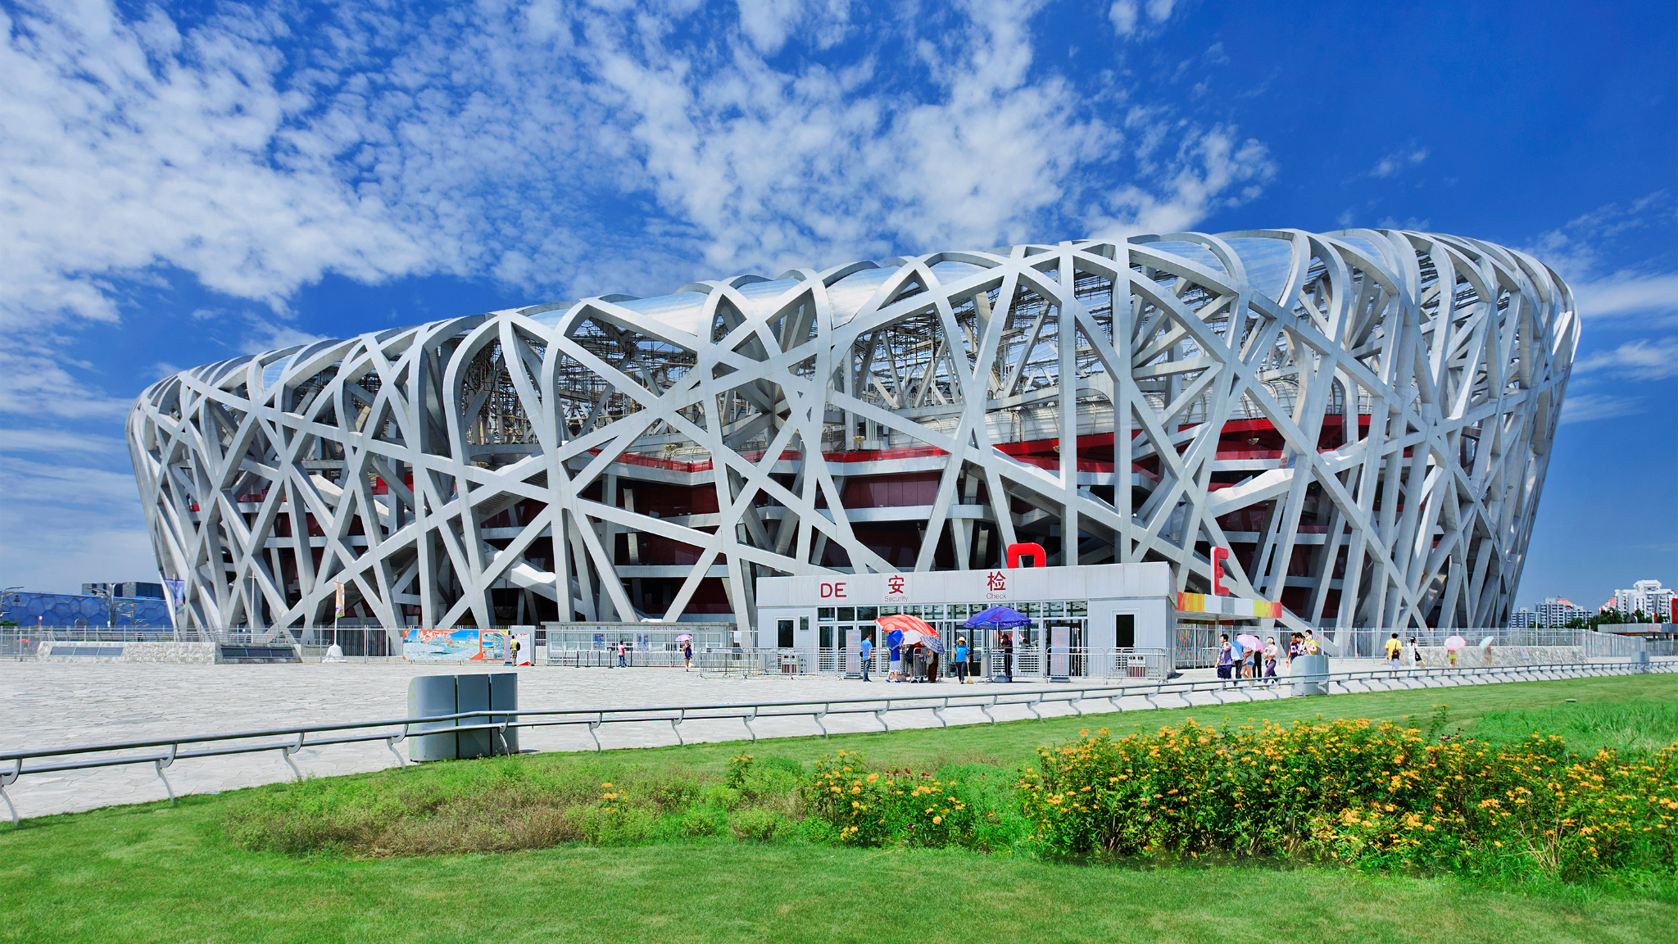
Beijing national Stadium

Mathematics as a Bridge Between Art and Science
One of the most remarkable aspects of mathematics in architecture is its ability to bridge the gap between art and science. While architecture is often celebrated for its aesthetic qualities, it is equally a technical discipline rooted in logic, measurements, and calculations. Mathematics ensures that imaginative ideas can be translated into reality: safely, sustainably, and efficiently. For example, the design of eco-friendly buildings often relies on mathematical modelling to optimise natural light, airflow, and energy consumption. Even acoustics in concert halls are shaped by equations predicting how sound waves behave within curved spaces. These are not just scientific exercises, but vital parts of the artistic experience. Mathematics gives architects the confidence to innovate, knowing they can calculate the implications of their creativity. In this way, maths doesn’t just support architecture, it inspires it, enabling designers to dream bigger, build smarter, and shape the spaces in which we live, work, and imagine.

Mathematics is the invisible framework upon which architecture stands; not just physically, but conceptually. It gives architects the tools to model forces, the proportions to design beautifully, and the creativity to push boundaries through abstraction. Whether in ancient pyramids or parametric skyscrapers, mathematics has always been at the heart of architecture. As computational power increases and mathematical understanding deepens, the future of architecture will continue to be shaped and expanded.

