The Physics Of Karate

Introduction
The two loves of my life: crunching numbers and breaking boards. The two disciplines of Physics and Karate certainly evoke very different images in people’s minds - what do Newton’s laws of motion have in common with Bruce Lee’s greatest kicks?
A great deal, actually. And this is the subject of this essay: how utilising the laws of physics can help knock down boards, punching bags and even people. I am a black belt in Shotokan Karate and have competed nationally. I am also a massive physics fan and I shall take you on a journey through punches, kicks and calculations. I am going to use these core concepts of physics: Newton’s second law, moments, angular momentum and pressure. I shall explain what they are and then and demonstrate how they are used in the practice of karate.
Newton’s Second Law
Perhaps his most recognisable physics equation, F = ma, Isaac Newton’s second law states that the force of an object with a given mass is directly proportional to its acceleration. But how did he find it? Well, he knew that force was directly proportional to the rate of change of momentum or just F ∝ (mv – mu) / Δt where m is mass, v is the final speed of an object, u is the initial speed and Δt is the change in time. He then simplified this by factoring out m to be left with F ∝ m(v – u) / Δt . He could still simplify it more by representing (v – u) / Δt as acceleration, which is the rate of change of velocity over time. Therefore, he was left with F ∝ ma. Now if he wanted to directly relate F and ma to each other through equality, he would need to introduce a proportionality constant, k. This therefore forms F = kma. But this proportionality constant, through experimenting with applying a 1 Newton force to an object with a mass of 1kg, is 1 because the acceleration is also 1 ms^-2. Therefore, our equation F = ma has been successfully derived. We shall see the applications this has for Karate soon. But let’s look at another physics concept: moments.
Moments
Ever felt what it’s like to push a door? Wonder why it’s harder to keep a door shut when pushing closer to the hinge than from further away? The idea of moments can explain that. A moment is defined as the product of the force acting on an object about a pivot point and the perpendicular distance of that force to the point. In other words, opening a door from the handle requires less force than from closer one more towards the hinge because the distance at the handle is greater. We can define an equation, therefore, saying M = Fd where M is the moment (measured in Newton-meters) and F is the force whilst d is the perpendicular distance.
Angular Momentum
When something is moving around in a circle about a point, we say in physics that it is accelerating. This is because its direction is constantly changing, meaning its velocity is changing over time, resulting in acceleration. Linking this back to F = ma, if an object is accelerating, it therefore has a force. Since force is the change in momentum over time, an object moving around a point therefore has momentum. Because the radius of the object from the point also matters, the equation becomes: L =I ω where L is the angular momentum, I is the moment of inertia (dependent on the mass and radius of the system) and ω is the angular velocity of which the object is rotating.
Pressure
When a force is applied onto a specific area, we call it pressure. This is summed up in the formula P = F/A where F is the force in newtons (N), A is the area in meters squared (m^2) and P is measured in Pascals (Pa). This is very important within the first Karate move we shall look at: the Seiken Choku Tsuki.
Seiken Choku Tsuki (Straight Punch)
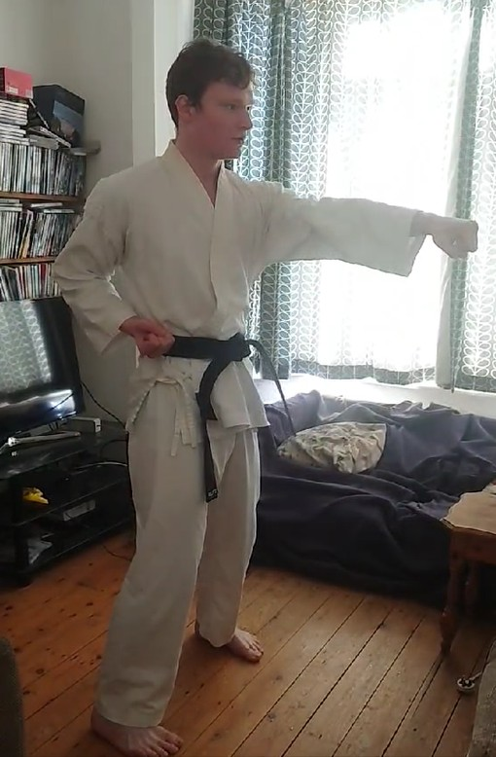
A Seiken Choku Tsuki is simple: it’s a straight punch loaded from the hip/guard, and it goes directly to the target of impact. This attack is typically done whilst stepping forward but can be practised from a standing position to co-ordinate the upper body correctly. At the point of impact, the attacker strikes with the first two knuckles connected to your index and middle finger. This is because they have a small area of impact. The force is the same, so what can change is the area you strike with. To reduce the chances of breaking your hand and hurting yourself more than your opponent in the process due to Newton’s third law that every force applied on an object will experience an equal and opposite force, a greater area is used than that of the other two knuckles (but not so great that the pressure applied onto the opponent is small as well).
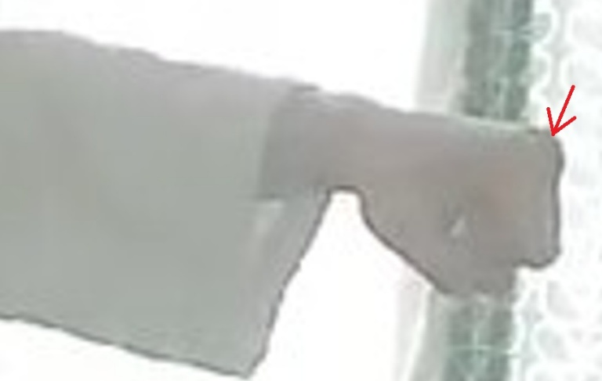
Looking at the upper body, the way the hand moves is rapid - first relaxed, and then tight at the point of impact. Using Newton’s second law, we know what we’ll need to maximise to produce a greater force: acceleration. No, not mass. No matter how hard you tense your fist, it doesn’t change at all. To increase acceleration, a relaxed hand until the point of impact is needed. At the moment of impact, the hand is twisted with the palm facing from upwards to downwards. What this does is create torque, an expression of a rotational or twisting force. This twisting effect reduces any air resistive forces that might prevent the punch from having as much impact, as well as creating differences in air pressure on opposite sides of the fist. The latter effect is known as the Magnus Effect, which creates an additional force, allowing it to move in a certain direction faster. What this also creates is a small yet significant amount of angular momentum that is transferred to the point of contact.
Now towards the hips/mid-section. Just before the punch is released, the hips rotate slightly to the side. This is so that, when they return to their normal position, part of your upper body is rotating about a point. This generates angular momentum, which is equal to the product of the mass, velocity and radius about the point it is spinning around. Because the hips change from stationary to moving, this generates an angular force (remember F = ma) as it is accelerating, causing a greater resultant force to be transferred towards the target on the moment of impact. But what exactly causes the hips to move this way? The legs. A slight bend in the knees allows this form of dynamic rotation to occur. Which brings us to our first principle of Karate: power, being force x distance where distance is considered constant in a situation, is generated from the ground up. In other words, you punch not with your hands and arms, but with your feet and legs.
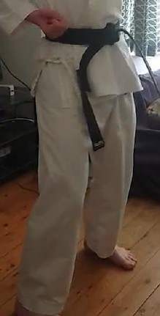

Mae Geri (Front Kick)
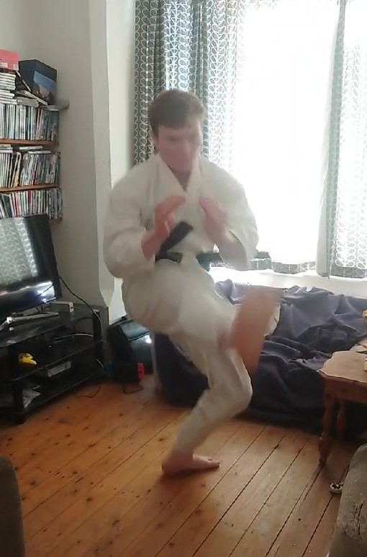

Within Karate, the front kick is designed entirely to cover as much range as possible whilst delivering maximum force and putting yourself out of harm’s way. First, from a stance, the knee of the leg used in kicking is driven up as quickly as possible using the hips. This is so that the next part of the kick, releasing it, can be executed properly (a kick that scrapes up someone is not going to apply a proper force over a specific area). As this happens, the foot is angled upwards, flexing the ankle. Once the knee is up, the leg is extended in a straight line so that the time taken to reach the opponent is shorter over the same distance, allowing a greater velocity, increasing momentum as p = mv. At the same time, the foot is angled downwards so that there is a greater resultant force. To get more of a force in the kick and to shift the centre of mass onto the balancing foot when kicking (as in a momentum diagram, your opponent’s mass is added onto yours if you were to connect), the upper body goes backwards, thrusting the hips in a direction more towards that of the kick. Whilst doing this, to not only prevent your opponent from seeing your intentions but also to keep the angular momentum he may transfer to you with a Teisho Uke (more on that later) to a minimum, the arms and upper body is kept close together.
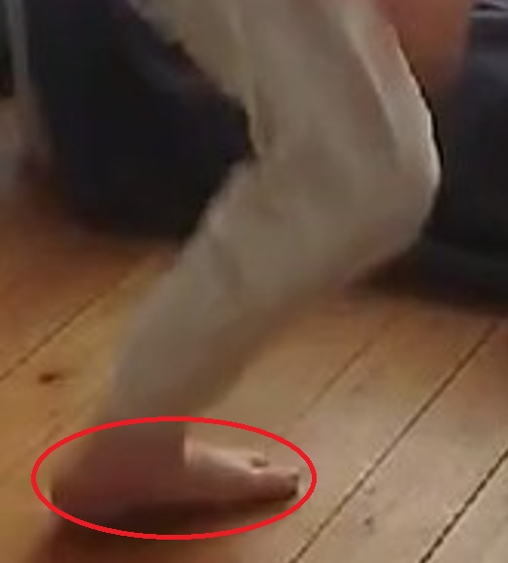
After this is performed successfully, the attacker is left standing on one leg, vulnerable to being set off balance and attacked. To prevent this, the kicking foot must be brought back in quickly. The foot is at a closer distance towards the centre of mass, meaning that the movement applied onto the attacker at this point won’t be so great. The attacker can then put the foot down quickly, back on their own two feet and reducing any chances of their opponent from setting them off balance. Since being on one foot alone poses danger of falling onto the ground, this leads to the second principle of karate related to physics: keep your centre of mass low. This is the reason Karate stances are often quite deep compared to stances of other martial arts; it allows us to stay put when receiving any attack from an opponent.

Soto Uke (From-Outside Block)
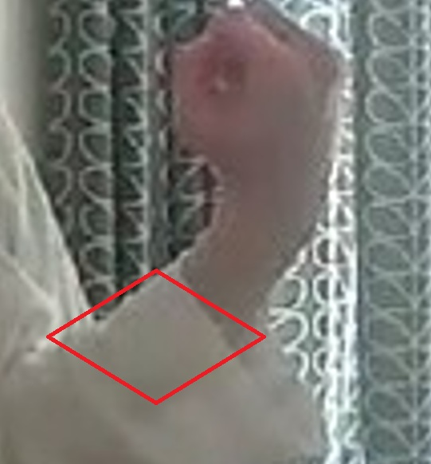
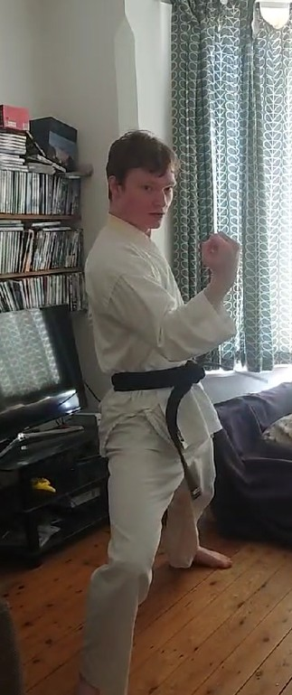

Now that we have discussed some attacks, what about some ways to defend them? Here’s a way to defend against a Choku Tsuki. From a stance, the front hand twists to the left slightly whilst moving in that direction. This is so that a greater distance between the attack and the block is created, allowing the block to have a greater velocity. As the punch comes in, the moment it is about to reach its target, the blocking hand makes an impact on the fist with the lower part of its forearm, minimising pressure onto the defender due to a greater area being the point of impact. The fist is blocked because it is the furthest away from the shoulder, the pivot point of the attack. Therefore, a greater moment shall be created. As the defender connects with the fist, the arm twists with the hips, turning towards the right, generating angular momentum towards it, as well as linear momentum. What this does is changes the trajectory of the attack away from its target.
It’s important to note that within blocks and attacks in Karate, the shoulders are kept down and always relaxed. This is so that no excess energy is wasted from the upper body and so that the lower body does the main part of the work. This is the third principle of Karate.

Teisho Uke (Palm Block)
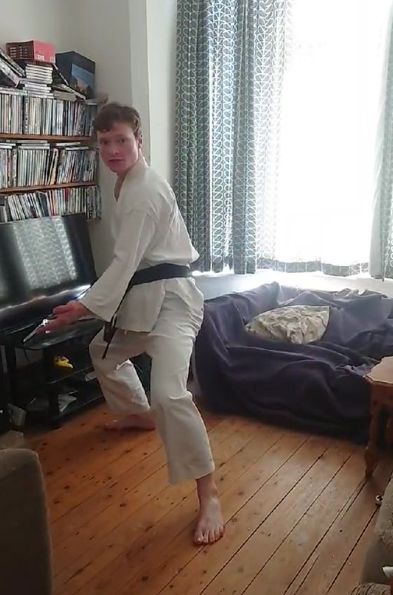

This block works mainly for a Mae Geri attack. From a stance, the attacker moves forward, launching a Mae Geri straight to their groin. The defender, stepping back, uses their back hand to catch the heel of the kick with the palm of their hand. This is so that the attacker is unable to bring their leg back as there is a resultant force going in the direction the defender is moving in. From there, pivoting on the balls of their feet to allow the defender to use their hips when blocking, they send the foot the other way, causing the attacker to land on the outside of the opponent with their back faced towards them due to a large moment being caused. From there, the defender can throw an attack themselves whilst the opponent cannot see them. Or they can run away, which is often the best thing to do when in the street.

Practical Self-Defence
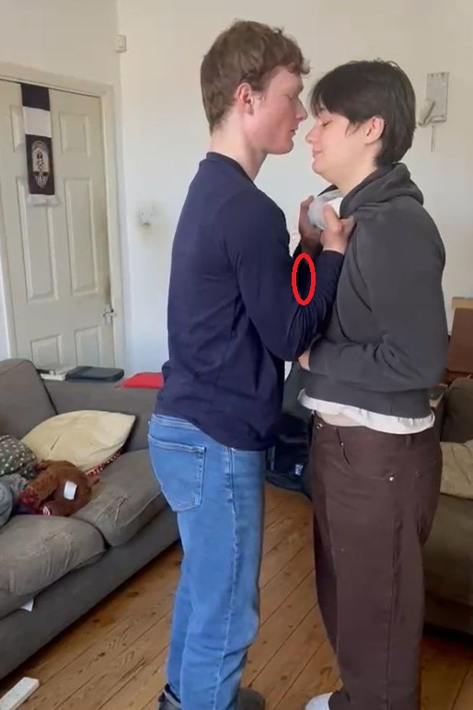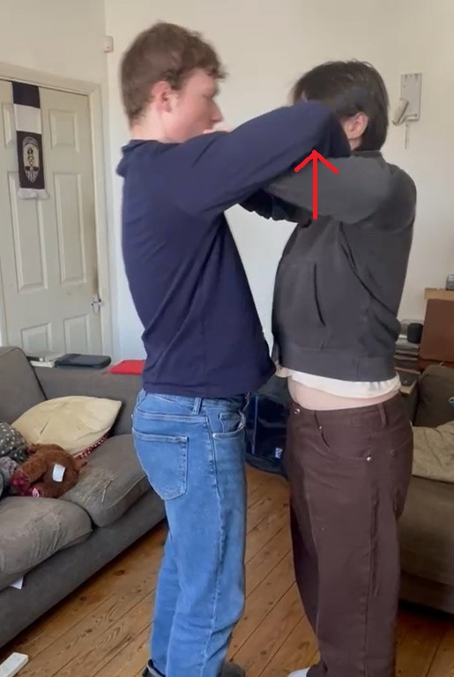

So how can you apply any of this if you end up in a tricky situation? Karate can help you - for example, if someone were to come up to you and grab your clothing by your neck. There is often a gap in between the person’s arms, simply because the joints of the elbows never touch each other. Using the principles of angular momentum, you can fit both of your arms into there, push them out whilst twisting your arms outwards. After that, a Mae Geri to their groin would be the best solution, disarming them, or simply just push them out of the way by first driving your weight forward to involve a greater mass in the force at play, pushing you and the aggressor backwards due to Newton’s third law. After that, the best solution is to run.

Conclusion
The laws of Physics weren’t just used for making calculations with celestial bodies but can also underly the practice of karate. Gichin Funakoshi (the inventor of modern karate) unwittingly used the universal laws of force and motion to develop a global martial art that could also be used to save your life one day.

Sources and further readings:
- Gichin Funakoshi: https://www.skifworld.com/Gichin-Funakoshi.php
- Newton’s Laws of motion: https://www.britannica.com/science/Newtons-laws-of-motion
- Magnus Effect: https://www.britannica.com/science/Magnus-effect
- Kinematics of Karate: file:///C:/Users/lgs19steva2/Downloads/Dialnet-PhysicsOfKarate-3694887.pdf
- Physics of Karate Strikes: https://citeseerx.ist.psu.edu/document?repid=rep1&type=pdf&doi=ba8924b948ffebba3c9f1110386a830802dfc49b
- Torque: https://www.clrn.org/what-is-a-torque-in-physics/

