Seemingly Random, Mathematically Defined: Modeling Button Transitions in Console Games Using Graph Theory and Fitts' Law
Ali Mehralizade

1. Introduction

In modern video games, players’ ability to swiftly switch between different buttons on a console controller (for example, momentarily releasing the “A” button and immediately pressing the “B” button) plays a decisive role in gameplay. Game controllers typically act as the primary input device, and many games are designed specifically to match the capabilities of these controllers; as a result, the controller device becomes a central element of the user’s gaming experience. The skillful execution of complex combinations by expert players depends precisely on how efficiently these button transitions are performed. Conversely, flaws in the design of the controller can hinder the gaming experience — for instance, the excessively large size of the first-generation Xbox controller made it difficult for users with average-sized hands to comfortably reach some buttons. Such examples indicate that button-to-button transitions are not random factors in game dynamics but are critical elements directly related to device ergonomics and user performance. These fast button-switching behaviors, although seemingly reflexive, are in fact not random sequences — they are systematic processes governed by certain regularities that can be mathematically described. Each time a user interacts with an interactive system by performing an action (e.g., pressing a button), they effectively transition from the end state of the previous action to the start state of the next action. To formalize these transitions, directed graph models can be used; in such graphs, each node represents the action of pressing a specific button, and each directed edge represents the transition from one button to the next. In other words, a sequence like “after pressing button P, button Q is pressed” is represented by an arrow on the graph. This kind of graph structure enables tracking the player’s button sequences, identifying which button is most frequently followed by which, and detecting the frequency/patterns of such transitions. As a result, hidden patterns of player behavior emerge and can be explained through mathematical models. One of the classical models of human-computer interaction, Fitts’ law, makes it possible to quantify the timing of such button transitions. According to Fitts’ law, the time required for a user to move a pointer to a target is determined by the ratio of the distance to the target and the size of the target; that is, the farther the distance and the smaller the target, the longer it will take to reach it. This law, introduced by psychologist Paul Fitts in 1954, demonstrated that rapid motor movements in humans can be statistically predicted. In the context of a game controller, this can be explained as follows: the time it takes for a player’s finger to move from one button to another depends on the physical distance between the two buttons and the size of the target button. For instance, a transition to a large and nearby button will occur faster than a transition to a small and distant one. Fitts’ law is widely used in both academic research and practical design fields — its speed-accuracy relationship is employed to ensure that the size and placement of buttons in interactive systems are optimal for the user. Therefore, it can be assumed that transitions on a game controller also follow Fitts’ law and possess certain logical temporal characteristics. The aim of this research is to analyze player button-to-button transition behavior on the controller based on directed graph models and Fitts’ law. For this purpose, we will first collect transition sequences from real gameplay scenarios, identifying which button is most often pressed after which, and model them as a directed graph. For each edge of this graph, the physical parameters such as the distance between the corresponding two buttons and the size of the target button will be considered, and using the formula provided by Fitts’ law, the theoretical time (i.e., transition speed) for that transition will be calculated. For example, if players frequently move from the left analog stick to the “X” button on the right side, it will be possible to determine the difficulty and time requirement of this action based on the distance between these two control elements and the size of the “X” button. Through the analysis of the collected data and model results, it will be identified which transitions players perform more quickly and which ones cause more time loss. This approach is not limited to empirical observations only, but also allows theoretical evaluation of all possible transition combinations. As a result, the acquired knowledge may offer valuable insights for optimizing game design: button placement and sizes in the game controller scheme can be adjusted to facilitate the most frequently used sequences, and critical functions can be assigned to buttons that require the least physical effort. Thus, the mathematical modeling of button transitions will not only provide a deeper understanding of game interactivity but also encourage the design of future game controllers and control schemes with consideration for user performance.

2. Assumptions

The following assumptions are made in this study:
The design of the game controller is fixed: All participants use the same model of game controller, and the size and placement of its buttons are identical.
Participants have similar hand sizes and motor skills: There are no significant differences in hand sizes and motor skills among the players participating in the study.
Transition behaviors are purposeful: The transitions between buttons by the players are not random; they serve a specific purpose and are carried out in a sequential manner.
The effect of game genre is not considered: Although the study includes various game genres, the analyses do not account for the impact of game genre on button transitions.
Accuracy of data: The correctness and reliability of the collected data are assumed; errors in observation and video analysis are considered minimal.

3. Graph Theory and Directed Graphs

Graph theory is a mathematical framework that enables the modeling of relationships between various objects (points). A graph is represented by the pair G = (V, E), where:

V – is the set of vertices (or nodes); E – is the set of edges (lines) connecting these vertices.
A graph typically refers to a collection of objects – vertices (or nodes) – and the relationships connecting them – edges. In other words, a graph consists of elements (vertices) that have certain “connections” between them and lines (edges) that represent those connections. A graph is usually depicted visually as dots representing each vertex and lines/arrows connecting them. If the edges of a graph are directed, meaning they go from one vertex to another, such a graph is called a directed graph. In directed graphs, connections are one-way; that is, a transition from vertex A to vertex B is considered different from a transition from B to A. In this study, the buttons of a console game controller (e.g., a PlayStation or Xbox controller) are taken as the vertices of the graph, and the player's transition from one button to another is modeled as a corresponding directed edge. The console controller's buttons are modeled as vertices (V), and the transitions between buttons are modeled as edges (E). For instance, if there is a directed transition from A to B, it is represented as (A, B) in the graph G = (V, E). This approach allows us to conceptualize all button transitions as a network and to analyze their sequential patterns.

4. Vertex Degree

In graph theory, vertex degree refers to the number of edges connected to a vertex in a graph. In other words, the degree of a node is defined by how many connections (edges) it has. In directed graphs, however, the vertex degree is considered in two forms: in-degree refers to the number of edges directed into a vertex, and out-degree refers to the number of edges originating from that vertex. In our application, this concept is used to measure how actively each button functions within the network. For example, if a certain button leads to many other buttons (high out-degree), it means that this button often serves as a starting point in sequential combinations. Similarly, a button with a high in-degree is pressed after many other buttons; that is, in the sequence of player actions, this button frequently becomes the next target. Thus, analyzing vertex degrees helps us identify which buttons are used more frequently and which ones play a central role in the transition graph.

5. Fitts' Law

Fitts’ law is a well-known law that models human motion and predicts the time required to reach a target. According to this law, the average time required to move toward a target using a hand/pointer is determined by the ratio of the distance to the target (D) to the size (width, W) of the target. Mathematically, Fitts’ law is often expressed with the following formula:

MT = a + b · log₂(D/W)​.

Here, MT stands for Movement Time, D is the distance between the starting point and the center of the target, and W is the effective width of the target (the allowable deviation for successfully selecting the target). a and b are empirical constants that depend on the device and conditions (determined experimentally). As a result, when the distance to the target is large or the target is very small, the time to reach the target increases; conversely, when the target is close and large, it takes less time to reach it. We apply this law to analyze button-to-button transition behaviors. For each button pair on the console controller, by considering the physical distance (the space between the two buttons) and the size of the buttons, the predictions provided by Fitts' law are calculated. For example, transitions between buttons that are very close together and of large size on the controller will be faster and easier (i.e., a lower index of difficulty), whereas transitions between distant or small-surfaced buttons will occur more slowly and with greater difficulty. In this way, it becomes possible to assign an approximate “index of difficulty” (or movement time) to each directed edge in the graph. Consequently, Fitts’ law allows us to determine under which conditions button-to-button transitions are relatively easier (faster) and under which they are more difficult (slower).

6. Methodology

In this study, data will first be collected by observing the button-to-button transition behaviors of players using a console controller. Personal observation and video analysis methods are planned to be used as the data collection process. For example, the player's hands may be recorded on video to track the sequence in which their fingers move across the buttons during gameplay. In the video frames, it will be noted which button is pressed after which (i.e., specific transitions). Through this process, the most frequently repeated button sequences and transition patterns in the collected data set will be identified. Subsequently, based on the collected data, a graph model representing the transitions between buttons will be constructed. In this model, all buttons on the controller are represented as vertices, and each observed transition connects those vertices with a corresponding arrow (directed edge). As a result, a visual map of button-to-button transitions is obtained: the direction of the arrow indicates the direction in which the transition occurred. In the final stage, Fitts’ law will be applied to this graph. That is, for each directed edge (button transition) in the graph, the physical distance between the respective buttons on the controller will be measured, and considering the button's physical size as the target size, the expected movement time (MT) for that transition will be calculated.Thanks to this methodology, it will be possible to analyze both the structure of the button transitions (through the graph model) and the relative difficulty of each transition (through Fitts’ law calculations) together. The purpose of these stages is to uncover the structural and functional characteristics of button-to-button transitions on the game controller using mathematical models. By constructing the graph, the connection network of these transitions will be described, while Fitts’ law will be used to demonstrate how systematic and measurable these transitions are. The main objective is to show that these behaviors are not random reflexes but occur in an analyzable and rule-based structural form. It should be noted that button-to-button transition sequences may vary depending on the game genre, scene context, and the player’s individual playstyle. For this reason, samples from different scenes (e.g., combat, shooting, open-world exploration) will be collected, and the most frequently repeated sequences will be taken as the basis. As a result, the model may cover both general transition patterns and behavioral differences in specific in-game situations. It will be possible to analyze both the structure of the button transitions (through the graph model) and the relative difficulty of each transition (through Fitts’ law calculations) together.

7. Application and Visual Example

The following buttons are present on console controllers. It should also be noted that the Right Stick and Left Stick are not considered as a single vertex, but rather each of their movements is treated as a separate vertex. The vertices (buttons) are shown in the table below. The console we used in our study is the following:


Main Buttons | Trigger Buttons | Left Stick (LS) Directions | Right Stick (RS) Directions
X (Cross) | L1 | LS↑ | RS↑
O (Circle) | L2 | LS↓ | RS↓
⬛ (Square) | R1 | LS← | RS←
🔺 (Triangle) | R2 | LS→ | RS→
 |  | LS↖ | RS↖
 |  | LS↗ | RS↗
 |  | LS↘ | RS↘
 |  | LS↙ | RS↙
 |  | LS⟳ | RS⟳

We will apply it to three basic skills in eFootball. The first move will be Step Over, the second move will be Multiple Scissors, and the third move will be Elastico.

1st Move: Step Over

By observing the video, we can see that this move is performed in the following sequence: [RS↓], [RS↘], [RS→], [LS↙]. Based on the given sequence, we will construct a graph for the Step Over move, then create the corresponding adjacency matrix, and finally apply Fitts’ law to that graph. In the end, we can easily determine which of the three moves is more efficient.
The graph for the Step Over move will be as follows:

[RS↓] → [RS↘] → [RS→] → [LS↙]

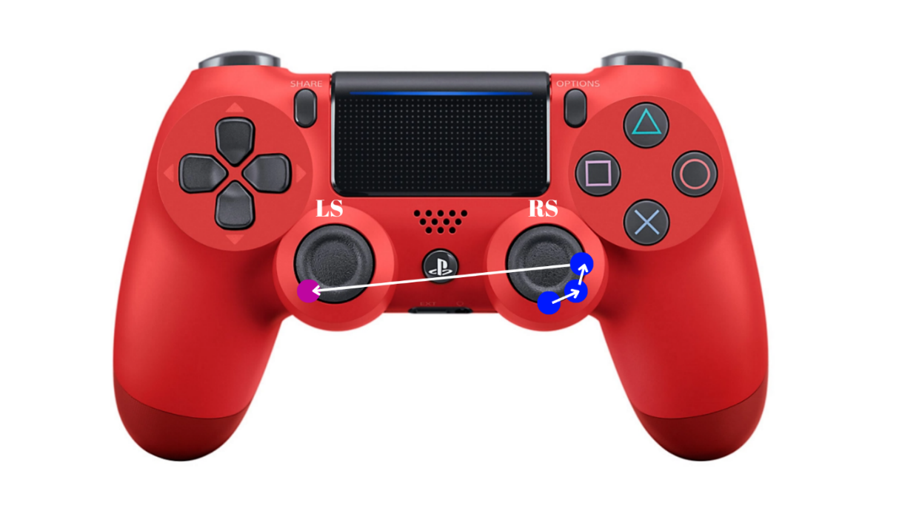

Figure 1. Directions of the button sequence corresponding to the Step Over move on the console controller.

To track the movements on the console, let us construct the adjacency matrix based on this graph:

 | RS↓ | RS↘ | RS→ | LS↙
RS↓ | 0 | 1 | 0 | 0
RS↘ | 0 | 0 | 1 | 0
RS→ | 0 | 0 | 0 | 1
LS↙ | 0 | 0 | 0 | 0

Based on the adjacency matrix and graph constructed for the Step Over move, the following conclusions can be drawn. This graph is a chain consisting of consecutive button transitions. Therefore, the total path length in the graph is 3, as there are 3 directed edges. The Step Over move does not form a cycle. Since it has a starting and ending point, the graph has a linear structure. This indicates that the move is executed once by the player. There is a one-way transition between two vertices in the graph. For example, there is no direct transition like [RS↓] → [RS→]. That is, the shortest path is the one that follows the given sequence. When we look at the adjacency matrix, we observe that [RS↓] has only one outgoing edge, and [LS↙] has only one incoming edge, while the intermediate buttons are involved in both incoming and outgoing transitions. These buttons are considered critical points in terms of “transition load” because the player both initiates and continues transitions through these buttons.

Let us apply Fitts’ law for this move:

MT = a + b · log₂(D/W)​.

Here, MT is the movement time (in milliseconds), D is the distance between the starting point and the target (in centimeters), W is the width of the target (in centimeters), and a and b are empirically derived constants. In this study, a = 100 ms and b = 150 ms/bit are used. These values are based on empirical studies conducted for hand-operated console controllers (joysticks or gamepads). Specifically, constants within this range were used in the following studies: [1] [2]. The reason for choosing these values is that in similar studies involving joystick- and thumbstick-based control systems, the a constant is taken between 50–200 ms, and the b constant between 100–300 ms/bit, which aligns with the context of our study. Each 90-degree movement of the RS and LS is taken as 0.7 cm, while 45-degree transitions are approximately 0.98 cm. The distance between RS and LS is 6.5 cm. Then MT will be calculated as follows:

Transition 1: [RS↓] → [RS↘]
D = 0.99
W = 1.4
MT₁ = 100 + 150 · log₂(1 + D/W) = 100 + 150 · log₂(1 + 0.99 / 1.4)
log₂(1.707) ≈ 0.77 → MT₁ ≈ 100 + 115.5 = 215.5 ms

Transition 2: [RS↘] → [RS→]
The calculation is the same → MT₂ ≈ 215.5 ms

Transition 3: [RS→] → [LS↙]
D = 6.5
W = 1.4
MT₃ = 100 + 150 · log₂(1 + D/W) = 100 + 150 · log₂(1 + 6.5 / 1.4)
log₂(5.64) ≈ 2.5 → MT₃ ≈ 100 + 375 = 475 ms

Total MT for Step Over:
MT_{total} = 215.5 + 215.5 + 475 = 906 ms

Based on Fitts' law, we calculated that the total MT = 906 ms, which is below 1 second and is a very good result. A professional player can perform this move in even less time than the given value, making the action more efficient.

2nd Move: Multiple Scissors

By observing the video, we can see that this move is performed in the following sequence: [RS→], [RS↘], [RS↓], [RS↘], [RS→], [RS↗], [RS↑]. Based on the given sequence, we will construct a graph for the Multiple Scissors move, then create the corresponding adjacency matrix, and finally apply Fitts' law to that graph. In the end, we can easily determine which of the three moves is more efficient.
The graph for the Multiple Scissors move will be as follows:

[RS→] → [RS↘] → [RS↓]

[RS↘]
[RS↑] [RS↗] [RS→]
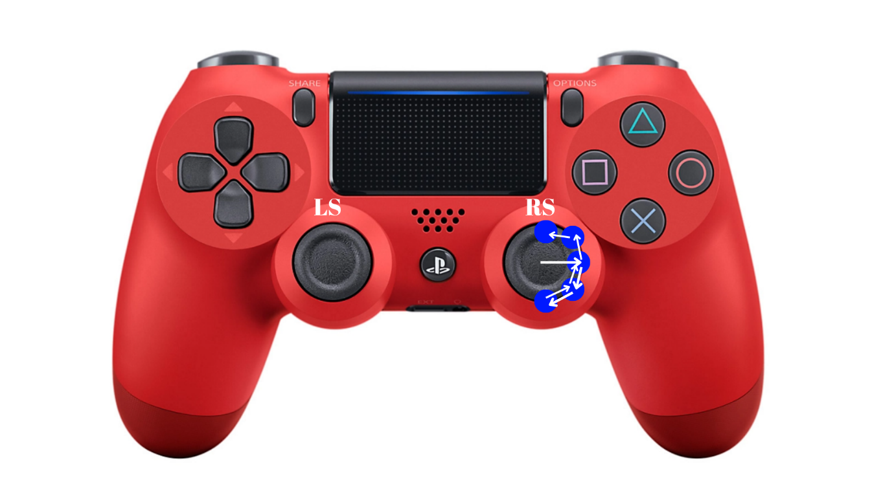
As seen from the graph, this move can be performed through 2 combinations. First, we will construct the adjacency matrix corresponding to these graphs, and then we will apply Fitts' law to both sequences to determine which of the two is more optimal.
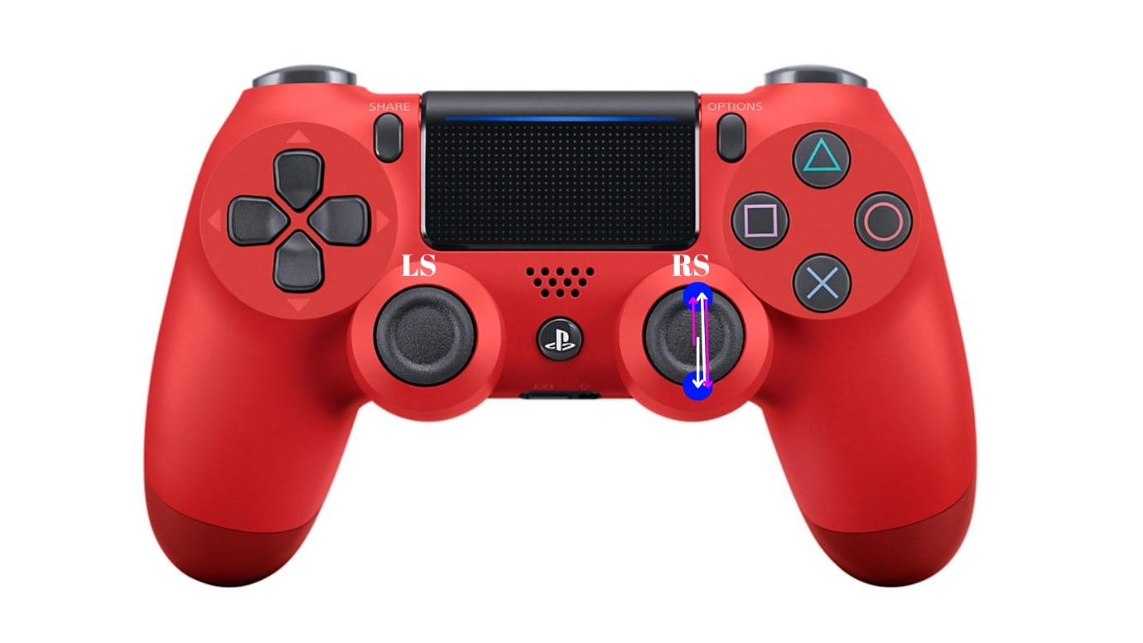
Figure 2. Directions of the button sequence corresponding to the Multiple Scissors move on the console controller. First combination

Figure 3. Directions of the button sequence corresponding to the Multiple Scissors move on the console controller. Second combination

The adjacency matrix is as follows:
 | RS→ | RS↘ | RS↓ | RS↑ | RS↗
RS→ | 0 | 1 | 0 | 0 | 1
RS↘ | 1 | 0 | 1 | 0 | 0
RS↓ | 0 | 1 | 0 | 1 | 0
RS↑ | 0 | 0 | 1 | 0 | 0
RS↗ | 0 | 0 | 0 | 1 | 0

Based on the adjacency matrix in the graph constructed for the Multiple Scissors move, the following results emerge. In the current graph, there are paths with 2 and 6 transitions. The longest path consists of 7 transitions, while the shortest consists of 2 transitions. From this perspective, since the move has both a starting and an ending point, the graph has a linear structure.
However, the transition [RS↓] ↔ [RS↑] seen in the graph technically forms a cycle. Since this transition does not represent a backward flow in the movement sequence, a cycle does not exist in practice. The reason it is represented with a double-headed arrow is that both [RS↓] → [RS↑] and [RS↑] → [RS↓] sequences perform the same action. This sequence is a move executed in one go by the player. As can be seen, since there are two possible combinations for this move, we will calculate which one is more optimal. As mentioned earlier, we will use Fitts’ law for this.

MT = a + b · log₂(D/W)​

Let us calculate the MT for the first combination using the formula:

Transition 1: [RS→] → [RS↘]
D = 0.99
W = 1.4
MT₁ = 100 + 150 · log₂(1 + D/W) = 100 + 150 · log₂(1 + 0.99 / 1.4)
log₂(1.707) ≈ 0.77 → MT₁ ≈ 100 + 115.5 = 215.5 ms

Transition 2: [RS↘] → [RS↓]
The calculation is the same → MT₂ ≈ 215.5 ms

Transition 3: [RS↓] → [RS↘]
The calculation is the same → MT₃ ≈ 215.5 ms

Transition 4: [RS↘] → [RS→]
The calculation is the same → MT₄ ≈ 215.5 ms

Transition 5: [RS→] → [RS↗]
The calculation is the same → MT₅ ≈ 215.5 ms

Transition 6: [RS↗] → [RS↑]
The calculation is the same → MT₆ ≈ 215.5 ms

Total MT for Multiple Scissors:
MT_{total,1} = 6 × 215.5 = 1293 ms

Now, let us apply Fitts' law to the second combination and compare the two combinations to determine the optimal one.

Transition 1: [RS↑] → [RS↓]
D = 1.4
W = 1.4
MT₂ = 100 + 150 · log₂(1 + D/W) = 100 + 150 · log₂(1 + 1.4 / 1.4)
MT_{2,3} =100 + 150= 250 ms
[RS↑] → [RS↓] və [RS↓] → [RS↑] For each of the transitions, MT = 250 ms

Note: The movements shown in Figure 3 are marked with two different colors, meaning that performing the move using the combination marked in pink is valid, as is using the one marked in white. Since both have the same MT value, only one will be taken into account. Now, let us compare the MT values of these two combinations. Since MT₁ = 1293 ms and MT₂,₃ = 250 ms, the result shows that the second combination is more optimal.

3rd Move: Elastico

As with the other moves, in the Elastico move, video observation shows that the combinations [RS↘], [LS↗] or [RS↓], [LS↗] are possible. As seen here, the same move can be executed using two different combinations. Following the same method, let us construct the graph and then apply Fitts' law to determine the optimal path.

The graph for the Elastico move will be as follows:

[LS↗] [RS↓]

[RS↘]

Graph analysis reveals that this move can be performed using two different combinations. After constructing the appropriate adjacency matrices for both sequences, Fitts' law will be applied, and as a result, it will be determined which combination is more efficient.
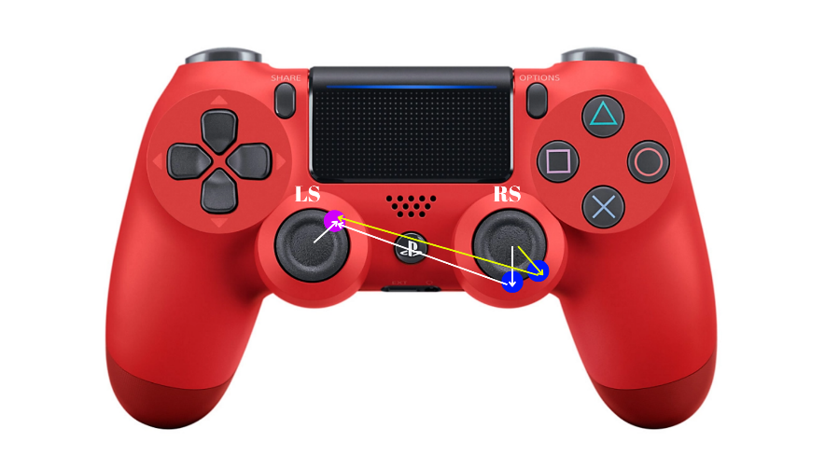

Figure 3. Directions of the button sequence corresponding to the Elastico move on the console controller.

To track the movements on the console, let us construct the adjacency matrix based on this graph:
 | RS↓ | RS↘ | LS↗
RS↓ | 0 | 0 | 1
RS↘ | 0 | 0 | 1
LS↗ | 0 | 0 | 0

Since there is no path in the graph that returns to the same vertex, it has no cycles. The vertex [LS↗] is considered the most loaded vertex because there are transitions to it from both starting points. Now, let us apply Fitts' law to determine which combination is more optimal.

MT = a + b · log₂(D/W)​

Let us calculate the MT for the first combination using the formula:

Transition 1: [RS↓] → [LS↗]
D = 6.5 cm
W = 0.7 cm
MT = 100 + 150 · log₂(1 + D/W) = 100 + 150 · log₂(1 + 6.5 / 0.7)
Log₂(10.29) ≈ 3.36 ⇒ MT ≈ 100 + 150 ⋅ 3.36 = 100 + 504 = 604 ms​

Since the transition distance and button size are the same for both combinations:

[RS↓] → [LS↗], MT = 604 ms

[RS↘] → [LS↗], MT is also = 604 ms

That is, from a technical standpoint, these two combinations are equally effective.

8. Conclusion

In this study, button-to-button transition behaviors of players on a console game controller were modeled within the framework of graph theory and Fitts' law. Three different technical moves featured in the game eFootball (Step Over, Multiple Scissors, and Elastico) were selected, and for each move, the button sequence was analyzed, appropriate graph models and adjacency matrices were constructed, and movement times were calculated based on Fitts’ law. As a result of the calculations, the efficiency level (MT — Movement Time) of each move was determined, and the more optimal combination was selected. For example, in the case of Multiple Scissors, it was found that one of the two combinations was more optimal than the other (MT₂ = 250 ms < MT₁ = 1293 ms). These analyses demonstrated that players’ transition behaviors are not random and can be systematically measured both structurally (via graph modeling) and in terms of motor responses (via Fitts’ law). Thus, this approach provides not only theoretical analysis but also practical implications for optimizing button layout in game design and enhancing user experience. It should also be noted that this study can be repeated with a wider range of game genres and various players to analyze how individual playstyles affect graph models. Comparative analyses between different console models (e.g., Xbox and PS) can be conducted to explore how design differences impact performance.

9. References

1. ISO 9241-9 Evaluation of Video Game Controllers
2. CHI2017_fitts_game_controllers.pdf
3. DUALSHOCK 4 wireless controller - PS4 Controller
4. Fitts's law - Wikipedia
5. What Is Fitts’ Law? | Figma
6. Dizaynda Fitts Qanunu. Fitts Qanunu | by Turab Yusifli | Medium
7. Degree | of a vertex | Britannica
8. West, D. B. (2001). Introduction to Graph Theory (2nd ed.). Prentice Hall.
Gross, J. L., Yellen, J., & Anderson, M. (2018). Graph Theory and Its Applications (3rd ed.). CRC Press.

