Taylor Series – An Approximation for the Lazy Physicist
Introduction
Anyone who has studied Mathematics for long enough will know the delight of dealing with polynomials, particularly when contrasted with other, more complex functions. For those less mathematically experienced, a polynomial is a function containing variables ($x, y, z$for example) and constants that, together, are added, subtracted, multiplied, or raised to a positive integer power. An example of a polynomial would be $3x^{2}-3x+4$. However, as many are likely aware, not all functions look like this – $\sin{x}$, $e^{x}$, or ${\left(1+x\right)}^{\frac{3}{2}}$ to name just a few. These are far more difficult to work with, so what if these pesky functions could be approximated by a much nicer polynomial, or even equated to one? This is the question Brook Taylor uncovered the answer to in 1715 with his creation of Taylor Series. But what are they? Where did they come from? What are their applications? And are they perfect? The intention of this essay is to answer all of these questions, beginning with the basics of differentiation, all the way to a general formula for a Taylor Series, highlighting the uses and limitations of the lazy physicist’s favourite approximation.
Differentiation
Let’s take things back to everyone’s first introduction to Calculus: differentiation. Differentiation is a fundamental operation in creating a Taylor Series so understanding what exactly it is and why it is useful is key. Additionally, this should help to emphasise the need for Taylor Series in the first place, as it should become clear that, generally, a polynomial is the easiest function to differentiate.
To begin, it’s necessary to define some notation:
$f(x)$ denotes some function of $x$ – e.g. $f\left(x\right)=4x^{3}+9∴\left(therefore\right) f\left(a+b\right)=4{\left(a+b\right)}^{3}+9$
$f'(x)$ denotes the derivative of $f(x)$. A derivative is the function given after differentiating the original function
$f^{''}(x)$ denotes the second derivative of $f(x)$, which is the derivative of the derivative of $f(x)$
$f^{n}'(x)$ denotes a derivative of $f(x)$ with order $n$ – e.g. the 6th derivative of $f\left(x\right)$ would be denoted as $f^{6}'(x)$
$\lim_{a→b}{ [f\left(x\right)]}$ denotes the action of finding the value of $f(x)$, after allowing some $a$ within $f(x)$ to tend towards $b$ – e.g. $\lim_{a→0}\left[2ax+4\right]=4$
The following notation will become useful later:
$\sum_{n=0}^{∞}{f(x)}$ denotes the infinite sum of a function as a variable, $n,$ increases in increments of $1$ (all usages are followed by an expanded format to help demonstrate this)
$x!$ denotes the product of $x$and all integers less than it down to $1$ – e.g. $3!=3*2*1=6$
$\left(\begin{matrix}x \\ y\end{matrix}\right)$ denotes a translation in the $x$-direction by “some $x$”, and in the $y$-direction by “some $y$”, so the point $(a,b)$ translated by this vector would be $\left(a+x, b+y\right)$
$\left|x\right|$although this notation can have many meanings, in the context of this essay, it denotes taking the positive value of $x$
So, now we have all the necessary notation, what is a derivative? Take $f\left(x\right)=7x-2$, the gradient of this function is clearly 7, or, in other words, the $\frac{change in y}{change in x}=7$. In actuality, it is also possible to say that the derivative of $f(x)$ or $f^{'}\left(x\right)=7$, since the derivative is simply the function that describes the gradient of another function. It just so happens that for our linear function, $f\left(x\right),$the derivative is a constant. This is obvious to see when looking at a graph of the function:
However, if we consider a new function, $f\left(x\right)=3x^{2}+8x-12$, this won’t have a constant gradient, so $f^{'}\left(x\right)≠constant$.
The linear nature of this function shows clearly that the rate of change, $\frac{change in y}{change in x}$, is constant, in this case, 7.

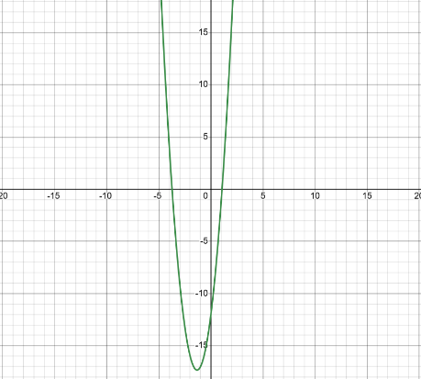
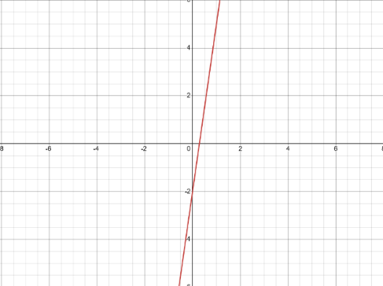

This is where differentiation becomes useful, as we are able to describe the gradient of a function using another function, which is given by differentiating the initial function. When a value for $x$ is substituted into $f'(x)$, the output will give the gradient of the function at that point on its graph. Effectively, the goal is to find the “instantaneous rate of change” or the gradient at a point. Once the derivative is found, the gradient of any point on that function’s graph can be found. So, how to differentiate to find this infamous derivative?
Consider the fact that we are trying to find this “instantaneous rate of change”. This could equally be described as finding the $\frac{change in y}{change in x}$ where that $change in x$ becomes infinitely small. Since these graphs are being used as a visualisation of a function, this can be seen to be $\frac{change in output}{change in input}$, such that the $change in input$ becomes infinitely small. Hence, we can derive the formula for differentiation from first principles:
$$f^{'}\left(x\right)=\lim_{h→0}\left[\frac{f\left(x+h\right)-f\left(x\right)}{\left(x+h\right)-x}\right], h=an infinitely small change in input$$
This simplifies to,
$$f^{'}\left(x\right)=\lim_{h→0}\left[\frac{f\left(x+h\right)-f\left(x\right)}{h}\right]$$
If we take, from the previous example, $f\left(x\right)=3x^{2}+8x-12$ and substitute it into our formula, we can find its derivative, and, hopefully, see that this same process could be applied to any function…
$$f^{'}\left(x\right)=\lim_{h→0}\left[\frac{f\left(x+h\right)-f\left(x\right)}{h}\right]$$
$$= \lim_{h→0}\left[\frac{3{\left(x+h\right)}^{2}+8\left(x+h\right)-12-\left(3x^{2}+8x-12\right)}{h}\right]$$
$$=\lim_{h→0}\left[\frac{3x^{2}+6hx+3h^{2}+8x+8h-12-3x^{2}-8x+12}{h}\right]$$
$$=\lim_{h→0}\left[6x+3h+8\right]$$
$$=6x+8$$
What may not be immediately clear, however, is that there is a much quicker way to differentiate a polynomial. This links very nicely as to the purpose of Taylor Series. By approximating a function as a polynomial, to differentiate it we can apply the Power Rule.
With the example, notice how it is possible to rewrite $f(x)$ as $3x^{2}+8x^{1}-12x^{0}$ and $f'(x)$ as $6x^{1}+8x^{0}$. Hopefully, the pattern that the Power Rule mandates is visible. Focussing on the first term, $3x^{2}$, multiplying the coefficient of $x (3)$ by the exponent $(2)$, we get $6$, which you will notice is the coefficient of the derivative of this term. Then, if we take the exponent $(2)$ and subtract $1$, we get $1$ – the exponent of the derivative. This pattern follows in the differentiation of any polynomial. With a bit of practice, it is easy to become very fast at differentiating almost any polynomial and is far quicker than using the first principles formula used earlier. This is a prime example of the utility of Taylor Series to simplify a problem and is also a very key component in forming one. Most generally, the Power Rule follows:
$${\left(ax^{n}\right)}^{'}=anx^{n-1}$$
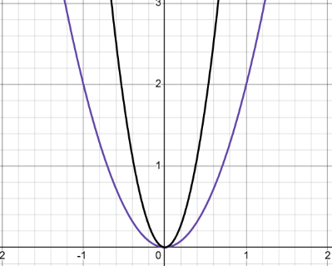
So far, we have found a function to describe the gradient at any point on a function’s graph, which can be said to be the rate of change at that point. This is what is known as the first derivative. Logically, if the aim of a Taylor Series is to approximate a function, surely it would be necessary for their first derivatives to be the same; their rate of change to be the same. But, again, going back to the example, looking at the graph, it’s plain to see that this rate of change isn’t constant, and this is reflected in the first derivative as it is variable. It would seem that the rate of change has a rate of change: the derivative has derivative (a second derivative maybe?). This second derivative can be used to describe the rate of change of the rate of change. Without any calculations, it should be fairly elementary to deduce which of the following functions has a greater second derivative.
The gradient of the black function is changing at a higher rate than that of the purple function, meaning it would have a greater second derivative. In fact, the second derivatives are $14$ and $4$ respectively.

The values of these derivatives are, evidently, impacting the shape of a function’s graph, and, therefore, the function itself. Consequently, it’s not unreasonable to further this logic to conclude that by taking more and more derivatives of a function, we could gather enough information to accurately approximate it. In summary, a Taylor Series approximation of a function must, fundamentally, have the same derivatives as the function it is approximating.
Accuracy
At the end of the previous section, it was stated that taking higher and higher order derivatives of a given function and creating a polynomial with those same derivatives, would create an accurate approximation of that function. So, how can we increase this accuracy? Simply, by making more and more of their derivatives equal. In fact, if infinitely many derivatives of a function are taken, and the polynomial we create has the same infinitely many derivatives, then all of their derivatives are equal. Essentially, this is a Taylor Series. It is an infinitely long polynomial that shares every single one of its derivatives with the function it is approximating.
Those with an eye for detail will have noticed a slight flaw still yet to be resolved. Take the following functions, $f\left(x\right)=\frac{1}{3}x^{4}+x^{3}-x^{2}-2x-5$, and $g\left(x\right)=\frac{1}{3}x^{4}+x^{3}-x^{2}-2x+1$. Calculating their respective derivatives, note that, for every order, they are equal. So, by our current logic, they are equal or are at least a close approximation of one another. But now, consider them graphically:
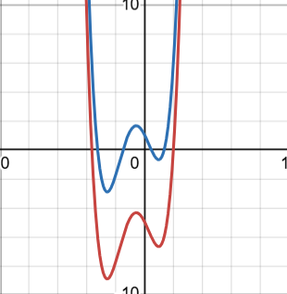
If it wasn’t clear from the functions themselves, despite having equal derivatives, the two functions are not the same. Although, interestingly, the graphs representing them take the same shape: they are just in the differing positions. By centring our approximation on a specific point on the graph – on a specific input of the function – then the graphs would take the same shape and have the same position. They would line up. We would find an accurate approximation of that function about that input.
Combining everything thus far, it can be said that an accurate approximation can be given by increasing the number of terms of our approximation polynomial – to infinity for a true Taylor Series – and centring the approximation about a specific input to determine its graph’s position. More bluntly, it seems it should be possible to, with an infinite series, equate any function to a polynomial.
Maclaurin Series
Now is where things may start to get a bit more complicated, but Maclaurin Series are a helpful stepping stone to fully understanding Taylor Series. For the sake of simplicity, Maclaurin Series centre their approximations about the input $x=0$, or the y-intercept of a function’s graph. As an example, let’s use $f\left(x\right)=\sin{x}$. For each step, we will compare our approximation to $\sin{x}$.
- Firstly, we need to centre our approximation to determine its graph’s position. For a Maclaurin Series we centre about $x=0$.
$f\left(0\right)=\sin{0=0}$
- Next, we want our first derivative to be equal at our centre of approximation.
$$f^{'}\left(0\right)=(\sin{0)'=cos⁡ 0=1}$$
- =Continue finding higher order derivatives, in the case of $\sin{x }$, a pattern emerges. What follows is evidence of this pattern using the differentiation from first principles formula derived earlier:
$${\left(\sin{x}\right)}^{''}={\left(\cos{x}\right)}^{'}=\lim_{h→0}\left[\frac{\cos\left(x+h\right)-\cos{x}}{h}\right]=\lim_{h→0}\left[\frac{\cos{x}\cos{h}-\sin{x}\sin{h}-\cos{x}}{h}\right]=\lim_{h→0}\left[\frac{\cos{x}\left(\cos\left(h\right)-1\right)-\sin{x}\sin{h}}{h}\right]=\cos{(h)}\lim_{h→0}\left[\frac{\cos\left(h\right)-1}{h}\right]-\sin\left(x\right)\lim_{h→0}\left[\frac{\sin{h}}{h}\right]=-\sin{x}$$
$$(\sin{x )'= \lim_{h→0}\left[\frac{\sin\left(x+h\right)-\sin{x}}{h}\right]}$$
$$= \lim_{h→0}\left[\frac{\sin{x}\cos{h}+\sin{h}\cos{x}-\sin{x}}{h}\right]$$
$$=\lim_{h→0}\left[\frac{\sin{x}\left(\cos\left(h\right)-1\right)+\sin{h}\cos{x}}{h}\right]$$
$$=\sin{(x)}\lim_{h→0}\left[\frac{\cos\left(h\right)-1}{h}\right]+\cos{(x)}\lim_{h→0}\left[\frac{\sin{h}}{h}\right]$$
$$=\cos{x}$$
$${{\left(\sin{x}\right)}^{4}}^{'}=(-\cos{x )'}=-{\left(\cos{x}\right)}^{'}=-\left(-\sin{x}\right)=\sin{x}$$
$${{\left(\sin{x}\right)}^{3}}^{'}={\left(-\sin{x}\right)}^{'}=-{\left(\sin{x}\right)}^{'}=-\cos{x }$$

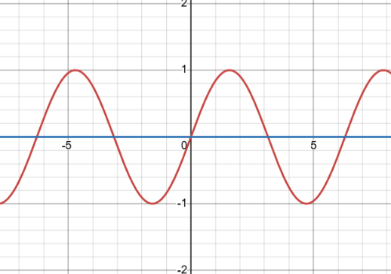
- Now, we have all the information to
construct an approximation polynomial. Let
this polynomial be
$f\left(x\right)=a+bx+cx^{2}+dx^{3}+ex^{4}+…$. Knowing
$f\left(0\right)=0$, our polynomial needs to have the same
output, $f\left(x\right)=0$, when $x=0.$Using our general polynomial,
all terms with an $x$ will go to $0$, when $x=0.$ Therefore,
for the whole polynomial to satisfy $f\left(0\right)=0, a=0$
and $f\left(x\right)=0+…$.
- Considering $f^{'}\left(0\right)=1$, the same should be true for
our approximation
$∴f^{'}\left(x\right)=b+2cx+3dx^{2}+4ex^{3}+…$using Power
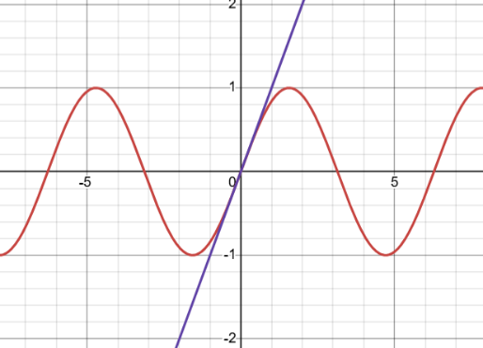
Rule. Since $x=0$, all terms but $b$go to $0$, and since
we want $f^{'}\left(x\right)=1, b=1$ and $f\left(x\right)=0+x+….$
- Next, $f^{''}\left(0\right)= -\sin\left(0\right)=0$. Applying to the
approximation, we see $f^{''}\left(x\right)=2c+6dx+12ex^{2}+….$
As before, everything becomes $0$ except $2c=0, c=0$.
Hence, there is no $x^{2}$ term to the approximation, just
as there is no constant from $a=0$, which is the same
as $ax^{0}=0$. It appears that a pattern is emerging for
even powers of $x$, in fact, this should not be that
surprising. From the loop of derivatives constructed
earlier, a more general formula can be created:
$${{\left(\sin{x}\right)}^{n}}^{'}=±\sin{x}, n is a positive even integer (n∈2Z^{+})$$
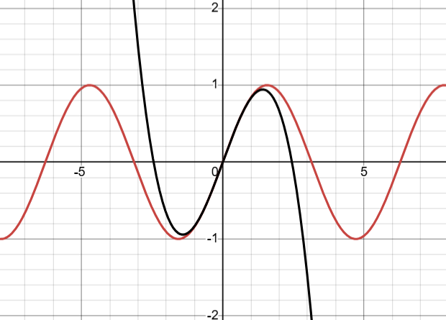
When $x=0$, as it does for our approximation, this will always be $0$, so no even powers of $x$ are needed for an approximation of $\sin{x}$.
- Finally, considering ${f^{3}}^{'}\left(0\right)=-\cos{0}=-1$.
- Now, the polynomial gives ${f^{3}}^{'}\left(x\right)=6d+24ex+…$
and, when $x=0, 6d=-1 ∴d=-\frac{1}{6} .$
By now, it should be plain to see that this polynomial,
$f\left(x\right)=x-\frac{1}{6}x^{3}$, gives a pretty good approximation of $\sin{x}$
for small $x$. What we have created is a third-degree Maclaurin
Polynomial of $\sin{x}$, and, as mentioned earlier, if we continued
to add more and more terms, a more and more accurate
approximation would be formed. Repeating this process
infinitely, we would form an exact approximation of $\sin{x}$ as a
polynomial: a Maclaurin Series.
Interestingly, another pattern is beginning to emerge from the use of Power Rule. Every time the approximation is differentiated, the exponent of $x$ multiplies the coefficient, and, subsequently, is decreased by $1$. When this process repeats, the coefficient is multiplied by some integer, then the number $1$less than that integer, then the number $1$ less than that and so on… Expressed as algebra, with some coefficient $a,$ we get $an\left(n-1\right)\left(n-2\right)…=an!$. Throughout the process of creating a Maclaurin Polynomial, we have constantly been equating the coefficient of the $n^{th}$ power of $x$, after it has been differentiated to a constant, therefore multiplied by $n!$, to the $n^{th}$ order derivative of $f\left(x\right)$
$$∴{f^{n}}^{'}\left(x\right)=an!, a is some coefficient of x$$
$$∴a=\frac{{f^{n}}^{'}\left(x\right)}{n!} .$$
As a result, now, an infinite Maclaurin Series can be formed for $\sin{x}$, noting that, from our differentiation loop:
$${f^{n}}^{'}\left(0\right)=±\cos{0 }= ±1, n is a positive odd integer \left(n∈\left\{2m-1 :m∈Z\right\}\right)$$
$$∴ \sin{x }= \sum_{n=0}^{∞}{\frac{{\left(-1\right)}^{n}}{\left(2n+1\right)!}x^{2n+1}}=x-\frac{x^{3}}{3!}+\frac{x^{5}}{5!}+…$$
In conclusion, we can now state a general formula to create any Maclaurin series:
$$f\left(x\right)=\sum_{n=0}^{∞}{\frac{{f^{n}}^{'}\left(0\right)}{n!}x^{n}}=f\left(0\right)+f^{'}\left(0\right)x+\frac{f^{''}\left(0\right)}{2}x^{2}+\frac{{f^{3}}^{'}\left(0\right)}{3!}x^{3}+…$$
Uses of Maclaurin Series
But why are such Maclaurin Series useful? These approximations are actually what calculators use to give quick and accurate outputs to many entries. Furthermore, as seen with the prominence of Power Rule, differentiating a polynomial is far simpler than most other functions, such as when compared to trigonometric functions, for instance. Often, especially in physics, the exact output of a trigonometric or other irritatingly difficult function is not needed so a close enough approximation can be given when the input is close to $0$ by using the first few terms of that function’s Maclaurin Polynomial, for trigonometric functions, these are commonly known as the Small Angle Approximations:
$$\sin{x}≈x$$
$$\cos{x}≈1-\frac{x^{2}}{2}$$
$$\tan{x}≈x$$

Equally, the Maclaurin Series for $e^{x}$ can be very useful, and a clear link can be made between this and the limit definition of $e.$ The standard limit definition follows, when rearranged with the use of the Binomial Theorem
$\left[{\left(1+x\right)}^{n}=1+nx+\frac{n\left(n-1\right)}{2}x^{2}+\frac{n\left(n-1\right)\left(n-2\right)}{3!}x^{3}+…\right]$ ,
that:
$$e=\lim_{n→∞}\left[{\left(1+\frac{1}{n}\right)}^{n}\right]=\lim_{n→∞}\left[1+n\left(\frac{1}{n}\right)+\frac{n\left(n-1\right)}{2}{\left(\frac{1}{n}\right)}^{2}+\frac{n\left(n-1\right)\left(n-2\right)}{3!}{\left(\frac{1}{n}\right)}^{3}+…\right]=\lim_{n→∞}\left[1+1+\frac{n-1}{2n}+\frac{\left(n-1\right)\left(n-2\right)}{3!n^{2}}+…\right] =1+1+\frac{1}{2}+\frac{1}{3!}+…=\sum_{n=0}^{∞}{\frac{1}{n!}}$$
which is the Maclaurin Series for $e^{1}$, since the general Maclaurin Series of $f\left(x\right)=e^{x}$ is
$$e^{x}=\sum_{n=0}^{∞}{\frac{x^{n}}{n!}}=1+x+\frac{x^{2}}{2}+\frac{x^{3}}{3!}+…$$
demonstrating a clear connection between the limit definition and the Maclaurin Series.
Another common use of Maclaurin Series is in Binomial Expansion. In fact, the Binomial Theorem used earlier is itself a Maclaurin Series. Whilst expanding expressions such as ${\left(1+x\right)}^{3}$ into a polynomial is quite easy, by using Pascal’s Triangle for example, expressions like ${\left(1+7x\right)}^{-\frac{1}{4}}$ are considerably more challenging. However, the Binomial Theorem – based on the general binomial ${\left(1+x\right)}^{n}$– does have limitations, the reasons for which will be discussed in a later section. To put simply, the domain of the Binomial Theorem (the validity of it) is restricted to $\left|x\right|<1$. Consequently, an issue arises if we wanted to approximate a binomial at the input $x=3,$ for example. This is what separates Maclaurin and Taylor Series. By shifting the centre of the approximation onto another input, we are able to circumvent this validity issue and approximate the function at any input. However, fundamentally, every term other than that which we are equating to a derivative, must cancel to $0$, only achievable by having the input acting as our “centre of approximation” be equal to $0.$ The way of achieving this is via Taylor Series.
Graph Transformations
This section gives a brief overview of the simplest graph transformation: the translation. By shifting the centre of approximation to a value other than $x=0$, we are changing the input value of our function at this centre. Visually, this can be seen to be the same as interpreting the $y$ – co-ordinate of the function’s graph at an input $x, x≠0$. To make this value still act as $0$, the base of each power in the approximation polynomial must be $x-α, α is the desired centre of approximation.$ Hopefully it should now be clear that, when $x=α$, all terms of the approximation polynomial, $f\left(x\right)=a+b\left(x-α\right)+c{\left(x-α\right)}^{2}+d{\left(x-α\right)}^{3},$ will go to $0$, except for $a$, which should be the output at the centre of approximation following on from the steps taken in creating a Maclaurin Series. Graphically, this is the same as a graph transformation, specifically a translation by $\left(\begin{matrix}α \\ 0\end{matrix}\right)$. But the key takeaway from this is that, for our Taylor Series to operate as necessitated, the base of all powers of $x$ must be equal to $0$ at the centre of approximation.
Tayor Series
Now, putting everything together we can derive a general formula for Taylor Series, by combining the general formula for Maclaurin Series and a general translation by $\left(\begin{matrix}α \\ 0\end{matrix}\right)$. We want the derivative information for the input $α$, but translated so that this input acts like $0$ to cancel the other terms. All together this comes to:
$$f\left(x\right)=\sum_{n=0}^{∞}{\frac{{f^{n}}^{'}\left(α\right)}{n!}{\left(x-α\right)}^{n}}=f\left(α\right)+f^{'}\left(α\right)\left(x-α\right)+\frac{f^{''}\left(α\right)}{2}{\left(x-α\right)}^{2}+\frac{{f^{3}}^{'}\left(α\right)}{3!}{\left(x-α\right)}^{3}+…$$
To reaffirm facts previously stated, if we centre about the input $0 ∴ α=0$ we get the general Maclaurin Series formula, since a Maclaurin Series is just a special case of Taylor Series centred on the input $x=0.$Secondly, using a third-degree Maclaurin Polynomial to approximate $\sin{6}$, we find:
$\sin{6}≈6-\frac{6^{3}}{3!}=-30$ but $\sin{6}=-0.279…$ so, clearly, this approximation isn’t very accurate.
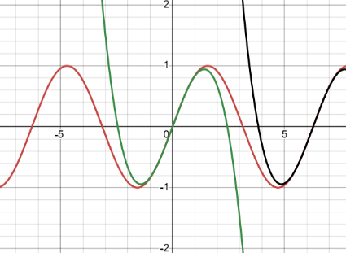
Of course, we could add infinitely many terms to increase the accuracy of the approximation, but, consider a third-degree Taylor Polynomial of the same function, centred about $2π$. Although both polynomials have the same degree, our desired approximation is closer to the centre, so the approximated output will be closer to the true value. Comparing this graphically we see the following:

And in output, $\sin{6}≈\cos\left(2π\right)\left(6-2π\right)-\frac{\cos\left(2π\right)}{3!}{\left(6-2π\right)}^{3}=-0.279…$ the Taylor Polynomial gives a much more accurate approximation for the same number of terms. An important fact to note is that, for Taylor Series with validity $x∈R$, no matter the centre of approximation – so long as it is Real – as we take the infinite series of terms for the approximation, these will be equal, because both are equal to the approximated function. Now, we return to the earlier problem with the validity of Taylor Series that are more restricted, such as that of the Binomial Theorem. As we move the centre of approximation, we are able to create accurate approximations within a range around that centre, which seems quite an incomplete resolution, but why can it not approximate for the entire function, and therefore, allow the infinite series to equal?
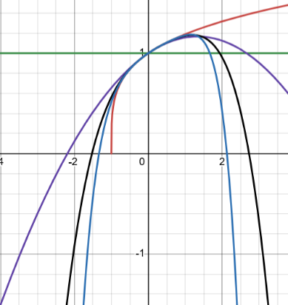
Validity and Divergence
Firstly, let’s compare the graph of $f\left(x\right)={\left(1+x\right)}^{\frac{1}{4}}$ to increasing degrees of Maclaurin Polynomials. Notably, as we move farther from the centre of approximation, the approximation gets far less accurate. Particularly, outside the range of $\left|x\right|<1$, the approximation shoots off to $±∞$ very quickly: the approximation diverges. But why?

Degree: Constant, Second, Fourth, Sixth
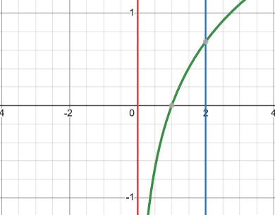
As with Maclaurin Series creation, the best way to explain this is with an example, so let’s use $f\left(x\right)=\ln{x}$ with our Taylor Series centred at $x=1.$The Taylor Series for this is:
$$\ln{x}=\sum_{n=0}^{∞}{\frac{{f^{n}}^{'}\left(1\right)}{n!}}{\left(x-1\right)}^{n}=\left(x-1\right)-\frac{{\left(x-1\right)}^{2}}{2}+\frac{{\left(x-1\right)}^{3}}{3}-\frac{{\left(x-1\right)}^{4}}{4}+…$$
and the validity is $0<x≤2$.
To check this, we pick an input comfortably within the validity, $x=\frac{1}{2}$, and plugging this into the Taylor Series and the original function, clearly both $=-0.693…$ Next, inputting the upper bound, $x=2,$both $=0.693…$ But, relatively marginally outside the validity, $x=5$, $\ln{5}=1.609…$, but the Taylor Series outputs values fluctuating between tendencies to $±∞$ as more and more terms are added.
Fully generalising a method to find validities for Taylor Series is beyond the scope of this essay, however, this example should, ideally, demonstrate, in simple terms, why such validities are needed. What is found when calculating validities is that, from our centre of approximation, the series remains valid for some distances in both the positive and negative directions which are equal in magnitude. This can be termed as the Radius of Validity and describes the bounds within which the series is valid from the centre of approximation. For $f\left(x\right)=\ln{x}$, the Radius of Validity is $1$. But then why is $0$ not inclusive in our validity. This is because $f(x)$ in itself has set domain of $x<0$ in order that $f(x)∈R$. Put simply, for $\ln{x}$ to have a real output, $x<0$. Both restrictions for $x$ must be present, which, in this case, manifests itself in the validity $0<x≤2$. Generally, to set the validity of a Taylor Series, it is necessary to first consider the inputs for which the series converges, in order to give an appropriate approximation and find the Radius of Validity, then apply the domain of the function that which you are approximating. It is important to note that some Taylor Series, such as that of $e^{x}$ are valid for all $x∈R$, since the series always converges and there is no restriction to the domain.
Conclusion
To summarise, from the very fundamentals of Calculus to the transformations of graphs, and the constraints of one of the most useful tools in Mathematics, this essay was intended to provide a natural progression from core concepts taught in fairly rudimentary maths lessons, to the considerably more complex, and vast world of Taylor Series. Although much more in-depth interrogation of this essential tool could be done, hopefully a relatively concise, but logical explanation has been achieved in these few thousand words, with the aid of some visuals, on the fascinating topic of Taylor Series – An Approximation for the Lazy Physicist.
Acknowledgements
I would like to thank Mr Aiden Chamberlain for teaching Maclaurin Series and Calculus as my A-Level Further Mathematics Pure teacher and Mr Sam Blatherwick, Head of Mathematics, for hosting extra maths sessions every Monday, where I was able to ask any questions I had, and who helped me to narrow down ideas for essay subject. Additionally, I wish to acknowledge the incredible work of 3Blue1Brown on YouTube, who is an incredible source for learning maths outside of the A-Level curriculum, and who was essential in my expansion of knowledge from Maclaurin to Taylor Series. Finally, a massive thank you to my amazing partner, Harmony, for proof-reading and helping with the final editing: without her, most of this would likely be unintelligible.
Desmos link:
https://www.desmos.com/calculator/sz1otbpc2i

