The Foolproof Guide to Making a Mathematically Perfect Map

Introduction

Imagine, at this moment, it has been declared that a new habitable planet has been discovered! There are no known residents. The planet is covered in a vast area of land with the only sources of water being these strange large lakes of water, all congruent in size and shape, and distributed randomly among the land. You are designated as the official mapmaker for this new planet. Hooray! You are now in charge of deciding the placement of the capital cities and the borders of these countries (let’s ignore any actual geopolitics for now). Furthermore, you need to decide the number of colours you will use to colour the countries so that no two countries that share a border also share the same colour. Finally, you need to take into account how you are going to transpose this new planet from 3D to 2D. So, how do you do this? How do you create the most mathematically perfect map according to these conditions? This essay will guide you through the essential mathematical tools needed to solve each of these problems.

Cities, Borders and Voronoi diagrams

Firstly, how do we allocate capital cities in such a vast area of land? One could simply allocate them randomly; however, this would be an inefficient allocation of resources as one city may be extremely close to a lake whereas another may be miles away from its closest lake. Another alternative would be to distribute the capital cities at equal distances from one another. However, this would cause the same problem of inequal opportunities to a water source as the lakes are randomly distributed. The best solution would be to allocate a capital city for each lake, in the same distribution as how the lakes themselves are distributed.
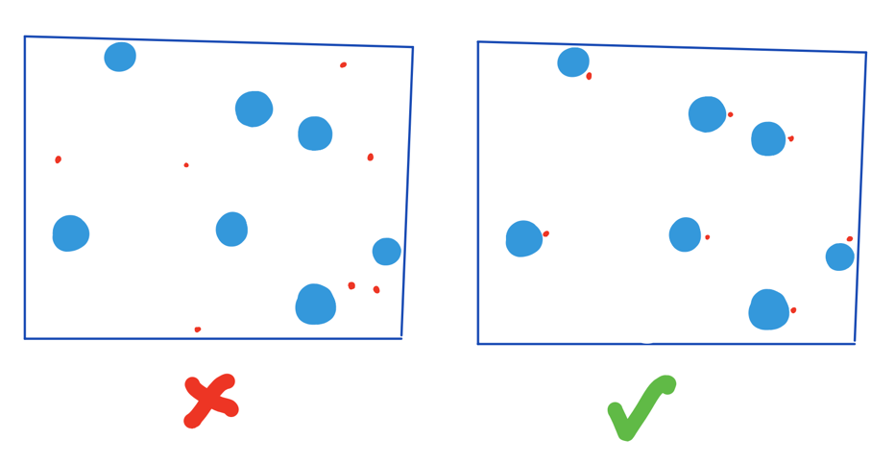
So, with these lakes being our signposts for capital cities, we can assume that these cities are ‘randomly distributed’. How do we create borders around these cities to make sure that every point inside a country is closer to their own capital city than another’s? To do this, we can illustrate our borders through Voronoi diagrams. Voronoi diagrams are a type of fractal found in plant cells, bubbles, crystallisation etc. consisting of polygonal structures. It partitions a space into subsections based on a set of seed points, where each point in a ‘cell’ is closer to its cell’s seed point than any other seed point. The boundary of each cell is a perpendicular bisector of the seed points of each side of the boundary. If you pick any point on the boundary partitioning two cells, it will be equidistant from both seed points.
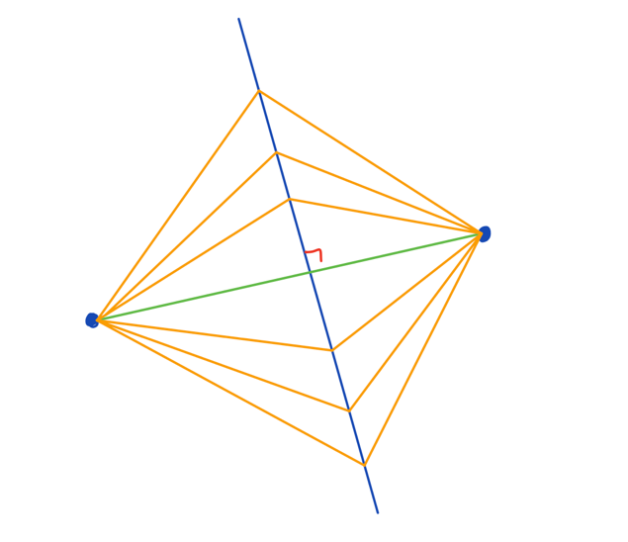
We can use this concept to create our mathematically perfect map. In our case, the seed points are the capital cities, the cells are the countries, and the boundaries are the borders of the countries. If we draw the borders of our map according to the boundaries of a Voronoi diagram, all the points inside of the country will be the closest to said country’s capital city or at most equidistant to the nearest other capital city.
This also means that we can construct a Delauney triangulation based on the seed points (the capital cities). A Delauney triangulation is a straight line dual of the Voronoi diagram, meaning that, each vertex on a Delauney triangulation graph corresponds to a seed point on a Voronoi diagram. This triangulation aims to ‘maximise the minimum angle in each triangle’, ensuring that if you circumscribed a circle around any triangle on the graph, it would not touch any points other than the ones on the boundary.
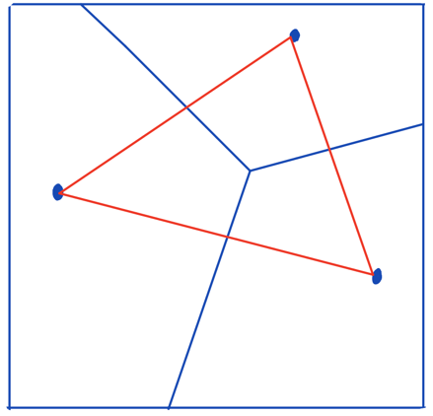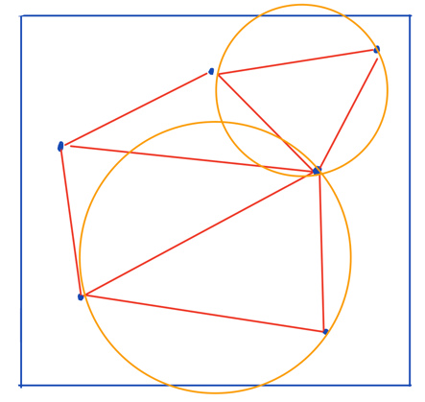
So, what does this mean for our ‘mathematically perfect’ map? Well, if we were to suddenly need to construct a new city (due to advancements in tech or something or the other), we would need to find the point on the map at which there is the least number of surrounding cities. How would we achieve this? It would be too difficult and time-consuming to calculate each of the surrounding areas. Instead, we can construct a Delauney triangulation around our borders (a Voronoi diagram) and circumscribe a circle around each of the triangles. Then, you would find the circle which is largest in area and place your new city at the centre of that circle. This would ensure that you have maximised the area of your planet and efficiently allocated this new city.

The Four Colour Dilemma

Now that you have a map with borders around each of the different countries, you can begin colouring the map. You have two conditions to fulfil. Number 1: no two countries that share a border should be the same colour. Number 2: you must use the least number of colours as possible. Luckily for us, this is a mathematical conjecture that has already been solved. The Four Colour Theorem is the conjecture that every map can be coloured with four colours without any colours touching one another. Initially proposed by mathematician Francis Guthrie, the seemingly simple problem had kept the math community in turmoil for centuries. People tried to solve it geometrically, algebraically etc… however, it ended up causing more problems and uncovered more difficulties along the way. The first conjecture that they encountered followed the line of reasoning that ‘every map has at least one country with five or fewer neighbours’. In 1879, Kempe and Tait gave proofs that were accepted for over a decade, however, were soon proven false. Kempe’s method of a ‘Kempe chain’ was proved false by Percy Heawood. The Heawood conjecture itself showed that for map colouring in a genus 0 space, four colours are enough. Interestingly, in his proof, using his study of knots, Tait suggested the ‘Hamiltonian graph conjecture’ which focused on the edges of a graph and proposed that a Hamiltonian cycle could prove the four colour conjecture. It was only until 1946 that this theory was disproven by William Tutte. By the 1900s, the concept of a dual graph came into play and was essential for reducing the complexity of the problem. With advancements in technology, this conjecture was the first to have a computer-assisted solution, confirming that 4 colours are the minimum number of colours needed to colour a map without touching colours.

Orange Peels and Distortion

There are many different ways of projecting a 2D map to 3D, however, at this point in time, there is not a valid method that perfectly transforms each point in a Euclidian plane to a non-Euclidian plane without some form of distortion. This is due to the Gaussian curvature of a spherical planet. This is made up of multiplying together how a surface curves in one direction and how it curves in its perpendicular direction. The usual map projections like Mercator, Goode Homolosine and equirectangular all have some form of distortion in order for it to be readable and usable for navigation. However, we are not looking for the most geographically perfect map in this essay- we are looking for the most mathematically perfect map. One of the methods we can use to minimise distortion on our map can be illustrated through an orange peel. In the paper ‘Orange Peels and Fresnel Integrals’, it discusses how if you cut an orange peel in a spiral like pattern and then lay it on a flat surface, you get this S-like shape which tends towards a Euler spiral, where the curvature changes linearly as you move along it. As the number of spirals increases, the amount of distortion in the projection decreases. Even more specifically, as the number of spirals tend toward infinity, the amount of distortion tends towards 0. So, we would use a Euler spiral projection if we wanted to minimise distortion in our map.
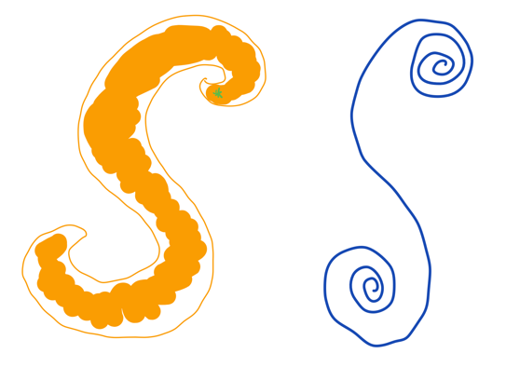

Conclusion

Although not a geographically perfect map by any mean, we have now created a mathematically perfect map (according to my specific conditions of course). I hope that my essay has encouraged you to delve deeper into the mathematics of map-making and these fun concepts of thought. Happy map-making!

Bibliography:
https://www.youtube.com/watch?v=D3tdW9l1690
https://googlemapsmania.blogspot.com/2018/12/the-euler-spiral-map-projection.html
https://mathworld.wolfram.com/Four-ColorTheorem.html
https://nrich.maths.org/articles/four-colour-theorem
https://www.savemyexams.com/dp/maths/ib/ai/21/sl/revision-notes/geometry-and-trigonometry/voronoi-diagrams/voronoi-diagrams/
https://www.sciencedirect.com/topics/physics-and-astronomy/voronoi-diagram#:~:text=A%20Voronoi%20diagram%20is%20defined,to%20any%20other%20seed%20point.
https://www.youtube.com/watch?v=b_uvofsYl9s&t=1s
https://en.wikipedia.org/wiki/Voronoi_diagram
https://www.youtube.com/watch?v=GafRRl5XRPM
https://ianthehenry.com/posts/delaunay/

