The Mathematics of Decision Making

Exploring Optimal Stopping and the Secretary Problem
Akash Dharmavaram

Table of Contents
Abstract 1
1 Introduction 2
2 The Secretary Problem 2
2.1 The Setup 2
2.2 Solving the Problem 3
3 Applications of the Problem 8
4 Conclusion 12
References 13

Abstract
This essay provides a brief insight into one key topic in optimal stopping theory: the secretary problem. From selecting the perfect restaurant to dine at, choosing the perfect job applicant, or even finding love, mathematics provides an answer.

1 Introduction
The Secretary Problem is a classic dilemma in decision mathematics about how to maximise the chance of hiring the single best applicant, given a pool where we only have one chance to hire each applicant, or they are gone forever.
This problem is the first instance of an optimal stopping problem and paved the way for a whole sub-field of mathematics. These optimal stopping principles are widely used in the context of statistics and finance, including in real estate, the stock market and even in gambling.
Despite these different scenarios, the main principle remains the same: optimal stopping is about choosing a time to take a particular action, to maximise expected gains while minimising expected costs.
In this essay, I will explore the secretary problem, its mathematical derivation, and analyse how its principles can be applied both mathematically and intuitively elsewhere.

2 The Secretary Problem

2.1 The Setup
In its simplest form, the secretary problem has the following setup:
- There is one position available for secretary.
- A known number of N candidates are applying.
- It is possible to rank all candidates from best to worst on some ordinal scale (i.e. you know the ranks of other candidates compared to each other).
- The candidates are being interviewed sequentially, in a random order.
- For each candidate, you must decide whether to accept or reject them. If you reject them, they are gone forever.
The goal here is to try and maximise our chances of selecting the best candidate.
What makes this problem hard is the fact that as you interview each candidate, you do not know how good the next candidates will be.
- If you select too early, there is a good chance you probably will never see the best options.

- While if you select too late, you have probably rejected the best option already.

From this, we would want to start making a final decision at around the middle of the sequence. That way, we know enough information of the previous candidates to make a more informed decision, and we still have a pool of further candidates to choose from acting as leverage.
The optimal strategy involves these steps:
- Explore a set number of candidates m and reject automatically to gather information about the quality of the candidates you are dealing with relative to each other.
- After observing m candidates, stop rejecting and accept the first candidate you come across who is better than all the previous ones.
We must find this optimal stopping position m that would maximise our chances of picking the best candidate in the pool.

2.2 Solving the Problem
Let there be N applicants and our stopping position be at the m^{th} applicant. This means that after the m^{th} applicant, we stop rejecting and start searching for the best candidate we have seen so far.
$1 2 3 4 5 6 … m m+1 m+2 m+3 … N$
The probability that any one of the candidates is:
$\frac{1}{N}$
As all candidates are chosen randomly and have an equal chance of being the best.
However, we also must consider the probability of reaching the best candidate, given the stopping point. For example, if the best spot is in position m + 3 (after the stopping point m), but the best we see so far is in position m + 2, we will just select the candidate at position m + 2 because they exceed the rank of all previous candidates we have seen so far.
Candidates 1 to m are rejected so we can focus on the remaining candidates after m:
$m+1 m+2 m+3 m+4 … N-2 N-1 N$
The probability that we get to the m + 1th candidate is 1 as this is directly after the stopping point.
The probability that we get to the m + 2th candidate is:
$1-\frac{1}{m+1}=\frac{m}{m+1}$
This is because the best candidate can be in any of the first m + 1 positions with equal probability which is 1/(m+1). So, the chance it is not in that position is 1 – (1/(m+1)).
Using similar logic, the probability that we get to the m + 3th candidate is:
$\frac{m}{m+2}$
This continues up until the N^{th} candidate. But if we reach the N^{th} candidate, it means the actual best candidate (for up to N-1th) was among the first m rejected candidates (in the observed sample). The chance of this happening is the same as the probability of getting to the N^{th} candidate which is:
$\frac{m}{N-1}$
Forming a table of results:
[note: any candidate before m + 1 is irrelevant as we are rejecting them anyway.]
$Candidate$ | $m+1$ | $m+2$ | $m+3$ | … | $N-1$ | $N$
$P(Candidate is the best)$ | $\frac{1}{N}$ | $\frac{1}{N}$ | $\frac{1}{N}$ | … | $\frac{1}{N}$ | $\frac{1}{N}$
$P(We get to candidate)$ | $1$ | $\frac{m}{m+1}$ | $\frac{m}{m+2}$ | … | $\frac{m}{N-2}$ | $\frac{m}{N-1}$
$P\left(Candidate is best AND We get to candidate\right)$ | $\frac{1}{N}$ | $\frac{1}{N}×\frac{m}{m+1}$ | $\frac{1}{N}×\frac{m}{m+2}$ | … | $\frac{1}{N}×\frac{m}{N-2}$ | $\frac{1}{N}×\frac{m}{N-1}$

Since the two events ($P\left(candidate is best\right), P\left(We get to this candidate\right))$ are independent, for any candidate position:
$P\left(Candidate is best AND We get to candidate k\right) =P\left(Candidate is best\right)× P(We get to candidate)$
This means that the total probability of getting the best candidate is:
$P\left(We get to the best candidate\right)= \sum{}[P\left(Candidate k is best\right)× P(We get to candidate k)]$
$where m<k ≤ N$
This results in:
$P\left(We get to best candidate\right)=\frac{1}{N}×\left(1+\frac{m}{m+1}+\frac{m}{m+2}+\frac{m}{m+3}+…+\frac{m}{N-1}\right)$
$P\left(We get to best candidate\right)=\frac{m}{N}×\left(\frac{1}{m}+\frac{1}{m+1}+\frac{1}{m+2}+\frac{1}{m+3}+…+\frac{1}{N-1}\right)$
The sum inside the bracket can be represented as:
$\sum_{m}^{N-1}{}\frac{1}{r}$
This summation formula can be approximated as the area under the function of $y=\frac{1}{x}$ between m and N-1 as shown below:
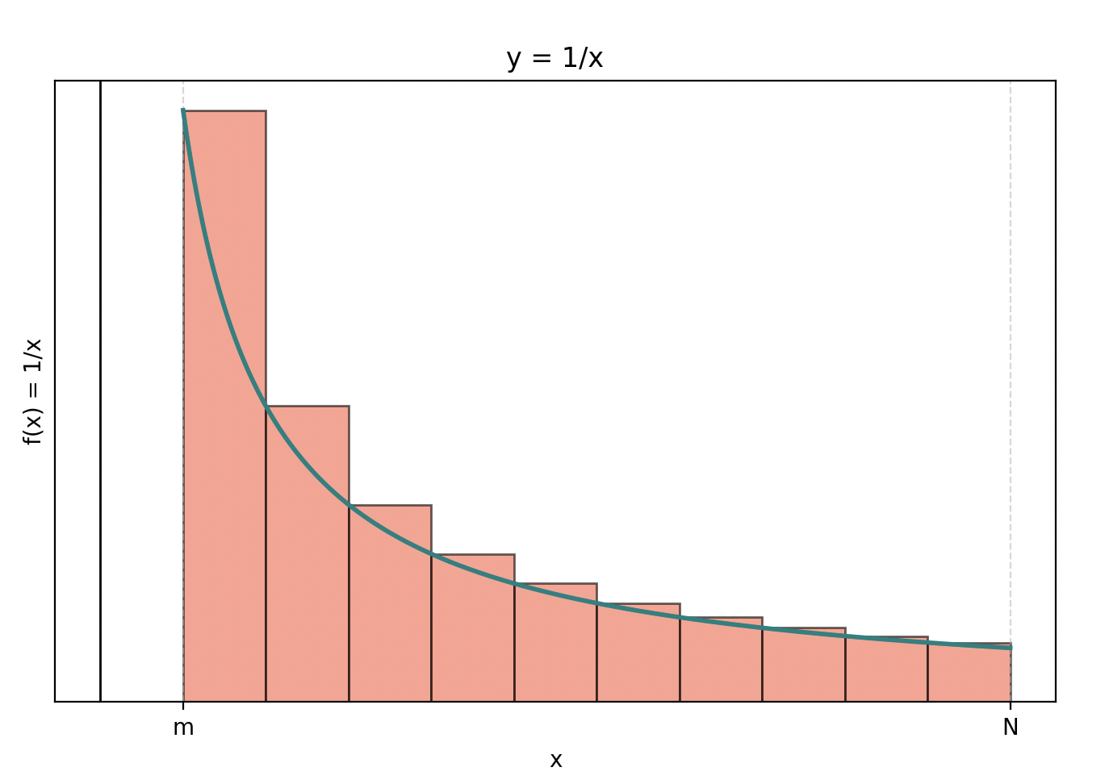
This is the same as integral (Area under the graph) of $\frac{1}{x}$ between m and N:
$\int_{m}^{N}{}\frac{1}{x} dx={\left[ln\left(x\right) \right]}_{m}^{N}$
$=ln\left(N\right) -ln\left(m\right)$
$=ln\left(\frac{N}{m}\right)$
Putting things together this gives us:
$P\left(We get to best candidate\right)=\frac{m}{N}ln\left(\frac{N}{m}\right)$
This leaves us with a function where we can maximise m (as N in this case is a constant) by differentiating and setting equal to zero.
Using the product rule:
$\frac{d}{dm}\left(\frac{m}{N}ln\left(\frac{N}{m}\right) \right)=\frac{1}{n}ln\left(\frac{N}{m}\right) +\frac{m}{n}\left(-\frac{1}{n}\right)$
$=\frac{1}{n}(ln\left(\frac{N}{m}\right)) -\frac{1}{n}$
Now setting equal to zero:
$\frac{1}{n}(ln\left(\frac{N}{m}\right)) -\frac{1}{n}=0$
$\frac{1}{n}(ln\left(\frac{N}{m}\right)) =\frac{1}{n}$
$ln\left(\frac{N}{m}\right) =1$
Therefore:
$\frac{N}{m}=e$
Meaning that:
$m=Ne^{-1}$
- $m≈0.368N$
Substituting back into the original equation:
$P_{max}\left(We get the best candidate\right)=\frac{\left(\frac{N}{e}\right)}{N}×ln\left(\frac{N}{\frac{N}{e}}\right)$
$=\frac{1}{e}ln\left(e\right)$
$=e^{-1}≈37\%$
From the findings above, we can conclude that:
- The optimal strategy in these types of scenarios is to reject the first 37% of candidates, allowing you to gather enough information about the calibre of candidates.
Then after this period of exploration, accept the first candidate you come across who is better than all previous candidates.

- Using this method, your probability of selecting the best candidate is maximised to around 37%.
To confirm the effectiveness of this strategy, I created a Python program that simulates the process of picking candidates in the secretary problem. The simulation copies the sequential way of choosing candidates and applies the optimal stopping strategy to see how often the best candidate is selected given a stopping point and number of candidates.
The simulation counts how many times it ends up picking the best candidate and divides that by the number of candidates to get the probability that the candidate chosen is the best one.
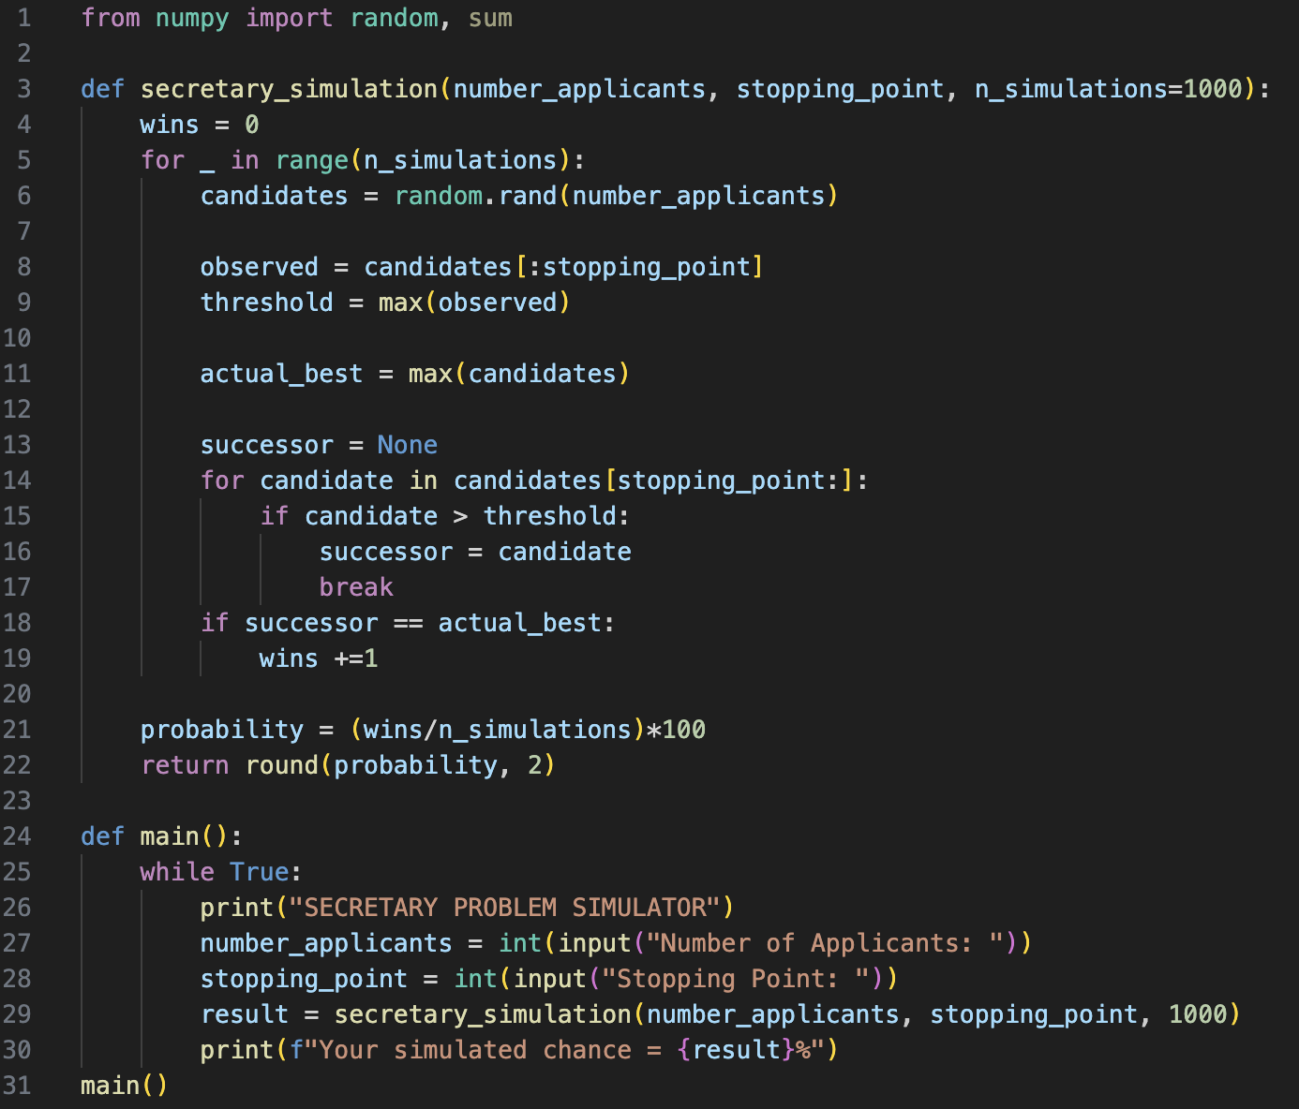
Remarkably, when I inputted a (highly unlikely) scenario where there are 1000 candidates and our stopping point is at 368th candidate, our simulated chance of picking the best candidate is also approximately 37%.
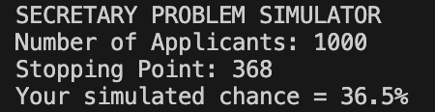

3 Applications of the Problem
Having explained the secretary problem in detail, we will now explore a few hypothetical scenarios where its underlying principles can be applied.
Selecting a Restaurant to Dine at
Imagine a scenario where you are driving down a one-way street in a city full of restaurants. You are famished and need to choose a place to eat at. However, you are very particular and want the best food possible.
Fortunately, for this situation, the principles from the secretary problem provides an optimal strategy to follow when making your decision.
To maximise our chances of picking the best restaurant it is simple:
- Observe the first 37% of restaurants you see to get to know what is out there.
- Then select the first restaurant that exceeds the quality of all other restaurants you have seen so far.
By following these steps, we give ourselves mathematically around a 37% chance of choosing the best restaurant. This example perfectly demonstrates how the secretary problem can be applied beyond hiring decisions, showing its relevance in everyday situations like selecting a place to dine at.
Finding the Best Parking Spot
Imagine you are driving on a road to a concert or popular event. The side of the road is lined with parking spots. You could easily park early and walk a long distance, but you are running late meaning the further away you park, the more concert you will miss. However, the closer you drive to the venue, parking spaces become increasingly rarer. So, what is the best strategy to get as close to the venue as possible without risking not finding a spot at all?
This is a classic example of optimal stopping and uses principles from the secretary problem. We must choose when we should park before opportunities start to disappear. In this case, we need to reduce the opportunity cost, being the amount of concert time, you lose depending on how far away you park.
The best strategy here is to use a fraction of your time driving to observe spots and learning how frequently parking spaces occur. Then after this, immediately take the first spot you see that is vacant.
What makes this slightly different to the secretary problem is that this fraction of time observing is not necessarily 37%, it depends on the proportion of parking spots that are available in that area. The occupancy rate, the higher occupancy rate, the sooner you should commit to an available spot.
- In a busy city like London where parking spots are extremely rare, the occupancy rate is high so you should spend less time searching before taking the first decent spot.

- However, in a smaller city like Lincoln where parking is more abundant, the occupancy rate is lower so you can afford to spend more time searching – allowing you to have a higher chance of getting a spot closer to the venue.
While these scenarios seem exaggerated, they apply the principles behind the secretary problem to everyday decision making problems where we must balance the cost of waiting with the opportunity at hand. Learning when to stop searching and commit is a skill that anyone can master that applies far beyond mathematics.
Investing in Stocks
The secretary problem plays a huge impact in the world of finance and real estate. These fields require decisions to be made in circumstances where the future of these fields may be uncertain with prices and rates constantly fluctuating. Investors must decide whether to take a chance at better opportunities with the risk of incurring losses, or to play it safe and prevent losing out.
For example, imagine you are investing in a stock that is steadily declining. You face this decision:
- Sell the stock to minimise losses?
or
- Keep the stock and hope that it rebounds.
This problem is a clear application of the secretary problem with a small twist, as we need to decide how long we should wait before we should sell the stock.
Hoping that the stock just rises again is purely luck based and is very risky as it could lead to major losses. The best approach, unlike the secretary problem, is to set a threshold in advance. That is if your losses exceed this threshold, you should sell the stock regardless of how you feel about it, which aligns with the threshold principle in the secretary problem. Obviously, this does come with exceptions. e.g. if a company suddenly announces bankruptcy, keeping the stock is definitely a bad move.
In Brian Christian and Tom Griffith’s Algorithms to Live By, they explain a similar principle in the world of real estate. They explain that as the cost of waiting increases, the threshold price (the lowest price at which you accept the offer) decreases. This is because the longer you delay, the more you risk accepting an even worse deal later while also suffering from the losses of waiting an even longer time.
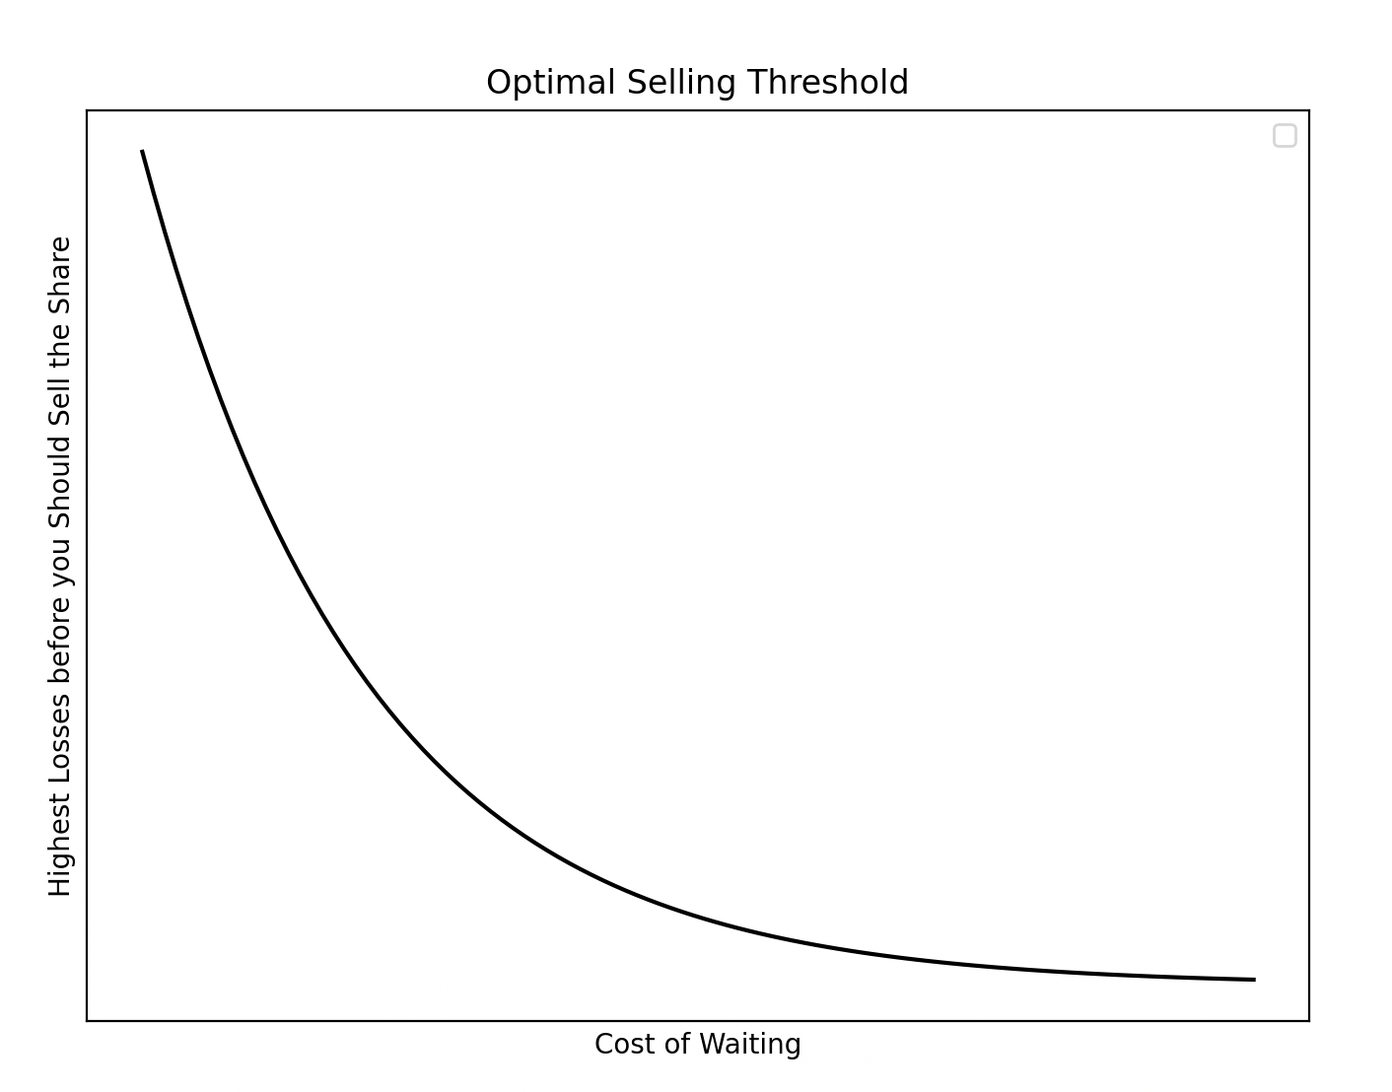
Figure 1: Graph showing the trend of how the cost of waiting influences at what point of losses should you sell the share.
The main principle this shows is that it is better to take a good offer now than later when you have suffered losses from waiting too long.
This logic extends to betting and gambling. In those scenarios, you are also presented with a similar choice:
- Stop playing and prevent further losses.
or
- Keep playing and hope to make up for previous losses.
Like stock trading and real estate, just waiting and hoping you win a jackpot is the wrong strategy as you will easily lose so much. Similarly, the optimal strategy is to set a threshold – a maximum amount you can lose – beforehand to prevent unnecessary risks.
As a disclaimer I am not a financial expert, stock market experts would most likely disagree and explain more sophisticated strategies. However, this explanation still highlights how the core ideas of the secretary problem, such as setting decision thresholds, avoiding emotional bias which balancing risk with opportunity can be used powerfully in finance, real estate and beyond.
Love
An intriguing application of the secretary problem is in romantic relationships, particularly in the process of choosing a partner. Throughout someone’s life, they go through a phase of searching for a partner, meeting, and dating people while figuring out what they would want out of a relationship. When is the right time to stop searching and commit to a relationship?
The content in this problem perfectly aligns with the secretary problem, as possible partners arrive in a sequential manner, and we can either accept or reject where if we reject, they are (most likely) gone forever.
So, the optimal strategy is that we should spend the first 37% of our time observing/dating to learn what qualities make up a good partner. After this ‘sampling phase’, we should immediately commit to the next person who is better than everyone else we have seen so far.
For example, if someone starts dating at 18 years old and expects to find a lifelong partner by 40. The 37% idea from the secretary problem suggests that they should spend the first 8 years exploring, then after they should commit to the next best person they meet.
Of course, a mathematical model could never accurately predict love. While the secretary problem does provide a good guideline to possibly follow, relationships are complex involving emotions, events, and timing which no formula can accurately measure.

4 Conclusion
Overall, the secretary problem displays how mathematics can be applied in real-world decision-making. Including contributions in areas of decision maths and optimisation problems, finance as well as many general problems such as optimal parking or finding the best partner. The secretary problem will never be able to accurately reflect real world scenarios due to uncertainty with changeable conditions, anomalous results, and emotional factors. However, it does provide valuable lessons into how we should balance exploration and commitment.
Ultimately, this problem reminds us that many outcomes of decisions in life are just down to luck, however by using logic and mathematics, we can increase our luck.
Thanks for reading!

References
The Graphs and Python code are of my own work, with the Graphs being made on Python’s Matplotlib library.
- Beckmann, M, 1990. DYNAMIC PROGRAMMING AND THE SECRETARY PROBLEM. [pdf] Available at: https://core.ac.uk/download/pdf/81933008.pdf [Accessed 3 April 2025].
- Christian, B. and Griffiths, T., 2016. Algorithms to live by: The computer science of human decisions. New York: Henry Holt and Company.
- Ferguson, T, 1989. Who Solved the Secretary Problem? [pdf] Available at: https://www2.math.upenn.edu/~ted/210F10/References/Secretary.pdf [Accessed 3 April 2025].
- GeeksforGeeks, 2021. Secretary problem | Optimal stopping problem. [online] Available at: https://www.geeksforgeeks.org/secretary-problem-optimal-stopping-problem/ [Accessed 3 April 2025].
- Veritasium, 2024. Why is this number everywhere? [Youtube] Available at: https://www.youtube.com/watch?v=d6iQrh2TK98 [Accessed 3 April 2025].

