The Mathematics of Survival – Squid Game, The Prisoner’s Dilemma and Optimal Strategies



Rishabh Kiran
Reading School

Introduction
Netflix’s compelling series “Squid Game” captivated millions by thrusting ordinary relatable people into life-threatening situations wherein every decision held great importance in their survival. Each scenario, brimming with tension and unpredictability naturally had me wondering the optimal, mathematically correct option to choose in any given scenario. Each scenario or “game” can be broken down and calculated by the fundamental concepts of game theory, a branch of mathematics that particularly interests me because of its applications in so many areas of real-life situations, or made-up ones in this case, combined with mathematical tools such as Markov Chains, and Survival Function Models. In this essay I attempt to demonstrate how even in emotional fictional scenarios mathematical reasoning can illuminate the logic behind some of the most intense and morally complex decisions.
I should introduce for some context before I begin, in “Squid Game”, a group of 456 distressed poverty-stricken people from all backgrounds are made to compete for the equivalent of £24.9 million, through a series of traditional Korean playground games, where the consequence for losing is death.

The Prisoner’s Dilemma in the Marble Game
The marble game in “Squid Game” involves pairs of players competing to obtain all of the other players marbles through any game decided upon by the 2 players. The losing player is eliminated.

(The above and all following images are taken from “Squid Game” Netflix)
Whilst this may seem like a complicated situation to unravel at first, we can simplify it through the application of the prisoner’s dilemma, a situation where individual rationality clashes with collective benefit.
Mathematically the prisoners Dilemma can be represented by the following payoff matrix :
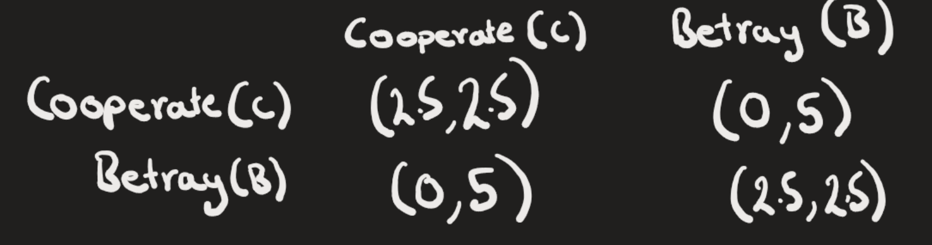
Each value in the matrix represents the utility, or chance of survival, of each player. Assume mutual cooperation to be a situation where the players decide to play a fair, even odds game where both players receive equal odds (3,3). Whilst one player cooperating and another player betraying is a situation in which one player believes the game is even odds (this is the cooperating player) and the other player either cheats or rigs the game (giving them (0,5) odds. Finally, the situation where both players are under the impression the other believes it is a fair game, but they themselves believe it isn’t, where they are both betraying each other they both receive utility (2.5,2.5).
In reality this game is rife with emotional manipulation in a very high pressure, high stakes situation, but mathematical thinking can simplify it. To take a numerical approach, suppose the numbers represent percentages, 2.5 corresponds to a 50% chance of survival and 5 represents a 100% chance. In this case, regardless of what the other player decides, the mathematically correct choice is to betray the opponent. Take a base case where both players cooperate, their individual chances are 50%, if they betray the opponent their chances jump to 50%. They are faced with either cooperating and assuming the other player does as well give both 50% or betraying and taking the chance of either receiving the possibility of surviving guaranteed, or receiving the same odds as they had before.

Markov Chains and the First Round Voting Decision
After the first game, where the players discover the harsh reality of losing, players are given the chance to vote on whether to continue or end the competition. In the show, the players initially choose in favour of ending the games, but after being released back into their dire financial situations and given the option to return, a large majority of the players choose to come back to the games and try for a chance to win the money.


This can be modelled using a Markov Chain, a mathematical system that tracks the probability of moving between different states over time, where the probability of the next state depends only on the current state and not in the past history.
In this case the player can be in one of 2 states :
C: Chooses to Continue/Return
L: Chooses to Leave/Stay out
The transitions between these states depend only on the current state, and not on the players full history.
From the show we can assume that a player who originally wanted to continue has a 70% chance of sticking with that decision and a player who originally wanted to leave has a 50% chance of changing their mind.
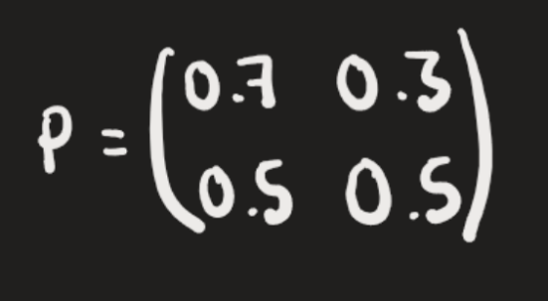
We can apply this to a transition matrix :

In order to find the long term behaviour, over may iterations we solve for the steady state distribution π where :
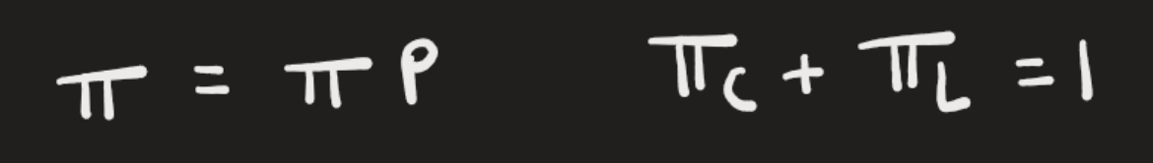

Solving for this we find :
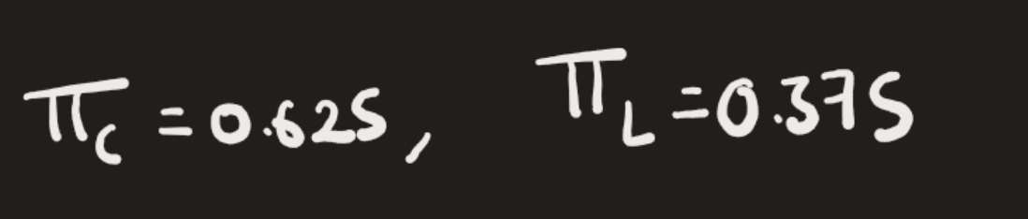
This means that over time, approximately 62.5% of players will choose to continue, which aligns well with the narrative portrayed in the story. Despite the trauma of participation, most players feel compelled to return due to a sense of financial and social desperation and the promise of reward, which we are able to represent mathematically.

Survival Function Modelling in Red Light Green Light
In the very first game, Red Light Green Light, players are tasked with crossing a strip of land whilst a song is playing. The song randomly stops, and the robot turns around from facing a wall to facing the players and identifies anyone still moving and they are shot. All those after a certain time who have not reached the other side are killed.


This game can be analysed using a survival function, which can help to quantify the likelihood of survival over time. In order to obtain a more realistic model of this situation, I opted against the use of a simple exponential distribution model, which would assume that the risk of being caught remains the same regardless of how long a player has been moving and instead applied a more realistic survival function that accounts for an increasing risk the longer that a player stays active. This much better captures the risk and tension of the situation where the longer a player moves, the more likely it is they are moving when the robot stops the music and so the less likely it is they survive.
To model this, I used a Weibull survival function written :
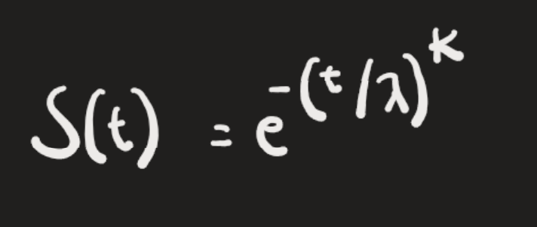
S(t) represents the probability that a player will survive past a certain time that they are moving for.
t represents the amount of time a player has been moving
λ is a scale parameter that sets how long players can typically move before risk becomes significant.
K is a shape parameter : if k > 1, the risk increases over a longer period of time moving.
Lets take for example λ to be 15s and k to be 2, reflecting a situation where the risk starts low but increases sharply over time.
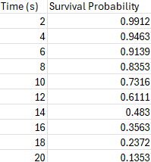

From this, it is clear that longer durations of movement significantly decrease the player’s probability of survival. For example, while moving for 4 seconds might give a player a survival probability of over 94%, moving continuously for 16 seconds drops that probability to around 35%.
Lets assume that if a player ran straight across the field with no pauses it would take them 20s. At first glance, this suggests that the safest strategy is to move in very short bursts and pause often. But there is a crucial trade off: shorter movements mean slower overall progress. If a player divides their 20-second crossing into ten 2 second intervals, they must complete 10 relatively risk-free movements, but the risk then lies for them in getting timed out of the game. Even though each individual movement is safe on its own, the risk will accumulate over intervals.
Taking this into account we can model the total survival probability for this strategy as :
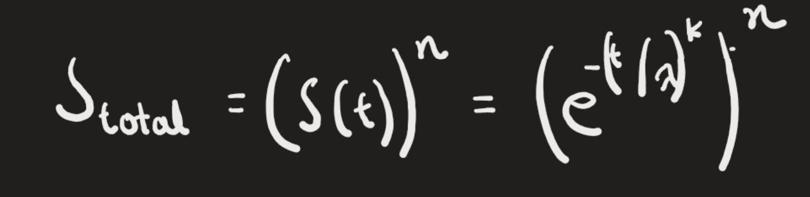
t is the time per movement
n is 20 / t
This formula shows how the total survival probability depends on how long each movement lasts and how many movements are made.
If we take into account a 1s pause in between each interval, the highest survival rate occurs still at the highest number of intervals, but the downside of this approach is the total time required. The total survival probability over 20 intervals including a 1s pause in between each burst is 0.9956, but this approach takes 39s.
Therefore, the optimal strategy for this game would lie in the players belief of how long the cutoff period is. The greater an individual player believes the cutoff period to be, the more intervals they should take.

Conclusion
Ultimately, “Squid Game” was intended to reflect the harsh reality of dire situations and the lengths that humans will go to in order to save themselves, both financially by joining the game, and literally by killing and betraying their fellows. However, in this mathematical exploration of “Squid Game” I hope to have demonstrated the rich complexity of strategic decision-making, and have shown how seemingly unpredictable, high-tension games can be simplified down mathematically to simple equations and logical decisions.
Thanks for reading,
Rishabh Kiran

