Tom Rocks Maths Essay competition 2025

Andy Baliaj

Dirac on the dance floor

The Dirac belt trick, first proposed by Paul Dirac, showcases the spin-half algorithm of electrons, and is fundamental to understanding how quaternions underpin this effect and are crucial to higher dimensional rotations. But first, let’s lay the groundwork starting from the basics, and slowly work ourselves up to this intriguing effect that explains why chemistry is what it is as we know it, and why neutron stars exist amongst other things. In this essay, we will explore the mathematical breakdown for how the belt trick is explained through matrices to describe particle spin and the importance of this trick. Notably, we will also look at the seemingly futile first impression of complex numbers we may have and start to learn how the unit $i$ is not imaginary at all and is rather useful!

Laying the groundwork

Do numbers have dimensions? Something you may have never really thought about as it begs the question, what does it mean for a number to be dimensional and what separates some numbers into their own distinct number system? Starting off more basically, let’s begin with real numbers. By plotting a basic number line from -5 to 5, we see our real numbers (integers in this case) on a flat line that only allows us to move either right or left, by performing the addition or subtraction operations to our starting position. Take the starting point 0, and we add 4 to it.

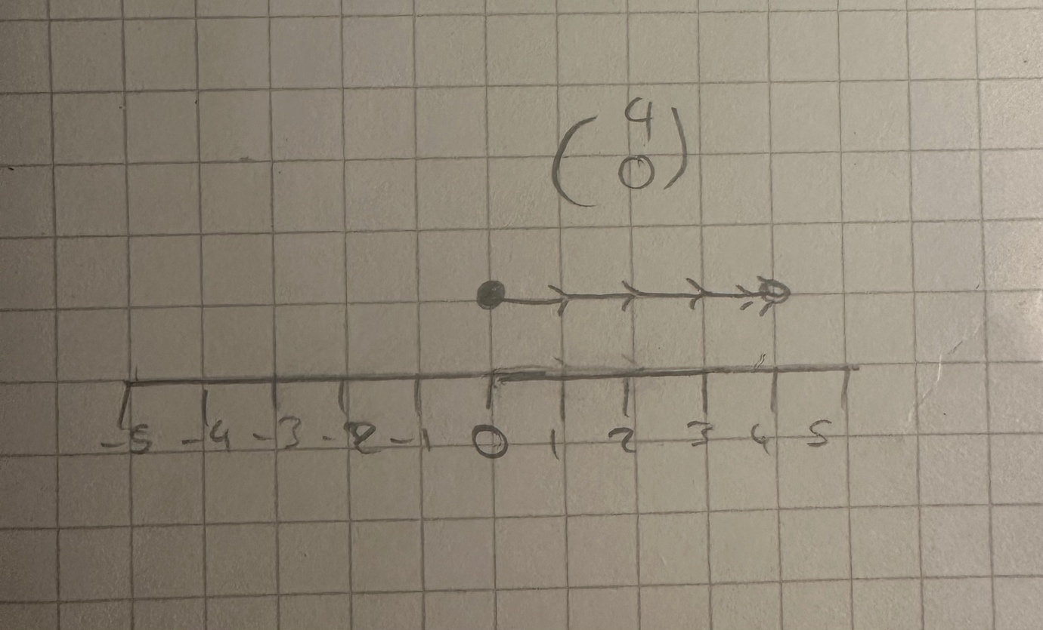

Well, this is simply shifting our starting position 4 units to the right. Equally if we subtracted from our starting number we would be shifted (or translated) to the left. A key takeaway from this would be to understand that real numbers are one-dimensional numbers, as we can only move in direction when we perform operations on them, and they lie on a flat one-dimensional plane.

Now as we know, the idea of 2 dimensional numbers may seem abstract, but the truth is more subtle than we think. Take the imaginary number ‘$i$’ which has two key properties:

$i$= $\sqrt{-1}$
$i^{2}$= -1
Adding a real and imaginary number together forms a complex number, which takes the form a+b$i$, where ‘a’ and ‘b’ are real numbers. But what does all this mean? How can the square root of a number be negative? It may seem daunting, but these fascinating numbers aren’t so imaginary after all, but have real geometric meaning that we will delve into.

In this case, we will express our complex number on an argand diagram, which has an imaginary axis vertically, and a real axis horizontally. Take any point on the diagram. Let’s go
for 2+3$i$? Good choice!

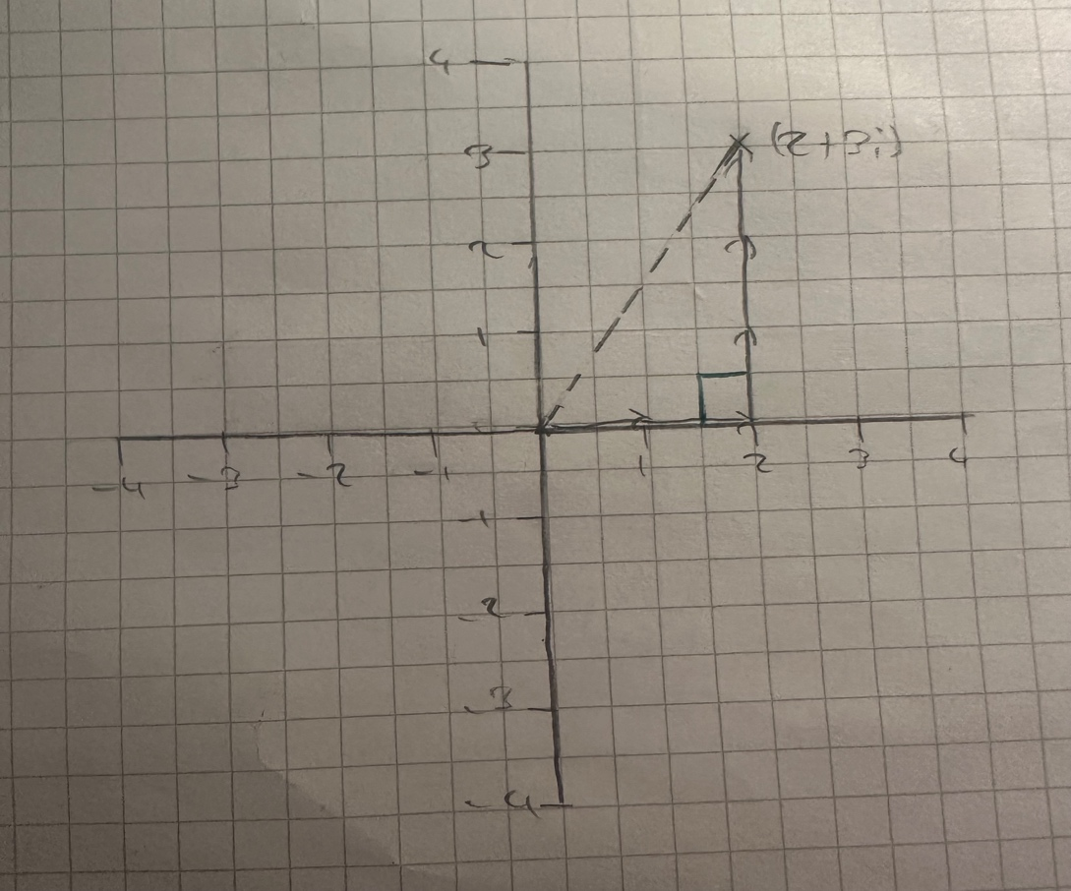

To get to our point, we can move two units to the right, and 3 units up. Simple enough right, as this is how we conventionally find the coordinates of a point on any graph. Let’s now look at it this way. Let r = 90$°$ rotation anticlockwise and let a point on the graph be ($a,b).$We start off by going in the x direction by $a$ units. Now, we encounter the b coordinate in the vertical direction, but how would be change our orientation of direction to now travel upwards to $b$? For this to work, we would multiply our b coordinate by r, so that we can rotate our direction of travel 90$°$ anticlockwise so that we can reach our b coordinate.

Let’s call this new position $a+br$ Does this seem like $a+bi$? From this we can see that the imaginary unit $i$ acts as a rotation and hence, we can see complex numbers are two dimensional numbers that can be rotated in a 2-dimensional plane. Let’s take this one step further, multiplying 2+3i by $i$?

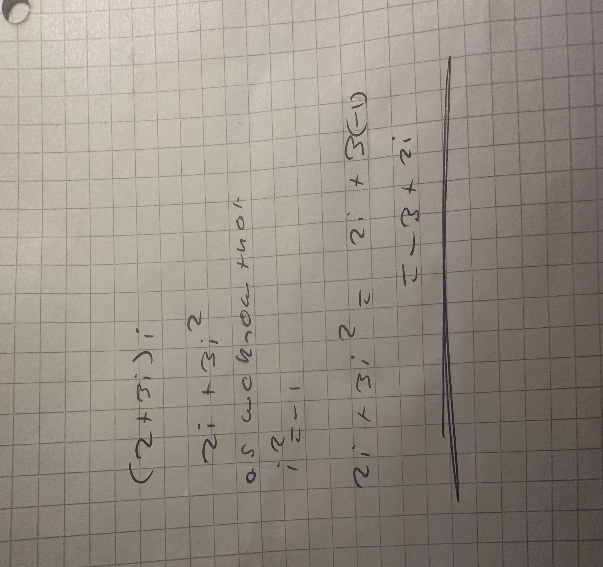

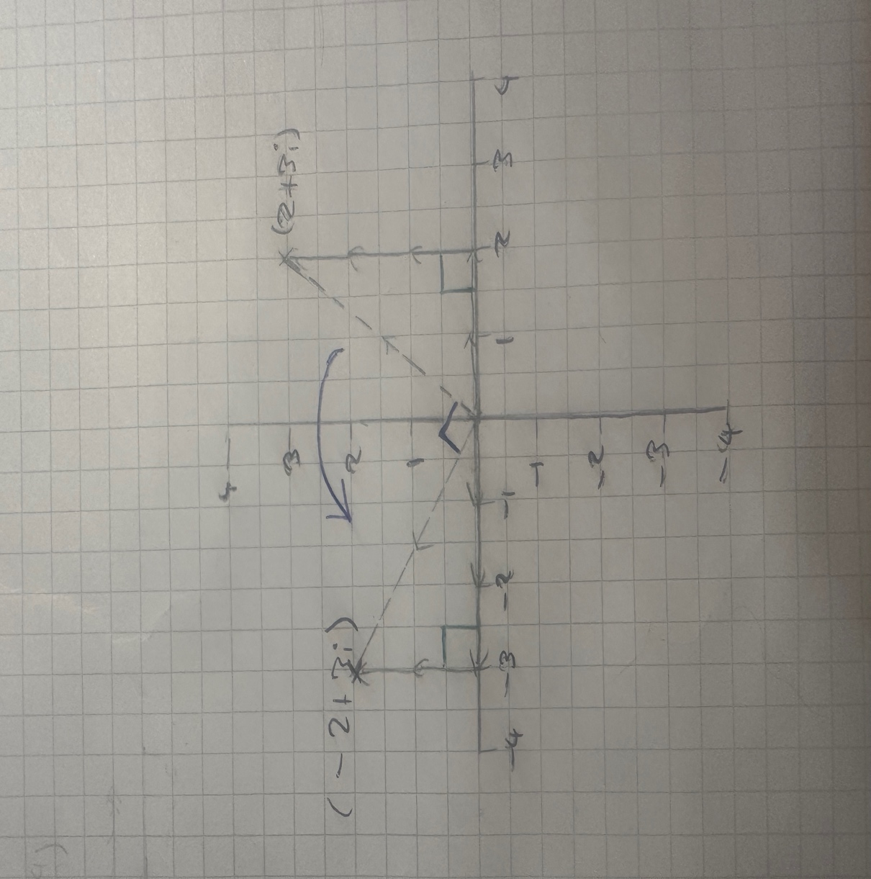

Our new complex number is -3+2i. But what changed about our point from its original point when we multiplied it by $i$? Geometrically we can see our original point is rotated 90 degrees anticlockwise, from 2+3i, to -3+2i. We can now focus on the fact that now we understand the imaginary number ‘$i$’ represents a 90-degree anticlockwise rotation and is not just a cool trick we can use to now solve equations with no real roots – it has real meaning that we can use to optimise the world around us.

As mentioned earlier, rotations are expressed through matrices, so what do complex numbers have anything to do with matrices. One last step will help us understand this link and appreciate the power matrices and an advanced version of complex numbers, quaternions, when computing rotations in the real world.

The underlying link

We know matrices are used to represent linear transformations of objects, such as rotations, enlargements, reflections etc. For this purpose, let’s shift our focus to the 2x2 rotation matrices. The general formula of a rotation matrix anticlockwise takes the form$\left[\begin{matrix}\cos{θ} & -\sin{θ} \\ \sin{θ} & \cos{θ}\end{matrix}\right]$.
Substituting π/2 into this matrix gives us the resulting matrix $\left[\begin{matrix}0 & -1 \\ 1 & 0\end{matrix}\right]$, as π/2 is equal to 90$°$in radians. Now what happens if I square this matrix? Multiplying it by itself, using the algebraic rules of the algebra that matrices follow under, will give $\left[\begin{matrix}0 & -1 \\ 1 & 0\end{matrix}\right]\left[\begin{matrix}0 & -1 \\ 1 & 0\end{matrix}\right]$=$\left[\begin{matrix}-1 & 0 \\ 0 & -1\end{matrix}\right]$. This resulting 2x2 matrix may look familiar, as. By factoring out -1, we can rearrange this into -$\left[\begin{matrix}1 & 0 \\ 0 & 1\end{matrix}\right]$, which is equal to -1 multiplied by the identity matrix, $Ι$. Multiplying any matrix or point in space by the identity matrix has no effect, so we can look at it as just multiplying by 1. This gives the fact that the negative identity matrix is the same as multiplying by -1. From this we can say that as ${\left[\begin{matrix}0 & -1 \\ 1 & 0\end{matrix}\right]}^{2}$= -1,
So $\left[\begin{matrix}0 & -1 \\ 1 & 0\end{matrix}\right]$ = $\sqrt{-1}$ . This also shows us that $i$ is a 90 $°$ anticlockwise rotation, but more notably can expressed through complex numbers and matrices. This is a powerful tool for us to geometrically interpret the significance of $i$ with regards to rotations.

Rotations and electron half-spin

All this stuff we have mentioned thus far seems cool, but why is it useful. First, we need to briefly understand the spin of an electron. Electrons are known as spinors, as they have spin-half, which means an electron must be rotated 720$°$ or 4$π$ to return to its original position. Particles with this spin-half property are known as fermions. The other particles that only require a 2$π$n rotation (where n is an integer) to return to original orientation, are known as bosons.

Now, a unique way I would like to introduce the importance of this spin-half algorithm, is through demonstrating the Dirac belt trick. Take a belt, however this can be repeated with a scarf, or a string, or even very long hair! We will fix our belt in place at one end completely. Then we will rotate one end by 2$π$, then by 2$π$ again.



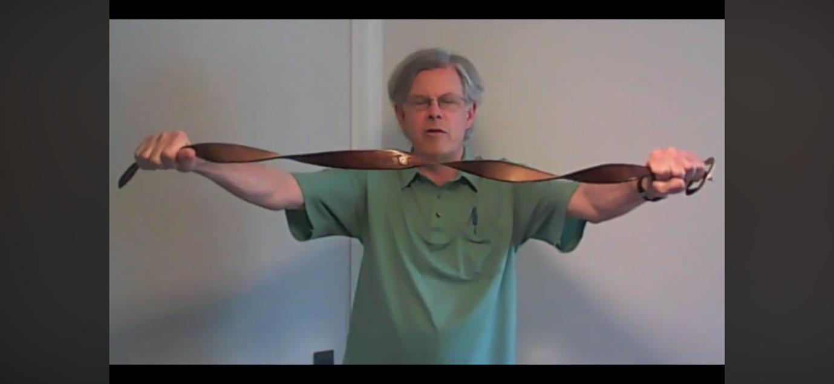

Now we will fold one end of the belt over from one end in a 180 $°$ rotation, as shown.





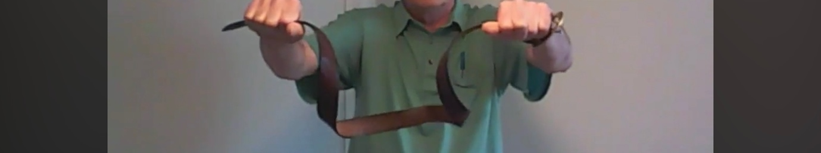

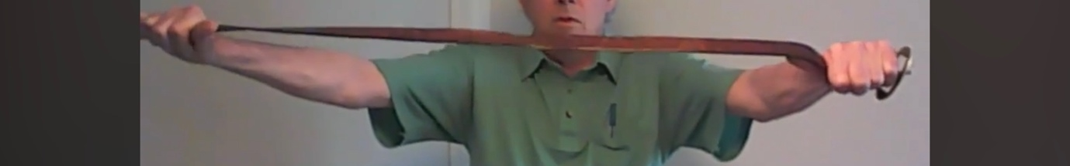
All rotation on the belt is gone and it is back to its basic straight orientation. Weird, eh?

Importance of this effect
This effect mirrors the same overall spin acting on electrons and is crucial to its applications to quantum mechanics. A particularly pivotal consequence of this effect is how it has shaped chemistry to what it is. As mentioned before, electrons are known as fermions, which are a type of particle that has spin-half. Fermions also obey the Pauli Exclusion Principle, which states that no two fermions can be placed on top of each other in space, or in other words they cannot occupy the same quantum (energy) state. It may seem like a fancy definition for something very niche, however this effect of the combined rotations on an electron giving it no net spin, mean that within an atom no two electrons can occupy the same energy level. This means that electrons must occupy different energy states and thus are found in different shells of an atom. If this was not the case, all electrons would fall to the lowest energy level of an atom, so atoms would not be able to bond to each other as we know it, and the entire structure of chemistry would be different as we know it – Organisms including humans would not be formed if this was this case.

The half spin algorithm also has uses in NMR as the fact the atom nucleus has a -1/2 spin is used to find the structures of molecules. It is also prevalent I quantum computing, where spin-half particles like electrons can be used as qubits, where spin state up represents 0 or spin state down represents 1.

Notably, this effect is not usually seen, as it cannot be demonstrated using solids. Say for example a professional cricket player spins a ball at top speed to make life difficult for his opponent batter. We cannot see this effect unravel as solids cannot turn itself inside out, however this is different for electrons. As electrons have an extra spin (longitudinal rotation), and that electrons really are just waves after all due to wave-particles duality, means this effect is prominent with waves and can be explained through the spin of an electron.

Can we use complex numbers to describe this effect?

Now what does all of this have to do with those complex numbers we mentioned earlier? To wrap it all up, we must take one more step into a higher dimension of numbers beyond complex numbers. Introducing, quaternions, which are 4th-dimensional numbers. Essentially, quaternions, or hypercomplex numbers, are used to rotate objects in 3 dimensions. Ever played jungle runner or Call of Duty on any devices? When we flick our controllers to look in a different direction, quaternions are used to calculate and allow us to make these rotations of orientation. Quaternions are ever present within computer graphics or rotation of a space shuttle entering space. Have you ever gotten slightly lost on your journey to somewhere new, and had to use your maps navigating app on a mobile phone? While you can rotate yourself to see how the arrow changed to orientate you towards the correct direction, that is quaternations being used. We can start off by understanding quaternions take the general form $a+bi+cj+dk$. Rather than in complex numbers, there are three imaginary planes being considered here, with $i, j, and k.$

If we want to rotate in 3 dimensions using quaternions, we must rotate through an angle $θ$, about some axis of a unit vector, with components I,j, and k.

Conclusion

I hope from this essay it became much more apparent the subtle power of complex numbers to describe rotations of objects, how this leads on to the idea of quaternions describing 3-dimensional rotations, and how it is pivotal to describing the Dirac belt trick!

