Uncovering Chaos: The Search for Order in the Brain
Introduction
Nature is full of non-linearity. Fractal structures are present, even at the molecular level, and physical systems such as weather display apparent stochasticity. Although Ed Lorenz was the first to make progress with the idea, Henri Poincare’s work on the “three body problem” in 1890, was the first piece of evidence for what we call “chaos”. After Newton’s work on determining the paths of two orbiting planets – influenced only by their mutual gravitational forces - attempts were made to establish that with three planets. With a possible 18 variables in the system, it appeared too complex to be solved mathematically. Through Poincare’s work on the three-body problem, he discovered that small perturbations in the initial conditions of the system would have vast changes to the outcome; a finding that denied him the chance to ever come to as complete a solution as Newton’s. The property of “sensitivity to initial conditions” is now a key indication of chaos.
The brain contains approximately 86 billion neurons with each neuron establishing around 7,000 connections – its complexity is immeasurable. To observe the activity of the brain, doctors can do an electroencephalogram (EEG) which uses small metal disks called electrodes, attached to the scalp, which measure the electrical activity of the brain, sometimes called brainwaves. Results appear as a complex set of wavy lines, and in the past have been analysed successfully with linear techniques able to detect abnormal behaviour in the brain, which could be a sign of seizures. However, hidden in the data lie neural assemblies and periodic oscillations that fail to be realised through simple linear analysis. We cannot ignore the chaotic nature of the brain, especially if we hope to grasp its complexities.
Chaos in Phase Space and The Strange Attractor
Ed Lorenz’s discovery of chaos was accidental. He worked as a meteorologist at MIT and using a program of twelve differential equations, attempted to run a simplified mathematical model of the atmosphere. After running his program once in 1961, he decided to continue running the model from where it had left off. He printed off the data obtained in the middle of the calculation and ran the system again. The results surprised him. Data previously obtained appeared vastly different to that gathered on the re-run, despite every initial parameter remaining the same. He checked his inputs again and noticed each one had been rounded to a meagre four decimal-places. Such a minor change in the initial conditions of his system surely could not have such drastic changes on the outcome.
More specifically, Lorenz’s equations model the rising and sinking of air in the atmosphere by convection. With the motion of fluids relying on the individual movements of every particle in the system, one would be correct in assuming it is of the utmost complexity. Nevertheless, Lorenz’s system can be simplified to the three differential equations in Figure 1.

Figure 1 – Three differential equations used to define Lorenz’s system. and are variables and and are adjustable parameters.

To display the evolution of the Lorenz system visually, he used – as many do – a phase space diagram. A phase or state space diagram is used to represent all the possible states of physical system. A position in phase space corresponds not to an objects physical position in space but allows variables such as temperature or momentum of an object or system to be defined by the coordinates of a point, with each coordinate indicating the value of one variable. Lorenz’s system is plotted in a three-dimensional phase space, allowing each variable that determines the current state and future state of the system to be expressed. It was in plotting his system in phase space, that Lorenz was surprised again.
On inputting certain parameters, Lorenz’s map was infinitely complex. Each trajectory bifurcated to produce two new trajectories and on zooming into the map, the same happened again. Whilst the complexity of the system was daunting, it was far from random. In fact, it was clear the system tended to some set of points (sometimes said to be in the shape of a butterfly), which we can call an “attractor.”
A simpler system may have an attractor that is defined by a single point in phase space whilst others involve more complex geometrical configurations. The swinging of a pendulum can be mapped in phase space and its attractor would be a stable fixed point in which the set of variables that define it are some fixed values (which corresponds to the pendulum being at rest). No matter where you begin in phase space, the system will evolve to a set of points – the attractor.
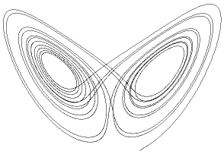
The Lorenz System has an attractor that is fractal, meaning we call the attractor itself, a strange attractor. Fractals are infinitely complex geometric shapes that display self-similarity at various scales. In this case, on magnification, single trajectories on the attractor become pairs of trajectories that are themselves made up of more pairs. The attractor appears as pairs of trajectories at all scales. Fractals are the only thing that permit infinite complexity in a finite space and so the strange attractor must be such.
Figure 2 – The Lorenz Attractor
In order for the attractor to display such infinite complexity is for the attractor to never cross itself. It’s important to remember the system is not random but deterministic – a key property of chaos - distinguishing it from truly stochastic systems. If all initial parameters are the same, the system will follow the same trajectory repeatedly – nothing is up to chance. Therefore, if the attractor were to intersect with itself, an orbit will form as it takes the same path again. The systems determinism allows the state of the system in the short term to be predicted using the equations that define the system. Predicting the long-term outcome of these initial conditions is where chaos takes control.
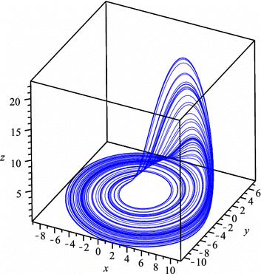
Other strange attractors have also been studied with one of the most influential being the Rossler attractor. Defined again by three differential equations. The Rossler attractor (Figure 3) displays the same fractal properties as Lorenz’ but demonstrates more explicitly the “stretching and folding” of phase space that so well defines these attractors.
Figure 3 – The Rossler Attractor
Rossler himself cleverly employs the metaphor of stretching and folding of phase space to produce his attractor. Take a flat “sheet” of phase space and stretch it. This causes nearby points to diverge. Continual stretching will cause greater divergence but will not allow for all the infinite complexity of a strange attractor to remain bounded in a finite phase space. Folding the stretched “sheet” keeps points restricted whilst also increasing complexity. Try dropping a small drop of dye into a dough. Kneading the dough follows the same process of continual stretching and folding and the dye that began as a set of nearby points diverge rapidly, spreading throughout the dough (just as points spread across the phase space.
Routes to Chaos
Robert May, an Australian biologist used the equation below to model the growth of a population.

It is an example of a difference equation and highlights clearly that the population of the next generation - Pt+1 - is dependent on the initial population Pt and a rate of reproduction r. The equation could not be simpler and iterating it with certain r values will cause the system to settle on a single value, implying a population with those initial conditions will eventually reach a state of equilibrium.
As the parameter r was increased however, an orbit of period 2 formed meaning as the equation was iterated it did not settle, but instead oscillated between two distinct points. Increasing this parameter further led to oscillation between 4, and then 8 and then 16 values. Eventually the system refused to form periodic orbits, and instead jumped endlessly from value to value with no clear pattern or destination.
On observing the madness produced by May’s difference equation, the data appears stochastic and its complexity “masks the simplicity of the underlying rule”. Mays “logistic equation” lends itself to applications in cryptography as simple rules or “keys” produce complex sequences of “random” numbers.
In order to reach this state of disorder however, period doubling bifurcations are observed and these have become key prelude to chaos. More interestingly, period doubling bifurcations apparent across unrelated systems share a universal constant – Feigenbaum 1st constant. If a is the point at which a trajectory bifurcates and are the 1st,2nd and 3rd points at which they occur respectively, the ratio . Fluid dynamics is another mystery accessed by chaos and period doubling bifurcations often indicate a fluid is about to become “turbulent.” In the brain, period doubling bifurcations are observed in individual neural firing patterns (and we will look at this more when discussing experimental evidence for chaos in the brain).
Reconstructing Phase Space
Phase Space portraits provide an idea of a systems evolution over time and for analysing the networks in the brain, allow for each component to be represented in one visual plot. Like with Lorenz’s system, they can unveil hidden order behind a set of seemingly random data. The disadvantage of linear analysis of experimental neuronal data has always been the inability to identify complex neuronal assemblies in experimental data as each component of the brain is analysed separately and simply “adding components” is not sufficient. By presenting data in phase space, we can encapsulate the full complexity of the system in one map without ignoring the underlying dynamics.
Data collected during an EEG is a continuous measurement of one variable (we will call electrical activity) over time and it appears impossible to display such in a multidimensional phase map when we are completely oblivious to other variables.
In order for continuous time series data like that gathered in the EGG to be displayed in phase space, two main parameters need to be determined – a time delay and an embedding dimension – and these are crucial in ensuring the phase diagram is true to the original data. Like most experimental data, EEG’s will be polluted with noise and so it is important not to mistake this for significant data or in trying to ignore it, ignore crucial patterns waiting to be revealed in the phase map.
Continuous data is divided at equal time intervals, and measurements can be plotted with the vector described as…

where is the time delay and d is the embedding dimension. Choosing too small a value of results in each coordinate being too similar and renders a useless phase map. Alternatively, choosing too large a means we lose crucial patterns in the data as coordinates are too far apart and important correlation is lost.
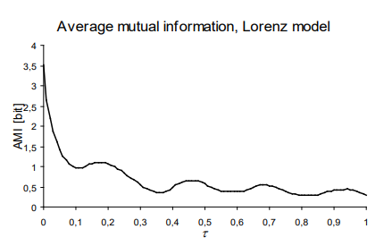
To quantify the information “shared” between data points we can use the average mutual information function (AMI). This function measures statistical independence of two subsequent points, separated by a certain parameter. Plotting the AMI against and determining where the graph “levels off” provides the optimal value for as at this value, holds little information on and so provides new information, without “missing out” key data that would serve to strengthen the correlation.
Figure 4 - A graph of AMI against time delay for the Lorenz System (only x variable). The first located minimum was a 0.11.

Once a time delay is chosen, we must define an appropriate embedding dimension in order to display the full complexity of the data. In choosing this parameter we are not choosing the number of variables being represented; phase space reconstruction is needed when we have one variable against time and mapping it into more dimensions aids in revealing the intricacies of the system.
When data is represented in too low a dimension, data points can appear very close together in phase space with trajectories even crossing. Increasing the embedding dimension would expose some of these points as false neighbours as when another dimension is represented, we can see these in fact lie very far apart in phase space.
False Nearest Neighbours (FNN) are determined when the distance between a vector and its nearest neighbour exceeds a certain threshold (tolerance threshold). If the value of…

exceeds the tolerance threshold it can be considered a false nearest neighbour. is the value in the data with index k, plotted in embedding dimension d with time delay . is that of the nearest neighbour (measured with Euclidian distance). is the distance between the two points in the lower dimensional space such that the equation overall represents the ratio between the distance of two points in dimensional space and dimensional space. It makes sense that if the distance between the two points in dimensional space is much greater than that in dimensional space, points should be considered FNNs.
Quantifying Chaos
Once data is successfully mapped in a suitable phase space – and a hidden structure hopefully unveiled – we must look for a way to compare and contrast different levels of chaotic behaviour.
The most explicit method tests whether the property of “sensitivity to initial conditions” applies and requires calculating the Lyapunov Exponent. In the formula below:

indicates the initial distance between two trajectories at time 0 and refers to that at time t. Rearranging the equation helps establish what the Lyapunov Exponent () itself represents:

We can see the exponent is a measure of the rate of growth of distance between neighbouring trajectories at time t. Using this, it’s clear that a positive exponent indicates chaos as small changes in initial conditions (changes from to ) have significant impacts on outcomes. An exponent of 0 would indicate periodicity and this would be displayed as a closed orbit in phase space. Finally, a negative exponent indicates convergence to a singular point and would be calculated for a system like the single pendulum as trajectories do not diverge but converge instead.
The number of Lyapunov exponents calculated will be the same as the embedding dimension of the phase space as we calculate the rate of divergence of trajectories along one independent dimension. In practice, we take the Largest Lyapunov Exponent calculated from the data and if this is positive, we conclude that the dynamics of the system must be chaotic. When working with experimental biological data there is uncertainty around using Lyapunov Exponents with raw, noisy data as periodic systems could possess positive exponents when contaminated with noise.
Instead of looking at the motion of the trajectories, we can utilize the fractal nature of a chaotic systems attractor to calculate the attractors fractal dimension and quantify chaos this way. A “fractal” dimension is “fractional” hence the name fractal. The idea of a fractional dimensional space seems impossible to conjure up, especially if the idea of a dimension is taken to be the number of variables n needed to define a point in an n dimensional space. Instead, think about the way that fractals fill space. They are infinitely complex and self-similar and so a fractal that appears in 1 dimension (probably as a set of squiggles) fill more space than a usual 1-dimensional object but not enough to be classified as 2 dimensional. It would be fair to say the dimension lies somewhere in between.
Calculating the fractal dimension can be done in multiple ways but the 2box-counting method” is most useful for data plotted or reconstructed in phase space. First, the space is gridded in squares for 2 dimensional maps, cubes for 3 dimensional and what are called “hypercubes” for attractors presented in higher dimensions. Secondly, the number of boxes containing at least on point in the attractor are counted and the process is repeated, this time with smaller and smaller boxes. Like in choosing the parameters for phase space reconstruction, the side length parameter is chosen such that the boxes span the “scaling region” of the fractal where the fractal exhibits consistent self-similarity. Outside this region, detail is missing in the fractal whilst “zooming in” too far means calculations are subject to noise, especially in experimental data. The fractal dimension is calculated with the formula:

is the side lengths of the boxes. We can see calculating the dimension takes advantage of the scaling properties of fractals and utilises the inversely proportional relationship between number of boxes needed to display the fractal - ) - and the side length. It is a simplified calculation that illustrates how much of the fractal structure remains when it is scaled.
In practice, with experimental data, we cannot allow and so the relationship between and is plotted and the gradient of the linear section will provide a suitable approximation for fractal dimension.
Unstable Periodic Orbits and Controlling Chaos
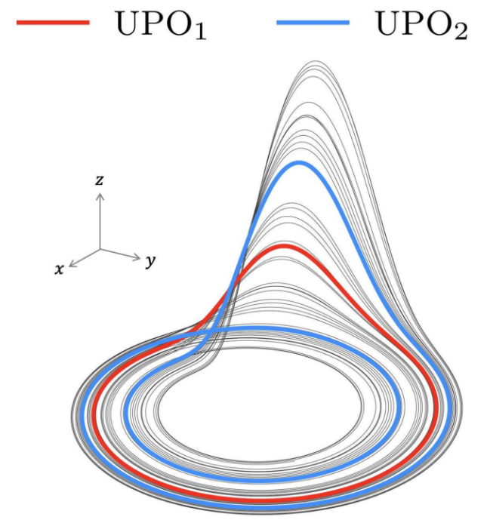
In understanding the dynamics of the brain, we finally stand a chance at controlling it. Data gathered using an electrocorticogram (abbreviated to ECoG and similar to an EEG, generally with a higher signal-noise ratio but requiring more invasive operation) can be analysed and Lyapunov exponents (L) calculated before, during and after a seizure to characterize the chaotic behaviour taking place during these events. The preictal state marks the onset of a seizure and high values of L are observed. During the seizure, the ictal state, sudden drops occur in L however the attractor remains fractal. Finally in the postictal state, L increases above initial levels. Epilepsy can be said to involve a transition from chaos to order and back to chaos. The use of non-linear analysis with biological data is still subject to critique but studies like the ones above indicate non-linear patterns do exist in the mind.
Figure 5 – The Rossler Attractor in 3-dimensional phase space with two Unstable Periodic Orbits (UPOs) labelled.
Working with chaos means that we have to take advantage of its characteristics with the main one being sensitivity to initial conditions. This allows small perturbations to have major effects on the systems dynamics and it has been argued that the brain exists on the “edge of chaos” for this reason – to quickly adapt to changing conditions. With the help of the phase map, we can decide how the brain or other chaotic systems can be altered successfully, giving us the chance to control chaos.
Figure 5 illustrates the familiar Rossler attractor with two labelled UPOs or unstable periodic orbits. A trajectory that repeats itself after a set number of steps would be classified as a periodic orbit. We know the complexity of fractals denies the presence of a periodic orbit but within each attractor lies an array of orbits the system follows briefly before diverging. These are called unstable periodic orbits or UPOs. They make up the “skeleton of the attractor.” An orbit is deemed most unstable when the system spends only a brief time following its trajectory before diverging.
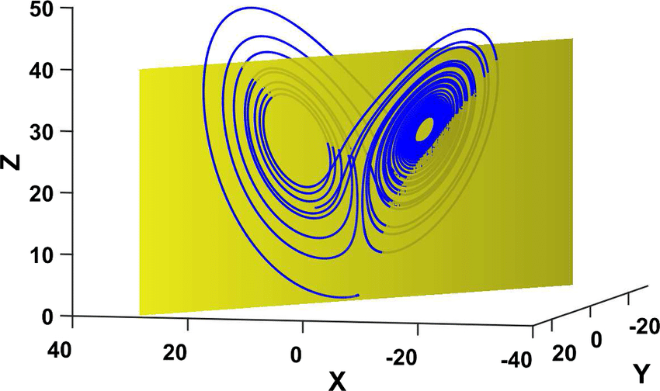
Identifying UPOs in experimental data is difficult as noise in the data obscures them. Instead, we can assemble what are called Poincare or return maps, constructed by taking a “slice” out of an attractor and plotting the number of times the attractor intersects with a single plane (line or hyperplane depending on the dimension of the attractor). In biological data this in invaluable and also helps when working with high dimensional maps. In taking a Poincare section, we reduce continuous time data plotted in phase space to discrete data, that’s more easily analysed. In Figure 6 a “slice is taken from the Lorenz attractor to produce a Poincare map.
Figure 6 – A visualisation of a Poincare or return map of the Lorenz attractor. Yellow plane cuts the attractor, and a return map would plot the points at which it cuts this plane.
UPOs in the data will correspond to fixed points or periodic orbits on the Poincare section. A fixed point is simply an orbit with period 1. It is identified when the system crosses itself after one cycle and so in data … plotted on the return map, a fixed point is present if . A period 2 orbit occurs when a point is intersected again after 2 crossing and a period 3 orbit after 3 crossings. The Poincare map illustrates where the system visits regularly and so where periodic orbits might lie. UPOs in practice are estimated when points pass arbitrarily close to each other on the Poincare map.
Looking closer at the framework of the attractor we see there are sets of points that will evolve towards or away from periodic orbits or fixed points – these are called the Stable and Unstable manifold, respectively. They can be defined as surfaces or curves in phase space. The stable manifold pulls points towards a state whilst the unstable manifold pushes them away denying the system the chance to remain in a periodic orbit.
To identify the stable and unstable manifold, the map is linearized around the fixed point on the Poincare map using the Jacobian Matrix. For a dynamical system, the matrix describes the linear transformation that occurred to transform the phase space near a specific point (the fixed point identified). Take the system below:

The Jacobian Matrix will be defined as:

The matrix appears quite complex but each element measures how tweaking the x and y parameters in the input space around the fixed point changes the final position of the points once transformed by the equations defining the system.
From the matrix, eigenvalues are calculated, and these quantify the pulls and pushes when the matrix performs its transformation; they are taken in a certain direction. If the eigenvalue is positive, the system is pushing values along a certain direction, causing them to diverge from the fixed point. If it’s negative, points are being pulled in towards the fixed point. These values give us the direction points along a manifold are heading as they meets the fixed point on the return map. Eigenvalues can also be complex with the real part still telling us whether the matrix is pushing or pulling and the imaginary part quantifying rotation (a pure imaginary solution indicates a spiral around a certain point). Eigenvectors are useful for predicting the motion of the manifold close to the fixed point as they act in the direction where there is only pulling or pushing, no rotation, and therefore only the effect of one manifold is being felt, allowing its structure to be predicted.
The system can then be run forwards and backwards in time with points around the fixed point, acting as the initial conditions. Using the Jacobian matrix the initial evolution of the stable and unstable manifold is identified. The eigenvector with the negative eigenvalue is used to identify the path of the stable manifold as the stable manifold is what pulls points towards the fixed points. The eigenvector with the positive eigenvalue traces the path of the unstable manifold as it defines the motion of points as they are pushed away from the fixed point.
Using these paths as the “seed” the model is run forwards to trace out the unstable manifold as it is at this point the system evolves away from the periodic orbit. Running it backwards shows you the path taken to reach the fixed point and maps out the stable manifold as it pulls the system in.
UPOs are found primarily at the intersection of the stable and unstable manifold as a balance of push and pull keeps the system briefly stable. This is why it is so useful to identify the manifolds that make up the attractor.
When trying to control non-linear dynamical systems UPOs in the attractor become prime targets for stabilization. The OGY method looks at altering the parameters of a system just enough to “nudge” it into one of the orbits that make up the attractor. The OGY algorithm is complex but essentially involves changing system parameter p depending on how far the systems current state lies from the desired state (a fixed point or periodic orbit).
Despite being experimental, chaos control via the OGY method has been successfully used to stabilize arrythmia in the heart of a rabbitand work with epileptic slices of the hippocampus in a rat.
Working with Experimental Data in the Brain
Chaos is discovered in the brain at all levels. In the EEG, “brain waves” are detected and non-linear patterns emerge as a result of the brains overall function. Meanwhile, the activity of single and coupled neurons displays similar chaotic behaviour highlighting the versatility of non-linear analysis in the brain.
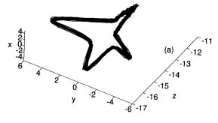
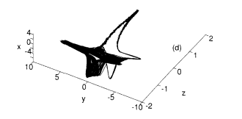
The study of a single neuron already uncovers rich non-linear patterns. When exposed to external stimuli a neuron generates an action potential as charged particles (ions) flow in and out of the neuron. They appear as spikes and can come in bursts, single spikes, or rhythmic oscillations.
Figure 7 – 3D reconstructed phase space of time serious of membrane potential at current of I = 2nA (left) and I = -1nA
A study from 1996 of an individual neurons response to an injected current was carried out, with the aim to “show that… noise cannot supress traces of a complex low-dimensional system”. A single isolated cell from a pyloric CPG (a neural circuit controlling a region of the stomach in crustaceans) is used and the “low-dimensional” behaviour allows the activity of the neurons to be displayed with few variables and therefore easily visualised in reconstructed phase space.
Figure 7 taken from the study shows periodic behaviour when an input current of 2nA is used and non-periodic behaviour with an input current of -1nA, indicated by the familiar fractal structure of the attractor once the data was reconstructed in phase space.
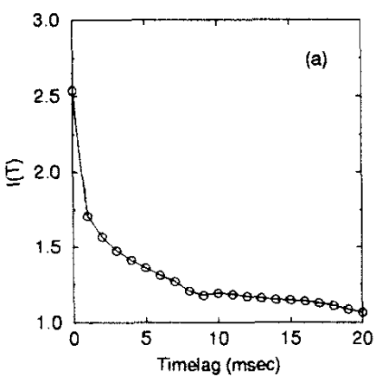
The average mutual information function was also employed when analysing this data to suggest an appropriate time delay, allowing for full and true representation of the data in phase space.
Figure 8 – AMI for intracellular voltage of a single neuron. First minimum at = 9ms.
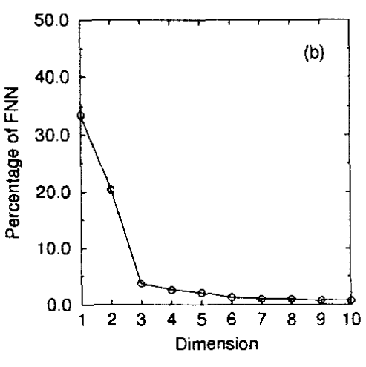
Utilising the false nearest neighbour method suggested an embedding dimension of 3 is sufficient to display non-linear complexity in the data as percentage of FNN drops significantly once the data is displayed in three dimensions (see Figure 9).
Figure 9 – Graph of FNN against embedding dimension for phase space reconstruction. Highlights significant drop in percentage of FNN at d = 3.

Despite percentage of FNN continuing to drop beyond dimension of 3, contamination of noise in the data can be exacerbated using higher dimensions as small fluctuations are stretched across phase space.
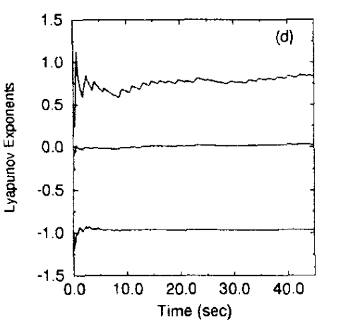
To confirm the dynamics of the neuron are chaotic, the Lyapunov exponents are calculated over time. The graph in Figure 10 shows three Lyapunov exponents as the data used to calculate them is based off a 3-dimensional phase map. Having one positive Lyapunov exponent was enough for researchers to conclude the nature of the neuron is in fact chaotic.
Figure 10 – Graph of Lyapunov exponents for reconstructed phase space with d = 3 and = 9ms.
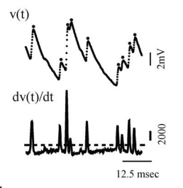
The brain is not however made up of a single neuron but an array of interconnected networks. These connections are called synapses. Unreliability in their behaviour and the transmission of signals has led to scientists coining the term “synaptic noise” meaning fluctuations in membrane potential as a result of these transmissions. Some researchers have refused to accept such stochastic behaviour as “noise”. and instead, research has also been conducted in uncovering hidden determinism in these signals too.
Figure 11 – Data gathered from Mauthner cells (M-cells) in teleosts. Voltage in post-synaptic cell measured over time.

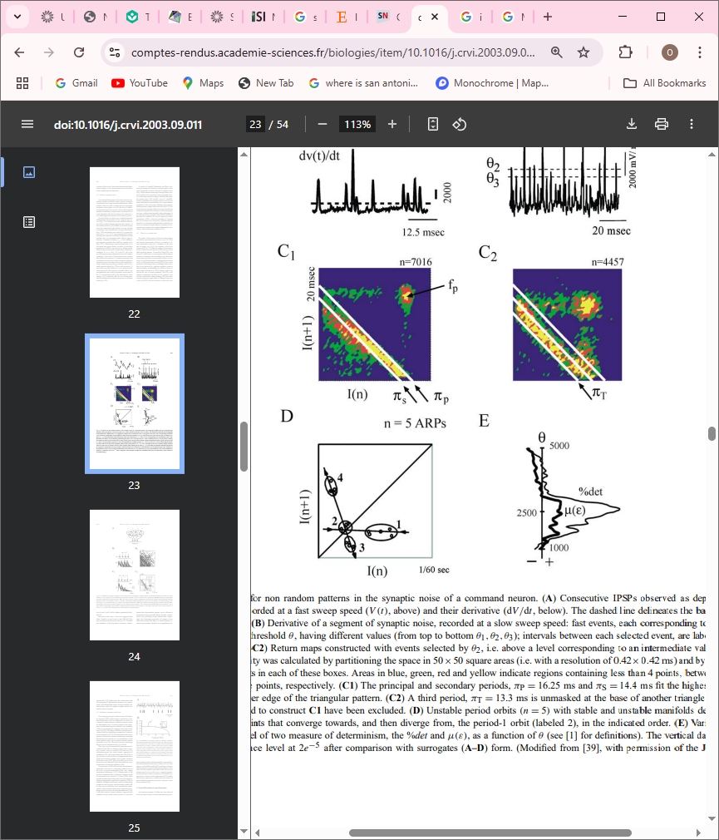
Figure 11 shows raw data gathered from an M-cell in a fish. It maps the voltage of the post-synaptic cell (cell that has just received a signal) over time as it is being sent inhibitory signals (ISPSs) that prevent it from generating its own action potential and sending its own signal. Fluctuations in the signal are a result of synaptic noise as each inhibitory signal is sent at the same strength.
Figure 12 – On the right, a return map for data in Fig. 11 with all data points plotted. On the left, a simplified version highlighting the UPOs in the data (circled and numbered)
Rather than calculating Lyapunov exponents or fractal dimensions to quantify and confirm the presence of chaos, UPOs can be uncovered in the attractor and its “skeleton” mapped instead. With data appearing completely stochastic at first glance, a return map is produced to highlight concentrations of points and uncover UPOs.
The return map on the left in figure 12 highlights concentrations of points and reveals a hidden triangular structure in the strength of the inhibitory signals received. On the right, a sample of data forms a new return map with “period-1 orbits” uncovered and made up of 5 points. The collections of points are circled and would also help researchers decide the location of the stable and unstable manifolds by following trajectories that converge to the periodic orbits and then diverge from it. Confirming there exists cycles in synaptic noise indicates this “noise” is in fact deterministic and chaotic.
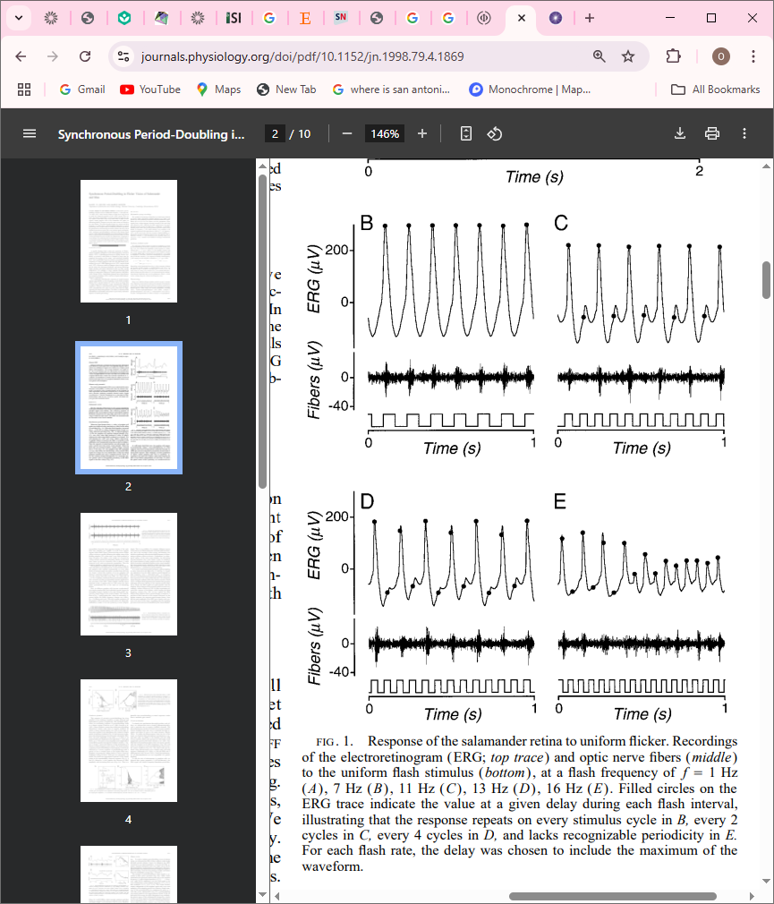
The neurones don’t always act chaotic, and rather than analysing the chaos directly, searching for the “road to chaos” can be just as good an indication data is deterministic. Period-doubling bifurcations have been detected in the retina of the salamander via an electroretinogram (ERG) that measures electrical activity in the retina in response to stimuli. Using a light flashing at increasing frequency, the electrical activity of the retina was mapped. The results at flash frequency 7Hz, 11Hz, 13Hz and 16Hz are displayed below and there is clear periodicity in data gathered at 7, 11 and 13Hz with each increase resulting in an orbit of a higher period. Finally, this period doubling leads to chaos at a flashing rate of 16Hz, electrical signals appear random.
Figure 13 – 4 graphs of electrical activity in the retina against time at a flashing frequency of 7Hz, 11Hz, 13Hz, and 16Hz (from left to right)

With all experimental data comes noise and whilst this can usually be ignored, when analysing data so complex and seemingly stochastic, there must be a way to ensure the underlying order uncovered through non-linear techniques is valid. Surrogate Data testing is common in such scenarios and requires creating “surrogates” – transformations of the data that preserve some quantities but not others. These surrogates are compared to the original data. One way to easily create surrogate data is by keeping the same data points but shuffling them in time. In this way the data has the same amplitude distribution, but the underlying order and chaos should be removed. A non-linear metric such as Lyapunov exponents or fractal dimension can be calculated for the original and surrogate data and then they are compared. Variation in these values suggests the original data truly holds non-linear and chaotic properties whilst little variation suggests the original data contains no significant pattern or underlying order that has been scrambled during the surrogate transformation. In many of the examples above surrogate testing was crucial in ensuring results obtained are valid and non-linearity is not a result of experimental noise.
Conclusion
The brain is one of many sources of hidden chaos. Non-linearity exists in the heart, governs the stock market, and could even reveal itself in music. Proper manipulation of data is the only way to reveal hidden order behind the shroud of false stochasticity. Recently, study showed that chaos could be behind the probabilistic computations inside the brain and its clear from previous research its role in the mind is irreplaceable. Many natural systems thrive in chaos, using its inherent sensitivity to initial conditions to move between states quickly and efficiently. It begs the question, what else in nature obscures order in disorder? If so many natural systems use it, why aren’t we exploiting the power of chaos?

https://www.scientificamerican.com/article/the-three-body-problem/#:~:text=In%201890%20Henri%20Poincar%C3%A9%20discovered,to%20the%20two%2Dbody%20problem
https://www.storyofmathematics.com/19th_poincare.html/
https://neuroscientificallychallenged.com/posts/know-your-brain-neurons
https://www.healthline.com/health/eeg
Comptes Rendus de l'Académie des Sciences - Series III - Sciences de la Vie. Volume 324, Issue 9, September 2001, Pages 773-793
https://mathshistory.st-andrews.ac.uk/Biographies/Lorenz_Edward/
https://www.dynamicmath.xyz/strange-attractors/#lorenz1963
https://www.math.ucla.edu/~tao/preprints/phase_space.pdf
https://mathworld.wolfram.com/Attractor.html
https://iternal.ai/what-is-a-fractal/
“Chaos” – James Gleick, Pages 83-118
Dynamics, The Geometry of Behaviour - Ralph H. Abraham and Christopher D. Shaw, Pages 310-317
https://www.islandsoforder.com/the-logistic-map.html
Reasoning About Luck: Probability and its Uses in Physics. By V. Ambegaokar. Cambridge University Press, 1996. 231 pp. ISBN 052144-737-2. £12.95. Journal of Fluid Mechanics. 1997;343:407-411. doi:10.1017/S0022112097276007
https://www.scirp.org/journal/paperinformation?paperid=56257#:~:text=Logistic%20map%20is%20generally%20used,for%20generations%20of%20binary%20numbers
https://www.sciencedirect.com/science/article/abs/pii/0375960180907884
https://pmc.ncbi.nlm.nih.gov/articles/PMC3253168/#:~:text=Period%2Ddoubling%20bifurcation%20to%20chaos%20was%20firstly%20discovered%20in%20the,and%20to%20period%2D3%20firing
https://physics.mff.cuni.cz/wds/proc/pdf11/WDS11_314_f8_Klikova.pdf
https://www.researchgate.net/publication/14317549_Synchronized_Action_of_Synaptically_Coupled_Chaotic_Model_Neurons
https://chaosbook.org/chapters/Lyapunov.pdf
Rabinovich MI, Abarbanel HD. The role of chaos in neural systems. Neuroscience. 1998 Nov;87(1):5-14. doi: 10.1016/s0306-4522(98)00091-8. PMID: 9722138.
https://www.researchgate.net/publication/307794867_Chaos_and_Nonlinear_Dynamics_An_Introduction_for_Scientists_and_Engineers
https://public.lanl.gov/jt/Papers/est-fractal-dim.pdf
https://advanced.onlinelibrary.wiley.com/doi/full/10.1002/admt.202301692
Iasemidis, L.D., Chris Sackellares, J., Zaveri, H.P. et al. Phase space topography and the Lyapunov exponent of electrocorticograms in partial seizures. Brain Topogr 2, 187–201 (1990). https://doi.org/10.1007/BF01140588
Freeman, W.J. Simulation of chaotic EEG patterns with a dynamic model of the olfactory system. Biol. Cybern. 56, 139–150 (1987). https://doi.org/10.1007/BF00317988
https://www.cam.ac.uk/research/news/the-human-brain-is-on-the-edge-of-chaos
https://www.researchgate.net/figure/Strange-attractor-for-the-Roessler-system-with-parameters-a-01-b-01-and-c-14_fig1_367557871
https://www.researchgate.net/figure/Poincare-map-for-the-3D-Lorenz-attractor_fig3_346234160
https://is.muni.cz/el/1431/jaro2016/M6201/um/OGY.pdf
https://www.fer.unizg.hr/_download/repository/Guckenheimer,_J._-_Nonlinear_Oscillations_Dynamical_Systems_and_Bifurcations_of_Vector_Fields_(1986).pdf
https://www.khanacademy.org/math/multivariable-calculus/multivariable-derivatives/jacobian/v/the-jacobian-matrix
https://www.mathsisfun.com/algebra/eigenvalue.html
http://www.scholarpedia.org/article/Unstable_periodic_orbits
https://is.muni.cz/el/1431/jaro2016/M6201/um/OGY.pdf
https://www.researchgate.net/publication/21636782_Controlling_Cardiac_Chaos
https://www.researchgate.net/publication/15134695_Controlling_chaos_in_the_brain
https://synbio.ucsd.edu/rulkov/papers/NECO_8_1996.pdf
http://www.scholarpedia.org/article/Stomatogastric_ganglion#:~:text=The%20pyloric%20CPG%20controls%20striated,ossicles%20in%20the%20gastric%20mill.
W. Calvin, C. Stevens, Synaptic noise as a source of variability in the interval between action potentials, Science 155(1967) 842–844.
P. Faure, D. Kaplan, H. Korn, Probabilistic release, and the transmission of complex firing patterns between neurons, J. Neurophysiol. 84 (2000) 3010–3025
https://eyewiki.org/Electroretinogram#:~:text=9%20References-,Definition,History
https://journals.physiology.org/doi/pdf/10.1152/jn.1998.79.4.1869
https://sapienlabs.org/lab-talk/using-surrogate-data-to-detect-nonlinearity-in-time-series/#:~:text=Surrogate%20data%20are%20essentially%20transformations,:%20Linear%20process%20x(n)
https://www.sciencedirect.com/science/article/abs/pii/016727899290102S
https://bu.ac.bd/uploads/BUJ1V5I12/6.%20Hena%20Rani%20Biswas.pdf
https://medicalxpress.com/news/2024-07-chaotic-dynamics-brain-enable-probabilistic.html#:~:text=Toyoizumi%2C%20with%20CBS%20colleague%20Yu%20Terada%2C%20wanted,illustrated%20by%20the%20butterfly%20effect%20whereby%20an

