

The Impossible Shot

Sebastian Nicol

Haberdashers’ Borough Academy

Teddy Rocks Maths 2025

Introduction
Since 1977, when the first Star Wars came out, this chain of blockbuster movies has taken the world by storm with 11 movies spanning 48 years. In this universe, certain people called Jedi and the Sith wield a power, or at least control a part of their universe, known as the force. It allows them to push and pull objects at will as well as having very fast and accurate reflexes. In this universe exists the empire which are a repressive and tyrannical body which try to take control of the galaxy. They wield a moon sized weapon called the death star, capable of destroying planets. In this essay, I will attempt to discover the scope and accuracy of the shot Luke takes to blow up the death star, that he does using the force.

The shot
In the original star war, “A New Hope”, the most famous use of the force is where Luke Skywalker, the main character and a jedi, uses the force to accurately land a shot, a photon torpedo, in an exhaust port in the death star. This subsequently shoot down into the centre of the death star and thanks to a purposeful flaw by the designer of the death star, it explodes, saving the galaxy.
I am going to look at how accurate the force needed to be to make this shot by looking at the distance and window of error that Luke had to overcome.
It is seen many times that these photon torpedoes move in a straight line as it has negligible mass and will therefore practically not feel the forces from gravity to a great enough extent to change its trajectory,
Weight = Mass x Gravitational Field Strength.
They will also keep at a constant speed as there is no air resistance in space.
In this scene, Luke is driving an X-Wing, spacecraft, that can fly like a jet in space, shoots the photon torpedo while flying along the surface of the Death Star.

Distance Travelled by the bullet
The photon projectiles move at on average 1000ms⁻¹ (1).
Using a stopwatch and the movie at x0.25 speed, I can find that the time taken by the bullet is on average
5.09/4 which is 1.2725s.
This makes the diagonal distance between the exhaust pipe and the blaster is 1000 x 1.2725 = 1272.5m.

The horizontal component
To find the horizontal distance travelled by the bullet, we must first find the distance of the curved area on the death star over which the bullet flew. Using the maximum speed of the x-wing as 1050kmh⁻¹ (2), which comes to 291.6667ms⁻¹, where we can assume this is what he is moving at as he would go full throttle whilst escaping the people chasing him.
The radius of the death star is said to be 80km (3). Using this, we can use πd to find the total circumference of the death star as
502654.8246m.
To find the distance the bullet travelled horizontally, we can use Speed = distance / time and use the final shot where we see the curved distance between Luke’s ship and the exhaust port, which is 20830m. To find the time it would have taken the x-wing to fly the whole distance. Instead, he shoots a bullet over the final time, so we can do
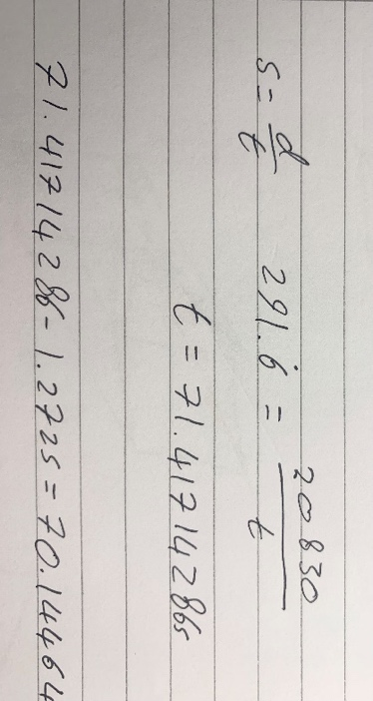
To find the time taken while he is flying before he shoots the bullet. We can then use s = d/t once again to find the distance he travels.
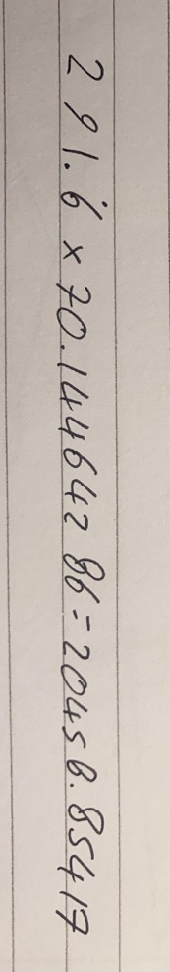
We take this number away from the original 20830 to find the curved distance below the bullet.
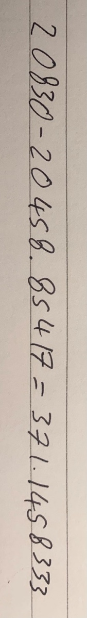

Take this number and divide it by the total circumference of the death star. Times this fraction by 360 to find the angle to form a triangle. Then, we can use cosine rule to find the horizontal distance.

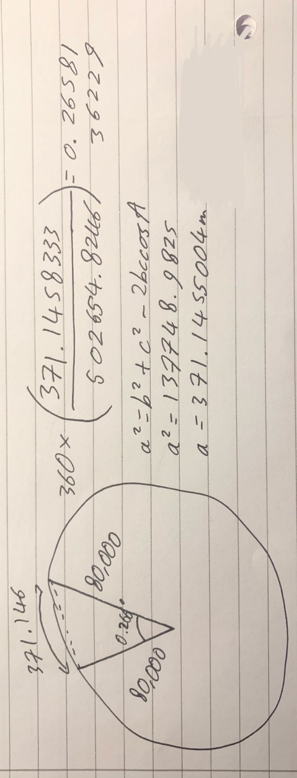

Lengths

Now that I had these values, I had to use trigonometry to form a triangle with the middle of the ship and exhaust port, so it is 2D. This was not the case as Luke shot two torpedoes, one from either arm of the ship.
Using the wingspan of the x-wing as 11.2776m (4). I can create a triangle between one the ends of the x-wing, the exhaust port and the centre of the x-wing at the midpoint of the blasters. The hypotenuse being 1272.5m and one of the sides being 11.2776m, I can use Pythagoras’ theorem to find the diagonal distance between the midpoint of the blasters and the exhaust port.

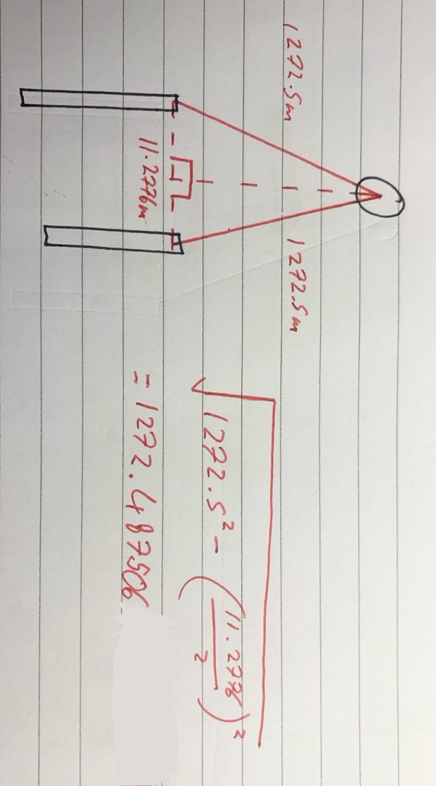

Once I have this, I can form a triangle between the midpoint of the blasters, the exhaust port and the point below the x-wing. Using this, I can find the vertical height.
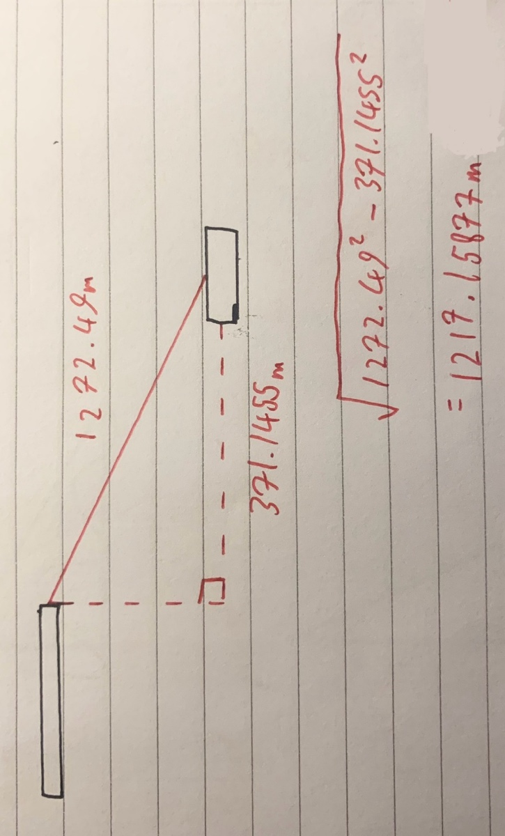

The Exhaust Port

To find the window of error for the shot, I must find how small the exhaust port is from where Luke is facing. Firstly, I find the horizontal distance between each blaster and the exhaust port as the distance found before (371.1455004m) was between the midpoint of the blasters and the port.
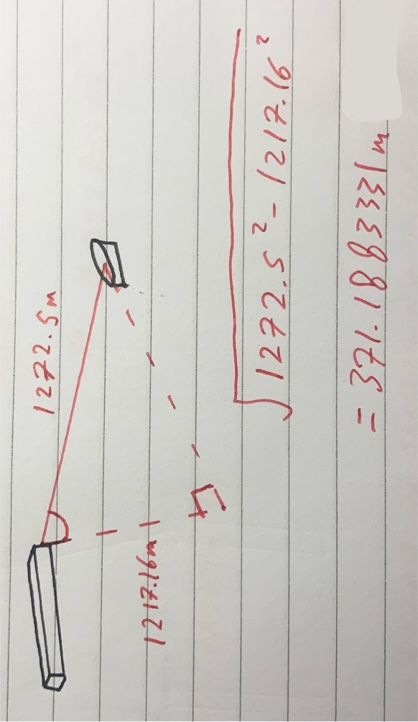

According to Jan Dodonna, detailing the plan of attack on the first Death Star, the port is 2m wide (5). Taking the closest side of the hole to Luke, I can take 1m away from the diagonal, horizontal component as we have calculated the lengths to the midpoint of the port, so the radius is 1m. Using this I can form a triangle between the closest end to the exhaust pipe, the point below the x-wing and the blaster to find the angle between the vertical and the furthest up he could shoot to make the shot.
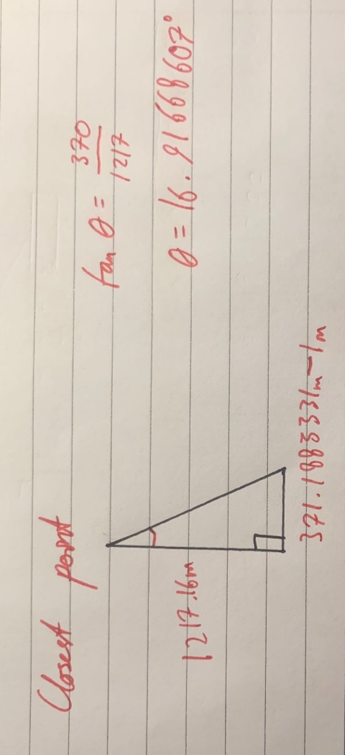
I can repeat this but adding 1m for the furthest point, where I’m finding the angle between the vertical and the furthest down, he could shoot to make the shot.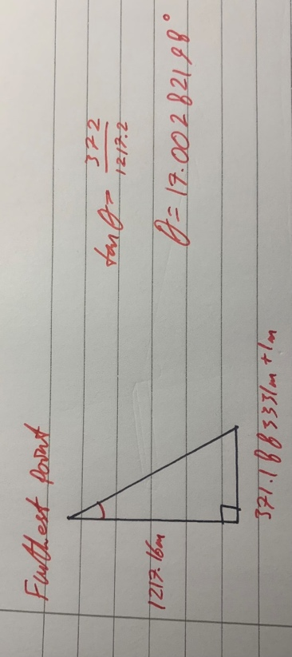

So, finally, the window of error for Luke Skywalker to shoot in to make his shot is 0.0814127674 degrees.
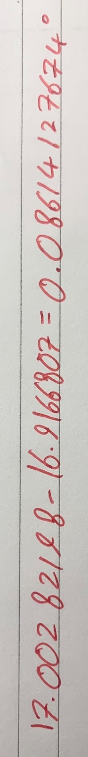

However, there is also a window for the bullet to go left or right so I must find the angle between.
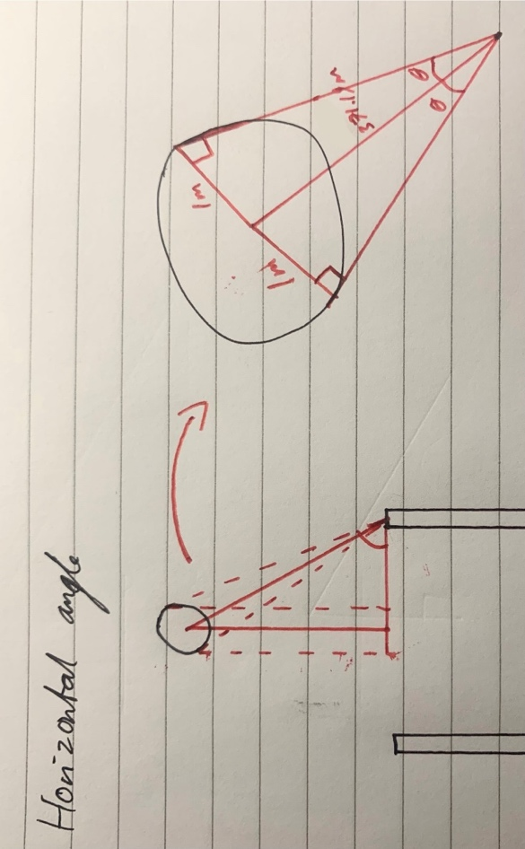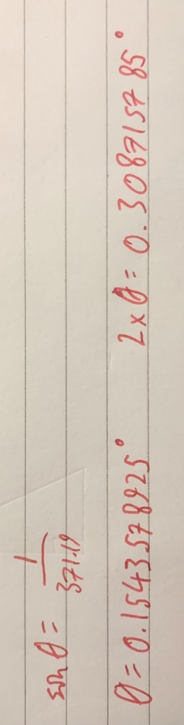
Therefore, the horizontal angle for Luke’s shot is 0.30815785 degrees.

Flaws

The first flaw with this number is that my original value for time will have an error due to human error from reaction speed. I tried to reduce this by repeating the experiment, however I cannot get rid of the error fully.
Another flaw is that I do not know if the x-wing Luke is flying is going at full speed or not. I can assume it is as he is being chase however, I cannot know for sure.
Trying to find a work around round these issues was difficult as without conducting the experiment for time and assuming speed, the distance needed was impossible to find without knowing exact measurements of certain parts of the death star, which is not known.
Furthermore, the distance shown by the computer may not be the curved distance, but it must be assumed to find the angle and may also be a bit before the exhaust pipe as it must leave room for the pilot to take the shot. Finding a work around this issue was impossible as previously said, the measurements of exact components of the death star are not known.
Another issue is reliability. Online, values of different distances and speed such as the radius of the death star or the speed of an x-wing for example are rarely agreed on which forced me to take the number that came up the most times (agreed on the most).
Lastly, the bullet is seen to curve into the exhaust pipe. This is a topic argued about online with some saying he used the force to curve it down while others say it ricochet off the sides of the exhaust pipe. If we assume the first to be true, there would be a greater margin of error as he would only need to shoot the bullet above the exhaust port, increasing the vertical angle needed to make the shot.
These flaws are apparent within my experiment as the horizontal distance travelled the bullet is far smaller than the vertical distance travelled by the bullet. In the movie, the bullet is seen to be shot more forward over a long horizontal distance.

Conclusion

To make this shot, while flying at 1050kmh⁻¹ , Luke had to shoot within a vertical range that spanned 0.0814127674 degrees vertically and 0.30815785 degrees horizontally. That means, at the speed he was going, if he had kept the angle of this shot the same but shot a thousandth of a second later or earlier, he would have missed. Not only is the angle of the shot humanly impossible, but the speed he was going out means his reaction speed is also impossible for a human to have. Therefore, the force allowed Luke to not only perfectly aim the shot, but also when to shoot it. Without the help of the force, this shot is impossible.

Sources

- http://stardestroyer.net/wiki/index.php/Proton_torpedo#:~:text=Michael%20Wong%20has%20calculated%20the,velocity%20of%201%20km%2Fs.
- https://en.wikipedia.org/wiki/X-wing_fighter
- https://www.quora.com/In-Star-Wars-how-big-was-the-second-Death-Star-compared-to-the-first-one-1
- https://www.smithsonianmag.com/air-space-magazine/star-wars-x-wing-starfighter-180979351/#:~:text=No%20Rebel%20craft%20is%20more,a%20wingspan%20of%2037%20feet.
- https://starwars.fandom.com/wiki/Thermal_exhaust_port#:~:text=An%20exhaust%20port%20on%20the,directly%20to%20the%20reactor%20system.%22

